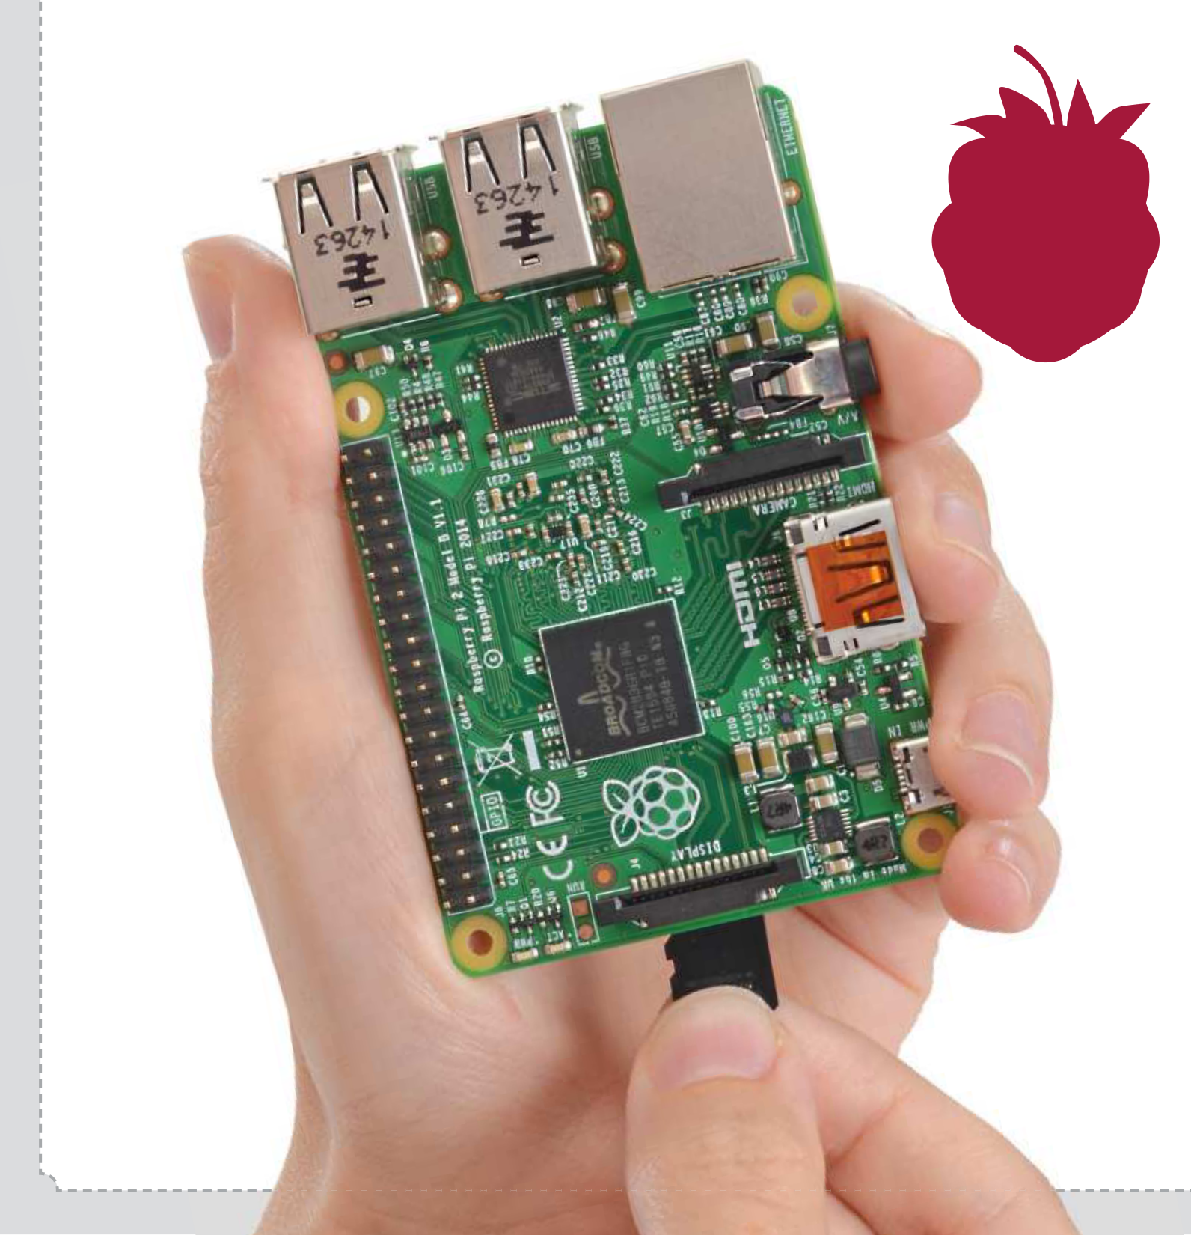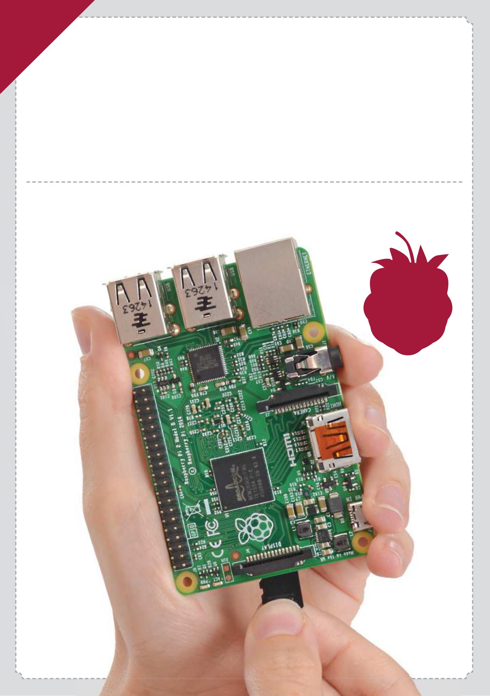

**Raspberry Pi The Complete Manual**

The essential handbook for all Raspberry Pi users

**90**   
**pages of**   
**projects**

Welcome to   
**Raspberry Pi**  **The Complete Manual**

The Raspberry Pi is one of the most exciting things to happen to computers since Steve Jobs revealed the iPad. As an educational tool, this credit card-sized PC has reignited interest in bare-metal computing in schools. As a platform for open-source software, it has also inspired millions of people to try Linux – many for the frst time. Most exciting of all is the potential to incorporate the device into practical projects, as demonstrated by the tutorials in this newly revised edition of the Complete Manual to Raspberry Pi. So get creating!

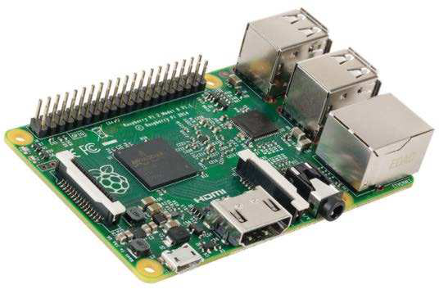

**Raspberry Pi The Complete Manual**

Imagine Publishing Ltd   
Richmond House   
33 Richmond Hill   
Bournemouth   
Dorset BH2 6EZ  
☎ +44 (0) 1202 586200   
Website: www.imagine-publishing.co.uk   
Twitter: @Books_Imagine   
Facebook: www.facebook.com/ImagineBookazines

Publishing Director   
Aaron Asadi

Head of Design   
Ross Andrews

Production Editor   
Fiona Hudson

Senior Art Editor   
Greg Whitaker

Designer   
Perry Wardell-Wicks

Photographer   
James Sheppard

Printed by   
William Gibbons, 26 Planetary Road, Willenhall, West Midlands, WV13 3XT

Distributed in the UK, Eire & the Rest of the World by   
Marketforce, 5 Churchill Place, Canary Wharf, London, E14 5HU Tel 0203 787 9060 www.marketforce.co.uk

Distributed in Australia by   
Network Services (a division of Bauer Media Group), Level 21 Civic Tower, 66-68 Goulburn Street, Sydney, New South Wales 2000, Australia, Tel +61 2 8667 5288

Disclaimer   
The publisher cannot accept responsibility for any unsolicited material lost or damaged in the post. All text and layout is the copyright of Imagine Publishing Ltd. Nothing in this bookazine may be reproduced in whole or part without the written permission of the publisher. All copyrights are recognised and used specifically for the purpose of criticism and review. Although the bookazine has endeavoured to ensure all information is correct at time of print, prices and availability may change. This bookazine is fully independent and not affiliated in any way with the companies mentioned herein.

Raspberry Pi is a trademark of the Raspberry Pi foundation

Raspberry Pi The Complete Manual Fifth Edition © 2015 Imagine Publishing Ltd

ISBN 9781785461651

Part of the



bookazine series





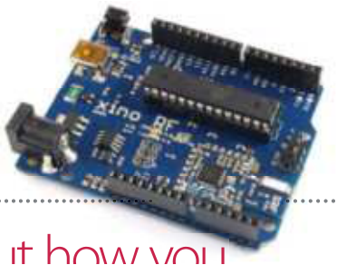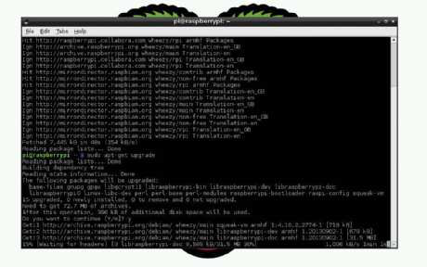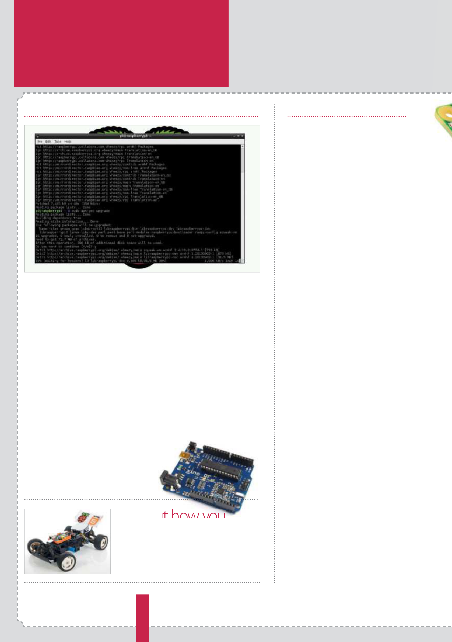

Contents What you can f nd inside the bookazine

Getting started The projects

**36 Supercharge your Pi**   
 Improve performance

**40 Control with gestures**   
 Add touch to any project

**44 Back up your Pi**   
 Never lose a file again!

**46 Beginner’s guide to nano**   
 Edit text from the CLI

**48 Remote desktop access**

|  |  |  |
| --- | --- | --- |
| **8 Raspberry Pi models** | **26 Get online** | Use Raspbian anywhere! |
| Meet models 2, A+ and B+ | Access a world of apps | **50 Access files with SSH** |
| **12 The starter kit** | **28 Install & use packages** | Get access from home |
| What you need for your Pi | How to use apt-get | **52 Monitor your network** |
| **14 Set up your Pi** | **30 Use graphical** | Analyse your local network |
| Configure your new PC | **installations** | **54 Tether to Android** |
| **16 Install a distro** | Install & remove graphically |
| Access the internet any- |
| **32 GPIO explained** | where using a hotspot |
| Get your new OS running |
| **18 Command line basics** | Get to grips with GPIO pins | **56 Share files with Samba** |
| **34 Top four add-on boards** | Share across your network |
| Learn essential new skills |
| **22 The Raspbian desktop** | Four of the best peripherals | **58 Turn your Pi into an** |
| **office suite** |
| Find your way around |
| Master LibreOffice |

**24 Master the Config tool**  How to tweak your settings

**6**

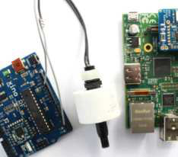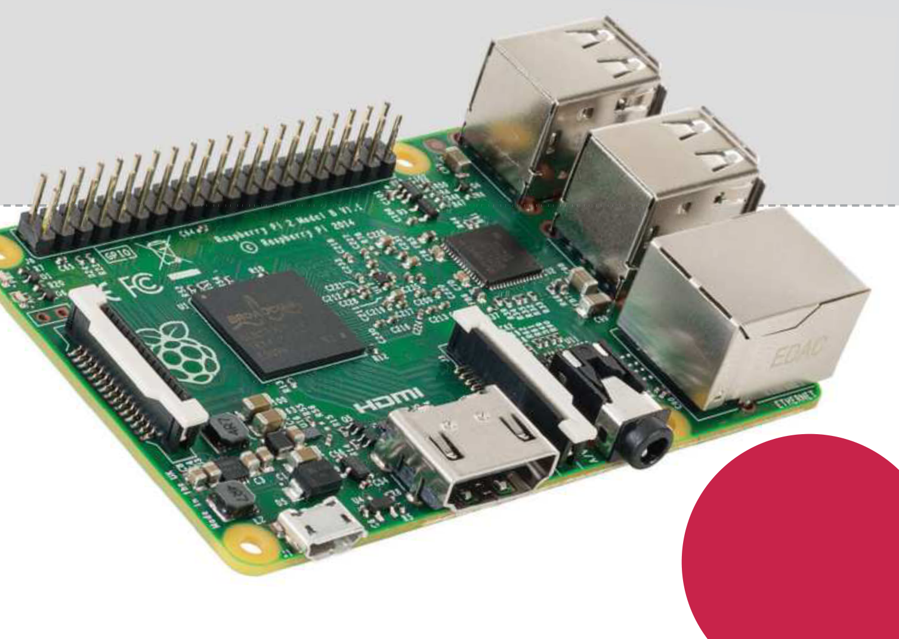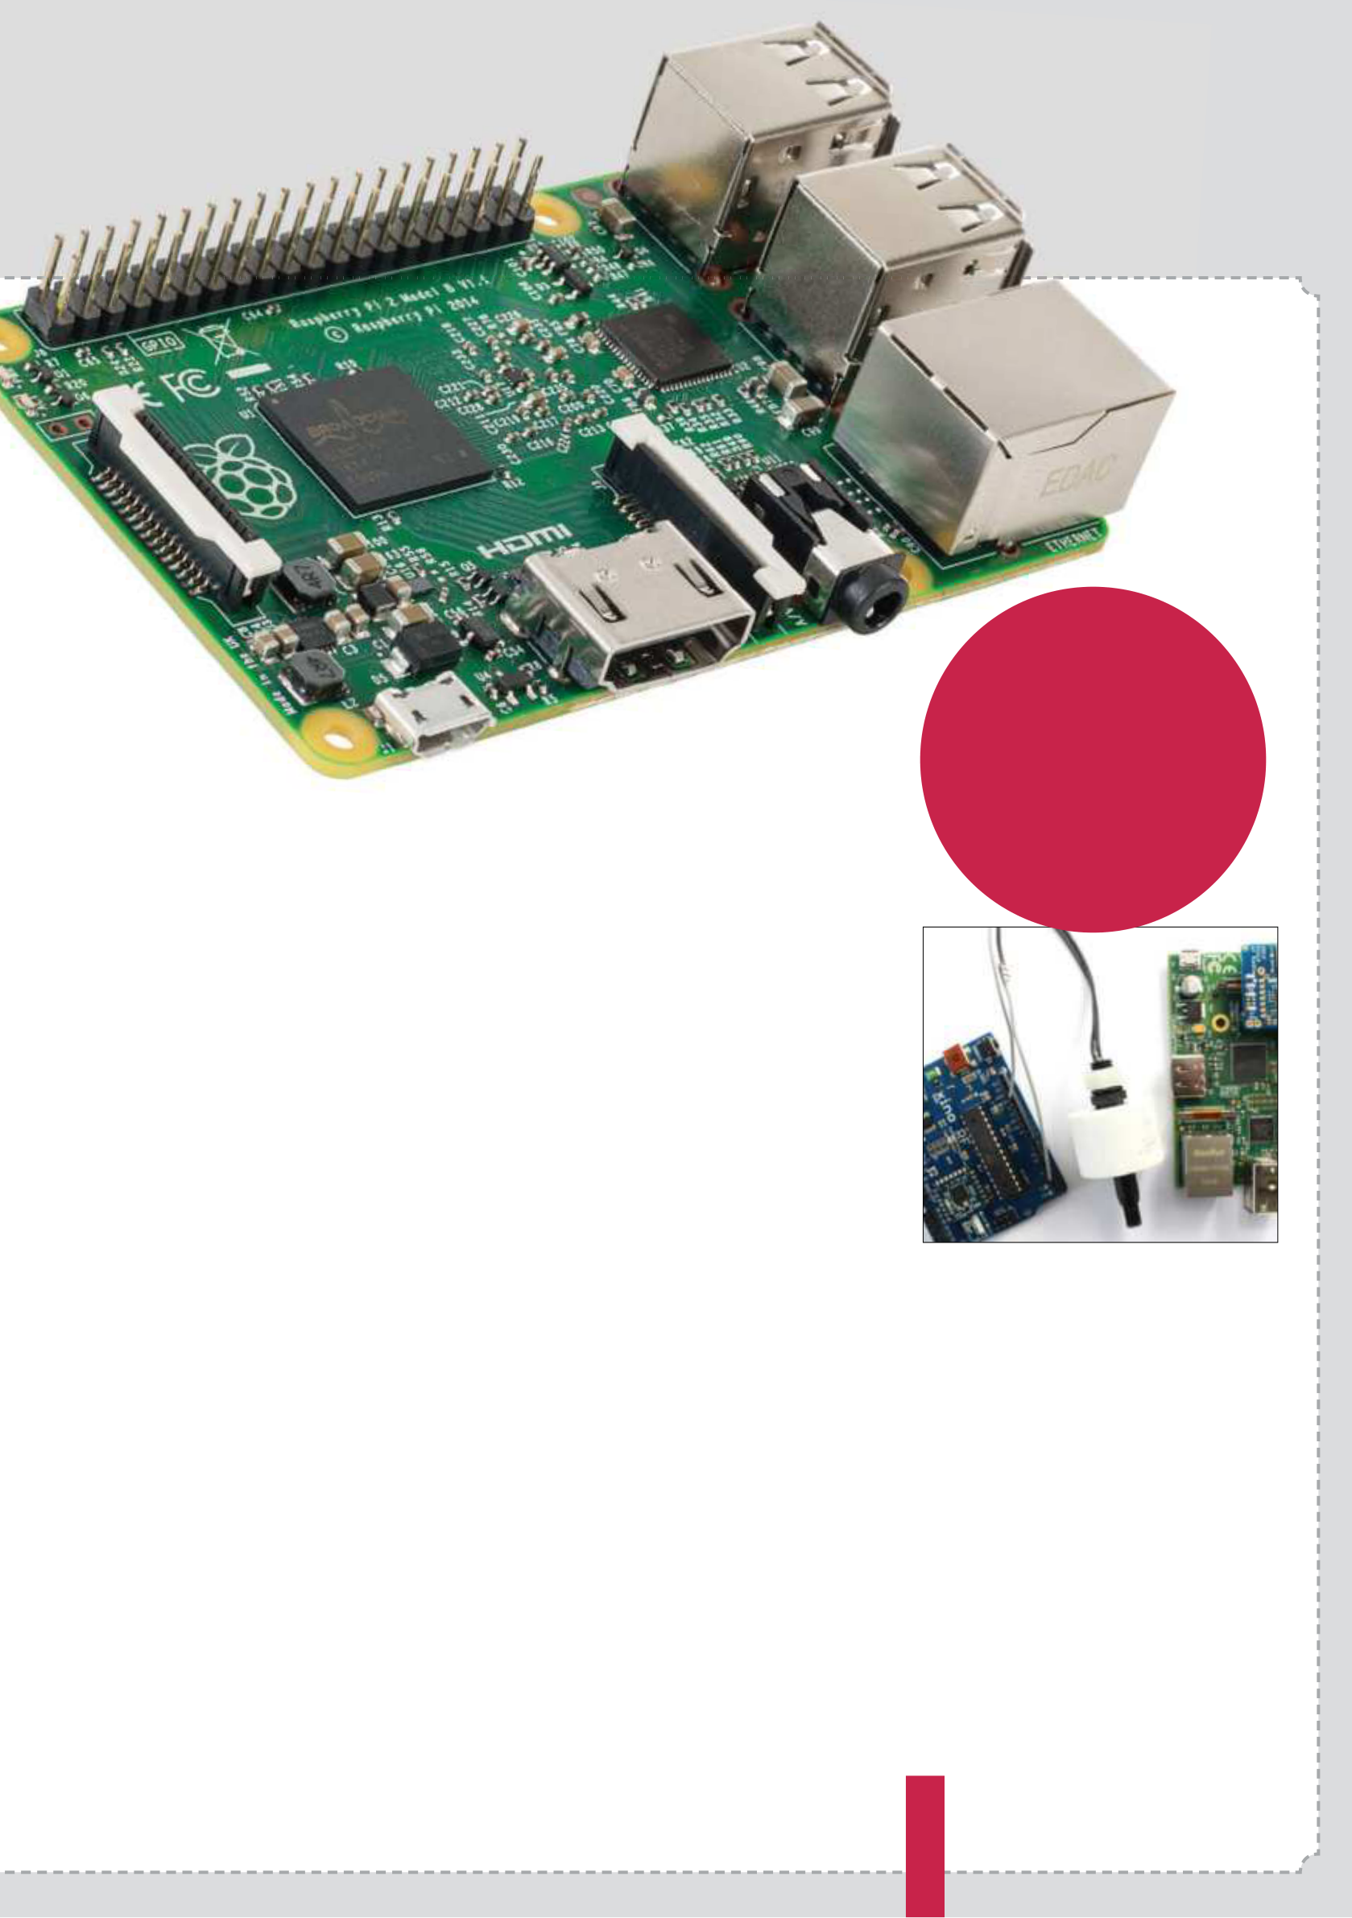

|  |  |  |
| --- | --- | --- |
| **70 Use the Camera board** | **90 Make music** | **Code**  **& create**  **with**  **your Pi!** |
| Code a number one hit! |
| **92 Voice synthesizer** |
| Take pictures and video | Teach your Pi to talk |
| **72 Control an LED** | **94 Build your first** |
| Get creative with light | **web server** |

Learn new web skills **76 Add a reset switch**   
 Restart your Pi **96 Code a Twitter bot**  Teach your Pi to tweet **78 Add Battery Pack**   
 Take your Pi mobile **98 Use an accelerometer**  Make your own controller **80 Draw circuits with paint**

|  |  |  |
| --- | --- | --- |
| Assemble circuits using | **100 Time-lapse camera** | **108 Build a security** |
| Bare Conductive paint | **trigger** | **camera** |
| Make a timelapse video | Keep an eye on your Pi |

**82 Send SMS**

|  |  |  |
| --- | --- | --- |
| Text for free from your Pi | **102 Build a portable** | **110 Build and control a Pi-** |
| **84 Make a Ras Pi HTPC** | **Internet radio** | **powered car** |
| Stream music online | The ultimate in RC |

Use Pi2 for a powerful HTPC

|  |  |  |
| --- | --- | --- |
| **86 Print wirelessly** | **104 Build an always-on** | **118 Build a Minecraft console** |
| **torrent box** | Make a fully-functional |
| Keep those wires hidden | Download apps easily | Pi-powered console |
| **88 Make your own retro** | **106 Wi-Fi signal repeater** | **126 Build a power** |
| **games console** | Find your own way to | **move glove** |
| Play games on your Pi | boost your Wi-Fi signal d | Create wearable tech |

**7**

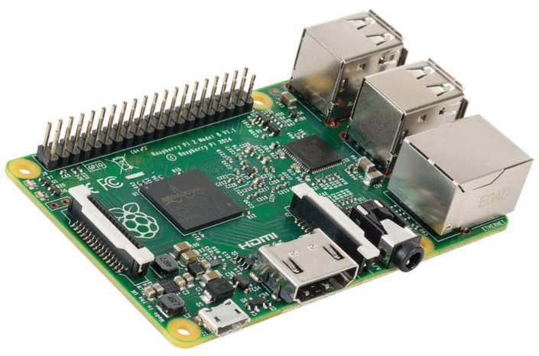

|  |  |
| --- | --- |
| **Getting started** | Raspberry Pi 2 |

Raspberry Pi 2

A super-charged Raspberry Pi that fnally does everything you’d want it to, for

the exact same price as the original

|  |  |
| --- | --- |
| While the Raspberry Pi has enjoyed years of success, there’s always been a couple of things a lot of users wanted. A slightly more powerful CPU that could handle day-to-day computing, more USB ports and maybe wireless to make connecting to the network easier.  The Raspberry Pi 2 solves most of these  problems. As it uses the same board design as the Model B+, it has four USB ports, up from the two that were on the original Raspberry Pi Model B.  More importantly, it has a much more powerful | core, 900 MHz beast that helps to make the Pi 2 a much more functional board. Whereas before you’d have had problems surfng the internet or writing a document, now the Pi 2 breezes through these tasks with ease and plenty of processor power to spare.  Otherwise it’s still the same board as the  Raspberry Pi B+. As well as the aforementioned four USB 2.0 ports, there’s the Ethernet port for wired internet, a good-quality 3.5mm headphone jack for sound, a HDMI port for digital video and |

processor and more RAM, making it six times faster than the original Pi. Unfortunately, there is no Wi-Fi, but with the option to get a cheap

audio and a 40-pin GPIO port. This expanded GPIO port is fantastic for making your physical projects even more involved and complicated to

dongle for the Pi 2 this is much less of a problem. do far cooler things.

The new BCM2936 chip is the heart of the   
Raspberry Pi 2, a modifed version of the BCM2835 chip from the old Raspberry Pi. Instead of having a single core, 700 MHz processor it’s now a quad-

|  |
| --- |
| **8** |

For those worried about compatibility, all your old fles and projects and such work just fne on the Raspberry Pi 2, and all you need to do is transfer them over like any normal fles.

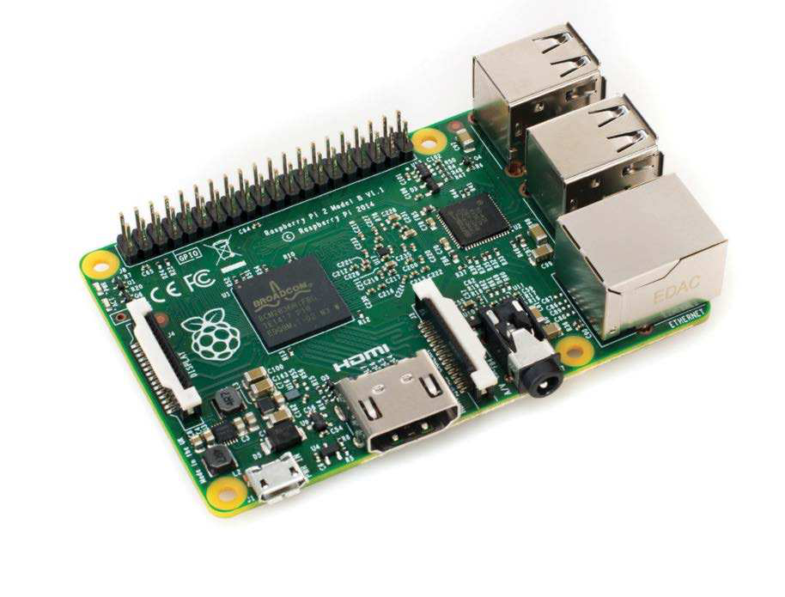

|  |  |  |  |  |
| --- | --- | --- | --- | --- |
| Raspberry Pi 2 | | | **Getting started** | |
| **HDMI port** | **GPIO port** | | |  | | --- | |  | | **USB ports**  The four USB ports give you much more flexibility with the Raspberry Pi 2, allowing you to easily add a keyboard, mouse, wireless dongle and external storage without  needing to constantly switch out or get a powered-hub |
| The Raspberry Pi’s special ability | The 40 pins in the GPIO port give | |
| is to decode 1080p video on the | you a range of power and function | |
| fly with very little problem, and | slots to control a project or read | |
| the same tech still exists in the | more data from your surroundings. | |
| Pi 2. The HDMI port is basically | This makes the Raspberry Pi 2 | |
| the same, allowing for high | the perfect core for an Internet of | |
| definition video and audio | Things or Maker project | |
| |  | | --- | |  |  |  | | --- | |  |   **MicroSD** | | |
| **Ethernet port**  The Pi 2 retains the wired  network and internet connection that was on the Model B of the original Raspberry Pi. It still tops out at 100 MB, but that’s plenty fast enough for the Raspberry Pi | |
| Underneath the board is where the boot medium lives – the microSD | | **Headphone jack** |
| card. Much smaller than the SD | | Need to listen to your Raspberry |
| card of the original, it still holds the | | Pi privately? Connect it to a pair of |
| full operating system and allows | | portable speakers? The 3.5mm jack is |
| the Pi 2 to be much smaller | | still on the Pi 2, and is one of the higher- |
| quality ones that was added to the B+ | | |

|  |  |
| --- | --- |
|  | “The Raspberry Pi 2 still won’t be able to power a USB hub, so if you need to  expand the compliment you’ll need to get a powered-hub” |

|  |
| --- |
|  |
| **9** |

|  |  |
| --- | --- |
| **Getting started** | Raspberry Pi (Model A+) |

Raspberry Pi Model A+ Good things come in small packages: fnd out why the Raspberry Pi A+ is ideal for mobile projects.

While the Raspberry Pi Model B+ is a step up from the Model B with its four USB ports, the Model A+ is smaller than its predecessor, weighing just 23g (down from 45g) and wielding one USB port. It’s also limited to just 256MB of RAM on the SoC, compared to the 512MB enjoyed on the B+.

But don’t think that all of this means that the A+ is inferior. Its 65mm length and lower weight

is a clue as to how it can be used. The lack of   
an Ethernet port meanwhile, isn’t a weakness, rather an illustration of the fact that this Raspberry Pi is designed not for media centres and print servers, but for projects where weight is a factor. Perhaps you’ll mount it on an Arduino-powered robot, where its lower power requirement can be satisfed with a battery.

|  |  |  |
| --- | --- | --- |
| **MicroSD Storage** | **Connectable**  **and flexible** | **256 MB RAM**  **Squeezed on board!** |
| No more worries about the SD |
| card being snapped off or lost. The | Both new Raspberry Pi models have | It seems amazing, but on top |
| Raspberry Pi A+ features a push- | had the GPIO header increased | of all of this, there is a System- |
| push slot for a microSD card | from 26 pins to 40, increasing the | on-Chip 700 Mhz processor |
| device’s flexibility | with 256 MB of RAM mounted |

in the centre of this versatile   
little computer

|  |  |  |  |
| --- | --- | --- | --- |
| |  | | --- | |  | | | |
|
|  |  |  |
|  |  |  |
|  |  |  |
|  |  |  |

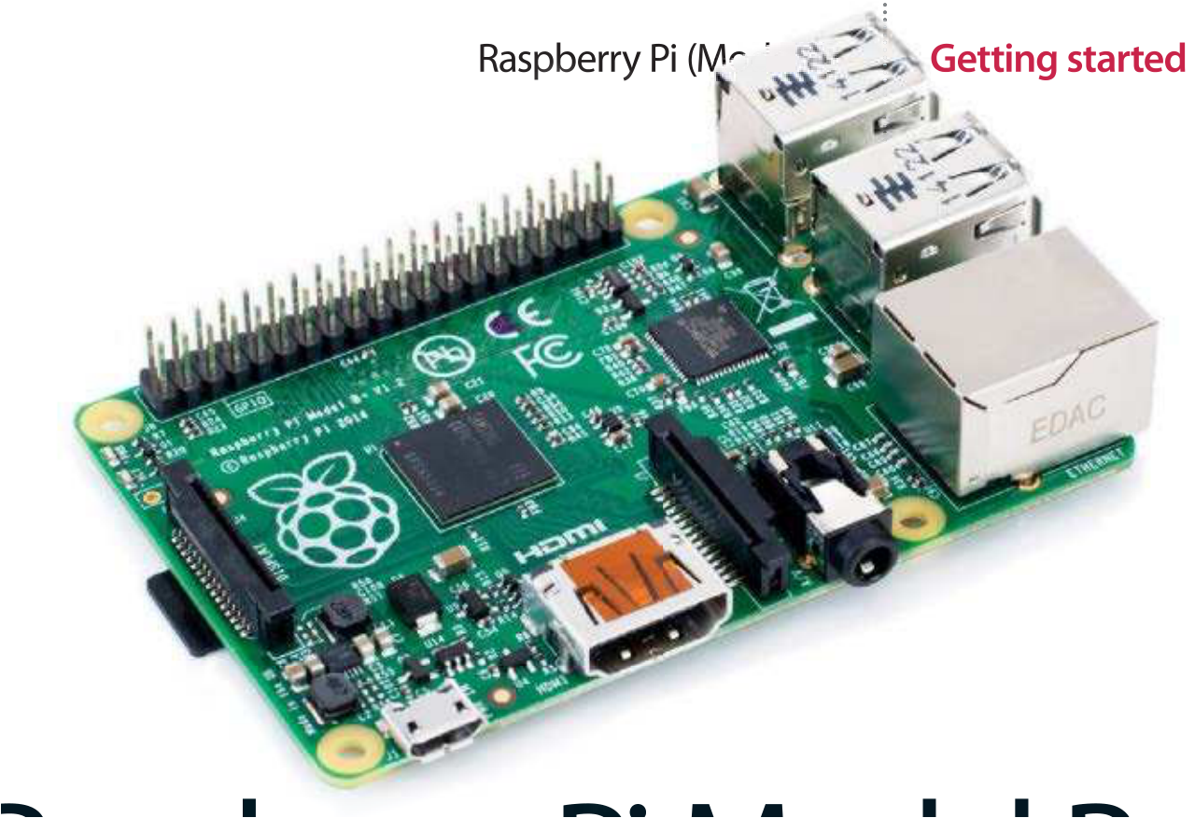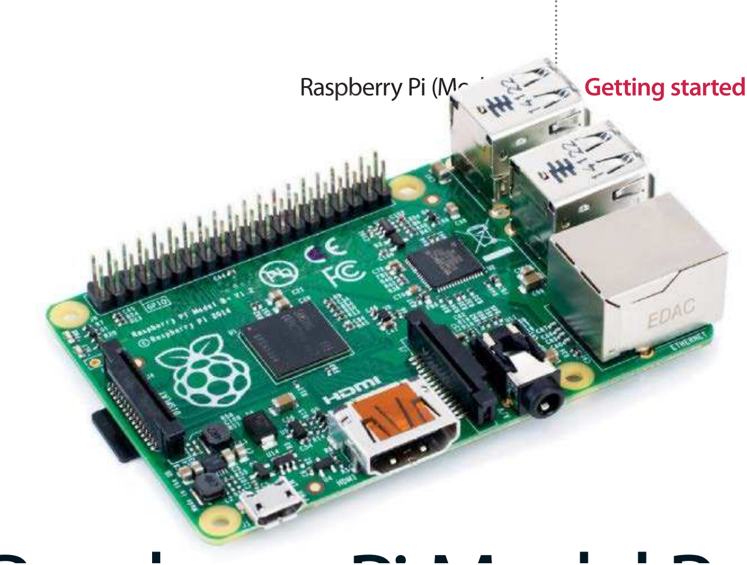

The latest version of the original Raspberry Pi has some essential updates while still remaining largely the same. Is it worth the upgrade?

With the Model B+, an enhanced version of the Model B revision two, some of the hardware has been relocated into a more logical and tidier layout. The new layout lends itself to a much tidier work station or project innards. Everything is much more f ush to the board without the USB ports or video connector sticking way out, and with all the ports along two sides rather than all four, the cabling can be a lot more tidy and the placement can be more f exible, and less awkward for specif c setups.

The inclusion of two more USB ports is a   
godsend to a lot of Raspberry Pi users who want to use a mouse, a keyboard, a Wi-Fi dongle and perhaps some external storage at the same time without needing a powered USB hub.

As well as two more USB ports there are 14 more pins added to the GPIO port, which still remains in roughly the same position on the side

of the board. The extra pins are merely added on to the end of the original layout, meaning your old projects will still work just f ne. You can now do a lot more with them, though.

The core of the B+ is fundamentally the same as the revision two of the Model B – it still has the same Broadcom ARM v6 system-on-a-chip along with the 512MB of RAM found in the revision two.

On the one hand, this is excellent. People   
getting into Raspberry Pi don’t need to learn the hard way that all the online tutorials have stopped being relevant. Those who decide to upgrade don’t need to learn anything specif cally new and they can create a copy of their SD card that will work straight away in the B+.

Either way, the Model B+ is replacing the Model B as the f agship Raspberry Pi. For those still   
hanging onto the revision one Raspberry Pi, it’s a great time to upgrade and get ahead of the curve.

|  |
| --- |
| **11** |

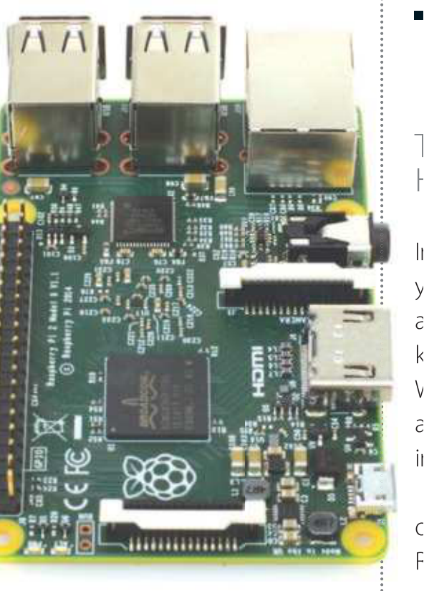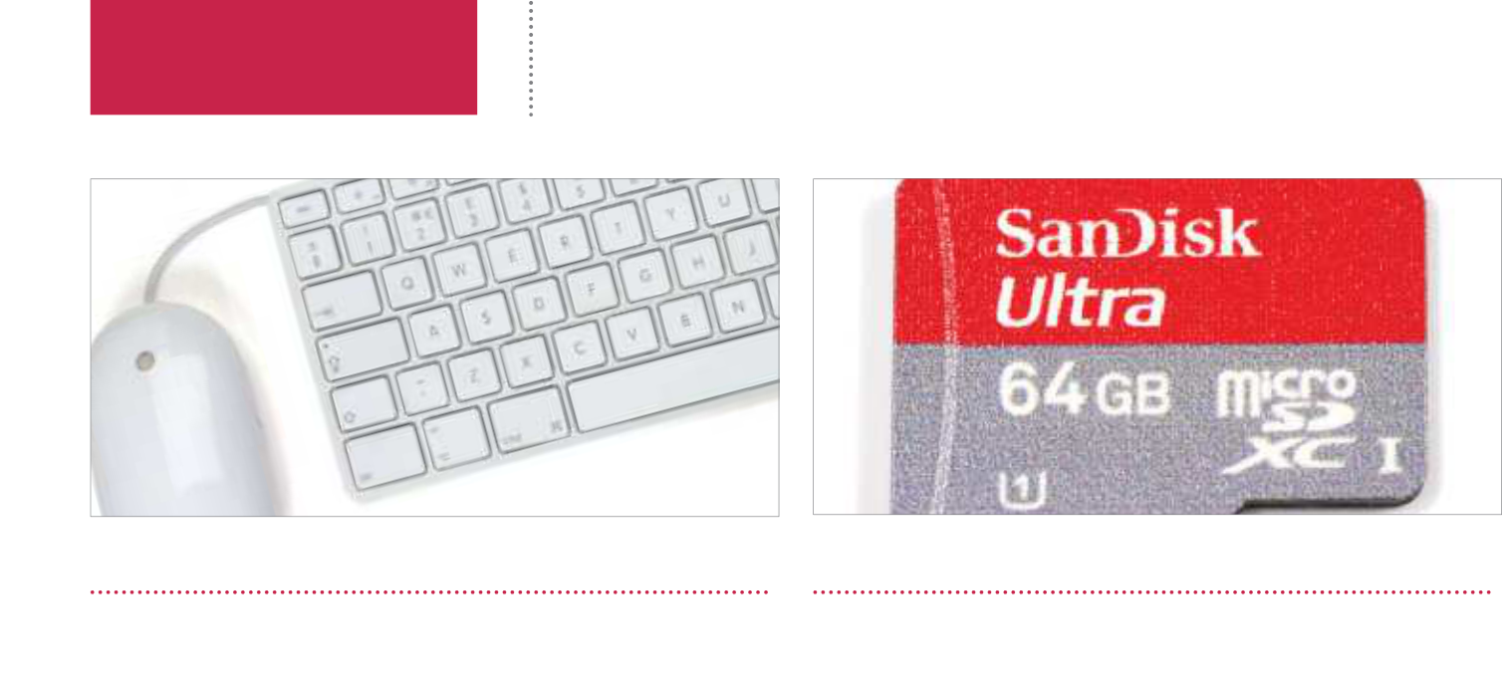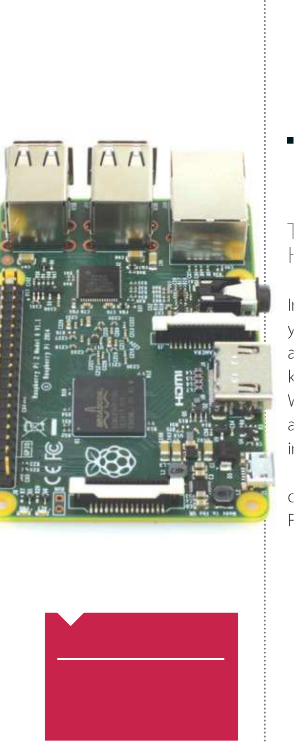

**Getting started**  The starter kit

**Did you know…**

Most online retailers sell   
packages complete with all the   
accessories you might need –  
even pre-installed SD cards.

Keyboard and mouse SD card

Let’s start with the most basic of components, the keyboard and mouse. Generally speaking, virtually any USB keyboard and three-button scroll mouse will work with the Raspberry Pi, and although for some projects you won’t even need a keyboard and mouse, you’ll need them for initial setup.

|  |
| --- |
| **12** |

Early Raspberry Pi computers required an SD card, whereas later models such as the Raspberry Pi 2 use microSD cards for storage. This is where your chosen operating system (such as Raspbian) is installed, and these can be bought in various sizes, pre-installed with the OS, or blank.

|  |  |
| --- | --- |
| The starter kit | **Getting started** |



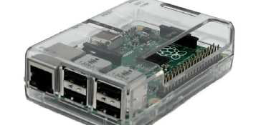

Power cable Case

The Raspberry Pi uses a standard micro USB connector for its power input, running at 5V. In most cases a micro USB to USB cable will suffice, of which one end can be plugged into your desktop computer’s USB port. An Android phone charger should also work perfectly (5.25V 1500mA).

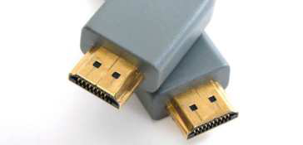

Securing your Raspberry Pi in a case will protect it and prevent the delicate GPIO pins from accidental damage. A case can also make your Raspberry Pi a more attractive or striking unit, perhaps as a media centre. Ensure you choose the right case for your Raspberry Pi model.



Video output Powered USB hub

There are two video output ports, a HDMI port and an RCA Socket. HDMI is the primary video-output connector for most users, but the RCA video-out port can also be used to connect TVs, monitors or to a SCART cable. Remote access to your Raspberry Pi is also possible via SSH or VNC.

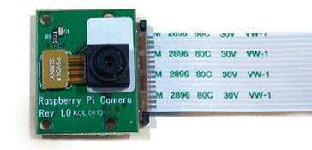

Raspberry Pi camera board

This is a custom designed add-on board that attaches to one of the Raspberry Pi’s on-board sockets via a flexible cable. It’s extremely small, but remarkably powerful, having a native resolution of five megapixels and supporting 1080p video. It’s essentially a smartphone camera for the Pi!

This is a custom designed add-on board that attaches to one of the Raspberry Pi’s on-board sockets via a flexible cable. It’s extremely small, but remarkably powerful, having a native resolution of five megapixels and supporting 1080p video. It’s essentially a smartphone camera for the Pi!

|  |
| --- |
|  |

USB Wi-Fi adaptor

|  |
| --- |
| Using a USB Wi-Fi adaptor will bring flexibility to where you position your Raspberry Pi. Without a restrictive Ethernet cable, it could be used for more advanced projects where  make sure you buy a Raspberry Pi-friendly Wi-Fi adaptor.  **13** |

running a wired internet connection isn’t a valid option. Just

|  |  |
| --- | --- |
| **Getting started** | Set up your Raspberry Pi |

Set up your Raspberry Pi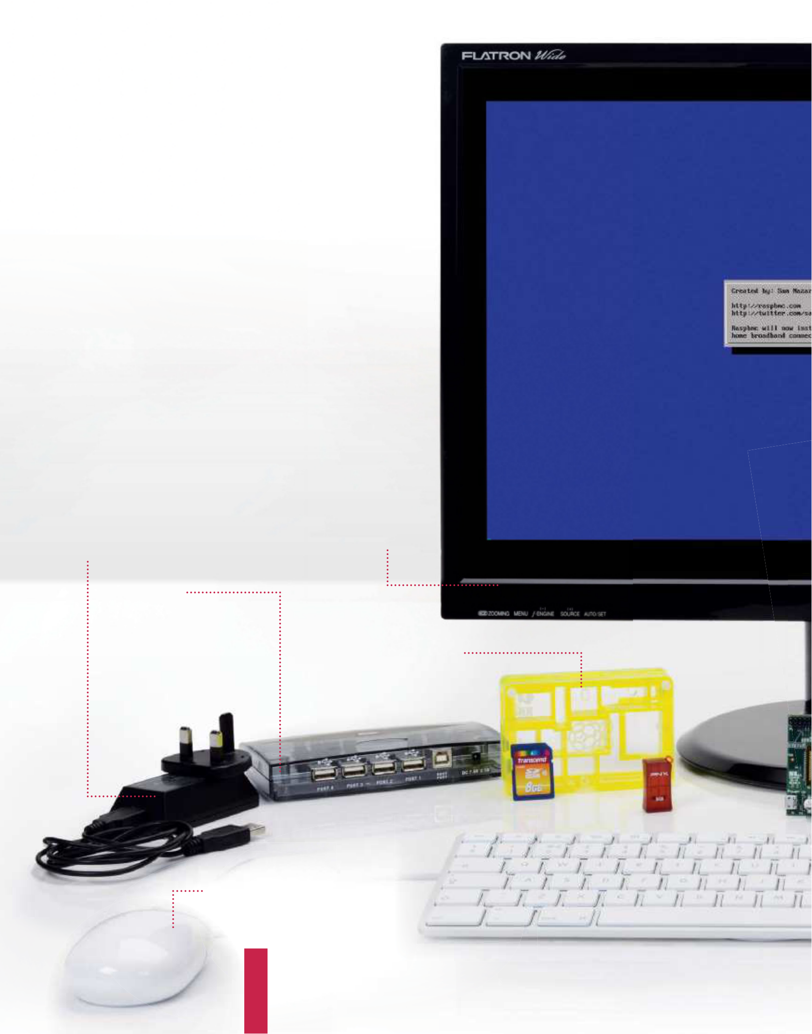

Learn what goes where in your brand new Raspberry Pi with our easy-to-follow guide

While it looks daunting, setting up the Raspberry Pi for day-to-day use is actually very simple. Like a TV or a normal computer, only certain cables will f t into the specif c slots, and the main job really is making sure you’ve got plugged in what you need at any one time. The Raspberry Pi itself doesn’t label much of the board. However, most good cases will do that for you anyway – if you decide to invest in one.

|  |  |
| --- | --- |
| **Power adapter**  The Raspberry Pi is powered using a microUSB cable, much like a  lot of modern Android phones. It can be powered off a laptop or computer. But to make the most out of it, a proper mains adapter – like this one – is ideal | **Monitor**  The Raspberry Pi is capable of  displaying a 1920 x 1080 output –  otherwise known as 1080p. Some  modern monitors allow you to  plug HDMI straight into them,  just like TVs do. However you may  need an adapter in some cases |

**USB hub**   
There are only a limited number

|  |  |  |  |
| --- | --- | --- | --- |
| of USB ports on a Raspberry Pi | **Case and accessories** | |  | | --- | |  | |
| (just one, if you have Model A). |
| To get around this you will need | A case is not necessary to use the |
| a USB hub. It’s important to get | Pi correctly, but a decent one can |
| a powered one, as the Pi cannot | keep it well protected from dust, |
| supply enough juice on its own | and make it easier to move while in |
| operation. You will need an SD card, |

however, of at least 4GB

**Keyboard and mouse**   
Like any computer, you’ll need a keyboard and   
mouse for any standard PC-style operations you   
do with the Raspberry Pi. The more basic the   
keyboard, the better; same with the mouse, as   
some special ones need additional software

|  |  |
| --- | --- |
| Set up your Raspberry Pi | **Getting started** |

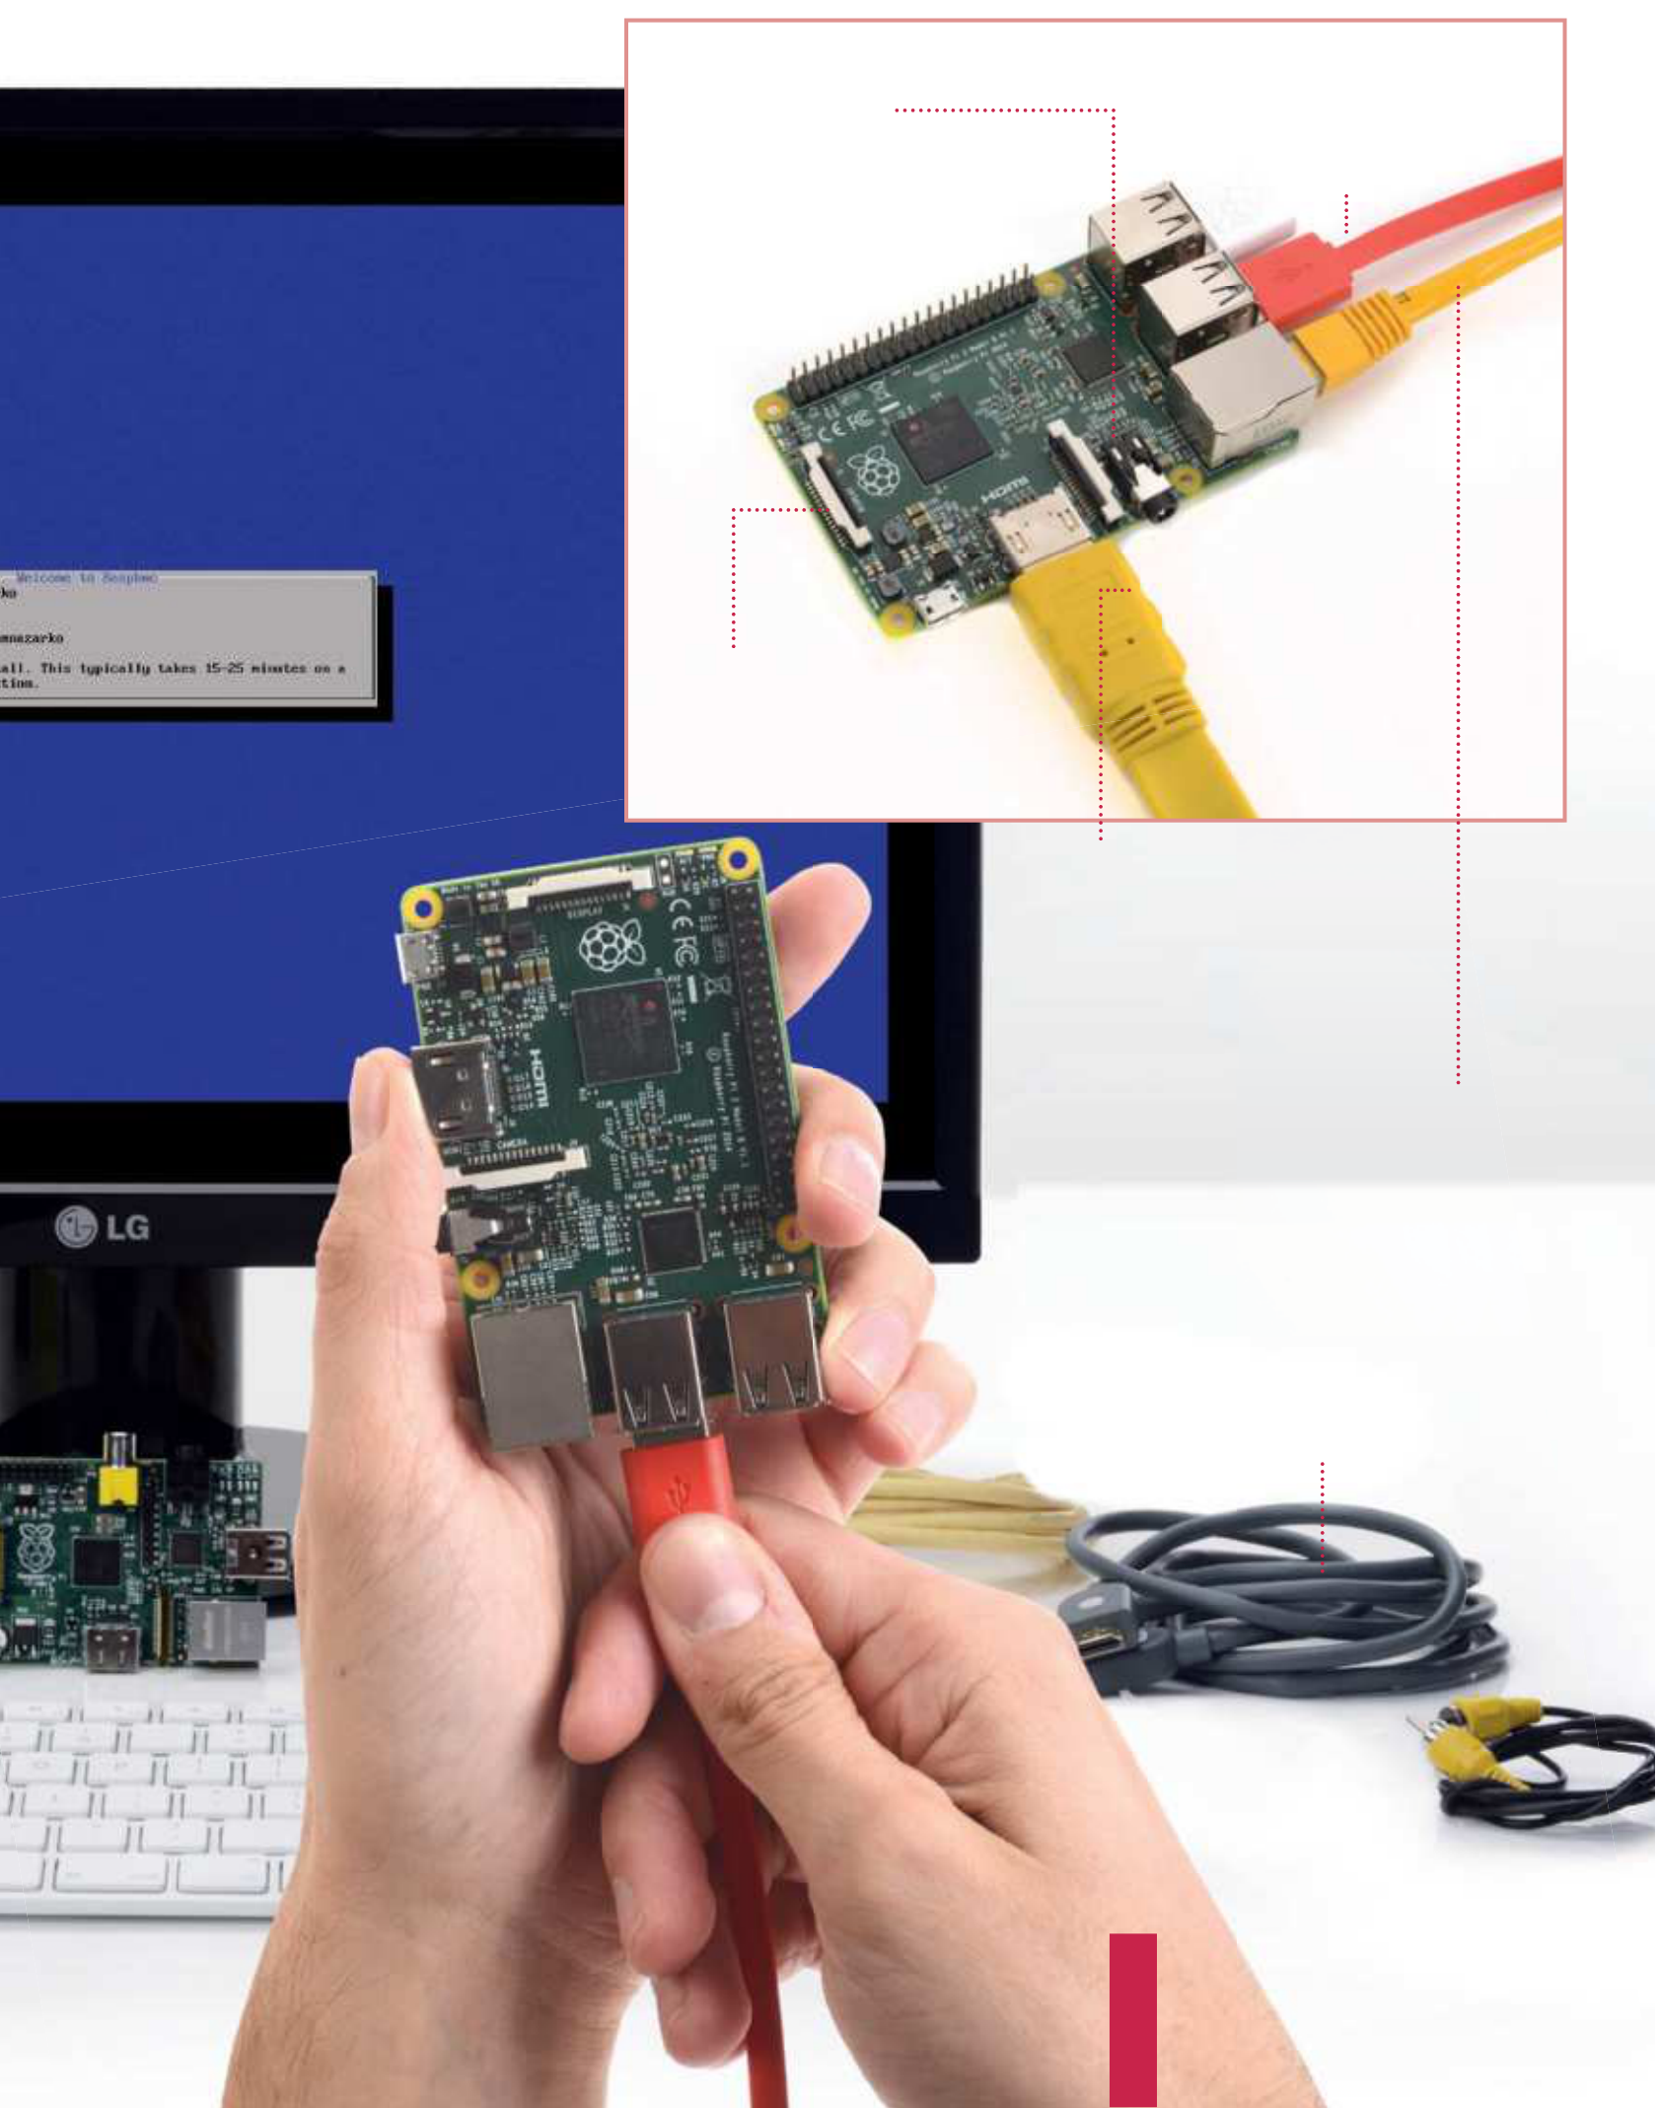

|  |  |  |
| --- | --- | --- |
| **Digital output**  The HDMI port is the main video (and  audio) output of the Raspberry Pi,  allowing you to display videos on the  desktop at a resolution of up to 1080p.  TVs that support it will also pick up the  audio automatically through it | | onnect ouse,  ere.  to the hough |
|

**Networking**   
The Raspberry Pi does not come with   
wireless internet, and while you can add a   
USB adapter, it’s usually easier to plug in an   
Ethernet cable. This will plug into the back   
of your router on the other end and give you   
internet and access to your home network

**Cabling**   
Make sure you have the right selection   
of cables, such as an Ethernet cable for   
networking and internet, and an HDMI or   
Video cable for video out. The HDMI can   
handle audio, but the video out will require   
an additional auxiliary cable

|  |  |
| --- | --- |
| **Getting started**  What you’ll need…  **Raspberry Pi downloads**  www.raspberrypi.org/downloads | Install a distro  Install a distro We take a look at some of the key aspects  involved in installing a pre-built OS |

With its small size and cheap price, many people might be fooled

|  |  |
| --- | --- |
| **Did you know…**  The ofcial distro for the  Pi is called Raspbian.That’s what we recommend, but there are other options. | into thinking that the Raspberry Pi is only usable for basic tasks, and learning to program on. While one of the primary goals of the Pi was to increase computer literacy at a lower level rather than just learning how to create Excel spreadsheets, the Pi has many other |

great uses.

As the Raspberry Pi is essentially a mini PC, with an HDMI and analog TV output rather than a traditional monitor connection, it can perform many common tasks that a laptop or desktop is often used for. While it doesn’t really have the processing power or RAM to run the latest version of Windows, there are other options.

There are a wealth of fully fedged operating systems, many forked from their desktop big brothers that have been optimised specifcally for the Pi. One of the most popular of these is Raspbian, which is a port of Debian. Debian is a key part of the Linux   
ecosystem, and many other popular open source distributions are forked from the Debian source code. The original Debian was released in 1993, and it’s come a long way since. Raspbian needed work to get performance levels up to standard, as the Pi uses the older ARMv6 architecture. It’s now a great everyday desktop.

|  |  |  |  |  |  |  |  |
| --- | --- | --- | --- | --- | --- | --- | --- |
| **Card speed**   |  |  | | --- | --- | | It's a good idea to  get a reasonably  fast SD card to keep your system running smoothly. Class 4 or above is best |  | | **Card format**  Before you copy  your OS image,  you’ll need to make sure the SD card is formatted into the FAT32 file system |  | |  |  |  | | --- | |  | |  |

|  |  |  |
| --- | --- | --- |
| Install a distro | | **Getting started**  Formatting the card  **05** simply insert and wait for it to In Windows, to format the card  mount. Then click on ‘My Computer’ and then right click on the cards icon.  After that choose format and then ‘FAT32’ from the drop-down menu.    Using the terminal  If you are using OS X or Linux, |
| Obtaining OSs | OS Format |
| **01** may be “where can I find some One of your first questions  operating systems to download?”. | **03** with a .img or .iso extension. Within the zip you’ll find a file  These are the equivalent of a | **06** then you’ll have to use the  terminal to copy the image. In OS X, the Terminal app comes installed by default, and most Linux versions come with one in some form or other. It  may be referred to as the ‘console’ or ‘command line’.  DD command |
| Most of the common images can be | ‘snapshot’ of an installation CD or DVD. |
| found on the main Raspberry Pi site: | Simply copying the file to the SD card |
| www.raspberrypi.org/downloads. | won’t do anything; you’ll need to use a |
| These are stable and well tested | program to extract it. |
| systems worth investigating. | |
| Unzipping | SD card format |
| **07** use is called ‘dd’. This is entered The command you need to  in the format of ‘sudo dd bs=1m if=[img] of=/dev/[sdcard]‘. Eg:  sudo dd bs=32m if=/Users/  rachelcrabb/Desktop/ArchLinux/ |
| **02** your image, the first thing When you’ve downloaded  you’ll most likely need to do is unzip it. | **04** from needs to be blank, so The SD card that you’ll boot  make sure there is nothing important  on it first. You’ll also need to format it |
| This can be done in Windows by right | to use the FAT32 file system. This is a |
| clicking and choosing ‘extract’. In OS X, | common system, used by most USB |
| just double click to extract the files. | sticks and cameras. |

archlinux-hf-2013-02-11.img

|  |  |
| --- | --- |
|  | of=/dev/disk1  Win 32 Disk Imager  **08** Disk Imager. Once you’ve   Windows users can use Win32  downloaded the tool, simply right  click on the .exe, and choose ‘run as administrator’ and follow the prompts. When the installation is complete you can put the SD card in your Pi. Easy! |
|  |

|  |
| --- |
| **17** |



|  |  |
| --- | --- |
| **Getting started**  What you’ll need…  **Raspbian**  www.raspberrypi.org | Command line basics  Command line basics |

Learn an alternative way to control your Raspberry Pi by using the command line and your keyboard

We’ve probably all been there with the Raspberry Pi. You’ve installed

|  |  |
| --- | --- |
| **Did you know…**  The command line remembers your last commands. Simply  use the Up and Down arrows to use them. | Raspbian or another Raspberry Pi OS to your SD card and you’ve rushed through the setup script or not quite done your research. You start the operating system and… you end up at a command line. The frst step here is to not panic: this is perfectly normal. It |

may just be a bit of a foreign concept to you, only seen in flms with streetwise hackers who want to bring down ‘the system’.

The second step, at least in Raspbian’s case, is simply to type: $ start x   
 That’s it. Raspbian will load up the desktop and you can start using the mouse again. Quick and painless in this case, and in that of many other operating systems as well. What you’ve done is use a command, specifcally in this case to start the X server. The X server handles the graphical interface and can be turned of by default on some Pi systems.

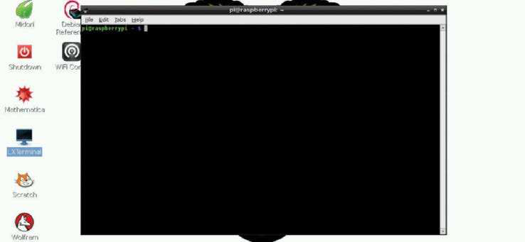

**Fig 1:** The terminal emulator allows you to access the command line while still being in the desktop environment

|  |
| --- |
| **18** |

Command line basics **Getting started**

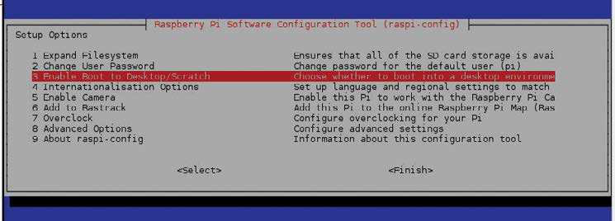

|  |  |
| --- | --- |
| A new world  Getting your Raspberry Pi into the desktop isn’t the only thing | **Fig 2:** Access raspi-config to change settings such as boot to desktop or adding a camera module |

you can do on the command line, though. There’s a whole world of functionality built into the command line; in fact, most of the graphical programs you’re using are just executing these commands in such a way. You don’t have to leave the comfort of the desktop environment to perform these commands either, as all Raspberry Pi operating systems will come with an application known as a terminal emulator.

This creates a window where a command can be written in the same way that we launched the desktop, and use the exact same commands (Fig 1). On Raspbian, look for the app LX Terminal in the Accessories section of the menu and click on it. If you’ve had to use start x to get into the desktop, then we can now fx that before continuing. In the terminal, enter:  
 $ raspi-config   
 Here’s the initial setup screen (Fig 2). From here you can enable the desktop on boot (Fig 3), and even update the frmware and add support for the ofcial Raspberry Pi camera module. This allows you to modify Raspbian without having to reinstall again.

You won’t be using those two commands very often, though, so

|  |  |
| --- | --- |
| is there practical use for delving into the command line? Very much so. For starters, Raspbian doesn’t have an ofcial package manager. This is a program that allows you to browse the available software for the operating system, similar to the Pi Store.  However, there’s other software available to Raspbian that you can’t get through the store. You also can’t specifcally update the Pi software either, and all of this can be fxed using the command line. | **Fig 3:** Change the default selection to desktop for the next time you use the Raspberry Pi |

|  |
| --- |
| **19** |

|  |  |
| --- | --- |
| **Getting started** | Command line basics |

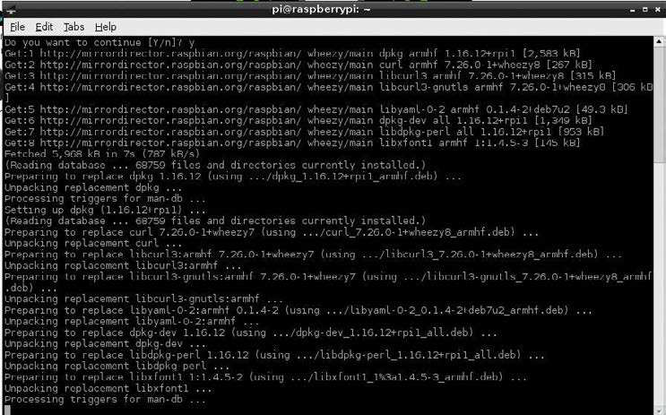

**Fig 4:** Upgrade your system and files, and have the latest updates and bug fixes in Software for all   
the process The frst thing you’ll want to do is let Raspbian know exactly what’s available online. It’s a very simple task: all you need to do is: $ sudo apt-get update   
 This will run down a list of online repositories (or repos) that contain the software that Raspbian uses. Once it’s fnished, the command-line prompt will pop up again waiting for your next command. As this is the frst time you’ve done it, you’ll likely need to update the current software on your Raspberry Pi. You can do that with the command:  
 $ sudo apt-get upgrade   
 It may ask you to confrm the upgrade, in which case type ‘y’ and then press Enter. What we’re doing both times is using the command-line package manager Aptitude (apt-get) to frst check the repos, and then upgrade packages according to that (Fig 4).

The frst command, sudo, allows it to run the apt-get task as an

|  |  |
| --- | --- |
| **Did you know…**  You can use the Tab to  complete commands. Just start typing and hit tab. If you like  what you see hit Enter to fnish! | administrator, and is used in a lot of other command-line operations. To install software you use install instead of update or upgrade, followed by the name of the package. For example, with the  mathematical programming language, you can install it with:  $ sudo apt-get install wolfram-engine |

|  |
| --- |
| **20** |

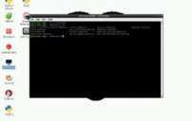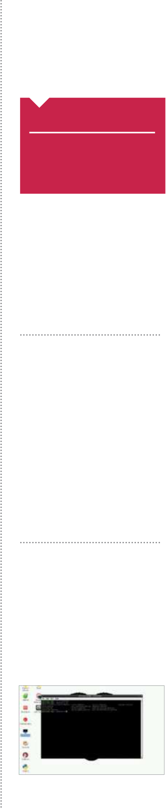

Command line basics **Getting started**

Move and create

|  |  |
| --- | --- |
| Installing and updating are just a couple of the many things you can do in the command line. You can also browse the entire fle system, move fles, create folders and delete items. All of these are very simple operations.  When you frst open the terminal, it will open up in your home | **Did you know…**  You can always return to your Home folder in the command line by typing cd ~ and  pressing Enter. |

folder. While you can’t specifcally tell that it is, you can display exactly what kind of fles are in the directory with (Fig 5):  
 $ ls   
 The tilde sign (~) is used to denote the home folder and can be used for navigating around the fle system. To navigate, we’ll be using the cd command, followed by the location you want to move to. This can be done like so:  
 $ cd /home/pi/Downloads

|  |  |
| --- | --- |
| This will move you to the Downloads directory. As we were starting of in the home folder to begin with, we actually only needed to do this:   $ cd Downloads  It’s context sensitive and knows to look in the directory it’s already in. There’s another trick you can use so you don’t have to remember the exact name of the path – the command line or terminal will try to autocomplete the phrase if you press the Tab key while something is only partially typed. Try the cd command again, but try pressing Tab when you’ve only written ‘Down’.  Finally, there are some quick commands you can use to | “The command line or terminal  will try to  autocomplete  the phrase if you press the Tab key while something is partially typed” |

manipulate fles. Individual fles can be copied using the command cp, followed by the flename and the new location like so:  
 $ cp file.txt ~/Documents/file.txt   
 You can also use this to rename fles by doing:  
 $ cp file.txt otherfile.txt   
 The original fle can then be deleted by using the rm command: $ rm file.txt   
 Want to create a new folder? Use cd to move to the directory you need to add a folder to, and then use mkdir followed by the name you want to give the folder:  
 $ mkdir NewFolder   
 There’s a lot more you can do with the command line, but these are the very basics. As you use Linux more and more, you’ll be confronted with tasks that need the command line, and through

|  |  |
| --- | --- |
| this process you’ll learn just how much can be accomplished when you work like a streetwise movie hacker. | **Fig 5:** There are many simple  command-line tools that can help you browse and use your system |

|  |
| --- |
| **21** |

|  |  |
| --- | --- |
| **Getting started** | The Raspbian desktop |

The Raspbian desktop

Although the Raspberry Pi’s Raspbian operating system is closer to the Mac than Windows, it’s the latter that the desktop most closely resembles

It might seem a little alien at frst glance, but

using Raspbian is hardly any diferent to using

a Windows desktop. There’s a menu bar, a web

browser, a fle manager and you’d expect, you

simply open the Menu and click the applications

you want to get started…

**Menu button**   
The Windows-like Menu button in the top-left corner displays a list of programs and options. The main categories are Programming (where you’ll find appropriate tools), Internet (browser and online resources), Games (Minecraft Pi is pre-installed), Accessories (an assortment of utilities), and Preferences (system tools). Programs downloaded from the Pi Store will appear in the appropriate category, while the Run launches a command-line interpreter, just like the one in Windows. Use Shutdown to switch off, logout or restart your Raspberry Pi.

**Task Bar**   
Stripped across the top of the screen is the Task Bar, upon which the Menu is situated. To the right of this are shortcuts to the Epiphany browser, the File Manager (PCManFM), LXTerminal for inputting text-based commands, the Wolfram Mathematica computational software and the Wolfram Language programming application. Next to these shortcuts, you’ll find that any open applications are docked, while in the right-hand corner you’ll find the clock, current CPU load, volume status and control, and the network status.

**File manager**   
No computer would be complete without a file manager, which can be opened by clicking the Task Bar shortcut. Files can be copied, renamed and deleted by dragging to the trashcan on the desktop (or by simply highlighting and tapping Delete on the keyboard). You can also create tabbed windows in the file browser or open further ones. Folder   
locations can be bookmarked for easy access and files themselves can be viewed as icons or in a detailed list.

|  |  |  |  |  |
| --- | --- | --- | --- | --- |
|  | |  | | --- | |  |  |  | | --- | |  | | |
|  |

“It might seem a little alien at frst glance, but using Raspbian is hardly any diferent to using Windows”

|  |
| --- |
| **22** |

|  |  |  |
| --- | --- | --- |
| The Raspbian desktop | | **Getting started** |
| **Web browser**   |  | | --- | |  |   Empathy is the default Raspberry Pi browser, although if you don’t like it you can add a new one from the Pi Store. As with any browser, web addresses are typed into the address bar and standard navigation buttons are provided to navigate back and forth through webpages. Empathy supports multiple tabbed windows and features private browsing and the ability to clear browsing data. Click on the Options icon at the end of the tool bar to access these functions.     |  |  |  | | --- | --- | --- | |  |  |  | | **Pi Store** | |  |   You can access the Pi Store from the Menu, or from a link on the  **www.raspberrypi.org** website. Much like Steam, Google Play or **Status and Time** | | |
| the App Store, the Pi Store requires you sign up for an account (with | On the far right side of the Task Bar is the Raspbian equivalent of the | |
| IndieCity), and you’ll need to sign in before you begin shopping for | Windows system tray, where you’ll find information concerning your | |
| free and paid-for software. Any games and apps downloaded and | Raspberry Pi’s status. In the corner is the clock, which when clicked will also | |
| installed from the Store will appear under the My Library tab, and | display the current date; if incorrect, you can adjust it here. To the left of | |
| some of those can only be launched from here. | this you will find a graph displaying current CPU load, the device volume | |
| control, and finally, confirmation that your Raspberry Pi is online. | | |

|  |
| --- |
| **23** |

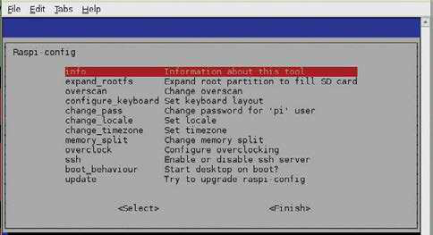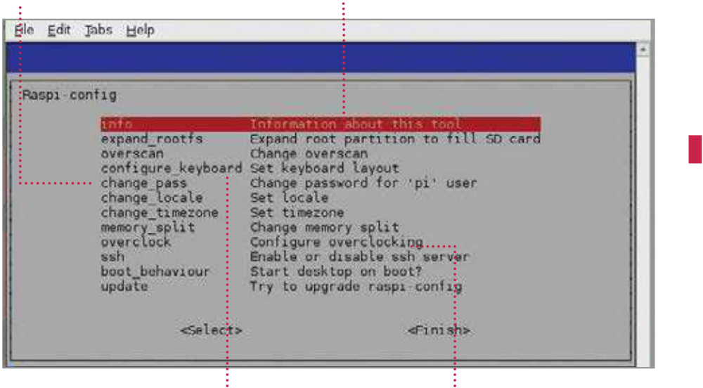

|  |  |
| --- | --- |
| **Getting started**  What you’ll need…  **Raspbian:**  www.raspbian.org | Master the Config tool  Master the Config tool |

Tell your Raspberry Pi how to behave using the powerful built-in conf g tool

|  |  |
| --- | --- |
| **Did you know…**  You can access the Conf g tool anytime by typing ‘sudo raspi-conf g’ from a terminal window or the command line. | The ‘RasPi Conf g’ tool allows conf guration of your system that would otherwise be trickier in the Linux environment and it’s the f rst thing you’ll see when you install Raspbian. Why? Tasks such as setting the date and time or regional settings for your keyboard are often done in a command-line interface with no dialogs, no |

additional help – for a new user, this is a nightmare.

There are some further specif cs for the Pi and Raspbian itself,

such as: the ability to easily enable overscan for your TV; change the

split of memory to the computer/graphics card or even overclock

your system to make it a little faster; enable remote SSH access to

the system; stop the system booting into the desktop environment

among other things. The Raspi Conf g tool takes the pain out of the

process and puts real power at your f ngertips.

|  |  |  |
| --- | --- | --- |
| **Change password** | **Expand roots** | Open the raspi-config tool |
| Change the password for your default | Allows you to very quickly and easily | **01** LXTerminal icon on your Start by double-clicking the  desktop. This will start the command |
| ‘pi’ username to make it something more | change the partition of the roots to fill |
| personal or easier to remember for you | the SD card completely |

prompt, where you’ll be able to run   
the config tool. To do this you’ll need   
to run a command.

sudo raspi-config   
When asked for your password, you   
won’t actually see it being typed.

When you’ve typed the password   
and pressed Enter to submit it, the   
config screen will be shown to you.   
There are a few settings of particular   
interest that we’ll cover in this section,   
although they all have their uses in   
the running of your Pi. Some of the

|  |  |  |
| --- | --- | --- |
| **Configure your keyboard** | **Overclocking** | settings in this menu are important |
| Set the correct keyboard up – there are | Allows you to quickly and easily | and some are irreversible, so use them |
| many different layouts. Using the wrong | overclock your Pi to give you some extra |
| one can be annoying | speed and power with little risk | with caution! |

|  |
| --- |
| **24** |

|  |  |  |
| --- | --- | --- |
| Expand the root file system | Master the Config tool | **Getting started** |
| and ensure good airflow around | start X automatically, on boot. Set this |
| **02** file system will be 2GB – this is By default, the Raspbian root  done so that the image provided for | your Pi. | option to ‘Yes’ to enable this behaviour |
|  |  |
| If you see any noticeable instability, | by default. |
| run this wizard again and set the | You can obviously revert this at any |
| clock speed back down to something | time to return to a text-based login |
| slightly lower – repeat until your | where you have to start manually: |
| it can fit on as many different SD cards |
| system is completely stable. For |  |
| as possible. |  |  |
| the scope of this tutorial, a Modest/ | Turn overscan on and off |
| If your card is larger the ‘expand_ |
| Medium overclock is recommended |
| roots’ option will make the OS use the |
| – it seems to give a little extra |
| entire space. Upon using this option, |
| the command will be executed | performance with no noticeable | **07** two behaviours if you’re using You may have noticed one of  your Pi with a modern HDTV. |
| side effects. It is also recommended |
| immediately. The operating can take |
| to reboot your system after making |
| some time. Reboot your system to see |
| this change. Hold the Shift key to |
| the changes. |
| There is a black border the whole |
| temporarily disable overclocking. |
|  |
| way around the image output by the |
| Change the memory split | Pi – it just doesn’t fit correctly. This is |
| caused by underscan. |
| **05** the Pi allows you to give either Changing the memory split of  the system or the graphics processor a |  |
|  | If you can’t see the edges of your |
| screen to get to them you’re suffering |
| Configure your location | from overscan. |
| If you have the former issue, you |
|  |
| larger amount of memory. | may need to either turn on overscan, |
| **03** regional settings that your Pi Locale is the language and  is using – while this generally has little | The value you give to it must be | or enable a ‘zoom’ mode or similar on |
| either 16/32/64/128/256. Here are our | your TV. |
| recommendations: | If you have the latter issue, you |
| impact on what you’ll see, it is also | 32MB GPU memory for basic distro | need to turn overscan off so that you |
| responsible for any default currency | usage where video and 3D rendering | can see the edges. |
| settings, etc, so could prove to be an | aren’t required. | Update raspi-config |
| irritant at a later time if wrong. | 64MB GPU memory for desktop |
| Upon selecting the option, you’ll | use that requires video playback or |
| be taken through a wizard. Use the | have 3D effects enabled. | **08** updates from time to time. The raspi-config tool receives  This is generally to either add more |
| arrow keys to check the built locale | 128MB GPU memory for graphical |
| before building more (it takes a while). | applications and games that do |
| Timezone will take you to a tzdata | extensive multimedia or play 3D |
| features or fix small bugs, or both! |
| screen where you can adjust it. | rendered games. |
| It’s not a bad idea to run the |
| Overclock your Pi | For most people, a 64MB split for |
| updater when you use the tool |
| graphics will suffice. |
| – before you start changing any |
|  |
| |  |  | | --- | --- | | **04** | You can set the clock speed | | Change boot behaviour | system settings. While it’s much |
| more likely that it’ll be updated |
| **06** will boot into a command-line By default, the Raspbian distro  interface, whereby you have to first |  |
| and voltage of your Pi to several different presets. Setting the | to look better or do more things, |
| it’s not impossible there could be |
| clock speed and voltage at higher | miscellaneous bug fixes hidden |
| rates than the specification may cause | within that would otherwise cause |
| instability, so do so in small increments | log in as ‘pi’. | you some grief. |
|  | If you then want to run a window | Remember, though, when you’re |
| manager (in this case, it’s called | trying to update your copy of the |
| ‘X’), you have to give the system a | raspi-config tool, you’ll need an active |
| command to let it know that’s what | internet connection, either through |
| you want to do. | an LAN cable or wireless dongle. |
| For a lot of people this isn’t really | Without them, it’s never going to get |
| ideal since command lines scare them. | any newer. Always try to make sure |
| Because of this, there’s an option to | you’re on the latest version. |

|  |
| --- |
| **25** |

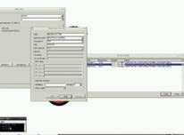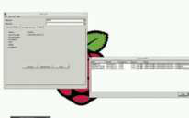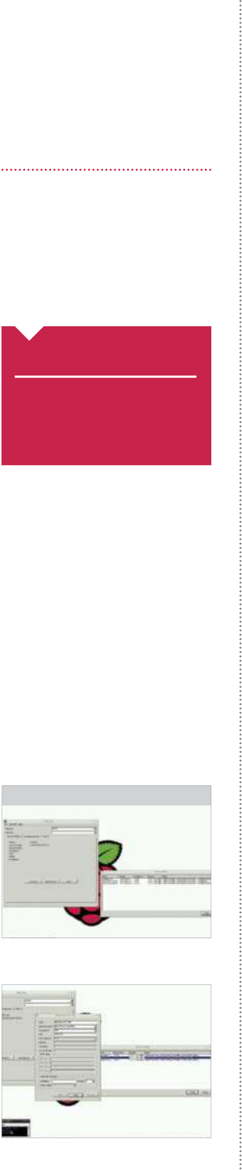

|  |  |
| --- | --- |
| **Getting started**  What you’ll need…  **Any Raspberry Pi distro**  www.raspberrypi.org/downloads  **Wi-Fi dongle or Ethernet** | Get your Pi online  Get online |

To access a world of utilities, apps and resources you need to get online. This is how to do it…

The easiest way to get online is to buy a Raspberry Pi Model B+, as

|  |  |
| --- | --- |
| **Did you know…**  If your Raspberry Pi is going to be placed near your Internet router, all you need to do is  plug in an Ethernet cable. | it comes with an Ethernet socket. The Model A not only lacks the Ethernet port, but is handicapped by only having one USB port. That means you will have to buy a power USB hub in order to get online. Back to the Model B+ though and to get online, simply plug an Ethernet cable into the socket on the Pi and connect it |

to a similar port on the back of your internet modem/router. Turn your Pi on and launch the desktop, then double-click on Empathy and you should see the internet appear (main image). To check that it’s working, look at the lights on the Pi itself. The red power light should be on. Above this is the green light that fickers when accessing the SD card. Below the power light are the three Ethernet-related lights. Note that the Model A does not have these LEDs because it doesn’t have the Ethernet socket. The middle light is green and comes on when it detects a Full Duplex LAN connection.

This means it is able to send and receive data to the internet. The next light is green and fashes when actually accessing the internet by sending or receiving data. The last light is yellow and will come on and stay on when a 100Mb LAN connection is detected.

The Wi-Fi option   
 If you aren’t close enough to the modem/router to be able to plug in the Ethernet connection, or you simply have a Model A, then a powered USB hub is required. This plugs into a USB port on the **Fig 1:** With a Wi-Fi dongle attached, run the utility and scan for available networks Pi. You can then plug a Wi-Fi dongle into this. Boot up the Pi and launch the desktop. Then double-click on the Wi-Fi Confg icon.

You should see a name for the dongle in the Adapter section.

Click on Scan to look for networks and a list of those found should appear (Fig 1). Double-click on the one you want to connect to and the details for it will be listed. Almost all home networks use a network key, which is usually written on the modem itself. Click

|  |  |
| --- | --- |
| **Fig 2:** Enter the pre-shared key in order to connect to your home router | on PSK, which stands for pre-shared key, and type it in (Fig 2). Then click on Add. It will process this, then associate the connection and |

|  |
| --- |
| **26** |

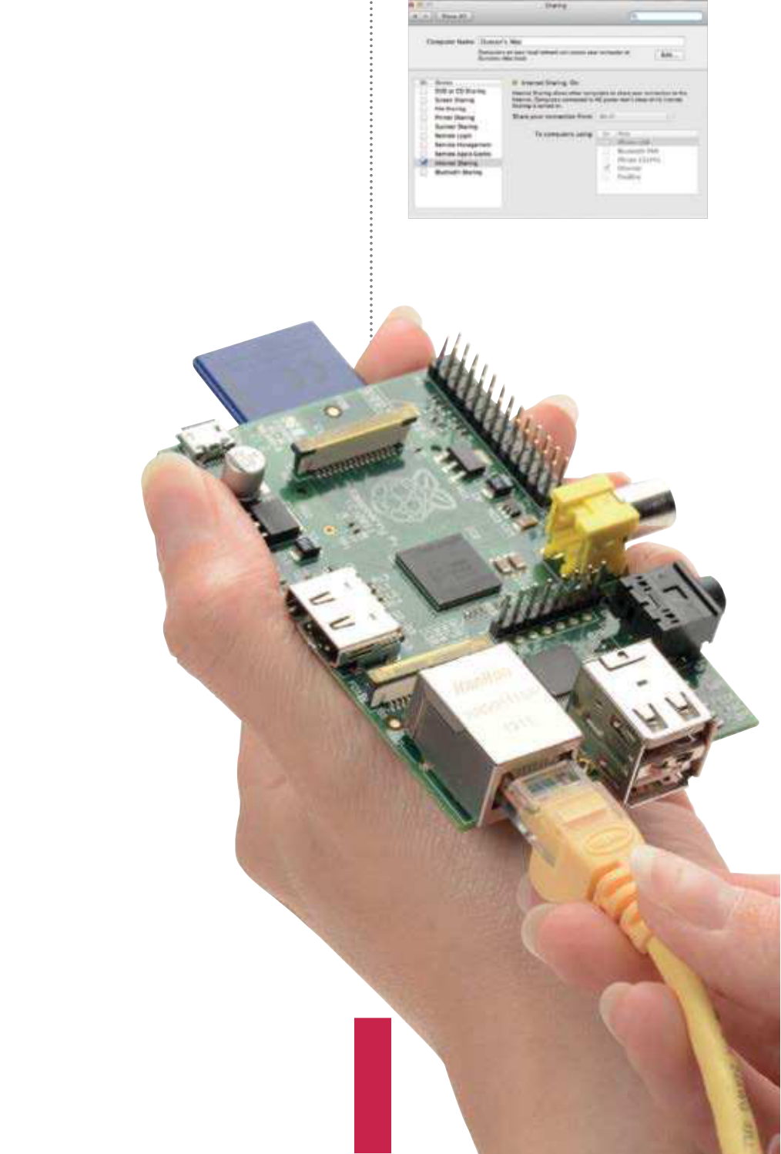

|  |  |
| --- | --- |
| Get your Pi online | **Getting started**    **Fig 3:** If it doesn’t look like the connection is working, there are some easy ways of checking what’s going on |
| then fnally, a new IP address for the Wi-Fi connection will appear.  If you click on the Manage Networks tab, the network will now be listed and have an Enabled radio button active. To get on the internet, simply launch Empathy and you’ll be connected. The Wi-Fi utility will remain running on the bottom right of the panel. If you right-click on the Wi-Fi icon you will see options to Disconnect or Reconnect, event history and the results of the most recent scan. Click on Status to see how it’s performing.  Checking the connection  To check that the Pi has a valid internet connection, double-click on |
| LXTerminal. Enter this command: |
| ip addr  You should see a list of numbers, with the bottom line starting ‘inet’ and then the IP address of the Pi connection (Fig 3). Typically this is something like 192.168.1.11 and this shows that the connection is working because the Pi has been assigned an IP address based on the one used by your internet modem/router. If this doesn’t come up then there may be a problem at the router end. The modem/ router should be running a DHCP server and when the Pi connects to it, it will be given the IP address. If it isn’t running then nothing | |  | | --- | |  |   **Fig 4:** Both Windows and Mac computers can share their internet connections with a directly-connected Pi |

else connected to it will be able to access the internet either.

Use the web interface with another device to log   
onto 192.168.1.0 or whatever is your modem’s actual   
IP address in order to check that the DHCP server   
service is turned on. Finally, in the terminal, type:   
 ping google.com

|  |
| --- |
| Sharing a connection  If you don’t have a Wi-Fi dongle, a powered USB  hub or a long enough Ethernet cable, but do  have another computer connected to the internet, there’s another way of getting access. On a Mac,  connect it to the Pi via a USB or Ethernet cable. Launch System Preferences; under Internet & Wireless, click on Sharing. Click on Internet Sharing, then select Wi-Fi (or AirPort) as the connection type to share, and select how the Pi is connected to your Mac (Fig 4).  On a Windows PC, go to Windows Explorer>Networking> Networking and Sharing Center>Change Adapter Settings.  **27** |



|  |  |
| --- | --- |
| **Getting started**  What you’ll need…  **Apt command help page:** http://linux.die.net/man/8/apt  **Apt-get help page:**  http://manpages.ubuntu.com/manpages/ lucid/man8/apt-get.8.html | Install and use packages  Install and use packages |

The Raspberry Pi is great, but it’s made better with the software you install onto it

On its own, the Raspberry Pi is a near-perfect mini computer. It

|  |  |
| --- | --- |
| **Did you know…**  If you press the Tab key the  command line will attempt to auto-complete your command for you – just press Enter to fnish. | already contains a wealth of educational software, a few games, some programming utilities and a number of system tools. But, as with most computers, this is only the tip of the proverbial iceberg. By installing more programs, you can do much more. |

These programs, known as packages, are as wide and as varied as the developers who originally designed them. In Linux, if there’s a need for a particular program, then someone develops one. They then put it out to the world and make the source code freely available, hence ‘open source’. Once the program has been tested, it will eventually make its way onto one of the many remote servers for that particular Linux distro.

These remote servers, called repositories, or repos, contain all the elements of the package in order for it to be downloaded and installed onto your system. The process is very quick and easy once you know how it’s done…

|  |
| --- |
|  |

|  |
| --- |
| **28** |

|  |  |  |
| --- | --- | --- |
| Update and upgrade | Install and use packages | **Getting started** |
| you will need to know to be able to | Apt Easter eggs |
| install it. Use the arrow keys up/down |
| **01** on the Raspberry Pi involves Getting hold of a package  dropping into the command-line |  | **07** non-menu-driven variant   The Apt command is a shorter,  of the Aptitude command. This |
| to navigate; press ‘Q’ to exit. |
| Installing a package |
| terminal, via the LXTerminal icon | command has a long history in |
| **04** keys, navigate the list. If you Using the up and down arrow  find something you like the look of, say |
| on the desktop, and entering a few | Linux, and as a result has some rather |
| commands. But before we do that, | special ‘features’, also known as Easter |
| we need to make sure the system is | eggs. Purely for a little bit of fun, type |
| up to date. Enter the following into | Angry Drunken Dwarves, remember | in the following commands and see |
| the terminal: | the name of the package, in this case | the results: |
| sudo apt-get update | ‘angrydd’, and press ‘Q’ to exit the list. | aptitude moo |
| To install the package, enter the |
|  |  |
| sudo apt-get upgrade | following in the terminal: | aptitude -v moo |
| Or… |  |
|  |  | aptitude -vv moo |
|  | sudo apt-get install angrydd |  |
| sudo apt-get update && sudo |  | aptitude -vvv moo |
| apt-get upgrade |
| aptitude -vvvv moo |
|  |
| Search for a package |  | aptitude -vvvvv moo |
| aptitude -vvvvvv moo |
|  | sudo apt-get moo |
| **02** (Advanced Package Tool) is The apt-get command  the key to downloading and installing |
|  |
| packages on the Raspberry Pi. In |
| the previous instance, we updated | Executing the package |
| the existing packages and system, |
| upgraded any that needed it, and |
|  | **05** command should be the The result of the previous  successful download and installation |  |
| updated the current package list. |
| Now, let’s search the list of server |
| packages for available games. |
| apt-cache search game | less | of the game, Angry Drunken Dwarves. |
|  | To execute the newly installed |
| package, you can either run it from | Man the Apt command |
| the LXDE Menu under Games>Angry |
| Drunken Dwarves, or by typing in the | **08** to the simple Apt command As you can see, there is more  than what first meets the eye. There |
|  |  |
| following into the terminal: |
| angrydd |
| Remove a package | are many different sub-commands |
| that you can run, and many different |
|  | **06** perfectly fine, and you can This installing of packages is  see just how powerful a command | variations in which to run them. |
| If you want to see what else the Apt |
| command can do, enter the following: |
|  |
| Apt searching | Apt really is. But, what if you want to | man apt |
| remove a package? |  |
| **03** yourself in is the name of all The current list you find  the packages labelled as ‘games’ from | Using the Apt command again, let’s |
|  |  |
| say we want to completely remove all |
| trace of Angry Drunken Dwarves from |
| the Raspberry Pi. |
| the available server. In the list, the | sudo apt-get --purge remove |
| part before the hyphen tells you the | angrydd |
| name of the package, which is what | Enter ‘Y’ to accept the removal. |

|  |
| --- |
| **29** |

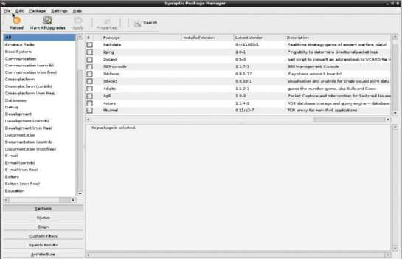

|  |  |
| --- | --- |
| **Getting started**  What you’ll need…  **Synaptic:**  www.nongnyu.org/synaptic/ | Use graphical installations  Use graphical installations |

Would you prefer a graphical interface to install new programs? If so, then read on…

If you’re new to Linux, you may fnd using its built-in Apt package

|  |  |
| --- | --- |
| **Did you know…**  Synaptic has access to the  same repo as via the command line as demonstrated on the  previous two pages. | management tool a bit intimidating and confusing. The apt-get command is used for installing applications through the internet, connecting to the remote servers – called repositories – which house the programs as packages. But it is used through the |

terminal command prompt, which can be daunting, so we need an alternative: a desktop environment interface method of getting hold of packages.

This is where Synaptic comes in. Synaptic is a friendly-looking graphical interface to the apt-get terminal command which allows you to manage your application installations, and removals, through the already familiar desktop environment. Think of it as a kind of online shop where you can pick and choose the programs you want and have them downloaded and installed onto your Raspberry Pi without you having to drop into the terminal.

|  |  |  |  |  |  |  |  |  |  |  |  |  |  |  |  |  |
| --- | --- | --- | --- | --- | --- | --- | --- | --- | --- | --- | --- | --- | --- | --- | --- | --- |
| |  |  |  | | --- | --- | --- | |  |  |  | |  |  |  | |  |  |  | |  |  |  | |  |  |  | | **Upgrade entire systems** Synaptic has the ability to update and upgrade every program or package, and it can upgrade your entire system to the latest version  **Install and more**  Synaptic is a very powerful tool.  With it you can install, remove,  upgrade and downgrade single or multiple packages and programs  **Browse all**  **documentation**  From within Synaptic, you are  able to browse and read all available online documentation related to a package or program  **Easily find programs**  Synaptic enables you to easily locate packages and programs by name, description, version and even by  who developed the program |

|  |
| --- |
| **30** |

|  |  |  |
| --- | --- | --- |
| Update the system | Use graphical installations | **Getting started** |
|  | the menu and left-click Properties. In |
| **01** aversion to dropping into the Unfortunately, if you have an  command-line terminal, then you’re | the Command text box, change the |
|  |  |
| text to add the gksudo command. So |
| instead of ‘synaptic-pkexec’, it will read: |
| gksudo synaptic-pkexec |
| Fixing Synaptic – |
| going to be stuck at the first step. |
| Before we install anything, we need to |
| make sure that the Raspberry Pi is fully |
| Running Synaptic – Part 2 | Option 2 |
| updated and any existing packages |
| are upgraded. Simply enter the | **04** the Synaptic program window, You should be now looking at  where you can scroll through the list of | **07** is to drop back into the   The second, and best, option  terminal and alter the way in which |
| following into the LXTerminal: |
| sudo apt-get update |
|  |
| sudo apt-get upgrade | available programs and click on each to | the program is executed from the |
|  | download and install. Now we need to | menu. All that’s needed is to change |
| test whether it will run from the LXDE | one line to another, so that the gksudo |
| menu. Click on the icon in the bottom | command is again used instead of |
| left, then go to Preferences>Synaptic | the plain synaptic-pkexec. From the |
| Package Manager. | terminal, type: |
|  |
|  | Running Synaptic – Part 3 | sudo nano /usr/share/ |
| applications/ |
|  |
| Installing Synaptic | |  |  | | --- | --- | | **05** | Running Synaptic from the | | synaptic.desktop |
| Change ‘Exec=synaptic-pkexec’ to… |
|  |  |
| **02** need to enter the LXTerminal To install Synaptic, you’ll first  and run the command below – don’t | Don’t panic, however: all it’s doing | Exec=gksudo synaptic-pkexec |
| is asking for a password. Enter the | Synaptic fully working |
| following password into the box: |
|  |  |
| forget to type Y to any prompts asking | raspberry | **08** changes, exit nano via Ctrl+X, After you’ve entered those  followed by Y to accept the changes, |
| you to accept the installation: | This is the default Pi password so we’re |
| sudo apt-get install | assuming you haven’t changed it! |
| synaptic |

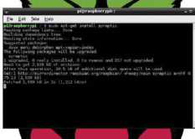

Running Synaptic – Part 1

**03** to do. Synaptic is now installed In essence, that’s all you need

and ready to use. However, due to   
its complexity, there may be some   
bugs that need ironing out first, so it’s best to follow these steps. To test if Synaptic is working okay, first enter the following command into the terminal:

gksudo synaptic

|  |  |
| --- | --- |
| Fixing Synaptic – Option 1 | and then press Enter a couple of  times to get back to the command prompt. You can now launch Synaptic |
| **06** issue, but to permanently This will temporarily fix the  resolve it, do one of the following.  First, right-click the Synaptic icon in | from the menu, or by entering the following command when you’re in the terminal:  gksudo synaptic |

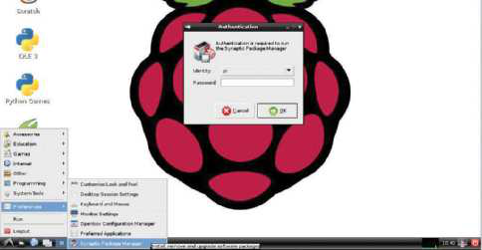

|  |
| --- |
| **31** |

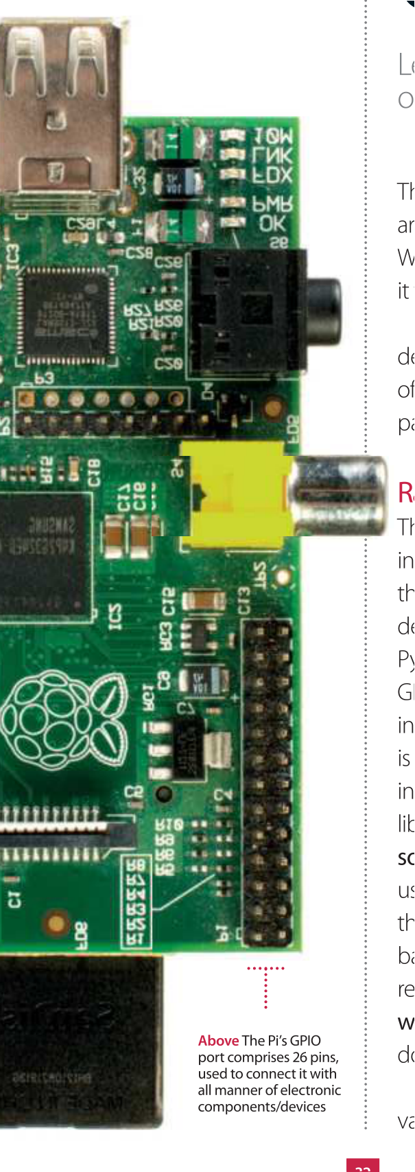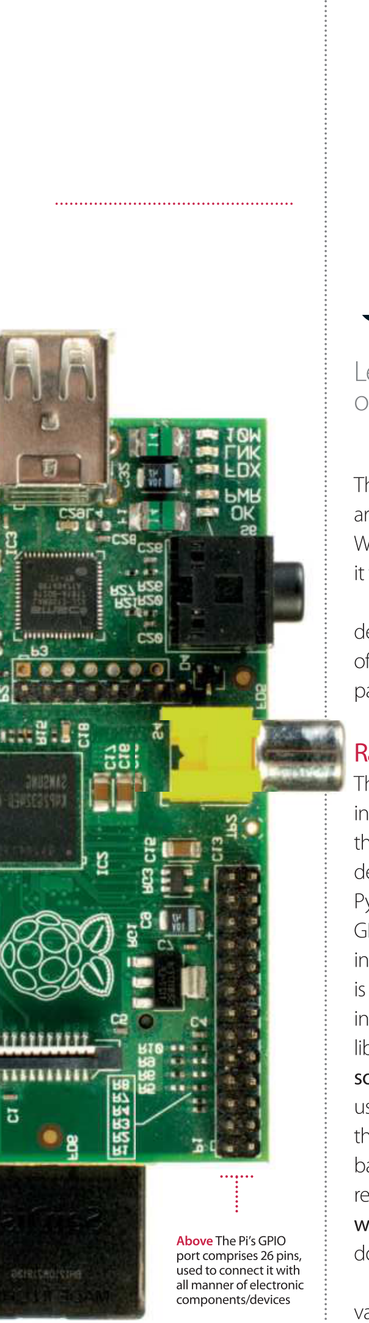

**Getting started**

What you’ll need…

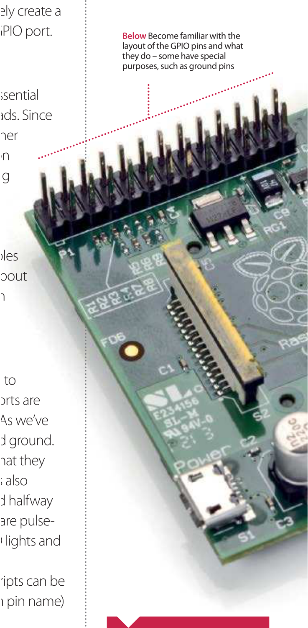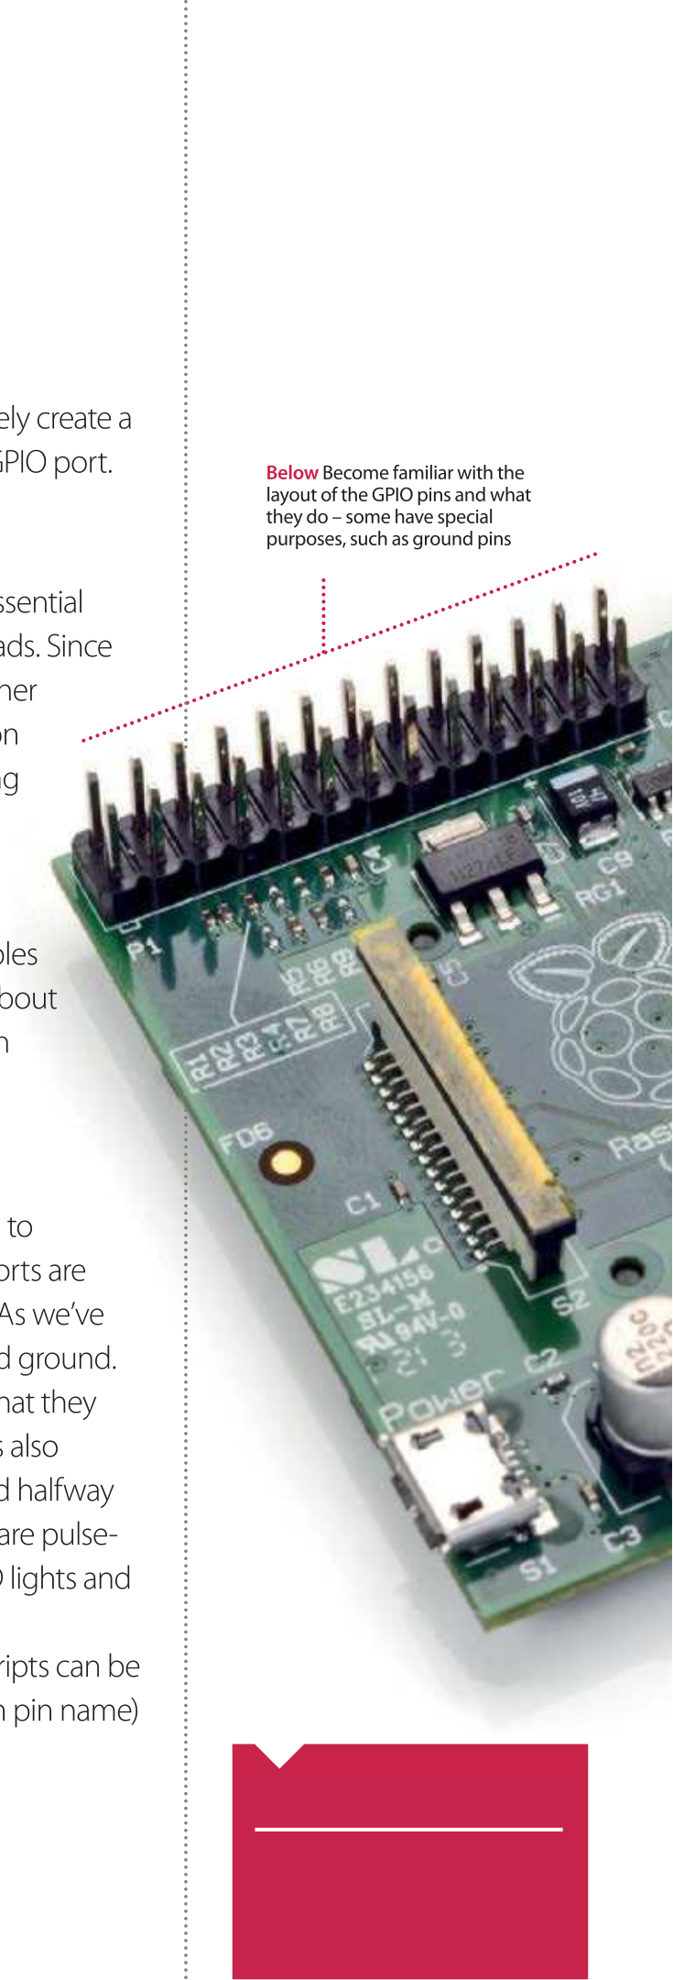

GPIO port explained **Getting started**

**Did you know…**

The RPi.GPIO libraryhas some   
really useful documentation. All   
you need to do is click on the   
‘wiki’ on Sourceforge.

|  |
| --- |
| **33** |

|  |  |
| --- | --- |
| **Getting started** | Top four add-on boards |

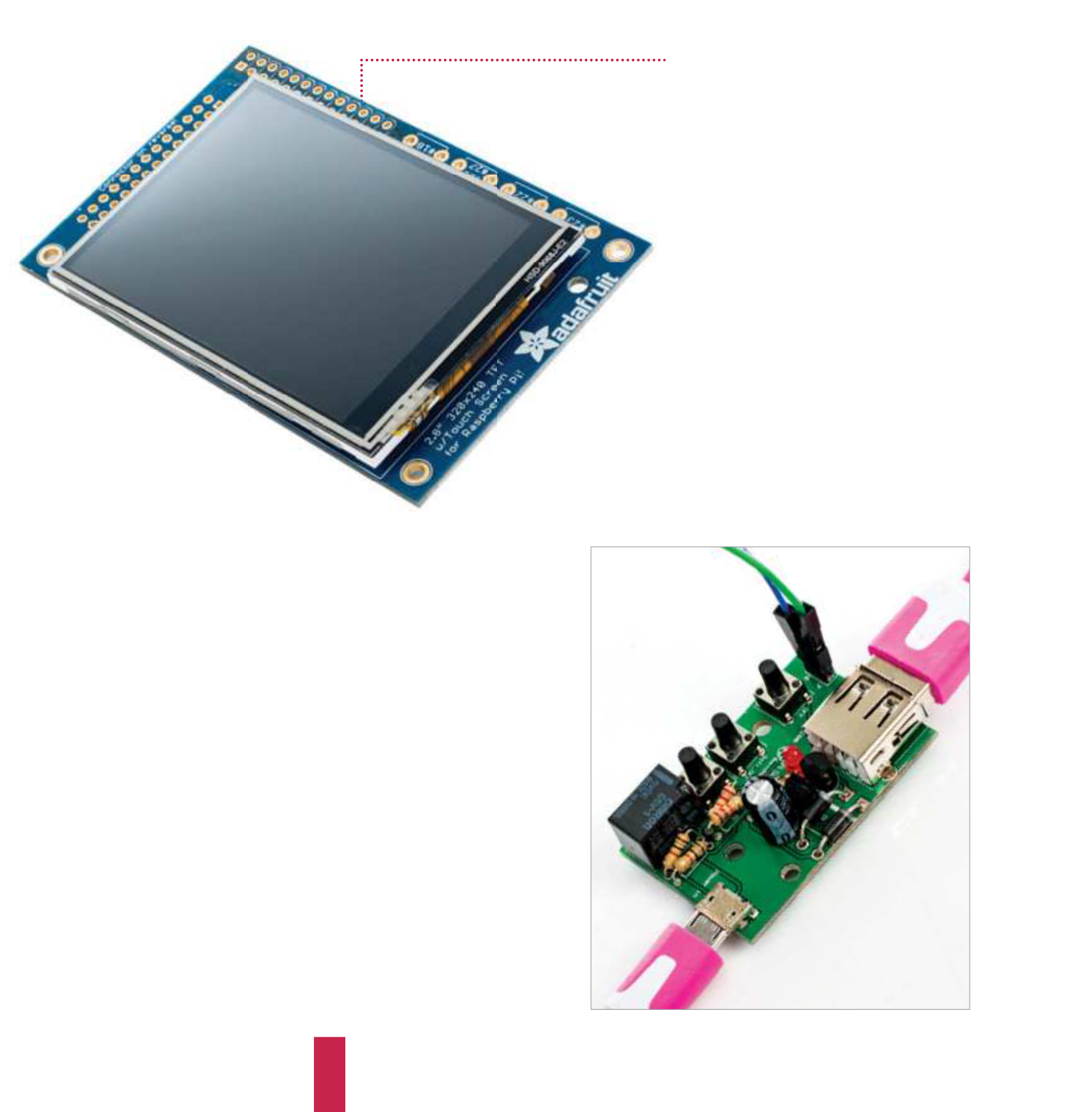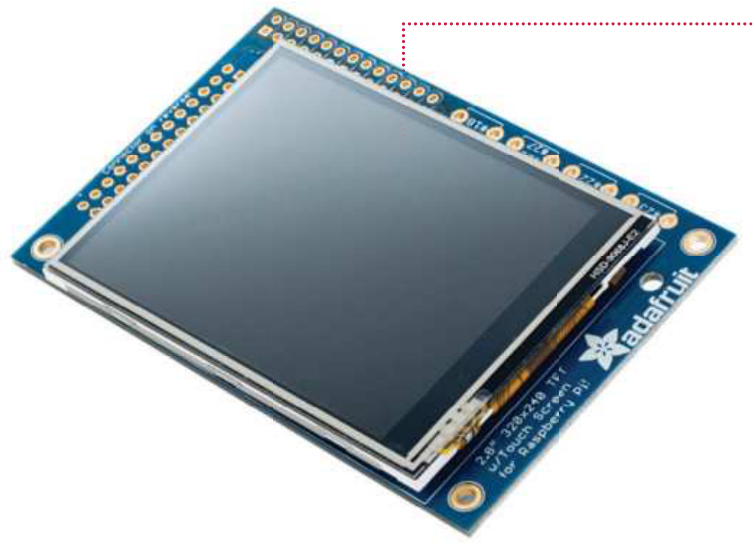

Top four   
add-on boards

Get more out of your Raspberry Pi by using these

add-on boards to extend its functionality

PiTFT Mini Kit £30   
This is a 2.8-inch capacitive TFT LCD touchscreen that’s been specif cally designed with the Raspberry Pi in   
mind by the project gurus over at   
Adafruit. It’s capable of slotting directly on top of the Raspberry Pi and is about as big as the Pi is itself.

There are numerous reasons why you’d want to add such a screen to a Raspberry Pi but they all generally come down to the fact that the Pi is very small and very portable and most monitors are not. While you could VPN in via a phone if you’re on the go, the screen is connected directly to the Pi and doesn’t involve awkward wireless networking. Also as a touchscreen   
you don’t need to bring along other input devices, as it’s powered of the Raspberry Pi as well.

This opens it up to a world of   
possibilities. Portable computer,   
touchscreen control pad, video   
camera… anything that could benef t from your Raspberry Pi having a screen and human input while away from   
your main monitor.

|  |  |  |
| --- | --- | --- |
| Pi Supply Switch £15  The Raspberry Pi has been so popular, in part, because of the extremely good value for money of the hardware. It packs a lot of punch for the price point and, because it is designed by a charity, they don’t need to inf ate the price with high prof t margins as much as would be done with a more commercial product. Unfortunately, as with anything low-cost, some compromises had to be made in order to bring it in at such an af ordable and small form factor.  When comparing it to your more standard desktop or laptop computer, one thing that it is obviously lacking is a power switch and power  management functionality. It is surprising how something as simple as a power switch can be so very useful, and it is not until you do not have one that you realise this!  The Pi Supply Switch is a self-solder kit which provides an on, of and soft-of (f le-safe shutdown) button to give you basic power management functionality for your Pi. With some provided sample scripts you can make sure your Pi is correctly shut down when you switch of – without the need to open any menus or issue any commands in the terminal – and the circuitry in the switch ensures that power is only removed after the Pi has been shut down. As well as making it more convenient for you, it also reduces the possibility of corruption to your SD card from prematurely pulling the power cable. | |  | | --- | |  | |

|  |
| --- |
| **34** |

|  |  |
| --- | --- |
| Top four add-on boards | **Getting started** |

HiFiBerry DAC+ £30   
As a high quality audio device, however, you may f nd the Raspberry Pi lacking due to the fact it only has a 3.5 mm stereo output that isn’t tuned for high f delity. You have probably dreamed of enhancing the   
audio and taking your setup to the next level. The good news   
is that the clever folk at the Raspberry Pi Foundation,   
from the second revision of the original Model B, have   
provided access to the I2S pins; initially on the separate   
P5 header, and now on the A+, B+ and 2B models it is   
available from the main 40-pin GPIO header.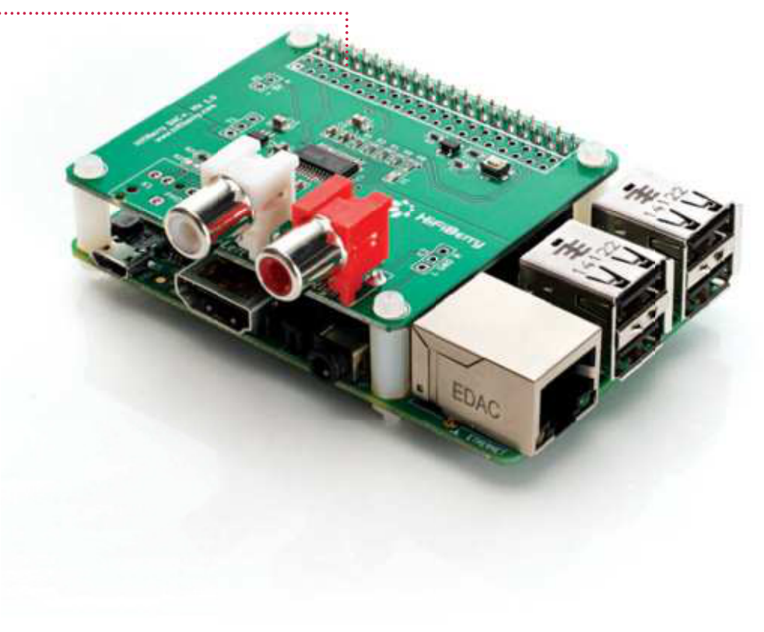

I2S is a communications protocol designed   
specif cally for audio devices and has enabled a number   
of companies like HiFiBerry and IQaudIO to create high   
quality audio add-ons. The HiFiBerry DAC+ is an add-on   
which brings a high resolution (192 kHz, 24-bit) Burr-Brown   
digital-to-analogue converter to your Pi. It has hardware volume   
control using Alsamixer, among other features, and as it is a HAT-  
compatible board. It works plug-and-play out of the box with the latest   
Raspberry Pi f rmwares, and it works with all the popular operating systems   
for both standard use and media playback, such as Raspbian, Arch Linux, OSMC, OpenELEC, Volumio, Pi MusicBox and many more. If you are serious about your audio quality and want a high quality, low cost, Internet-connected solution, then you no longer have any excuse – you can build your own for under £100.

|  |  |
| --- | --- |
|  | Energenie Pi-mote £50  Home automation is all the rage at the moment; automating tasks like f ddling with heating controls and turning of the lights before you go to bed can make our lives much easier.  One thing that we are always told is to turn of devices at the plug rather than leaving them on standby, as they use a lot of electricity when not properly turned of . This is where the Energenie Pi-mote control starter kit comes in. It contains two remote-controlled plug sockets which can be turned on and of with an RF remote.  What does this have to do with the Raspberry Pi? Well you also get an add-on board to enable you to control the sockets via software on the Raspberry Pi, which unleashes whole new possibilities – you could set your lamps to turn on and of automatically at specif ed times |

when you are away to avoid burglars,   
or create a basic web app to control

|  |  |
| --- | --- |
| “The magic of the RasWIK is that it comes with a wireless radio chip that f ts snugly onto the GPIO ports out of the box” | your plug sockets remotely using your smartphone alone.  They only come in UK and EU plug  types, so if you use a dif erent plug then you may need to look for something else (and maybe send Energenie a request to |

make more versions).

|  |
| --- |
| **35** |

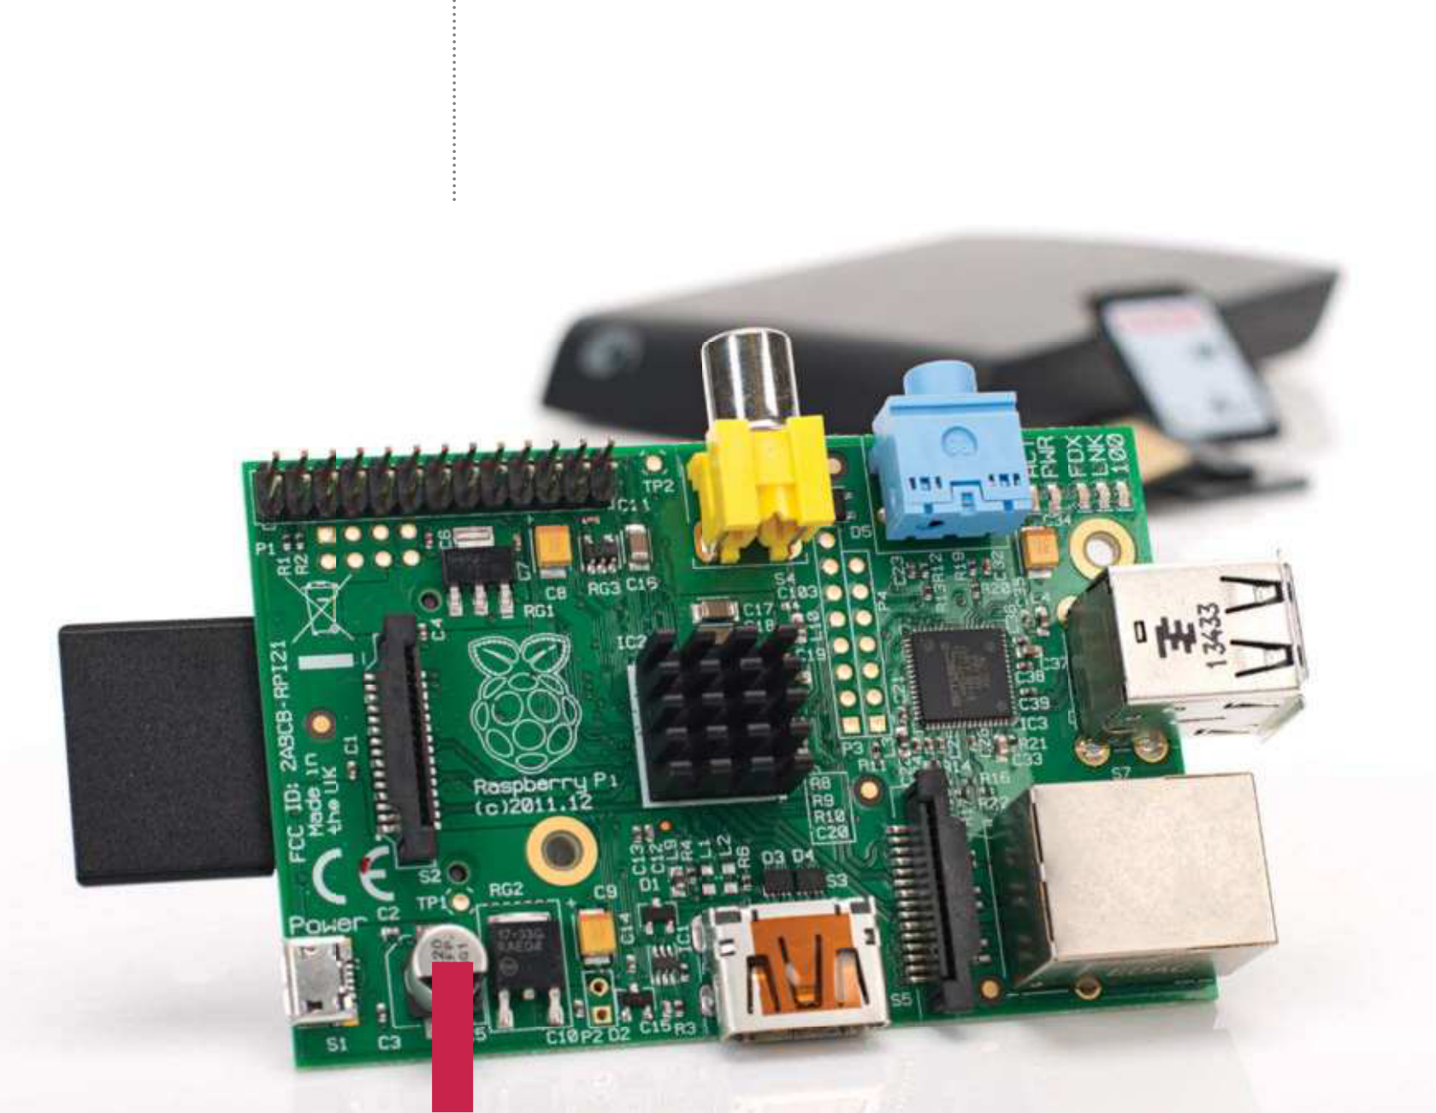

|  |  |
| --- | --- |
| **Projects**  What you’ll need…  **Raspbian**  www.raspberrypi.org/downloads  **SD card** | Supercharge your Pi  Supercharge |
| your Pi |

Get the most out of your Raspberry Pi with these performance-enhancing tips and tricks

Your Raspberry Pi is plugged in. Raspbian is installed on the SD card and you are right in the middle of setting up a wireless print server or building a robot to collect your mail from your doormat. But are you truly getting the most from your little computer? Perhaps you haven’t explored the full set of options in Raspbian, or you’re running the entire OS from SD card, something that can reduce SD card lifespan. Various tools and techniques can be employed to improve performance, from choosing the right hardware to overclocking the CPU. You might even maximise storage space on the Pi’s SD card or all but replace it with a secondary device. Use these tips and tricks to reconf gure your Pi setup and optimise software and hardware to ensure you get the best performance.

|  |
| --- |
| **36** |

|  |  |
| --- | --- |
| Supercharge your Pi | **Projects** |

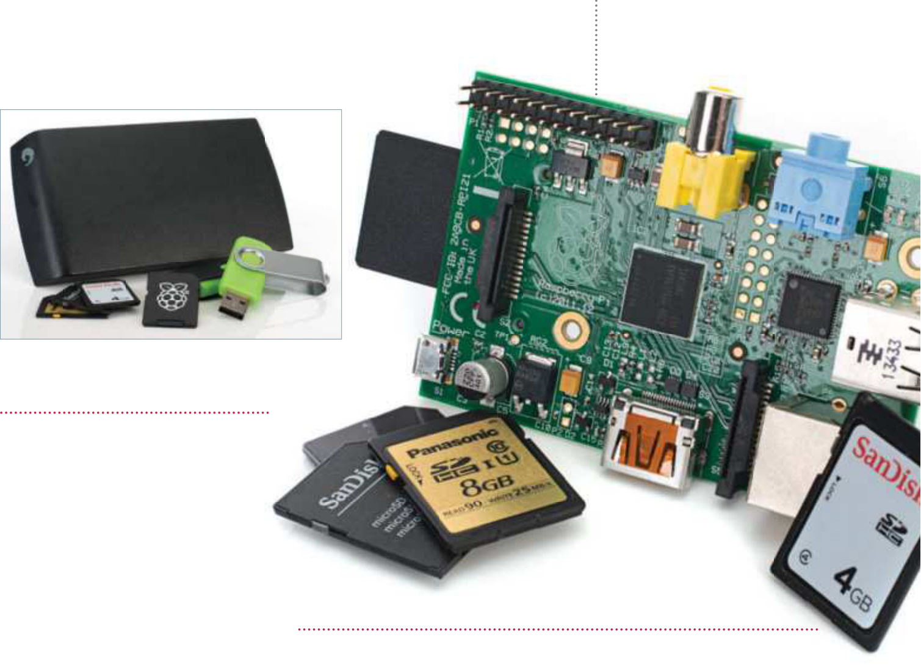

|  |
| --- |
|  |

Use better   
storage hardware

|  |  |  |
| --- | --- | --- |
| you need to find the right balance for your project and shop wisely. | Expand the Raspbian partition  **04** will increase the media’s lifespan (there is more space to write too, so the Maximising the partition affords the full capacity of your SD card, which  same sectors aren’t being overwritten as often). With raspi-config running, use the arrow keys to select expand_rootfs in the menu. Then wait briefly while the partition is resized. | |
| Choosing the best SD card  **02** are available, with the more Various standards of SD card  expensive designed for better error correction. For the best performance on your Raspberry Pi, choose an SDHC |
| Write data to RAM | Enable fstab in Raspbian |
| card with a high rating. The same  advice applies to MicroSD cards, which you can use on your Raspberry Pi with an SD card adaptor or directly insert | **05** writing data to your SD card – Rather than reading and  something that will eventually result | **06** RAM disk in Windows. In the  This is much like creating a  command line, enter: |
| in a deterioration of reliability and | sudo nano /etc/fstab |
| into a Raspberry Pi B+.  Make the most  of your storage  **03** of storage for your chosen  You’ll typically need 1-2GB  Raspberry Pi distro, so any remaining |
| performance in the card – you can | Add the following line to mount a |
| configure Raspbian to write to the | virtual file system: |
| system RAM, which will speed things | tmpfs /var/log tmpfs |
| up slightly and improve the SD card’s | defaults,noatime,nosuid,mode= |
| overall performance. This is achieved | 0755,size=100m 0 0 |
| using fstab (file systems table), a | Follow this by saving and exiting nano |
| system configuration available in | (Ctrl+X), then safely restarting the Pi: |
| most Linux distros. | sudo shutdown -r now |

|  |  |  |
| --- | --- | --- |
| used for updates and data you |  | “You’ll typically need 1-2GB |
| create or save. In Raspbian you can |
| open a command line and run the |
| of storage for your chosen |
| configuration utility to gain more |
| space (only if your SD card’s greater | Raspberry Pi distro” |
| than 2GB): |

|  |
| --- |
| **01** can have an impact on   Your choice of storage media  your Raspberry Pi’s performance,  regardless of the operating system. A  low capacity SD card with poor error  correction, is going to be slower than  a larger card with greater resilience, so  storage on your SD card will be  sudo raspi-config  **37** |

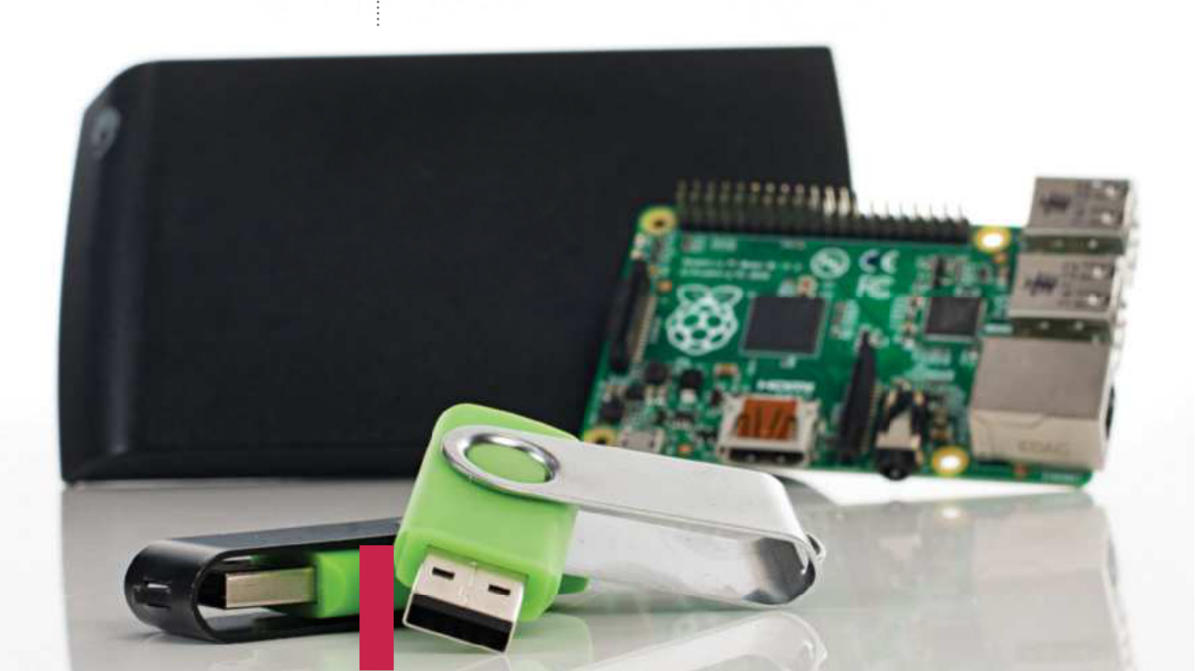

|  |  |  |  |
| --- | --- | --- | --- |
| **Projects**  Picking an | Supercharge your Pi  Configure fstab for fast performance | | |
| external USB drive  Speeding up your Raspberry Pi by migrating the root filesystem to an external USB drive is a  start, but what sort of device  should you use for the best | **07** | Upon restarting, the virtual filesystem will be mounted and /var/log on the RAM disk. Other directories that can be moved to RAM include: | |
| tmpfs /tmp tmpfs defaults,noatime,nosuid,size=100m 0 0   tmpfs /var/tmp tmpfs defaults,noatime,nosuid,size=30m 0 0   tmpfs /var/log tmpfs defaults,noatime,nosuid,mode=0755,size=100m 0 0 tmpfs /var/run tmpfs defaults,noatime,nosuid,mode=0755,size=2m 0 0 tmpfs /var/spool/mqueue tmpfs defaults,noatime,nosuid,mode=0700,gid= 12,size=30m 0 0  Add each to /etc/fstab in nano. | | |
| performance? With a USB thumb |
| drive you can add flash storage up to 16GB without running into any significant problems (the  larger the drive, the greater the current is required to read/write). |
| Move your OS to a HDD | | Back up the SD card |
| Anything larger is expensive and unnecessary. If you’re planning to use an external HDD, there are no power issues as it will have its own power supply. As ever, your choice should suit your project. | **08** lifespan of the SD card, why If you’re concerned about the  not reduce your Raspberry Pi’s reliance | | **09** card. Shut down, remove the Create a copy of your Pi’s SD  card and insert it into your desktop |
| on it? Instead of using the SD card as | | computer. In the command line, run: |
| a sort of budget SSD, change its role | | sudo dd bs=4M if=/dev/sdb |
| and add a HDD or USB stick to run | | of=~/backup.img |
| the operating system, leaving the SD | | The path /dev/sdb represents the |
| card for bootstrapping. This can give | | SD card. Copying takes 5-10 minutes. |
| a marked performance boost to the | | When complete, remove the SD card |
| SD card. | | and connect your USB device. |

Copy Raspbian to USB

**10** destination drive, enter:   
 Using a blank Ext4-formatted USB thumb drive (or external HDD) as the

sudo dd bs=4M if=~/backup.img of=/dev/sdc

|  |  |
| --- | --- |
| **Below** Having your filesystem on a  USB stick is great for backups as well as performance boosts | Leave the backup on your computer, just in case something goes wrong. With an SD card and USB storage device sharing an identical disk image, it’s time to consider what you’re going to do next – create a faster Raspberry Pi. |

|  |
| --- |
| **38** |

|  |  |
| --- | --- |
| Supercharge your Pi | **Projects** |

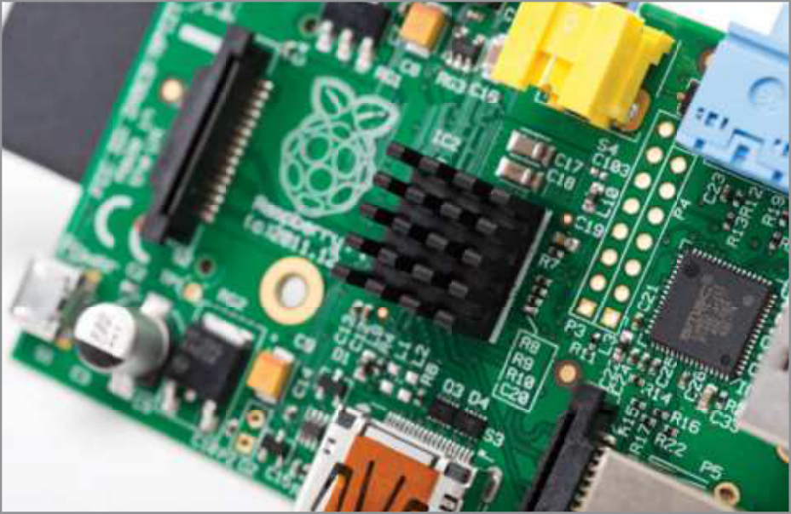

Split the Raspbian partitions

**11** should remain on the SD card Ideally, the boot partition

while the root filesystem is run from the external HDD or USB thumb   
drive. Using your preferred partition manager (Disk Utility is in most   
distros), unmount and delete the root filesystem from the SD card, ensuring you have retained the boot partition. After removing the SD card, connect your USB device and delete the boot partition, taking care to leave the root filesystem intact. Then resize the root filesystem on the USB device, making sure that 10MB remains.

Identify the root filesystem

**12** card and the external USB You’re going to have the SD

storage connected, so you need to tell the Pi where the root filesystem is. On the desktop Linux computer with your SD card inserted, run:

sudo nano /boot/cmdline.txt Find root=/dev/mmcblk0p2 (or similar) and change that to read root=/dev/ sda2 which is your external USB   
storage. Save and exit.

**Above** Heat   
sinks for the Pi are   
widely available and   
usually cost less than $10

Make your Pi fast and reliable

**14** txt and change root=/dev/mmcblk0p2 to root=PARTUUID=XXXXXX, Make a note of the GUID and then switch to the SD card. Reopen cmdline.

where the numerical string from the partition unique GUID should replace the XXXXXX. When you’re done, save and exit. You can then start your Raspberry Pi.

Congratulations, your Raspberry Pi is now faster and more reliable to use!

Boost performance with overclocking

**15** you should be aware of the risks inherent with this activity. You should also Need more from your Pi? It is possible to overclock the computer, although

ensure that your Raspberry Pi’s processor is suitably cooled – heatsinks for the CPU, Ethernet controller and power regulator can be purchased online.

Add other USB devices

|  |  |
| --- | --- |
| You can now restart your | Overclock your Pi  **16** line and arrow down to the overclock option. Four further options are Overclocking is available through raspi-config. Launch from the command  available: Modest, Medium, High and Turbo. With your ideal clock speed selected, exit raspi-config and restart your Raspberry Pi to apply: |
| **13** Pi with the storage devices attached, but as soon as you connect further USB media you’ll suffer  problems. Avoid by installing gdisk: |
| sudo apt-get update  sudo apt-get install gdisk Then run gdisk:  sudo gdisk /dev/sdb  Enter ? to display the options and select Recovery and Transformation options (experts only), followed by Load MBR and Build Fresh GPT. Tap ? | sudo shutdown -r now  Now you will need to perform tests to see how stable it is overclocked. Raspberry Pi founder, Eben Upton, suggests running Quake 3 as a good stress test. Should the Pi fail to boot, hold Shift to boot without overclocking, run raspi-config and select a more modest overclock.  Run Raspbian without the GUI  **17** yourself running a lot of commands in bash, the best thing to do is disable Despite these changes, you may find that the GUI remains slow. If you find  launching into X. In raspi-config, choose boot_behaviour and select the first (default) option to ensure your Pi boots to the command line. Should you need the GUI, enter ‘startx’ in Terminal. |
| one last time and select ‘Write Table to Disk’ and exit. Remove and replace the USB device and run gdisk again. This time enter I and then 1 to display the Partition Unique GUID. |

|  |
| --- |
| **39** |

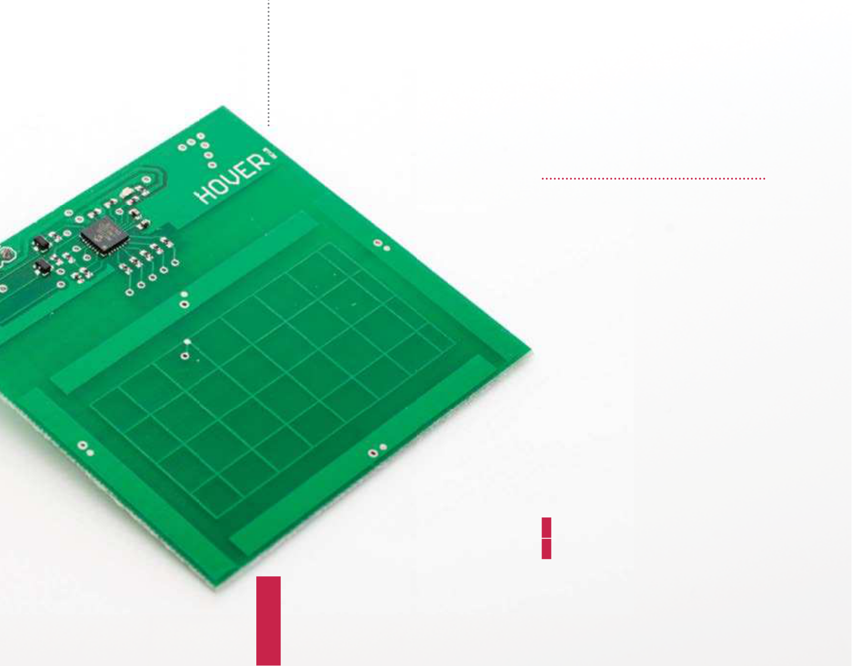

|  |  |
| --- | --- |
| **Projects**  What you’ll need…  **Hover**  www.hoverlabs.co/#shop  **Breadboard**  **Male to female jumper cables Speaker or headphones** | Control with gestures  Control with |
| gestures |

Hover is an impressive add-on board for your   
Raspberry Pi that allows you to easily add touch and gesture control to any project

People often ask what the best way is for them to get started

with Raspberry Pi. In a more general sense it’s often the hardware

projects that win out. Pi projects teach a variety of skills and are also

varied enough to both keep beginners interested and allow them

to work out for themselves exactly what aspect they love best. Even

a professional will get a kick out of physical computing!

One of the most important aspects of a hardware project is often

the user input mechanism, and as technology is ref ned we see new

and more intuitive ways to accomplish this task. Gesture and touch

control is now present in a large number of consumer devices. It is

time to bring your Pi projects into the 21st century with Hover!

Get the gear!

**01** available to purchase direct   
 The Hover add on board is

from Hover (http://www.hoverlabs.   
co/#shop) for $39 (£25), however this   
will ship from Northern America and   
therefore if you are based in the UK   
or Europe it will likely be quicker and   
cheaper to order from one of the   
other retailers listed via the above link.   
The added benefit of ordering from   
a retailer is that if you need any of the   
other items you can likely get those at   
the same time!

Hover will work perfectly with any   
Raspberry Pi, including both the new   
plus versions and the older models –   
just make sure your system is fully up   
to date with:

|  |
| --- |
| **40** |

|  |  |
| --- | --- |
| **Left** You can tap the Hover or swipe in four directions just above it | sudo apt-get upgrade |

|  |  |
| --- | --- |
| Control with gestures | **Projects** |

Update GPIO and I2C

**02** I2C (or any other interfacing When making use of GPIO and

technique on the Raspberry Pi) it is always good practice to update to the very latest software versions possible.

Newer versions typically have bug   
fixes and additional futures which can come in very handy. GPIO and the   
RPi.GPIO Python library are installed by default on Raspbian, but you may need to enable I2C if you haven’t   
already. This is a fairly standard process and has been covered many times so we won’t go into it here. We would, however, highly recommend the   
brilliant I2C setup tutorial from Adafruit (https://learn.adafruit.com/adafruits-raspberry-pi-lesson-4-gpio-setup/

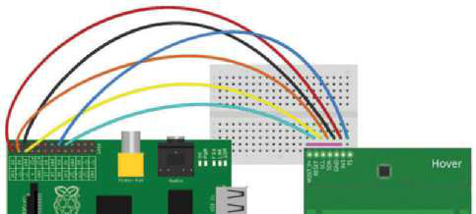

Set up the hardware

**03** power before starting this step, to avoid any unnecessary damage to Make sure your Raspberry Pi is powered down and not connected to

your Raspberry Pi. Pick up your Hover, breadboard and wires and connect the as shown in the Fritzing diagram. The physical pins you should be using on the Raspberry Pi are 1, 3, 5, 6, 16 and 18. Whilst a Model B Pi is shown, this will be the same connection on a Model A, B, A+ or B+ of any revision. Once completely set

|  |  |  |  |
| --- | --- | --- | --- |
| configuring-i2c). | up like the image, reconnect the power cord and open an LXTerminal session. | | |
| Check the connection | |  | |
| **04** the main 26 or 40 pin GPIO bank (depending on which version of the Hover connects to the Raspberry Pi through the I2C interface located on  Raspberry Pi you are using). There is a very easy way to check if your Raspberry Pi is correctly connected to Hover using the simple command line I2C tools. Issue the following command:  sudo i2cdetect -y 1  If you see 42 in the response then you are successfully connected to Hover!  Using a Rev 1 Pi? | |
| **05** system which I2C bus to look at. The first revision Raspberry Pi) made use In the code, we have passed an option “-y 1” which tells the operating  of I2C bus 0, whereas all other versions of the Raspberry Pi since have used I2C bus  1. So the above code would change to:  sudo i2cdetect -y 0 | | | Download the sample code **06** hooked up correctly and your Now you have everything  Raspberry Pi is fully up to date, it is |
| And you should expect the same output (42) as in Step 7. Additionally you will | | | time to get the Hover Python library, |
| need to edit line 27 of the Hover_library.py file, changing bus = smbus.SMBus(1) | | | which makes using the board from |
| to bus = smbus.SMBus(0). A patch that automatically detects the Raspberry Pi | | | Python scripts extremely easy. You can |
| version and makes this change for you has been submitted, but not yet accepted | | | get this using the following command: |
| into the master branch so this may not be necessary in future versions. | | | git clone https://github.com/ |
| jonco91/hover_raspberrypi.git | | | |
| be using on the Raspberry Pi  are 1, 3, 5, 6, 16 and 18” “The physical pins you should | | | This should download a folder called hover_raspberrypi to your /home/ pi directory containing all of the files needed for this article. Alternatively you can download the zip file from https://github.com/jonco91/hover_ raspberrypi/archive/master.zip. |

|  |
| --- |
| **41** |

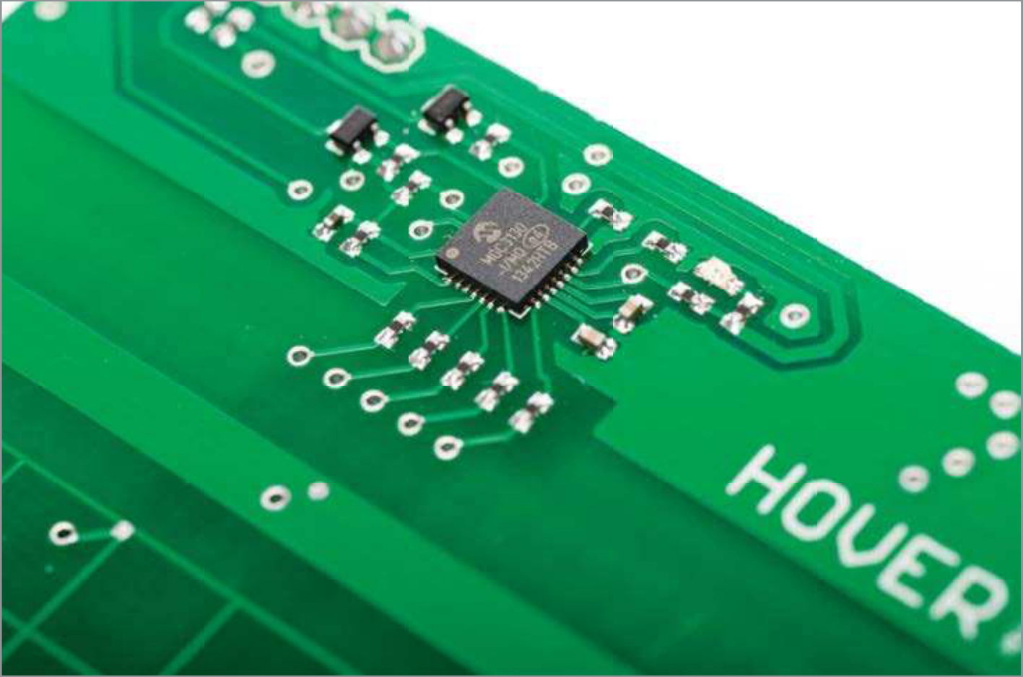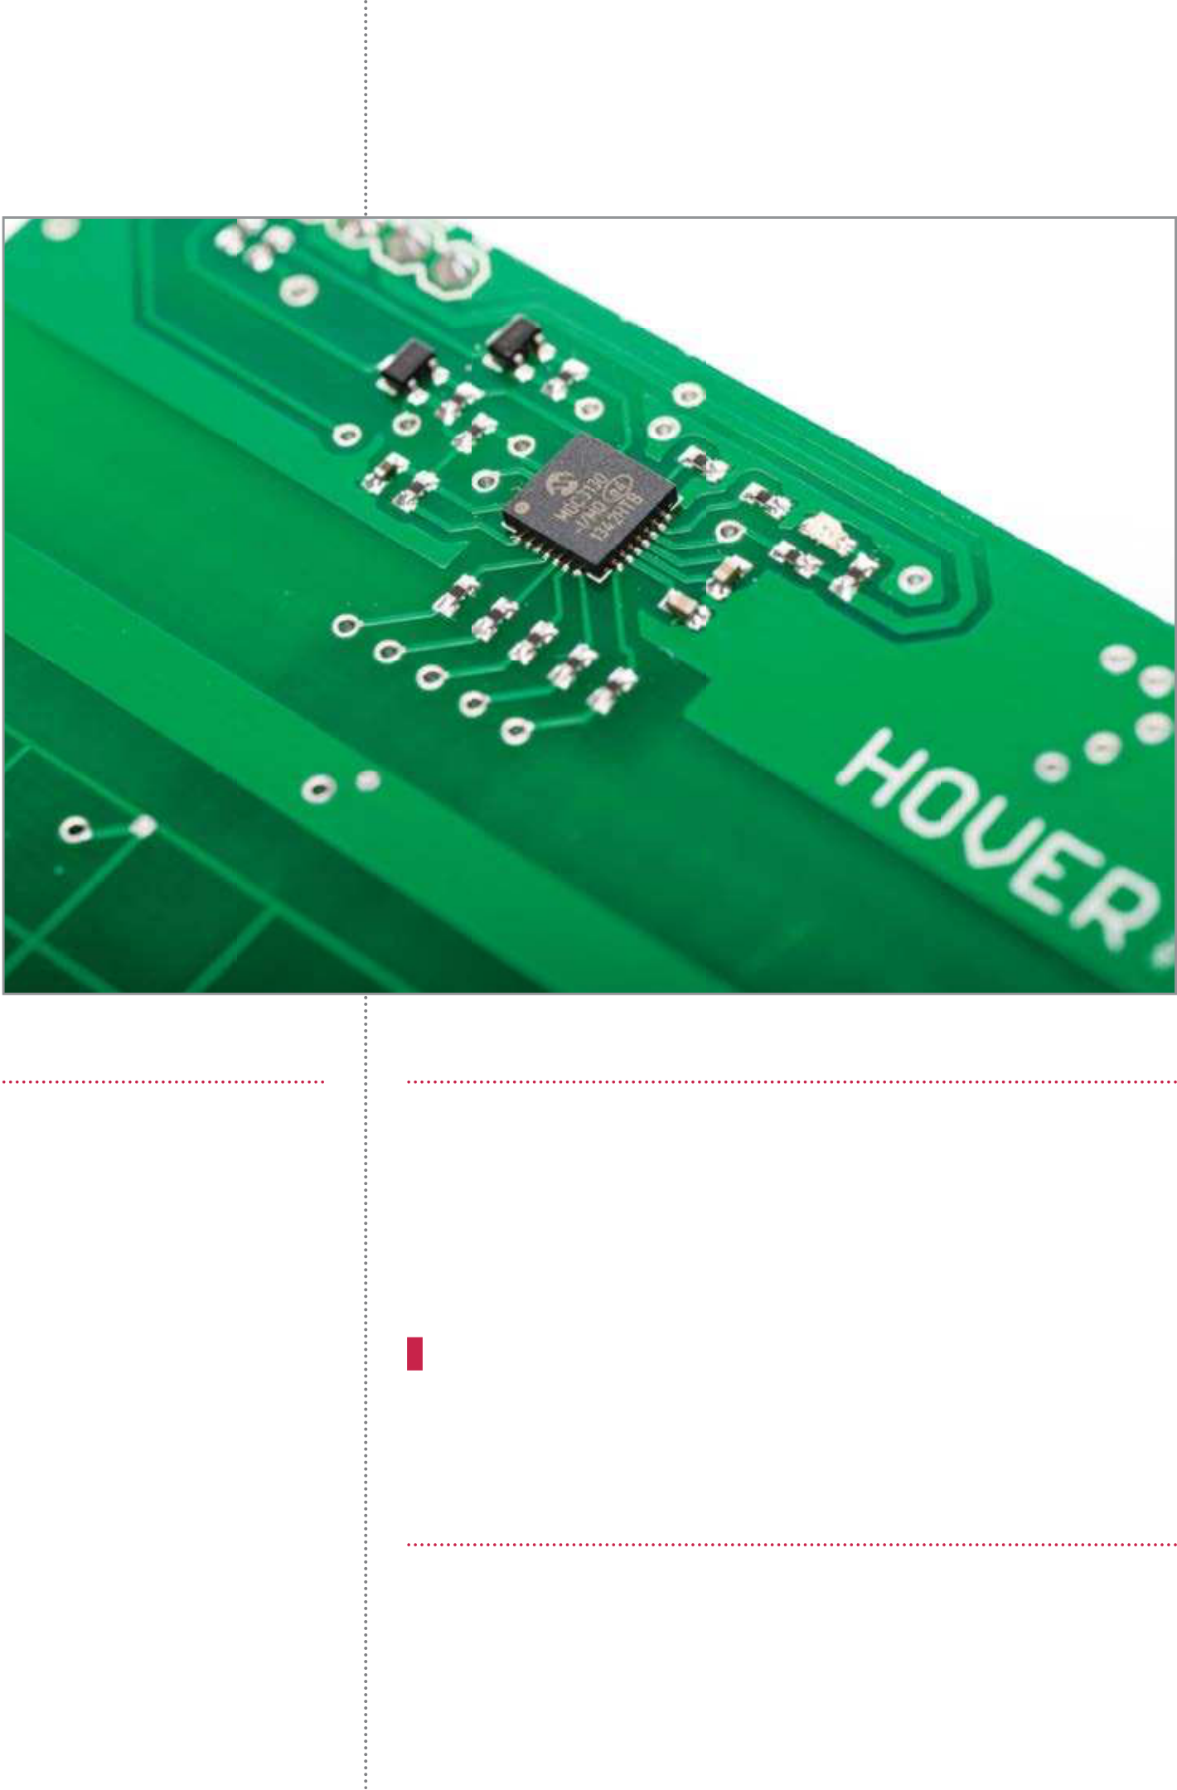

**Projects**  Control with gestures

**Left** This MGC3130 chip works as the 3D   
 tracking and gesture controller

Plenty of platforms Run the example file

|  |  |
| --- | --- |
| The Hover board has intelligent on-board level shifting, meaning that it can be used with either 3.3V or 5V logic levels which  means it can be used with  pretty much any microcontroller your heart desires. There are | **07** functions included within it, rather than an installable package (however, The current Hover library is simply a Python file with all of the necessary  this may change in the future). In order to use the functions contained within the Hover_library.py script discussed above, it is therefore necessary to make sure that the Hover_library.py script is located in the same folder as any script you have written that makes use of any of the Hover functions. In a terminal session, navigate to the folder containing the Hover_example.py file and run it using: |

connection examples and code   
snippets available for Arduino, sudo python Hover_example.py   
Sparkcore and PCduino on the   
Hover website (hoverlabs.com) The Hover board will initialise and you will then see the message ‘Hover is ready’, and these can also be adapted meaning you are good to go.

to suit other devices fairly easily.

|  |  |
| --- | --- |
| If you decide to create your own example with another device then why not submit a pull  request to the Hover GitHub  (github.com/jonco91) if you are happy to share! | Investigate the output  **08** gestures above it you will begin to see output in the terminal which is a Once you have completed Step 7, if you touch the Hover board or make  bunch of 0s and 1s and then a description of what it has seen – right swipe, north tap, etc. The way the Hover works is that it can sense any one of nine different |

actions and these are sent to the Raspberry Pi over I2C as an 8-bit binary value.

The first three bits describe whether it was a touch or gesture event and the remaining five bits describe the specific type or direction of the event. The exact breakdown can be seen in the code listing to the right.

|  |
| --- |
| **42** |

|  |  |  |
| --- | --- | --- |
| Enable 3.5mm audio | Control with gestures | **Projects** |
| Full code listing | |
| **09** plug them in to the 3.5mm Grab your speakers and  jack plug on your Raspberry Pi. You will then need to route audio to  the 3.5mm jack using the following command (you can skip this step if you are using an HDMI display, which | import time  from Hover_library import Hover  hover = Hover(address=0x42, ts=23, reset=24)  try:   whileTrue: | |

has in-built audio):

sudo amixer cset numid=3 1

Make a drum machine

**10** folder is another folder In the hover_raspberrypi

called examples that contains code and sounds to turn Hover into a   
drum machine! Navigate to the   
hover_raspberrypi directory and then copy the Hover_library.py file into the examples folder by using:

cp Hover_library.py examples You can then move into the examples folder and run the Hover_drum.py file using:

cd examples

sudo python Hover_drum.py Make some gestures and taps on and around Hover and you will have your own basic drum machine!

Create your   
own responses

|  |
| --- |
| **11** having a Python library The great thing about  available is that it is easy to |

integrate this device into any of your existing or future projects. The code shown is all you need

# Check if hover is ready to send gesture # or touch events   
if (hover.getStatus() ==0):  
 # Read i2c data and print the type of # gesture or touch event  
 message = hover.getEvent()   
 type(message)   
 if (message == “01000010”):   
 # code for west touch goes here   
 elif (message == “01010000”):  
 # code for centre touch goes here elif (message == “01001000”):  
 # code for east touch goes here   
 elif (message == “01000001”):  
 # code for south touch goes here   
 elif (message == “01000100”):  
 # code for north touch goes here   
 elif (message == “00100010”):  
 # code for swipe right goes here   
 elif (message == “00100100”):  
 # code for swipe left goes here   
 elif (message == “00110000”):  
 # code for swipe down goes here   
 elif (message == “00101000”):  
 # code for swipe up goes here

# Release the ts pin until Hover is # ready to send the next event  
 hover.setRelease()  
 time.sleep(0.0008) #sleep for 1ms

exceptKeyboardInterrupt:   
 print “Exiting...”  
 hover.end()

except:   
 print “Something has gone wrong...” hover.end()

|  |  |
| --- | --- |
| to get started with Hover. You will see that on line 15 and onwards | Other project ideas |

there are comments saying ‘code

|  |  |
| --- | --- |
| for … goes here’. Essentially all you need to do is insert the actions you want to occur on the particular  event mentioned in the comment and you will be up and running... it really is that easy! | **12** could use Hover in, but let’s face it – pretty much any project that requires Most of you are probably now wracking your brains for projects you  physical interaction would be made better with touch and gesture control. If you think it is cool but are lacking inspiration, we recommend looking at the projects section of the Hover website at http://www.hoverlabs.co/projects, where there are projects by the creators and community alike. |

|  |
| --- |
| **43** |

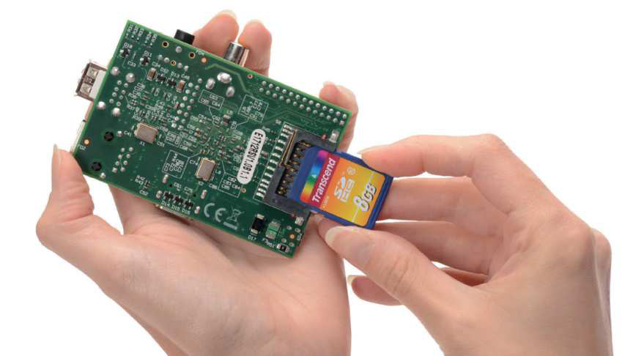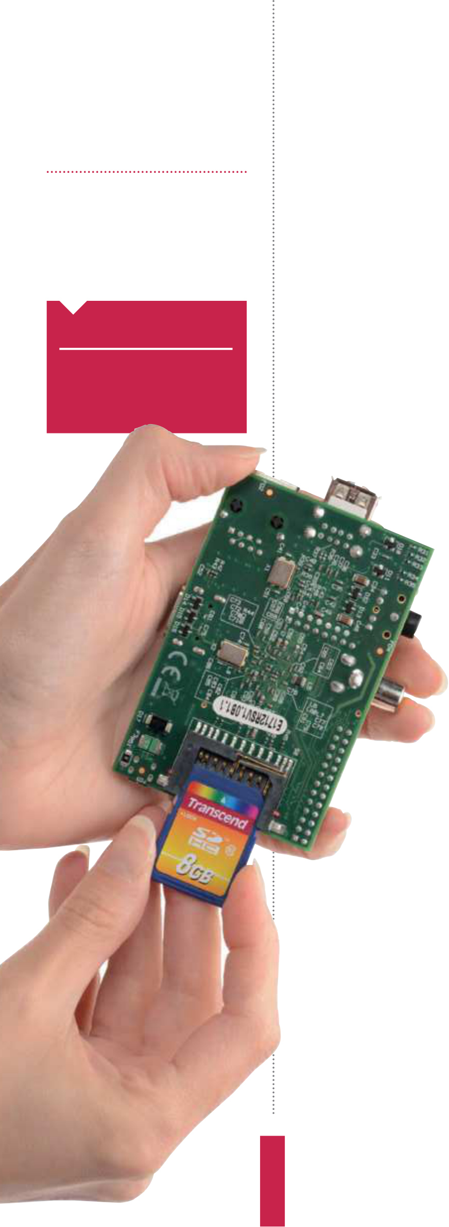

|  |  |
| --- | --- |
| **Projects**  What you’ll need…  **A second computer**  **External storage** | Back up your Pi  Back up your Pi |

Take the initiative and back up your Raspberry Pi to make sure you never lose fles again

While the Raspberry Pi is a very solid piece of kit, failure can happen,

|  |  |
| --- | --- |
| **Did you know…**  SD cards don’t last forever so always make sure you’ve got a backup of your fles and your entire OS. | so it’s best to be well prepared and keep your fles safe.  The good news is that the Pi’s fles are all kept externally on the SD card. If your Pi breaks, everything will still be available on the SD card and accessible from elsewhere. The SD card is still susceptible |

to problems, though. There are a number of ways to back up a Pi. The methods can be broken down into two main categories: saving the important fles and creating an exact copy of the state of the SD card. The former involves having copies of fles elsewhere, while the latter has you create the same kind of image that you’d normally write to the SD card when installing Raspbian or other Pi-operating systems.

Important files   
 To save important fles, we need to create a copy on an external source, such as external hard drive or another PC. One of the best methods to do this doesn’t even involve a Pi; all you need is a PC or laptop with a card reader and you’re good to go.

Turn of your Pi, unplug it and remove the SD card from the slot. Find the SD card reader on your PC and slot it in.

The main fle system of the SD card can be read by Linux PCs by default, and a Windows or Mac computer once you’ve installed a program that lets it read the ext fle system, such as Ext2Fsd. On Windows, the SD card will be listed with the rest of the drives under My Computer (Fig 1). On Linux and Mac, it will be listed wherever storage is shown on the menus and fle managers.

Once you’ve found the SD card on here, open it up and navigate to home and then pi. This is where the Documents, Downloads, Desktop and other directories can be found. All you need to do is select the fles you want to copy and move them to a secure directory on your PC or a connected external hard drive.

**44**

|  |  |
| --- | --- |
| Back up your Pi  If you want to keep the f les on another computer, that’s f ne, but it will be prone to the exact same problems as the Pi in the long run. Keeping them on an external hard drive is a good idea, and putting them on a cloud storage service is better yet, enabling you to access them from anywhere with an internet connection (Fig 2).  Cloning  Creating a clone depends on what operating system you’re using | **Projects**    **Fig 1:** Accessing the SD card from another  PC is an easy alternative to transferring files  between machines via a USB stick |

on your main computer. For Macs and Linux, you can use a simple

command-line tool called dd to create an exact copy of the SD card

|  |  |
| --- | --- |
| (Fig 3). This is done in the terminal emulator or command line, so bring that up f rst. Make sure the SD card is plugged in and enter: $ fdisk -l  This lists all connected storage devices. The SD card will have 2, 4 or 8GB of space, depending on its size. It’ll likely be listed as something like /dev/sd[x], where x is the letter the computer attaches to the SD card. To copy it using dd, enter the following into the terminal: $ dd if=/dev/sd[x] of=backup.img bs=1M  You can also add a path to the image you’re creating to put it in a | **Fig 2:** Cloud storage services make backing up files easy and secure, as they’re a lot less prone to problems |

specif c folder. The process will take some time, and will produce

a multi-gigabyte f le which you can then write onto the SD by

|  |  |
| --- | --- |
| reversing the previous command:  $ dd if= backup.img of=/dev/sd[x] bs=1M  While this is useful as a backup, you can also use the image to mass-produce SD cards to give to friends or keep in the various places where you use your Raspberry Pi.  Windows  To create a clone on Windows, we can use the Win32 Disk Imager (Fig 4). Download it from here to install it: bit.ly/L8JdYG. | **Fig 3:** The dd tool is what you’ll use on a Linux and Mac computer, and it’s available by default in the terminal emulators |

Once installed, insert the SD card and launch the software.

Choose a name for the backup f le and select the SD card from the

|  |  |
| --- | --- |
| list of devices. Now press Read and it will create the backup f le.  Again, this might take a while; however, this time you are at least shown a progress bar.  Storing your cloned image is a little more dif cult than your important f les – the size of the image being in the gigabytes means it will f ll up a lot of cloud-storage services. If you have the space, def nitely keep it on there; however, you may need to put it on an external hard drive. | **Fig 4:** Win32 Disk Imager makes backing up the entire OS easy, and you can even use it to write the image back to the SD card |

|  |
| --- |
| **45** |



**Projects**  Beginner’s guide to nano

www.nano-editor.org/dist/v1.2/nano.1.htmlBeginner’s   
 guide to nano

Learn how to edit text on the command line and in a terminal with one of Linux’s best tools

|  |  |
| --- | --- |
| **Did you know…**  Nano is one of the best  command line editors for  beginners, but there are lots of options like Kate and Vim. | If you have the itch to do more with your Pi, one of the skills you’ll need to learn to pull of many projects is the ability to edit system fles. The command line text editor nano is defnitely one of the best tools for the job. Text editors are very basic tools; the clue is in the name in this case. There’s no formatting or colouring or anything |

of the sort you would get in a word processor, but that’s the point.

The kind of fles you’ll be creating or editing will generally contain code – code which doesn’t require to be made bold or bulleted.

nano removes all of these distractions, but still has a few of the more handy features you’d fnd in a graphical text editor. We’ll teach you how to make the most out of nano to make your projects run quickly and efciently.

|  |  |  |  |  |  |  |
| --- | --- | --- | --- | --- | --- | --- |
| Edit system files to suit  your needs and projects  without digging through a  file manager  **Advanced**  **functions**  Search, copy, paste and  insert text from another file  using some of the built-in  nano functions   |  |  | | --- | --- | |  |  | |  |  | |  | |  |     **Writing**  Create plain text files in the  command line, even write  some code for a program  **Editing** |

|  |
| --- |
| **46** |

|  |  |
| --- | --- |
| Beginner’s guide to nano | **Projects** |



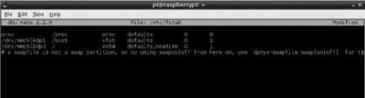

|  |  |  |
| --- | --- | --- |
| Open nano | Save and exit | Advanced navigation |
| **01** command line, and simply type Open the terminal, or enter the  nano. This will open a blank new file. | **04** modifying the file and need Once you’ve finished  to get on with the next task, you can | **07** the arrow keys to move one You’ve probably been using  space at a time left, right, up or down. |
| From here you can create a simple text | press Ctrl+X to exit nano. It will ask if | There are other ways to move around |
| file such as a list, or create a system | you want to save any modifications, | the file, though. Using Ctrl+A will act |
| file, script or piece of code. How the | which just requires a Y to confirm. | the same way as the Home key does |
| system interprets your file depends on | If you want to exit without saving | in a graphical editor, moving the |
| what you write and how you save it. | changes, you can just use N. To cancel | cursor to the start of the line. Same |
|  | before making a decision, use Ctrl+C. | with Ctrl+E moving you to the end like |
| the End key. Ctrl+V is page down, and |
|  | Ctrl+Y is page up. |
| Searching a file |
|  |  | **08** for a specific line or phrase in Sometimes you’ll be looking  a large text file. Instead of using the |
| Save and continue |
| **02** nano, you can save/write Once you’ve finished with  out using Ctrl+O. All shortcuts and |  | arrow keys and tirelessly reading every |
| line, you can use the search function |
| via Ctrl+W. Entering the search term |
| will begin looking through the |
| functions such as this are done using |
| Copy and paste | document, and once you’re finished |
| Ctrl and a letter key. It will ask you what |
| you can press Ctrl+C to exit the search. |
|  | **05** specific command, but it can This is more of a terminal-  be used just as well in nano. While you |
| name to save the file under. Whatever |  |
| you name it, it will be saved in the |
| directory you opened nano from |
| unless you specify a path. |
|  |
| cannot use your mouse to navigate |
| around the file in nano, you can |
| highlight text in the same way you |
| would in a graphical text editor. Once |
| highlighted, pressing Ctrl+Shift+C will |
| Opening files | copy any text. Ctrl+Shift+V will paste. |
|  |  |
| To edit already existing files, | Insert from file | Extra help |
| **03** you’ll first need to know their  location and name. To open them in | **06** the contents of another file, If you need to directly insert  there’s a quick way to do it without | **09** functions available in nano. There are many more  For a full list of commands, you can |
| nano, type the following: |
|  |
| $ nano /path/filename | needing to use copy and paste. Typing | use Ctrl+G, which lists all the shortcuts |
| For example, to edit fstab you | Ctrl+R and entering the path to the | and what they do. The caret symbol |
| would type: | file will insert it into the spot your | (^) in this list denotes the use of Ctrl on |
| $ nano /etc/fstab | cursor is at. | your keyboard. |

|  |
| --- |
| **47** |



|  |  |
| --- | --- |
| **Projects**  What you’ll need…  **TightVNC**  www.tightvnc.com/release-2.7.php | Gain remote desktop access  Gain remote  desktop access |

Learn how to get access to your Raspberry Pi desktop without it being in front of you…

VNC (Virtual Network Computing) is a graphical desktop access and

|  |  |
| --- | --- |
| **Did you know…**  TightVNC Viewer is a free  resource for accessing VNC  servers, like the one we’ll install in this tutorial. | sharing system that allows a user to remotely control and use the desktop of another computer from their own system.  It’s handy in many ways: to give you control over a remote system; to help out another user elsewhere; to allow a computer to |

remain powered on, but without the need for a keyboard, mouse or even a monitor.

In our case, we aim to allow access to the Raspberry Pi desktop without it being hooked up to the aforementioned peripherals. This way, you can do everything you would normally do, but with just the power supply and network attached, thereby freeing up space and saving extra expense. In real-world terms, this means you could potentially access the Pi desktop via an Android tablet or phone!

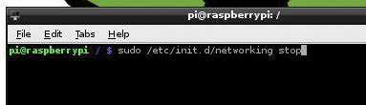

|  |  |  |
| --- | --- | --- |
| Static IP address | Static IP part 2 | Static IP part 3 |
| **01** sure that the Raspberry Pi   The first step for us is to make  has a static IP address. Basically, an IP | **02** addressing for the Pi. You need This file controls the IP  to scroll down to the ‘iface eth0’ line | **03** details, exit nano by pressing After you’ve entered those  Ctrl+X, followed by Y to accept the |
| address is a group of numbers that | and remove DHCP and replace it with | changes, and then press Enter a |
| your network assigns to devices in | static. Now, on the line directly below, | couple of times to get back to the |
| order to tell them apart. To set up a | enter the IP address that you want | command prompt in the terminal. You |
| static IP address, simply double-click | force your Pi to have, along with the | can now either reboot your Pi, or type |
| LXTerminal and type the following | subnet mask and the gateway: | the following into the terminal: |
|  |  |
| and then press Enter: | address 192.168.1.93 | sudo /etc/init.d/networking stop |
|  |
| sudo nano /etc/network/ | netmask 255.255.255.0 | sudo /etc/init.d/networking |
| interfaces | gateway 192.168.1.254 | start |

|  |
| --- |
| **48** |

|  |  |
| --- | --- |
| Gain remote desktop access  Installing VNC part 1 | **Projects**  Reboot and ready to go |
| **04** the Pi is booted up. This used to be a bit annoying under older Raspbian Now we’ll install VNC and ensure that it starts automatically whenever  versions, as configuring services often had a nasty habit of breaking the system. But no longer. Enter the following commands, pressing Enter after each one: sudo apt-get update   sudo apt-get install tightvncserver   tightvncserver | **08** to save, followed by Enter a Now press Ctrl+X, then Y  couple of times to get you back into the Terminal. What we need to do now is edit the permissions of the script we’ve just created so that it’s executable and active. Do this by  typing the following commands into the terminal, ensuring that you press Enter after each one otherwise it will not be registered:  sudo chmod 755 /etc/init.d/ tightvncserver |

update-rc.d tightvncserver

|  |  |  |
| --- | --- | --- |
| Installing VNC part 2 | Configuring boot service | defaults |
|  |
| **05** downloaded and installed, When the packages have  follow the instructions on screen | **07** need to enter some lines   We’re back in nano, and we’ll  of commands in order to allow the | sudo reboot |
| Once you have completed these |
| steps, the final thing that you will |
| need to do is to unplug the Raspberry |
| (see below) to set up a password | Raspberry Pi to activate the VNC server | Pi and locate it somewhere that has |
| and confirm it, but answer ‘n’ to the | when it boots. In the editor, type: | easy access to a network cable. If you |
| view only option. This really is just | #!/bin/sh | install the likes of TightVNC Viewer, |
| a security feature and since you are |  | or any other remote access software |
|  | # /etc/init.d/tightvncserver | (as long as it uses the Tight protocol) |
| only accessing the Pi at home, it’s not |
|  |
| absolutely necessary – it’s still good | # Set the VNCUSER variable to | then you should be able to point the |
| the name of the user to start |
| practice, though. | client to the IP address 192.168.1.93:1 |
|  |
|  | tightvncserver under | (or whatever the static IP address is of |
| You will require a password |  |  |
|  |
| to access your | VNCUSER=’pi’ | the network that you wish to connect |
|  |  |
| desktops | case “$1” in | the device to) and have full access to |
|  | the Raspberry Pi. |
|  |  |  |
| Password: |  |  |
|  |  |
| Verify: | su $VNCUSER -c ‘/usr/bin/ |  |
|  | tightvncserver :1’ |
| Would you like to enter a |  |  |
| view-only | echo “Starting TightVNC |  |
| server for $VNCUSER” |
|  |
| password (y/n)? n |  |  |
|  | ;; |  |
| New ‘X’ desktop is raspberrypi:1 |  |  |
| Configuring VNC server | stop) |  |
| pkill Xtightvnc |
| echo “Tightvncserver stopped” |
| **06** installed, up and running. That’s the VNC server  Now we need to make sure it loads |  |  |
| **;**; |
| *) |
|  |
| up as a service every time the | echo “Usage: /etc/init.d/ |  |
| tightvncserver |
| Raspberry Pi reboots, so you can |
| {start|stop}” |
| access it even if the Pi undergoes a |
|  |
| power cycle. To configure the Pi to do | exit 1 |  |
|  |
| this, type the following in the terminal | ;; |  |
| and press Enter. |  |
| sudo nano /etc/init.d/ | **esac** |  |
| tightvncserver | **exit 0** |

|  |
| --- |
| **49** |

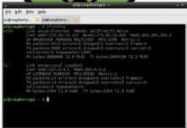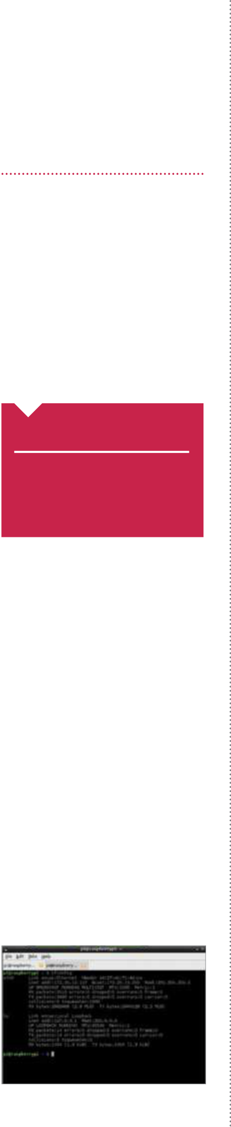

|  |  |
| --- | --- |
| **Projects**  What you’ll need…  **Any Raspberry Pi distro**  www.raspberrypi.org/downloads  **Internet connection**  **Second computer** | Access your files with SSH  Access your files with SSH |

Use the terminal of your home computer to gain quick and secure access to your Raspberry Pi

|  |  |
| --- | --- |
| **Did you know…**  SSH is the most secure  method of accessing any machine remotely. It’s also quicker than VNC. | While remotely logging into the full X environment is – as we demonstrated on the previous pages – very useful, it has its  disadvantages. Firstly, it’s not particularly quick or convenient to do. The user experience can be slow and cumbersome too, but worst of all, it’s not as secure as we’d really like. |

If you want to take a more convenient and secure approach to accessing your Raspberry Pi from another computer, you’ll fnd that all well-versed Pi enthusiasts will use SSH. SSH stands for Secure Shell and is a cryptographic network protocol which is designed to ensure secure data communication via the command line.

While beginners might argue it’s easier to remotely access their Raspberry Pi using the full graphical interface, as soon as you’ve learnt a handful of basic command-line techniques you’ll quickly fnd ‘dipping in’ to your Raspberry Pi via SSH is by far the most convenient way to talk to it remotely.

You’ll be pleased to hear that SSH is already well confgured out of the box – there’s very little you need to do to make it work, especially if your remote computer runs Linux or OS X, as we’re going to demonstrate here.

SSH is easy with Linux and OS X   
Assuming your Raspberry Pi is on and connected to a network either by Ethernet or a Wi-Fi dongle, the only piece of information you need is the IP address of your Pi. To discover this, all you have to do is open a terminal window on your Raspberry Pi and type the command ifconfig (Fig 1).

If you’re connected by Ethernet cable you’ll see ‘eth0’, then

|  |  |
| --- | --- |
| **Fig 1:** Use the ifconfig command in the terminal to discover the IP address of your Raspberry Pi | several lines of results. The IP address will be the number on the second line next to words ‘inet addr’. If you’re connected by Wi-Fi, |

|  |
| --- |
| **50** |

|  |  |
| --- | --- |
| Access your files with SSH  the result will be on the second line of ‘wlan0’. The IP address itself is a group of four numbers separated by full stops. If you’re on your home network, it will likely be similar to 192.168.0.15. We’ll use this number for our guide, but replace it with the IP address you’ve seen via ifconf g.  With this information in hand, all you need to do is open a terminal window on your remote Linux PC and type:  ssh pi@192.168.0.15   This assumes your Raspberry Pi’s username is still the default (which is pi) and you’re replacing the IP address with the one you | **Projects**    SSH with Windows  As is the way with most things in the Windows world, accessing your Raspberry Pi with Microsoft’s operating system isn’t quite as  straightforward as you’d think.  Fortunately, there is a useful tool to help. Putty allows you to make your Secure Shell connection and it’s easy to set up and use. You can download Putty from:  www.chiark.greenend.org.uk/ ~sgtatham/putty |
| made note of just now. If you’ve added user accounts or changed the default, you’ll need to replace the username before the ‘@’ with whatever you’ve changed it to. When you press Enter, you’ll be prompted to enter the password for your Raspberry Pi – again, if it’s the default you can type raspberry, otherwise type in your Pi’s password and press Return.  You’ll now see that the username details on the command line have changed to ref ect those of your Raspberry Pi – you’re now connected remotely. Try looking through your f les or using nano to open a f le to edit it! |

Never type another IP address   
Of course, if you take your Raspberry Pi to another network, your Pi’s IP address will be dif erent. If you just want to connect to it remotely, it becomes incredibly tiresome to set up your Pi with a keyboard, mouse and monitor just to get the IP address. Wouldn’t it be easier if you could just type the Raspberry Pi’s name into the terminal to connect? It sounds too good to be true, but it’s actually very easy to do.

All you need is a small piece of software which ef ectively lets you discover hosts and services on your local network by name instead of IP address (Fig 2). To set it up on your Pi all you need to

|  |  |
| --- | --- |
| do is open a terminal and type:  sudo apt-get install avahi-daemon   Once the installation is complete, all you have to do to access your Raspberry Pi via SSH is type the following into the terminal: ssh pi@raspberrypi.local   What’s more, you can use the name of your Raspberry Pi when you access it via any other form of networking, be it Samba, remote login with VNC or anything else! | **Fig 2:** The Avahi tool enables you to log into your Pi via SSH by name, rather than needing to discover its IP address |

|  |
| --- |
| **51** |

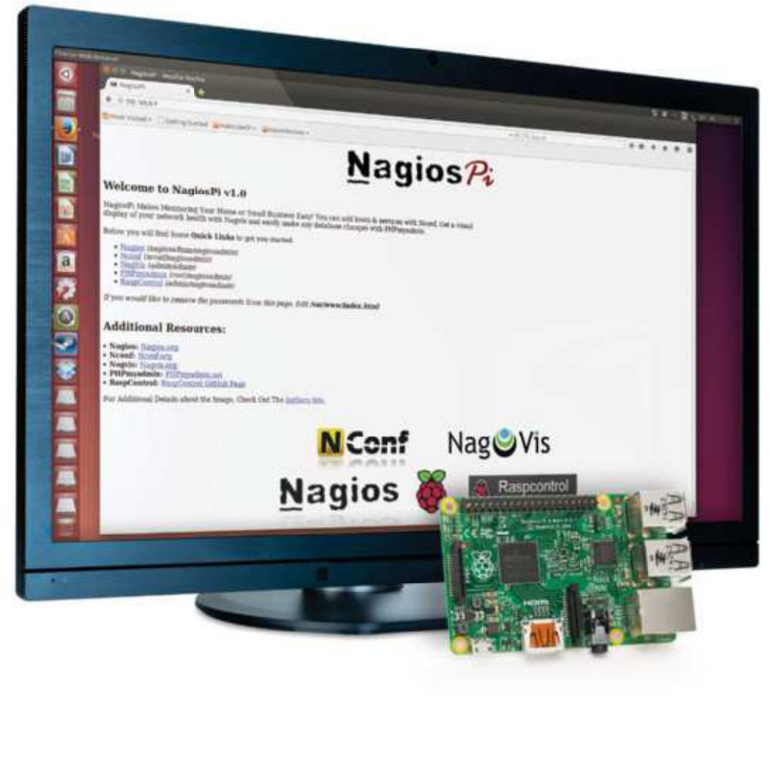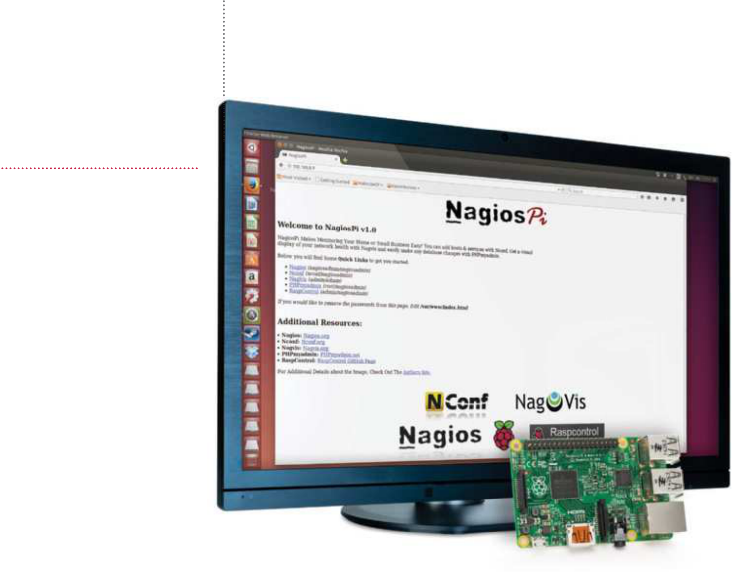

**Projects**  Monitor your local network with NagiosPi

What you’ll need…

**NagiosPi**   
piimagehub.com/project/nagiospi

**Win32 Disk Imager**   
bit.ly/L8JdYG

**Disk Utility**   
bit.ly/1Lec9r5

**Internet connection**   
**4 GB (or larger) SD card**

Monitor your local   
network with NagiosPi

Embrace the power of Nagios to keep an eye on servers, switches and applications on your network

Is your PC of ine? Has your Linux box stopped serving Minecraft or Counter-Strike? If you’re out of the house, or even the country, there is no real way of knowing without trying to log in – something you probably won’t be able to do without being on the premises (unless you’re using remote desktop software).

A far better way would be to simply receive notif cations when your network devices are knocked of ine, and this is why we turn to NagiosPi, a Raspberry Pi-built version of the popular open source network monitoring tool.

NagiosPi is available as a full image ready to be written to SD card, with the real conf guration taking place once it’s up and running. Let’s get started.

|  |
| --- |
| **52** |

|  |  |  |  |
| --- | --- | --- | --- |
| Monitor your local network with NagiosPi | | | **Projects** |
| Download NagiosPi |  | | |
| **01** the extracted contents   Windows users should write  of the NagiosPi_v2.0.zip file to a formatted SD card using Win32 Disk Imager. Linux desktop  users can use Disk Utility or the command line (bit.ly/1z36sp8).  With the image written to SD, safely eject the card and insert it into your Pi before booting.  Log in to NagiosPi |
| **02** you’ll probably want to As with most Pi projects,  operate via SSH, so check your |
| router’s list of connected devices | | Monitor your NagiosPi box |  |
| to find the IP address and connect. | |
| You can also use a keyboard | | **05** you’ll get a flavour of just In the RaspControl section  what Nagios can do. On the home |
| and monitor connected to your | |
| Raspberry Pi. The default username | |
| and password for NagiosPi is pi/ | |
| raspberry. | | screen you’ll see general hardware |
| Expand the filesystem | | information such as connectivity and |
| system status, and as you flick through |
| Details, Services and Disks you’ll see |
| **03** sudo raspi-config. You’ll Before proceeding, run  need to select the first option, | what level of monitoring is possible. | | Create configuration file |
| View host status | | **08** individually. Some require the Each check must be set up  installation of NRPE (Nagios Remote |
| Expand Filesystem, and wait | **06** Hosts. Here you will see the Next, go to Nagios and pick  current status for the configured | |
| a moment as the filesystem is |
| expanded to the full size of the |
| Plugin Executor) on remote devices |
| SD card. |
| to interrogate and present full system |
| Once done, select Change User | hosts, which is a combination of | |
| details, but this isn’t necessary for basic |
| Password to add some security to | items detected on your local network | |
| things like ping. |
| your NagiosPi, then select Finish | and preset entities. Look for Current | |
| When you’re done, click Submit, |
| and reboot. | Network Status in the upper-left area | |
| then Generate Nagios Config. |
| of the console, just below this you will | |
| Following this, select Deploy. |
| Open in your browser | find alternate views. | |
| Monitor your server |
| **04** you’ll be able to open With the Pi rebooted,  the NagiosPi web console in your | Add a host to monitor | |
| **07** you wish to monitor, using Open NConf to add the server  the ‘Hosts – Add’ button to input the | | **09** Services for a view of currently In the NagiosPi window, select  monitored servers and devices. |
| browser. Visit http://[your.IP.address. |
| here] to see the available options. | For each listed device, there will be |
| Here you’ll spot a menu of | | device hostname, IP address and alias. | additional information that you drill |
| links in the top-left corner, each | | Click Submit when done, then switch | down into by clicking Actions. We’ve |
| accompanied with the username | | to ‘Services – Add’, where you can | only shown you the basics of NagiosPi |
| and password to sign in. Start with | | assign a name and check command | – investigation will demonstrate just |
| RaspControl. | | (such as check_ping) to monitor. | how powerful it really is! |

|  |
| --- |
| **53** |

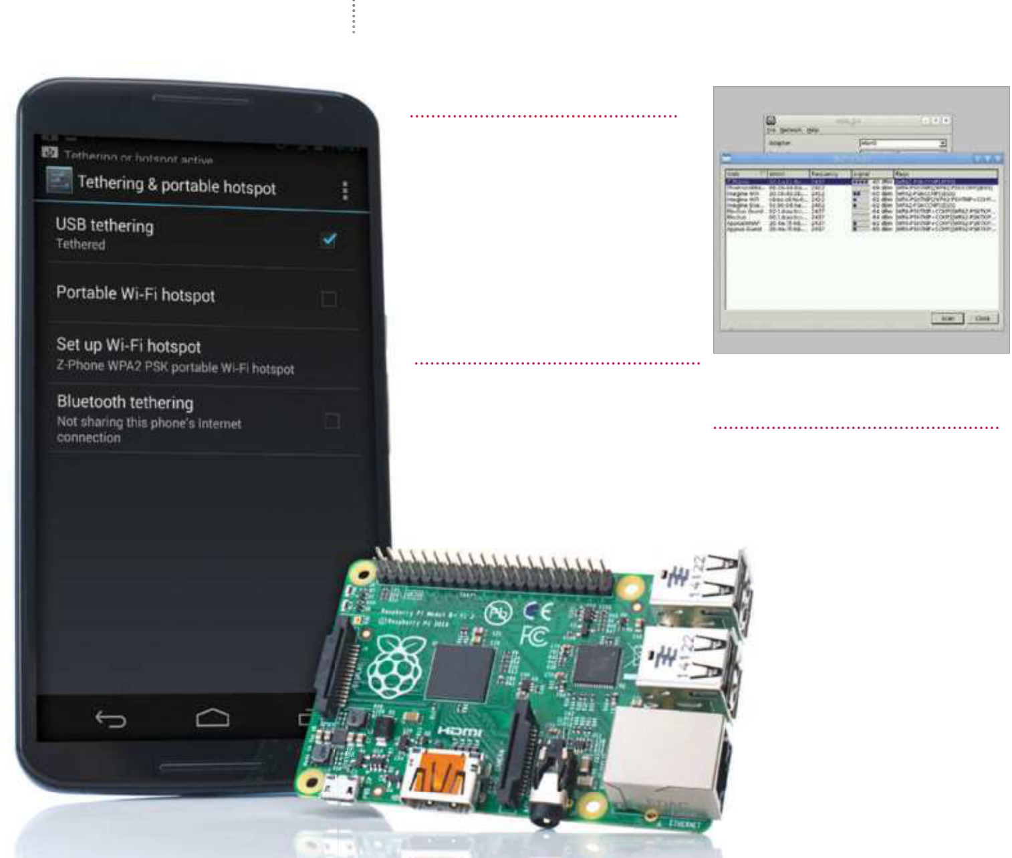

|  |  |
| --- | --- |
| **Projects**  What you’ll need…  **Android device**  **USB cable** | Tether to an Android device  Tether to an  Android device |

Need the internet on your Pi? Try out a physical tether to your Android device for online access

The portability of the Raspberry Pi is one of its most lauded features. Mini screens, mini wireless keyboard and mouse combos, portable batteries and more can get you out and about, but the internet is a stumbling block that you can’t easily f x with an accessory. What you do also usually have with you is an Internet-connected magic pocket box called a smartphone that, with a bit of know-how, you can connect the Pi to and steal some internet from. Over the next two pages we will impart this know-how to get you using your Raspberry Pi on the Internet when you’re on the go.

|  |  |
| --- | --- |
| The easy way  **01** Wi-Fi hotspot feature, which Many smartphones have a  your Pi can easily attach to. First of all, turn the hotspot on and then boot into the Pi. Connect a wireless dongle and open up the wpa_gui in Preferences>Wi-Fi Configuration.  Scan for device |  |
| |  | | --- | |  | |
| |  |  | | --- | --- | | **02** | Click Scan to open up the scan window and then | | Set up tether  **03** your Raspberry Pi via a USB First connect your phone to  cable – depending on the amount of power your Pi has, it might have trouble charging your phone but it |
| select Scan again from inside there.  It should pick up your device –  connect it as you would to any Wi-Fi network and the Pi will remember it for when it needs it next. |

will still let you tether. In the   
tethering menu you can now   
activate USB tethering.

|  |  |
| --- | --- |
| Tether to an Android device | **Projects** |
|  | “What you do also usually have with you is an internet-connected magic pocket box called a smartphone  that you can  connect the Pi” |
| Check connection | Quick connect |
| **04** Raspberry Pi. You can check to make sure this is happening, and that it will Your Android device will create an interface known as eth0 on the  let you tether, by opening up a terminal and typing the following:  $ ifconfig | **05** terminal right now to access You can connect from the  the Internet. You should be able to  do this by typing the following into |

the terminal:

|  |  |
| --- | --- |
| Test connection  **06** and ping www.google.com, which you can do, or you can click on the There’s a few ways to test your connection. We’d usually stay in the terminal  browser and see if it loads the page. | $ sudo dhclient usb0  This will automatically grab any |
| available IP address that your phone will give to it.  Save the settings |
|  | **07** Raspberry Pi, it won’t Once you reboot your  remember to automatically connect to the phone’s tether. However, we can add an entry to its config so that it will try and do this in the future. From the terminal use:  $ sudo nano /etc/network/ interfaces  Tether on the go |
| Interface settings  **08** from ours depending on if you have added any fixed wireless settings or Here you’ll find all the current network settings – yours might look different  passthroughs. Using the same syntax as the eth0 line, add: | **09** Pi should now automatically After a save and reboot, your  connect to your phone, whether |
| it’s via Wi-Fi hotspot or a physical  connection. It may draw a little more charge than usual while tethering, so be sure to keep an eye on your |
| iface usb0 inet dhcp | battery level. |

|  |
| --- |
| **55** |



|  |  |
| --- | --- |
| **Projects**  What you’ll need…  **Raspbian**  www.raspberrypi.org/downloads  **Internet connection** | Share your files with Samba  Share your files with Samba |

Confgure your Pi to share the contents of the home folder over your home network

Regardless of whether you plan to set your Raspberry Pi up as a

|  |  |
| --- | --- |
| **Did you know…**  You can network with other Linux, Windows and Mac OS X computers with Samba – it’s totally cross-platform. | media centre, gaming machine or full-on development platform, the ability to share and access the contents of your Pi from other machines is very useful.  While the Raspberry Pi is very well confgured, by default it |

doesn’t include the ability to share the contents of your home folder with your local network. As you’ll see from this guide, though, it’s not too difcult to accomplish thanks to Samba and it can help you access your scripts, media or documents from any other machine.

|  |  |  |  |
| --- | --- | --- | --- |
|  | | | changes and additions to make.  Firstly, you need to make sure you  have assigned the correct workgroup.  Unless your network has been  configured differently, it will likely be |
| Update and install Samba | Load smb.conf | |
| **01** and type the following into Open a terminal window  the terminal to update the Raspbian | **02** installed, you now need to With the core packages  tell Samba how you want it to work. | | called WORKGROUP.  To find the workgroup setting, press Ctrl+W and type ‘workgroup’ then press Enter – this will take you to the first occurrence of the word |
| repository and then install Samba: | You do this by putting your preferred | |
| sudo apt-get update && sudo | settings in Samba’s configuration file. | |
| ‘workgroup’. Use the arrow keys to move between lines – the mouse doesn’t work in nano.  Windows support |
| apt-get install samba samba- | This file is called smb.conf and it’s | |
| common-bin | located in the /etc/samba folder. | |
| The operation itself shouldn’t take | While it’s easy to locate it using | |
| too long. Just make sure that you’re | the file manager, it’s easiest to open | |
| connected to the internet before | and edit it from the command line. | |
| **04** computers in your network, If you have Windows  you’ll need to ensure WINS support is allowed. Assuming you’re working from the default samba.conf  configuration file, you’ll find the flag |
| you start. | Type the following into the terminal | |
|  | | window to open it with nano:  sudo nano /etc/samba/smb.conf  Initial setup  **03** There’s lots of information Take a look through the file.  here and it seems a bit daunting, but there are only a handful of |
| for WINS support a few lines below the workgroup line. Edit it so it looks like this:  wins support = yes |

|  |
| --- |
| **56** |

|  |  |
| --- | --- |
| Share your files with Samba | **Projects** |

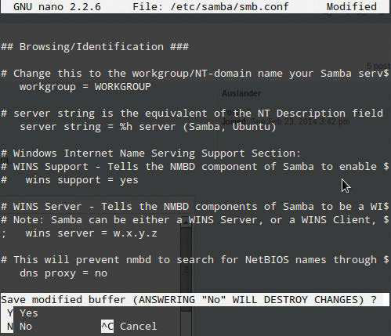

|  |  |  |
| --- | --- | --- |
| Add your share | create mask = 0777 | You’ll be prompted to enter and |
|  | confirm a new password. This is now |
| **05** section of the file called Share Next you need to find the  Definitions. Again, you can use the | director mask = 0777 |  |
| public = no | your username and password for |
| accessing your files. |
| Set up passwords |
| Restart Samba |
| key combination Ctrl+W to open |
| the search function, then type ‘share | **06** samba.conf file now. So, to You have finished editing the  save and exit, press Ctrl+X, then press | **07** restart Samba for your new The final step is simply to  settings to take effect. |
| definitions’ and press Enter to be taken |
| directly to it – it’s located right towards |
| the end of the document. |
| Go to the very end of the | Y to save, and Enter to exit. | At the terminal, type the following |
| document and add the following: | With this configuration, a layer | command to do so: |
| of password security is in place, |  |
| [pi] |  | sudo /etc/init.d/samba |
| so we now need to set up a |
| restart |
|  |
| path=/home/pi | Samba password to use with it. In | The next time you look at your |
|  |
| only guest = no | your terminal window, type the | home network from another machine, |
|  |  |
| browseable = yes | following command: | you’ll see your Raspberry Pi’s home |
| writeable = yes | smbpasswd -a pi |
| folder listed as a share. |

|  |
| --- |
| **57** |

|  |  |
| --- | --- |
| **Projects**  What you’ll need…  **LibreOffice**  Installed through tutorial using apt-get | Turn your Pi into an office suite |
| Turn your Pi into an office suite |

How to add a full, free ofce suite to your Raspberry Pi to turn it into the smallest home ofce ever

You can’t get far with a computer if you don’t have tools that cater for things like letter writing, spreadsheets and presentations. Thankfully this is well within the scope of the Raspberry Pi’s capabilities and, although Raspbian comes bundled with a couple of text editors, sometimes you need the extra functionality a full ofce suite can ofer. This is really easy on the Pi and the best option available is open source and thus completely free: LibreOfce.

LibreOfce is a fully featured Microsoft Ofce drop-in   
replacement and the Raspberry Pi will handle it well so long as you’re not creating huge documents with hundreds of images. You’ll need a working internet connection for this tutorial, so make sure your LAN cable or wireless dongle is plugged in and functional, because we’ll be using the built-in package manager. Installation does take some time, though.

|  |  |  |
| --- | --- | --- |
| **Presentations** | **Drawing** | Install LibreOffice |
| A really impressive piece of kit, it allows | Not artistic drawing as you might think, |

|  |  |  |
| --- | --- | --- |
| creation of presentations in just a few | | but a great application for creating quick, |
| simple clicks | good-looking flow-and-process diagrams | |
| |  |  | | --- | --- | |  |  | |  |  | |  |  |      |  |  | | --- | --- | |  |  | |  |  | | | |
| **Word processing** | **Spreadsheets** | |
| LibreOffice comes with a great word- | Also bundled is a spreadsheet application | |
| processing application that works | – its ability to read any popular spreadsheet | |
| brilliantly on the Pi with no hassle | file format makes it very powerful | |

|  |
| --- |
| **58** |

**01** software any time (so long **Y**ou can install open-source

as you have an internet connection or installation medium) at your total convenience – without having to   
worry about handing over payment details. So, let’s get right on with doing exactly that. Open your terminal –   
you can do this by double-clicking   
LXTerminal from your desktop. Install the LibreOffice office suit by using the package manager:

sudo apt-get install   
libreoffice   
Now type in your password. Press ‘Y’ and Enter when prompted to install other dependency packages. Now sit back, relax or make some tea!

|  |  |  |  |
| --- | --- | --- | --- |
| Turn your Pi into an office suite | | | **Projects**  Help yourself by using comments  **07** document you’ll often think When writing a long  of things that you should really check up on or add to the document later. When you think of these things, you can make notes about them using ‘Comments’ – even more useful when there are multiple people moving  through the document. Comments |
| Explore the suite | correct section within your document. To create your index, create some | |
| **02** LibreOffice, you can admire When you’ve installed  your new applications by hitting the | space at the top of your document, | |
| and then insert your index by using the menus to go to ’Insert Indexes and | |
| system menu. You’ll see a new ‘Office’ | Tables>Indexes and Tables’. Review | |
| category, underneath which you’ll see | the selected options and click OK | |
| the following applications: | when you’re happy. It’ll insert to the | |
| **LibreOffice Base** – A database | section of the document that your | |
| management application. | cursor is on. | |
| **LibreOffice Calc** – Spreadsheets. **LibreOffice Draw** – To make | What about images? | |
| flowchart/visualisations.  **LibreOffice Impress** – For creating presentations.  **LibreOffice Writer** – The word | **05** brighten up a document than There’s no better way to  with carefully chosen imagery. This | |
| can be added at the current point in the document with Ctrl+Alt+C or by using the menu option Insert> Comment. If you want to get rid of the extra ‘Comments’ pane, you can use the View menu to toggle it.    Linking out to the world  **08** resources in a document If you’ve used outside  that you want to reference, or maybe you don’t directly need to include all the information – it might be handy to have a way of getting back to  that document later on. You could include an Appendix of information at the end of your document that links to these other resources. You can hyperlink to these easily using the Hyperlink toolbar button or the same from the Insert>Hyperlink  menu. Select your text, then click it and you’ll be presented with a dialog to link to one of the appropriate  places. It’s important to note that  direct document links use full system paths. If it’s being sent to someone else, avoid using these as they’ll break for the reader. Ideally use it only a  personal reference guide on your  own machine. |
| processor, which is very similar to Word. | can be achieved with relative ease too. | |
| Most of these applications are able to | There are a couple of solutions | |
| open a majority of documents created | | – the easiest of which is to drag |
| in Microsoft’s Office counterparts and | an image in from the file manager | |
| are almost as feature rich. | directly into the document. Assuming | |
| the image is on your desktop, simply | | |
| Add some style | drag the file into LibreOffice Writer and you will see the icon change; upon | |
| **03** word-processing features on We’re focusing on some of the  the Pi specifically here, so go on ahead | letting go, your image will appear roughly where you dropped it.   Alternatively, you can use the | |
| and open up LibreOffice Writer. When | Insert>Picture>From File option. | |
| you’re writing documents, it’s usually | | |
| the formatting where people stumble. When you start writing, to the left of | Export as a PDF | |
| the font drop-down menu there’s another drop-down that currently reads ‘Default’. Select some text, then | **06** common way of exchanging The PDF format is a very  documents – mainly because in | |
| use this drop-down to change the | its simplest form, it’s an easy way | |
| current applied style. If you don’t like | of stopping accidental changes or | |
| the defaults, select ‘More’ from the | modifications to a document. It’s | |
| drop-down, or press F11. This will allow | | also easy to set passwords on PDFs |
| you to customise the styles and more. | and stop purposeful modifications | |
| to them. | | |
| Add an index | The main advantage of PDFs, | |
| however, is that you don’t really need | | |
| **04** using formatting is that it   One of the great things about  allows you to create a contents page | to worry about the recipient having a specific application to view them with. Most modern operating systems have | |
| for your work easily. So long as you use | some sort of PDF viewer built in so you | |
| consistent headings for the different | can be sure of a consistent experience. | |
| levels of your document, it’s a quick | With LibreOffice, this is easy. You | |
| and easy way to give a guide to what’s | can save your document as a PDF | |
| in your document. Another advantage | using the File>Export to PDF menu | |
| is that if you export the file to PDF, | option. Simply choose your desired | |
| you’ll end up with each heading in | options, click Export and save it in the | |
| the contents, hotlinking directly to the | appropriate place. | |

|  |
| --- |
| **59** |



|  |  |
| --- | --- |
| **Projects**  What you’ll need…  **Scratch**  **Internet connection** | Program with Scratch  Program  with Scratch |

An interactive guide to coding with the Pi’s graphical programming language

|  |  |
| --- | --- |
| **Did you know…**  The website for Scratch, **www. scratch.mit.edu**, contains lots of programs and games other users have made. | Would you like to delve into the world of animation and game creation? Do you want to bring your creative ideas to life without learning a software-development language? With Scratch you can do all this, and much more.  Scratch 1.4 is already installed on the of cial ’wheezy’ Raspbian |

operating system image. If your Raspberry Pi doesn’t already have Scratch installed, don’t worry, just hop on over to the of cial MIT Scratch website to f nd the download and install instructions.

To begin, all we need to do is open the Scratch Studio. Click on Scratch’s cat icon on the desktop, or f nd Scratch in the LXDE desktop menu.

The Scratch Studio is a complete development environment. It’s divided up into a number of separate panels. Each panel has a specif c role in the app-construction process and its own specif c set of features and tools.

Scratch studio projects

|  |  |  |
| --- | --- | --- |
|  | | |
| **01** are three quick-access icons   Located at the top of the Studio  and the main menu (Fig 2). | provides access to the browser-hosted | and the ’Upload To Scratch Server’ |
| help pages. | form (Fig 3). |
| Rather interestingly, the ’Share’ | Let’s load the ’Aquarium’ example |
| The first globe-style icon sets the | menu allows us to share our projects | project. Select the ’Open…’ option in |
| language for the Studio. The other two | with the whole world. Any Scratch | the ’File’ menu to display the Open |
| buttons provide rapid access to the | project can be posted onto the | Project dialog. From the list of large |
| project save and share features. | Scratch community website via the | buttons on the left, click on the |
| Under the ’File’ menu there’s | ‘Share This Project Online…’ option | one called ’Examples’. Next, on the |
| a typical set of file-management |  | right, select the ’Animation’ folder |
| features to open, save and import | with a double click. Then select the |
| Scratch projects. There is also a | ’6 Aquarium’ item. The open dialog |
| ’Project Notes’ option where we are | window contents should look like the |
| able to enter feature descriptions | one in Fig 4. |
| and comments. | With the Aquarium project loaded |
| The ’Edit’ menu contains a mixed | our Scratch Studio should look similar |
| bag of animation, image and audio- | to Fig 1. We’ll begin our Studio tour |
| editing tools. While the ’Help’ section | with the staging area. |

|  |
| --- |
| **60** |

|  |  |  |  |
| --- | --- | --- | --- |
| Program with Scratch | | | **Projects** |
|  | | | **Fig 3:** Project Share Dialog – We can share our projects using the Studio’s Share menu |
| **Fig 4:** File Open Dialog – Use the Studio’s File | | | |
| **Fig 2:** Scratch Studio Menu – Scratch Studio’s main menu and shortcut icons in action | | | menu and ’Open…’ to load the Aquarium project |
| Scratch studio stage | | Scratch studio sprites | |
| **02** action takes place and is The stage is where all the  located at the upper right of the | | **03**’Stage’ sprite is separated from the rest. It’s a little different to the others Beneath the Staging Area is the collection of sprites for this project. The  and acts as the background image for the stage. | |
| Scratch Studio. | | The three buttons across the top of this area offer various ways to create a | |
| The stage is constructed from | | new sprite. The first button opens up a blank canvas in the Paint Editor. The | |
| graphical elements called sprites. | | second button creates a new sprite based in an image file, as selected by the | |
| Here we have plants, bubbles, fish | | popup file section dialog window. The third will select a random image from the | |
| and other creatures. You can also | | pre-installed image collection. | |
| add and create your own assets with | | We can manage sprites directly from the stage using the four buttons to the | |
| scratch, but we’ll come to that later. | | right of the main menu. Here we click on a particular button and then a sprite | |
| At the top of the ’Staging Area’ | | on the stage. | |
| there’s a green flag and a red circle.  Click on the green flag to bring  the aquarium to life. Now spend a little time studying the Aquarium animation. Note the creature’s  movements and rising bubbles. The red circle icon stops the action.  We can set the view mode with the three buttons located just  above the green flag.  The two left-hand buttons  increase or decrease the size of  the Staging Area panel. A smaller Staging Area means the central area of the Studio increases in relative size compared.  The right-hand button is the Presentation Mode which displays the stage in full-screen mode (see Fig 5). Exit presentation mode with the curly arrow button at the top |  | | |
| left, or press the ’esc’ key. | | **Fig 5:** Stage Presentation Mode – The Studio’s stage presentation mode is the best way to see the project | |

|  |
| --- |
| **61** |

|  |  |
| --- | --- |
| **Projects** | Program with Scratch |

Use Scratch blocks and tools Getting to grips with the Scratch Studio toolbox

Situated in the centre of the Studio is the Edit Panel. The panel contents relate to the currently selected sprite.

Let’s start by selecting the jelly f sh sprite, called Creature1, from the Sprite Collection area.

At the top we have the sprite’s image and name, plus an   
indication of its current stage coordinates and direction. On the left are three animation control buttons. The top button will rotate the sprite, the second switches between left- and right-facing states, and the third turns animation of .

Below are three Edit Panel tabs. The script tab is where block scripts are created. Here’s where we’ll drag and drop our blocks, snapping them together in various combinations.

To change a sprite’s visual appearance we’ll use the ‘Costumes’ tab. Each sprite can have one or more costumes. For example, the jellyf sh has two costumes (Fig 1). Each costume has buttons to edit, copy and delete. New costumes can be painted, imported or captured using the three ’New Costumes’ buttons. The sound tab allows us to add audio to our project.

Scratch Block Styles

**01** the complete collection   
 The ’Blocks Palette’ contains

of scripting blocks. Blocks come in three basic styles, namely hats, stacks and reporters (see Fig 3 on the opposite page).

A hat-style block will start block script execution based on a specific event. The classic hat block is the   
’green flag’ click event. However,   
there are numerous other hat blocks, including hat blocks that start script execution after a specific key press, a mouse click and even following sensor event from the some GPIO connected hardware. As you can   
probably tell, this offers a lot of   
options to Scratch programmers.

Reporter blocks allow us to   
specify textual, numeric and boolean values. They fit into specific shaped ’holes’ in other blocks. A rectangular reporter will contain a text string.

While the rounded end reporters are associated with numeric values,

|  |  |
| --- | --- |
|  | angle-ended reporters contain boolean true and false values.  Stack blocks are the core  script building elements. They  interconnect with other blocks via their top-edge notches and bottom-edge bumps. Many stack blocks contain ’holes’ for reporter style blocks, which will modify their operation depending on the specified reporter block values.  The Scratch block collection is divided into groups. We select a  block group using the eight buttons located at the top of the Block  Palette panel, namely ’Motion’,  Control’, ’Looks’ and so on. These groups are colour coded. Apart from aiding block selection this colour coding provides a visual clue to a block’s type when reading a block |

**Fig 1:** Jellyfish Sprite Costumes – The jellyfish sprite has two different costumes

|  |
| --- |
| **62** |

script in the Edit Panel.

|  |  |
| --- | --- |
| Program with Scratch | **Projects** |

**Did you know…**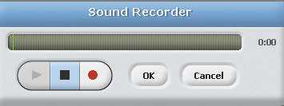

There is more thanone option   
available to start your scripts   
beyond the standard Green   
Flag block.

Block Script Walkthrough **Fig 2:** Sound Recorder Tool – Scratch Studio includes a tool to record our own sounds

|  |  |
| --- | --- |
| Scratch Block Help  **02** functionality and capabilities.  As we’ve seen, there are many blocks, each with their own specific  In one way this is great news. A large block collection means Scratch can be used in a vast range of software projects, such as games, animation, music, graphics, math, science, robotics, electronics and much more.  However, the wide selection of blocks can be quite a challenge for the novice Scratch coder. To help with this problem the Scratch Studio designers have included an informative set of block-centric help pages.  A simple right click on any block will display a pop-up help page option. The help page contains context-specific descriptions, graphical images and, where appropriate, a script example of how to use this particular block (Fig 4).  It’s a terrific feature which greatly simplifies the process of deciding which blocks to use. More importantly, studying these help pages is a highly effective way to enhance our scripting skills and discover the potential contained within Scratch’s feature-rich block collection.    **Fig 3:** Block Style Examples – the Scratch blocks come in a number of different styles | **03** a block script works in   Let’s dig deeper into how  practice. For this, we will use a |
| simple Aquarium project block script. From the ’Sprite Collection’ panel select the Stage sprite. Then go back to the central ’Edit Panel’ and select the ’Scripts’ tab.  There’s just a single block script.  Starting at the top there’s a ’green flag’ hat-style block to kick off the activity. Next there’s a ’forever  loop’. The blocks inside this loop are actioned until the stop button is pressed. This forever loop block contains two other blocks.  The first inner script block selects the next background image. Click on the ’Backgrounds’ tab to view all the stage images. The second inner block simply pauses execution for a number of seconds. Setting the value to ’1’ means that this script  will pause for a second before then performing the action specified by the next block.  It’s important that you remember these two blocks are enclosed in  the forever loop block. So, the stage background images will be displayed in sequence for one second each.    **Fig 4:** Block Help Window – Example of the help window associated with an ’ask and wait’ block |

|  |
| --- |
| **63** |

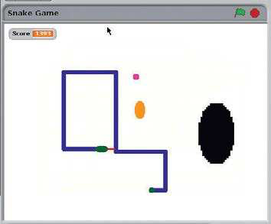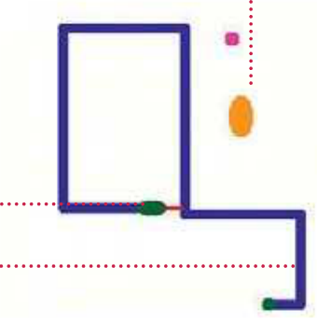

|  |  |
| --- | --- |
| **Projects**  What you’ll need…  **Scratch project archives**  www.scratch.mit.edu/explore/?date=ever | Create a Snake clone in Scratch  Create a Snake clone in Scratch |

Design your own version of Snake to test your new programming skills!

Here, we will create a version of the classic Snake game where you

|  |  |
| --- | --- |
| **Did you know…**  Snake is a very popular  beginner game that started life in the arcades in the Seventies and is still popular today. | move the snake around the Scratch stage using the arrow keys. You control the head of the snake and must avoid a collision with either the body of the snake or the edge of the stage.  The snake body grows longer each time you eat an egg. You get points added to your score for eating good yellow eggs and lose |

points for eating bad black eggs. There are also bonus sprites to eat for extra points.

By following this tutorial you will learn to create your own simple sprite graphics, send and receive broadcast events, use a list variable to store data, play sound efects, generate random numbers and use sensing commands to detect when a sprite is touching something.

**Egg sprite**   
The Egg sprite appears randomly on the screen and lets other sprites know when it has been eaten (touched by the snake tongue)

|  |  |  |  |  |  |  |  |  |  |  |  |  |  |
| --- | --- | --- | --- | --- | --- | --- | --- | --- | --- | --- | --- | --- | --- |
| It also detects  collisions with the  body or edge   |  |  | | --- | --- | |  |  | |  |  | |  |  |  |  |  | | --- | --- | --- | |  |  | | |  | | |   **Snake sprite**  The Snake sprite  moves the head  around the stage  and draws the  body behind it. | | |
| **Tail sprite** | **Bad Egg sprite** | |
| The Tail sprite follows the head, erasing the end | | The Bad Egg sprite also appears randomly |
| of the body so the snake moves, and pausing | | but decreases the score when eaten. It also |
| when it needs to grow | | grows in size, getting harder to avoid |

|  |
| --- |
| **64** |

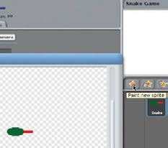

Paint the Snake sprite

**01** icon to paint the Snake sprite. Click the New Sprite: Paintbrush

In the Paint Editor, draw a small   
green ellipse for the snake head and add a red rectangle for the tongue.

It’s important that the tongue is a different colour to the head. Name your sprite Snake.

|  |  |  |  |
| --- | --- | --- | --- |
| Create a Snake clone in Scratch | | | **Projects** |
| Add a Snake sound | Initialise Snake variables | | Add main action loop |
| **02** touches the snake body or When the Snake tongue  the edge of the stage, we are going | **05** Control command and initialise Use a ’when green flag clicked’  the Snake variables as shown, using | | **07** an ’if-else’ command nested Use a ’forever’ command with  inside. We have a collision if the red |
| to play a Game Over sound. We need | commands from the Variables palette. | | tongue is touching the blue body (the |
| to add this sound to the Snake sprite. | We want to start each game with an | | head is always touching the body) or |
| With the Snake sprite selected, click | empty Next Direction list, so delete all | | the Snake sprite is touching the edge. |
| the Sound tab and choose Import. | of its entries. The Score must start at | | Use the Eyedropper tool to select |
| Select the Electronic>Screech sound. | zero. The Speed sets difficulty. | | colours within Scratch. |
|  | |  | | --- | |  | | | |  | | --- | |  | |
| Respond to arrow keys | Draw Snake body | |
| **03** commands from the Control Drag four when key pressed  palette, and four point in direction | **06** palette to control the drawing Use commands from the Pen  of the snake body. You should also use | | Handle Game Over |
| commands from the Motion palette. | commands from the Motion palette | | **08** detected, broadcast a Game When a collision has been  Over event (you’ll need to create a |
| Configure them as shown so that the | to move the snake to the centre of the | |
| up arrow changes the direction to | stage and point left at the beginning | |
| 0 degrees (up) and so on. Click the | of each game. The pen is up until the | | new event) to the other sprites so they |
| green flag above the stage to test this. | snake is in the starting position. In the | | can also react. Also, play the Screech |
| |  | | --- | |  |   Make Snake variables  **04** Make two variables, Score and Click on the Variables palette.  Speed, that are visible to all sprites.  Make a list called Next Direction which is visible to all sprites; it will store the sequence of directions that the head takes. Only have the Score variable  checked so it appears on the stage. | | next steps we’ll use colours to check | sound effect and stop all scripts so |
| to see if the head is touching anything | that the snake freezes in its current |
| it shouldn’t. | position at the end of the game. |
| |  | | --- | |  | | |

|  |
| --- |
| **65** |

|  |  |  |  |
| --- | --- | --- | --- |
| **Projects**  Handle movement | Create a Snake clone in Scratch | | |
| Make a Grow variable | Grow and move | |
| **09** where there is no collision and Now handle the typical case  the snake must move in its current direction. The pen is down so it will draw the body. The Speed variable determines how many steps to move. Add the current direction to the Next Direction list for the tail to read. | **12** for this sprite only – no other Make a Grow variable which is  sprites need access to it. The Grow | **15** keep the tail moving. If Grow Use a ’forever’ command to  is 1 it should pause and reset Grow to | |
| variable is used to determine when | 0 – this makes the body grow longer. | |
| the snake body needs to grow and | Use the first value from Next Direction | |
| the tail therefore needs to pause | to set the direction and remove it so | |
| before following to allow the head to | you get a new value next time. Move | |
| get further ahead. | Speed steps. | |
| Handle events | |  |
|  |
|  |
| Try out the snake | **13** new events which you create The Tail needs to listen for two  as you need them. When it receives an Egg Eaten event from one of the Egg sprites, it sets Grow=1 so that the tail can pause. And when it receives | Try out the tail  **16** sprite. The snake won’t keep Now you can try out the Tail  growing yet because it won’t receive | |
| **10** sprite. It will move around   You can now try out your Snake  the screen in response to pressing the arrow keys. It will draw its body, which will just get longer and longer because we need the tail to erase it. And it will screech and end the game on detecting a collision. |
| a Game Over event from the Snake, it | any Egg Eaten events. But the tail will | |
| must freeze. | follow the snake head around the | |
| Initialise the tail  **14** to start the game, Grow is set When the green flag is clicked  to 1 so the snake gets a short body. Move to the centre of the stage with the pen up and configure the pen to draw a trail the same colour and size as the stage background so that it erases the body. | stage, erasing the snake body as it goes by drawing over it with a white pen (which is the same colour as  the background). | |
| Paint the tail  **11** icon to paint the Tail sprite. Draw Click the New Sprite: Paintbrush  a small green circle to represent the end of the tail. Name this sprite Tail.  The Tail sprite will follow the Snake and erase the end of its tail so that the snake body doesn’t grow indefinitely. |

|  |
| --- |
| **66** |

|  |  |  |  |
| --- | --- | --- | --- |
| Create a Snake clone in Scratch | | | **Projects** |
| Paint the Egg sprite | Make Bad Egg | | Grow Bad Egg |
| **17** icon to paint a new sprite. In Click the New Sprite: Paintbrush  the Paint Editor, draw a small yellow | **20** the same way as the Egg Create the black Bad Egg in  but using a different graphic and the | | **21** clicked’ script to the Bad Egg Add another ’when green flag  so it sets its size to the default 100% |
| ellipse. Name the sprite Egg. The Egg | Instruments>StringPluck sound. Drag | | when a new game is started and |
| will appear randomly on the stage and | | the Egg’s green flag scripts onto the | then increases its size by 10 every 10 |
| cause the snake to grow and increase | Bad Egg to copy them – just change | | seconds. The Bad Egg will get bigger |
| its score. | the sound that’s played and reduce | | and bigger and harder to avoid. |
|  | | the score instead of increasing it. | |  | | --- | |  | |
| |  | | --- | |  | |
| Add Egg sound | |
| **18** Egg sprite and import the Go to the Sounds tab for the  Percussion>Cymbal Crash sound. Or you can choose a different sound if you like. This sound will play when the | Create Bonus sprite  **22** sound for the Bonus. Its scripts are similar to the Egg ones so you could Create the Bonus sprite in a similar way. You can choose the shape and  drag one of those to the Bonus sprite and work from that. Make sure you change | | |
| snake eats an egg. | the sound and increase the score by a random bonus. | | |
| Add Egg scripts  **19** the Egg appears randomly Copy the Egg script so that  at the start of the game. When the Egg senses that it has been eaten, it must hide, play the Cymbal sound (or whatever you chose in Step 18), update the score, broadcast the  Egg Eaten event and then randomly appear again. When the Game Over event is received, it must stop. |  | | |

|  |
| --- |
| **67** |

|  |  |
| --- | --- |
| **Projects**  What you’ll need…  **Breadboard**  **LEDs**  **Buttons**  **Resistors**  **Jumper wires**  **ScratchGPIO3** | Get interactive with Scratch |
| Get interactive with Scratch  Experiment with physical computing by using  Scratch to interact with buttons and lights on your Pi |

Scratch is a very simple visual programming language, commonly used to teach basic programming concepts to learners of any age.

In this project we’ll learn how to light up an LED when a button is pressed in Scratch, and then change a character’s colour when a physical button is pressed using the General Purpose Input/   
Output (GPIO) pins on your Raspberry Pi. With these techniques you can make all manner of fun and engaging projects, from musical keyboards to controllers for your Scratch games and animations.

|  |  |
| --- | --- |
| **Below** Scratch can be used to do Internet Of Things projects with a few tweaks | You’ll need some components for this guide. Just search online for ‘Raspberry Pi GPIO basic kit’ to get you started. |

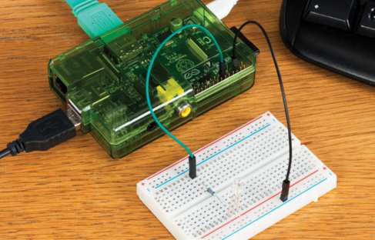

Install the required soft-ware packages

**01** with the username Pi and   
 Log in to the Raspbian system

the password raspberry. Start the LXDE desktop environment using the command startx. Next, open up LXTerminal and then type the following commands:

wget http://liamfraser.co.uk/ lud/install_scratchgpio3.sh

chmod +x install_ scratchgpio3.sh

sudo bash install_ scratchgpio3.sh

This will create a special version

“In this project we’ll learn how to light up an LED when a button is pressed in Scratch using the GPIO pins”

of Scratch on your desktop called   
ScratchGPIO3. This is a normal version of Scratch with a Python script that handles communications between Scratch and the GPIO. ScratchGPIO was created by simplesi

(cymplecy.wordpress.com).

|  |
| --- |
| **68** |

|  |  |
| --- | --- |
| Get interactive with Scratch | **Projects** |

Connect the   
breadboard to your Pi

**02** disconnect the power cable. Power off your Pi and

Get your breadboard, an LED, a 330-ohm resistor and two GPIO cables   
ready. You’ll want to connect the   
3.3V pin (top-right pin, closest to the SD card) to one end of the 330-ohm resistor, and then connect the positive terminal of the LED (the longer leg is positive) to the other end. The resistor is used to limit the amount of current that can flow to the LED.

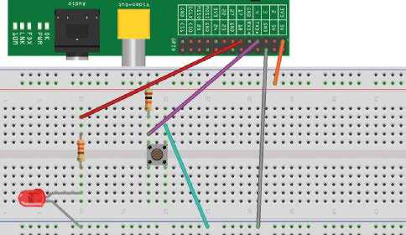

|  |  |  |
| --- | --- | --- |
| Then put the negative terminal | Control the LED | connected to the same negative rails |
| of the LED into the negative rail of |
| that ground is connected to. |
| the breadboard. Connect one of the | from Scratch |
| When the button is not pressed, |
|  | **04** environment and open Start the LXDE desktop  ScratchGPIO3. Go to the control |
| GROUND pins (for example, the third | GPIO 4 will be receiving 3.3V. However, |
| pin from the right on the bottom row |
| when the button is pressed, the circuit |
| of pins) to the negative lane. Now |
| to ground will be completed and |
| connect the power to your Pi. The LED |
| GPIO 4 will be receiving 0V (and have a |
| should light up. If it doesn’t, then it’s | section and create a simple script that |
| value of 0), because there is much less |
| likely that you’ve got it the wrong way | broadcasts pin11on when Sprite1 is |
| resistance on the path to ground. |
| round, so disconnect the power, swap | clicked. Then click the sprite. The LED |
| We can see this in action by |
| the legs around and then try again. | should light up. Then add to the script |
| watching the pin’s value and then |
| Switch the LED on | to wait 1 second and then broadcast |
| pressing the button to make it change: |
| pin11off. If you click the sprite again, |
|  |
|  | the LED will come on for a second and | echo 4 > /sys/class/gpio/ |
| and off | export |
| then go off. ScratchGPIO3 |
|  |
| **03** is connected to a pin that At the moment, the LED  constantly provides 3.3V. This isn’t very | Wire up our | echo in > /sys/class/gpio/ |
| gpio4/direction |
| push button | watch -n 0.5 cat /sys/class/ |
| gpio/gpio4/value |
| useful if we want to be able to turn it | |  |  | | --- | --- | | **05** | Power off the Pi again. This circuit is a little bit more | |  |
| on and off, so let’s connect it to GPIO | Let there be light! |
| 17, which we can turn on and off. |
| GPIO 17 is the sixth pin from the right, | complicated than the LED one we |
| created previously. The first thing we | **06** ScratchGPIO3. Go to the Boot up the Pi and start  control section and add when green |
| on the top row of pins. Power the Pi |
| need to do is connect 3.3V (the top- |
| back on. We can turn the LED on by |
| right pin we used to test our LED) to |
| exporting the GPIO pin, setting it to an |
| the positive rail of the breadboard. | flag clicked, then attach a forever loop, |
| output pin and then setting its value |
| Then we need to connect a 10Kohm | and inside that an if else statement. |
| to 1. Setting the value to 0 turns the |
| resistor to the positive rail, and the | From the operators section and add |
| LED back off: |
| other end to an empty track on | an if [] = [] operator to the if statement. |
|  |
| echo 17 > /sys/class/gpio/ | the breadboard. Then on the same | Then go to the sensing section and |
| export |
| track, add a wire that has one end | add a value sensor to the left side of |
|  |
| echo out > /sys/class/gpio/ | connected to GPIO 4. This is two pins | the equality statement, and set it to |
| gpio17/direction | to the right of GPIO 17. Then, on the | pin7. Enter 0 on the right. Broadcast |
| echo 1 > /sys/class/gpio/ | same track again, connect one pin | pin11on if the sensor value is 0, and |
| gpio17/value | of the push button. Finally, connect | broadcast pin11off otherwise. Click the |
| echo 0 > /sys/class/gpio/ | the other pin of the push button | green flag. If you push the button, the |
| gpio17/value | to ground by adding a wire that is | LED will light up! |

|  |
| --- |
| **69** |

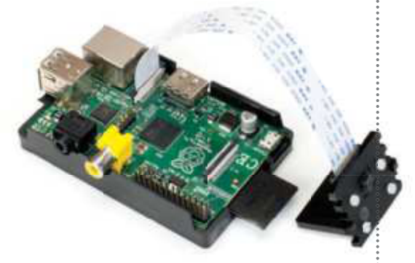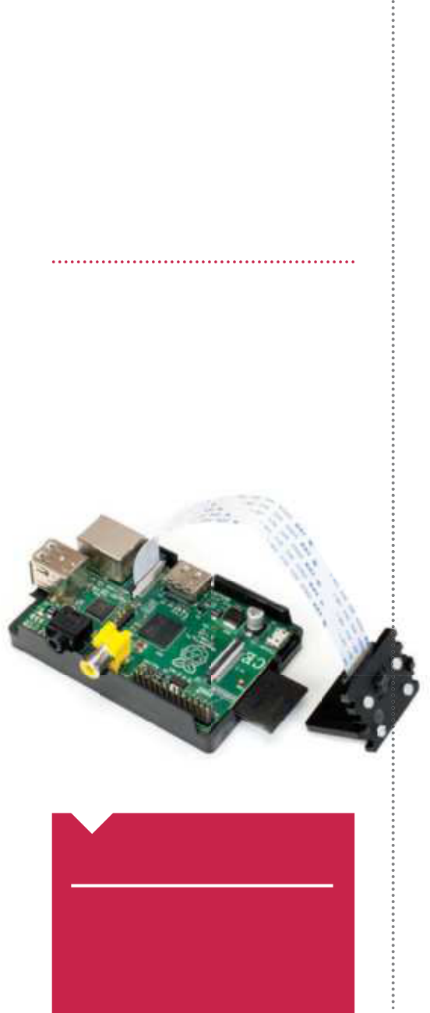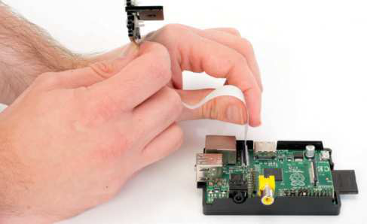

|  |  |
| --- | --- |
| **Projects**  What you’ll need…  **Raspberry Pi**  Raspbian:  www.raspberrypi.org/downloads  **Pi Camera**  Ashton’s picam module:  https://github.com/ashtons/picam | Use the Camera board  Use the  Camera board |

Here’s how to get your new Pi Camera set up on your Raspberry Pi, and how to use it…

One of the most recent Raspberry Pi accessories is the tiny Pi Camera board – a small PCB with a camera sensor mounted to it that connects via a ribbon to the Raspberry Pi. It’s not exactly plug-and-play, so you’ll need to do some extra set up.

The Pi Camera has multiple functions, such as for time-lapse photography, using as a webcam, or even as an optical sensor for a Pi-powered robot, like the one we’re making here. Because it

|  |  |  |  |
| --- | --- | --- | --- |
| **Did you know…** | doesn’t take up any USB slots, and draws very low power, it can be a | | |
| The Camera board uses the same kind of sensor and | | lot more versatile than a standard webcam.  The Pi Camera itself is not a low-quality piece of kit either – with | |
| hardware as the cameras in modern mobile phones. | a 5MP sensor, it’s also able to create up to 1080p quality video, the same as the Raspberry Pi’s HDMI output. | | |
| |  | | --- | |  | | | | Pi preparation  **02** Raspberry Pi Camera, we Before we try to enable the  need to make sure our firmware and software are all up to date with a quick |
| Attach Camera | software upgrade. In Raspbian, we | | |
| do this by opening the terminal and | | | |

**01** Ethernet and HDMI port and gently lift up the fastener. Insert the ribbon To attach the Camera to the Raspberry Pi, locate the slot between the

of the Camera board, making sure to align the ribbon’s connectors with those on

the Pi. The blue tab on the flex should be facing the Ethernet port.

|  |
| --- |
| **70** |

then using:  
 $ sudo apt-get update…followed by:  
 $ sudo apt-get upgrade

|  |  |
| --- | --- |
| Use the Camera board | **Projects** |

Pi config

|  |  |
| --- | --- |
|  | |
| **03** | Once that’s finished, run in the terminal or command line: |

$ sudo raspi-config   
to start the standard configuration screen. Navigate down to Enable Camera, press Enter and then simply key over to enable and confirm with another press of Enter. Select Finish and then reboot.

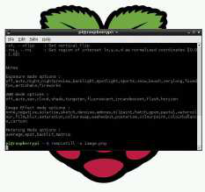

Take pictures

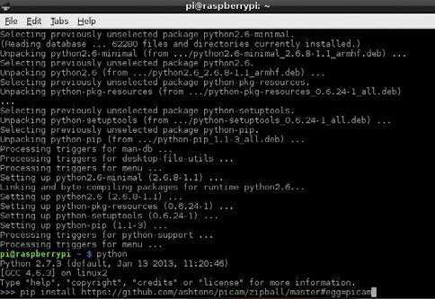

|  |  |
| --- | --- |
| Picam | try. All you need to do is enter: import picam |
| **06** with the Pi Camera, there’s If you want to do a little more  a simple Python wrapper currently available called picam. You’ll need to install it first, though, and we’ll use pip for that. Install pip with: | i = picam.takePhoto()  i.save(‘/home/pi/test.jpg’)  And running it will take a photograph called test.jpg.  Advanced photos |

|  |  |  |  |  |
| --- | --- | --- | --- | --- |
| **04** Raspberry Pi Camera, you’ll To take pictures with the  simply need to enter: | | $ sudo apt-get install python-pip  and then enter: | | **08** specific size and quality with a You can have it take photos of  time-based name by editing the code |
| $ raspistill -o image.png | | pip install https:// | |
| to look like this: |
| This will show a five-second preview | | | github.com/ashtons/picam/ |
| of the input of the camera and then | | zipball/ master#egg=picam | | import picam  import time |
| capture the last frame of the video. | | master#egg=picam | |
| Record video | | Picam photos | | ii = picam.  takePhotoWithDetails(640,480, 85) |
| **05** like so: | To record a video, we use a | **07** we can now use Python to With the module installed  construct a script to take photos with | | filename = “/tmp/  picam-%s.jpg” % time.  strftime(“%Y%m%d-%H%M%S”)  ii.save(filename)  Picam video and more |
| similar command, raspivid, |
| $ raspivid -o video.h264 | | the picam module. It’s not as difficult | |
| It will also take five seconds of video | | as you might think, so even if you’ve | |
| by default. | | never used Python before it’s worth a | |
| “With a 5MP sensor, it’s able to create up to 1080p video, the same as the Raspberry Pi’s HDMI output” | | | |
| **09** take video in a similar way to Picam also allows you to  the above, with the main difference being that you’ll use the recordVideo command. You can use the code  to take photos or video at regular intervals for time-lapse, or have it |

trigger during a specified event.

|  |
| --- |
| **71** |

|  |  |
| --- | --- |
| **Projects**  What you’ll need…  **Breadboard:**  www.proto-pic.co.uk/half-size-breadboard  **3mm LED light:**  www.ultraleds.co.uk/led-product- catalogue/basic-leds-3-5-8-10mm.html  **Wires:**  www.picomake.com/product/breadboard-wires  **270-ohm resistor:**  http://goo.gl/ox4FTp5ntj0091    **Fig 1:** All the items you will need to get going adjusting an LED using PWM. The wires should have a male and female ends    **Fig 2:** Place the female end onto the Pi, noting pin number 1 being identified by the small ‘P1’. The blue wire is ground    **Fig 3:** Once everything is connected up, | Control an LED using GPIO |
| Control an LED using GPIO  An introduction into using an external output, such as an LED, on the Pi  After you have fred up your Pi, maybe installed XBMC and had a play around with streaming, you might be ready for your next challenge. One route to go down is to fnd interesting uses for one of the many desktop OSs available for the little computer, perhaps using it as a web server, an NAS or retro arcade console. This is all great fun, but an often-overlooked feature of the Pi is its hardware pinouts. If you’ve never done any electronics before, then the Pi is a great place to start. Or maybe you have used a programmable microcontroller such as Arduino in the past; the Pi, with its increased CPU and RAM over the Arduino, opens up many more possibilities for fun projects.  The Raspberry Pi features a single PWM (pulse width modulation) output pin, along with a series of GPIO (General Purpose Input/ Output) pins. These enable electronic hardware such as buzzers, lights and switches to be controlled via the Pi. For people who are used to either just ‘using’ a computer, or only programming software that only acts on the machine itself, controlling a real physical item such as a light can be a revelation.  This tutorial will assume no prior knowledge of electronics or programming, and will take you through the steps needed to control an LED using the Raspberry Pi, from setting it up to coding a simple application. |

plug in your USB power cable

|  |  |  |
| --- | --- | --- |
|  |  | “We’ll take you through the |
| steps needed to control |
| an LED using the Pi, from |
| setting it up to coding” |
| **Fig 4:** Switch the power on. The LED will |

light up. If it’s dim, use a lower-rated resistor

|  |
| --- |
| **72** |

|  |  |
| --- | --- |
| Control an LED using GPIO | **Projects** |

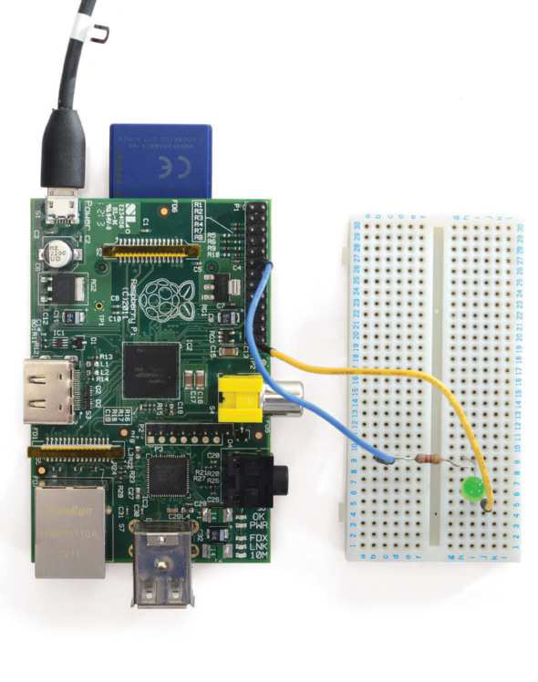

|  |  |  |  |  |  |
| --- | --- | --- | --- | --- | --- |
| **Breadboard**  The breadboard, or prototype board,  provides an easy-to-use and solderless   |  |  |  | | --- | --- | --- | | environment for creating and changing your development circuits  **Breadboard wire**  A must for any budding electrical engineer, these male-to-male and male-to-female wires make for fast and easy circuit building | |  | | --- | |  |   **Coloured LED**  Different coloured |   LEDs are a great way  to physically see which   |  |  | | --- | --- | | **GPIO header**  This provides a mechanism for both gathering input and providing output to electrical | part of the software  is running and help  you understand the  program flow |   circuits, enabling reactive program design |

|  |  |  |
| --- | --- | --- |
| The Pi’s pins | Pin numbers | GPIO pins |
| **01** code, let’s take a look at the Before we dive into writing  layout of the pins on the Pi. If you have | **03** left of the board you will see a If you take a look at the top  small white label, ‘P1’. This is pin 1 and | **05** are GPIO (General Purpose The other pins on the board  Input/Output). These are used for |
| your Pi in a case, take it out and place | above it is pin 2. To the right of pin 1 | other tasks that you need to do as |
| it in front of you with the USB ports | is pin 3, and above 3 is 4. This pattern | your projects become more complex |
| on the right. Over the next few steps | continues until you get to pin 26 at | and challenging. Be aware that the |
| we’ll look at some of the issues you’ll | the end. As you’ll see in the next step, | USB power supply doesn’t offer much |
| encounter when using the GPIO port. | some pins have important uses. | scope for powering large items. |
| Pi revision 1 or 2? | Pin uses | Basic LED lighting |
| **02** purchased your Pi, you may Depending on when you  have a ‘revision 1’ or ‘revision 2’ model. | **04** the main pin we will be using Pin 1 is 3V3, or 3.3 volts. This is  in this guide to provide power to our | **06** to business and start Okay, so let’s get down  making something. Firstly, get your |
| The GPIO layout is slightly different | LED. Pins 2 and 4 are 5V. Pin 6 is the | breadboard, two wires, a 270Ω resistor |
| for each, although they do have the | other pin we will use here, which is | and an LED. Note the slightly bent |
| same functionality. Here we have a | ground. Other ground pins are 9, 14, | leg on one side of the LED; this is |
| revision 1; revision 2s became available | 20 and 25. You should always ensure | important for later on. Make sure your |
| towards the end of 2012. | your project is properly grounded. | Pi is unplugged from the mains supply. |

|  |
| --- |
| **73** |

|  |  |
| --- | --- |
| **Projects**  Wiring the board | Control an LED using GPIO  Set up programming environment |
| **07** 1 pin, and the other end into Plug one wire into the number  the breadboard. Note that it doesn’t matter where on the breadboard you plug it in, but make sure there are enough empty slots around it to | **12** on – we want to be able to control it via code. Set up a new Raspbian Now, we need to be able to do a little bit more than just turn a light  installation (a guide to this is found on page 28). You don’t need a GUI for this – it can all be done via the terminal if you so wish. Before starting, it’s best to check everything is up to date with:  sudo apt-get dist-upgrade |

add the LED and resistor to. Now get

|  |  |
| --- | --- |
| another wire ready. | Open up terminal   Assuming we want to use the GUI, rather than SSH into the Pi, open up a |
| Add another wire  **08** the wire into pin number 6 Place the female end of  (ground) and the other end into the |
| **13** new terminal window by double-clicking on the LXTerminal icon. We need root access to control the LEDs, so either enter su now, or remember to prefix any commands with sudo. |
| breadboard, making sure to leave room for the resistor, depending on | su  followed by password or add |
| how large it is. Next, get your resistor ready. You can use a little higher or lower than 270 ohms, but not using a resistor at all will likely blow the LED. | sudo  to the start of each command.  Download GPIO library   |  |  | | --- | --- | | **14** | There is a handy GPIO Python library that makes manipulating the GPIO pins a breeze. From within your terminal window, use wget to | |
| Add the resistor  **09** resistor. Place one end next to Next we need to add our  the ground wire on the breadboard, and the other one slot below the 3V3 wire connection. This will sit next to the LED when we add it in a second. |
| download the tarball file, then extract it using tar. This will give us all the files in a new directory.  wget https://pypi.python.org/packages source/R/RPi.GPIO/RPi.GPIO-0.5.2a.tar.gz  tar zxf Rpi.GPIO-0.5.2a.tar.gz  cd Rpi.GPIO-0.5.2a |

Note that there is no correct or

|  |  |  |
| --- | --- | --- |
| incorrect way to add a resistor. | Install the library  **15** install method; so we need the dev version of Python. Make sure you are in Now we need to install the library. This is simply a case of using Python’s  the directory of the library before running this command. sudo apt-get install python-dev   sudo python setup.py install  Import the library in a script | |
| Add the LED  **10** ‘bent’ leg end next to the Grab your LED and place the  3V3 wire in the breadboard. Place |
| the other leg next to the resistor leg opposite the ground wire. This now completes the circuit and we are ready |
| to test out our little task. Power it up | **16** | Create a new Python script. Next import the main GPIO library and we’ll put it in a try-except block. Save the file using Ctrl+X and choosing ‘yes’. |
| cd /   cd Desktop   sudo nano gpio.py   try:   import RPi.GPIO as GPIO   except RuntimeError:   print(“Error importing GPIO lib”) | |
| **11** and either plug the mains end Now get your micro-USB socket  into the wall, or plug it into a computer |
| or laptop port (and powered on!). You |
| should see the LED light up. If not,  then check your connections on the breadboard or Pi, or try a different LED. |

|  |
| --- |
| **74** |

|  |  |  |
| --- | --- | --- |
| **Did you know…**  The ofcial Python docs are a great resource for beginners and professionals alike.  **http://python.org/doc**. | Control an LED using GPIO | **Projects** |
| Using PWM  **20** our program. Here we call the GPIO class again and then the PWM The next step is to tell the pin to output and then set a way of escaping  method, passing in the pin number; the second value is the frequency in hertz – in this case, 0.5.  p = GPIO.PWM(12, 0.5) | |

p.start(1) 

|  |  |
| --- | --- |
| Test the script  **17** script imported okay, we just Now to make sure that the  need to run the python command | input(‘Press return to stop:’)   p.stop()   GPIO.cleanup()  Adjust PWM |
| and then tell it the name of the  script that we just created. If all goes well, you shouldn’t see any error  messages. Don’t worry if you do,  though. Just go back through the previous steps to check everything is | **21** library and then set the 12 pin to have 50Hz frequency to start off with. To add a timer to the LED so it fades out, we first need to import the time  import time  import RPi.GPIO as GPIO |
| as it should be. | GPIO.setmode(GPIO.BOARD) |
|  | GPIO.setup(12, GPIO.OUT) |
| sudo python gpio.py | p = GPIO.PWM(12, 50) # channel=12 frequency=50Hz |

p.start(0)

|  |  |
| --- | --- |
| Set GPIO mode | Add the fade |
|  |
| **18** We will then set the GPIO   Reload the script in nano again.  mode to BOARD. This method is the safest for a beginner to adopt and  will work whichever revision of the Pi you are using. It’s best to pick a GPIO convention and stick to it because this will save confusion later on. | **22** the LED is at – and once it reaches a certain level, we reverse the process. Then we add in another try-except block, this time checking what power  To run this code, simply save it from nano and then sudo python gpio.py.  while 1:   for dc in range(0, 101, 5):   p.ChangeDutyCycle(dc) |
|  | time.sleep(0.1) |
| sudo nano gpio.py |  |
|  | for dc in range(100, -1, -5): |
| GPIO.setmode(GPIO.BOARD) | p.ChangeDutyCycle(dc) |

time.sleep(0.1)

|  |  |
| --- | --- |
| Set pin mode | except KeyboardInterrupt: |

pass

|  |  |  |
| --- | --- | --- |
| **19** either an input or an output A pin has to be defined as  before it can work. This is simplified | p.stop() |  |
| GPIO.cleanup() |
| in the GPIO library by calling the |  | “We’ll set the GPIO mode |
| GPIO.setup method. You then pass |
| in the pin number, and then GPIO. |
| to BOARD. This will work |
| OUT or GPIO.IN. As we want to use |
| an LED, it’s an output. You’ll be |
| whichever revision of the |
| using these conventions frequently, |
| so learn them as best you can so | PI you are using” |
| they soak in! |

GPIO.setup(12, GPIO.OUT)

|  |
| --- |
| **75** |

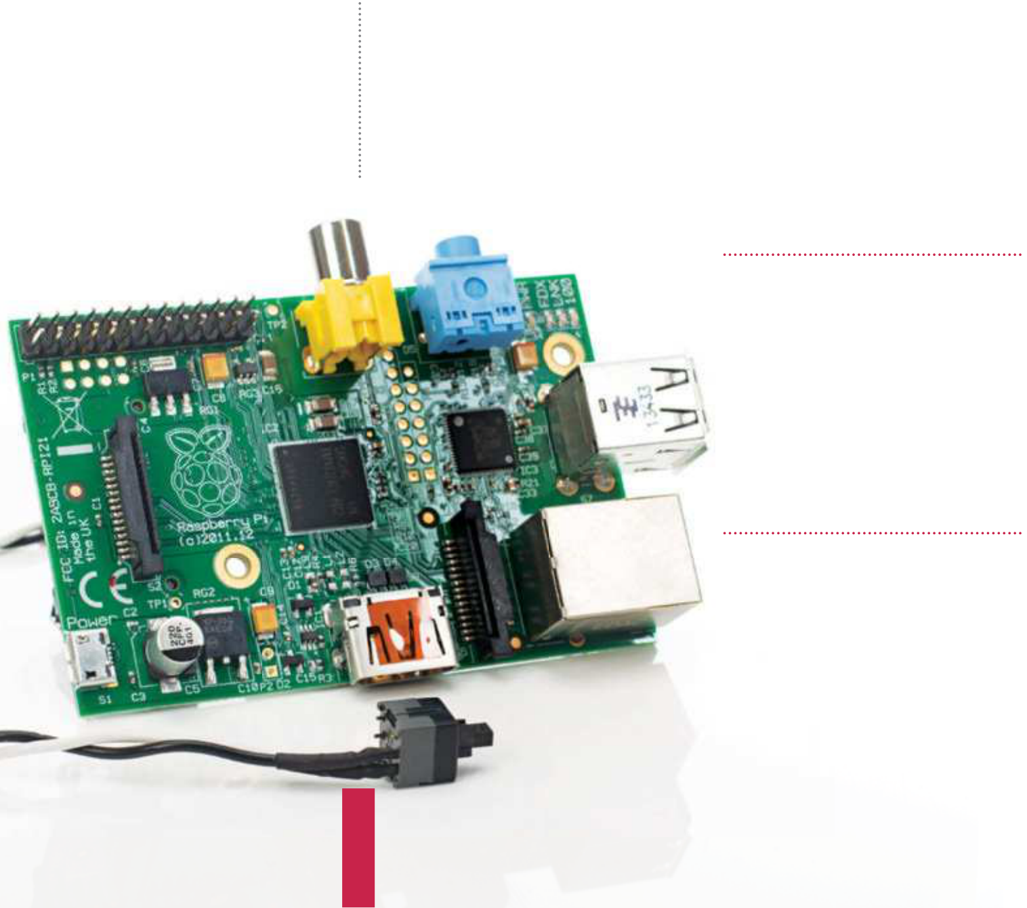

|  |  |
| --- | --- |
| **Projects**  What you’ll need…  **Momentary switch**  **Suitable wire for PCB projects Soldering iron and solder**  **Single pin pair header**  **HDD/motherboard jumper** | Add a reset switch  Add a |
| reset switch |

Need to restart your Pi after a system lock-up? Ease strain on the mains connector – install a reset switch

Shutting down a Raspberry Pi by removing the power cable is risky. Data may be writing to the SD card, leading to corruption. Repeated removal of the power cable can cause issues with the connector port.

Clearly this can cause problems when faults cause the Raspberry Pi to hang, so the simple f x here is to add a simple reset function to the device. There are three ways this can be done: with a USB reset button, a motherboard jumper on the GPIO bus or with a momentary button connected to newly-soldered pins on the P6 header on the Model B Rev 2 and B+ (a complicated option).

If you have an old PC, retrieving the reset button, cable and the connecting motherboard pins is achievable if you’re handy with a soldering iron. Otherwise, we recommend purchasing parts online.

Check your Pi model

**01** header: the Raspberry Pi Model   
 Only two models feature the P6

B Rev 2 (which you can find next to   
the HDMI port) and the B+ (to the left   
of the ‘© Raspberry Pi 2014’ label). You   
will need to install the pins manually,   
however, as they are not pre-installed   
for this function.

Find your components

**02** purchased online, although   
Header pins can be

this will invariably result in having   
to order more than you need.

Alternatively, if you have an old   
motherboard, remove a pair of pins   
with a soldering iron. Similarly, you   
might buy a new reset button or use   
one from an old PC.

|  |
| --- |
| **76** |

|  |  |  |
| --- | --- | --- |
| Solder pins to your Pi  **03** when soldering, place the Pi In order to gain stability  upside down on a layer of packaging foam, with the header slotted into the holes. | Add a reset switch | **Projects** |
| Pi by removing the power  cable is risky” “Shutting down a Raspberry    Identify the GPIO pins  **07** array, 26 pins on the A and B (Rev 2) and 40 on the A+ and B+. The jumper  This method works on most models of the Raspberry Pi. Each has a GPIO  should be placed on GPIO3, pins 5 and 6 counting from the left with the board  the right way around. | |
| Using fine solder, secure the  pins to the mainboard with your soldering iron. This will require a very steady hand, so get assistance if required.  Connect your reset switch  **04** few minutes before attaching Leave the solder to cool for a  the reset switch connector. Some  cases don’t have space for the pins and/or the connector, however, so take the time to plan ahead and make sure everything fits. If not, you may need to make some adjustments to your case.  Reset Pi following crashes  **05** you’ll be able to reset the With the switch installed,  Raspberry Pi when required. Note, |
| however, that this isn’t an option to be used for whenever you feel like restarting your Raspberry Pi. Rather, it should be done only when the system fails to respond within a |

reasonable time frame.

Detect jumper with a script

|  |  |
| --- | --- |
| Reset with a HDD jumper | Use the script at bit.ly/1Ge5n0O to detect the jumper, making it |
| **06** pins to your Raspberry Pi? Not keen on soldering new  That is perfectly understandable,  but it doesn’t mean you cannot  reset the computer. We have  another solution for you. Using a  motherboard jumper, two GPIO pins | **08** executable (sudo chmod 755) before running. Within a minute your Pi will shut down. Add this line to /etc/crontab to run the script whenever you boot up.  @reboot root /home/user/scripts/gpio_actions.sh Remember to remove the jumper before booting up!  Try a USB reset button  **09** your Pi for scenarios when the device needs to be rebooted. If the idea Specialist online stores offer USB reset buttons that can be connected to  of using the HDD jumper or doing some minor soldering doesn’t suit you, then a USB reset switch might be your best option. |
| and a script to initiate an ordered shutdown is a simple alternative that doesn’t involve solder and potential PCB damage. |

|  |
| --- |
| **77** |

|  |  |
| --- | --- |
| **Projects** | Add a battery pack to your Raspberry Pi |

What you’ll need…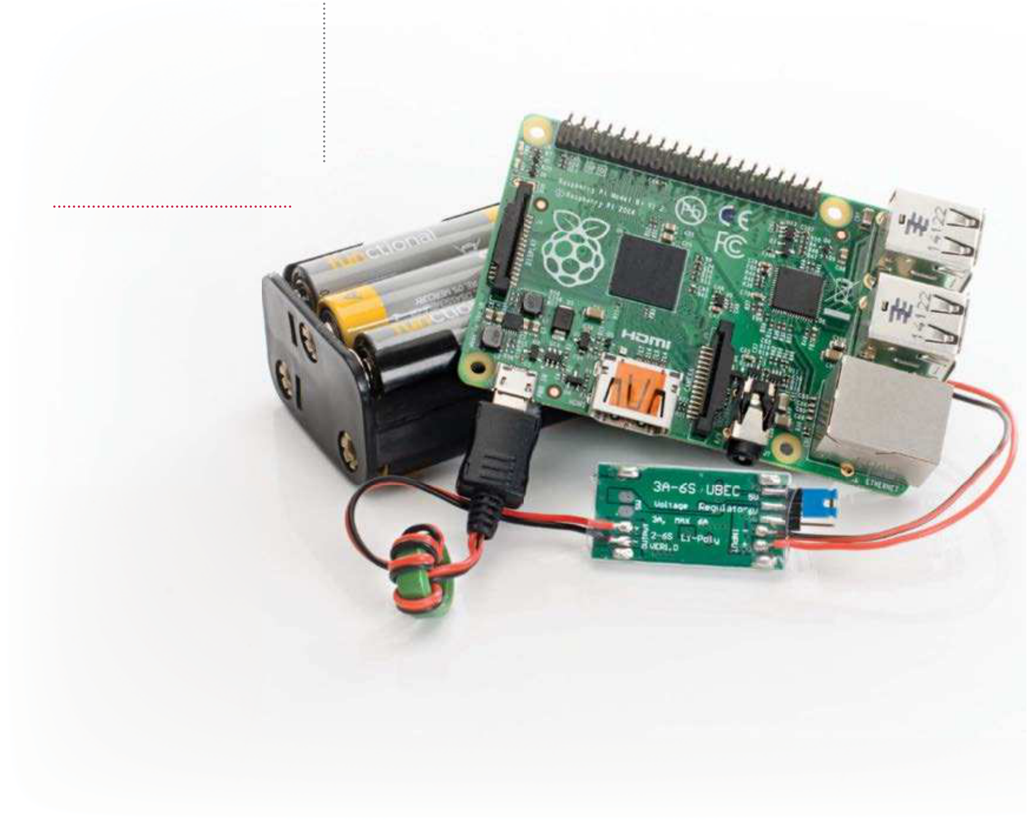

**AA battery box**   
bit.ly/1FDiJGa

**3-Amp UBEC**   
bit.ly/1HLKih7

**3-Amp terminal strip**   
**6x AA rechargeable**   
**batteries**

Add a battery pack to your Raspberry Pi

Don’t leave your Raspberry Pi behind – incorporate it into mobile projects by powering it up using humble AA batteries

Your Raspberry Pi’s mobility is usually restricted by the length of the power lead. Rather than limiting it to your desk or living room, however, you can use it for mobile projects as diverse as launching it into near-Earth orbit or monitoring and automating your garden.

Of course, to do this you will need batteries, but adding battery power to your Raspberry Pi is simpler than you might have   
imagined. All that is required are six rechargeable AA batteries (or single-charge alkaline), a battery box with space for the batteries and a UBEC. The latter is a Universal Battery Elimination Circuit, a voltage regulator that will regulate the power supply and prevent damage to the Raspberry Pi, and can be bought for under £10.

|  |
| --- |
| **78** |

|  |  |  |
| --- | --- | --- |
| Add a battery pack to your Raspberry Pi | | **Projects**  “You can use your device for mobile projects as diverse as launching it into near-Earth orbit” |
| |  | | --- | |  | | |
| Make your order | Move connector pins |
| **01** components online, you If you’re buying your  should be able to get them all within | **03** a 3-pin connector, you’ll need In order to use the UBEC with  to alter the position of the pins so | Measure uptime |
| **07** your Pi for SSH use, so connect You should have already set up  to the device via Putty after giving it time to boot fully (at least 60 seconds).  In the terminal, enter:  sudo dd bs=32m if=/Users/ |
| five days. However, if you’re ordering | that they occupy the two outer slots. |
| offline (specifically the UBEC), you | Just use a small jeweller’s screwdriver |
| should avoid traditional electronics | to lever up the small plastic catch |
| stores and instead visit a model | and remove the red wire from the |
| enthusiast store, as these circuits are | central slot, before sliding into the |
| regularly used in RC devices. | unoccupied outer slot. |

rachelcrabb/Desktop/ArchLinux/ 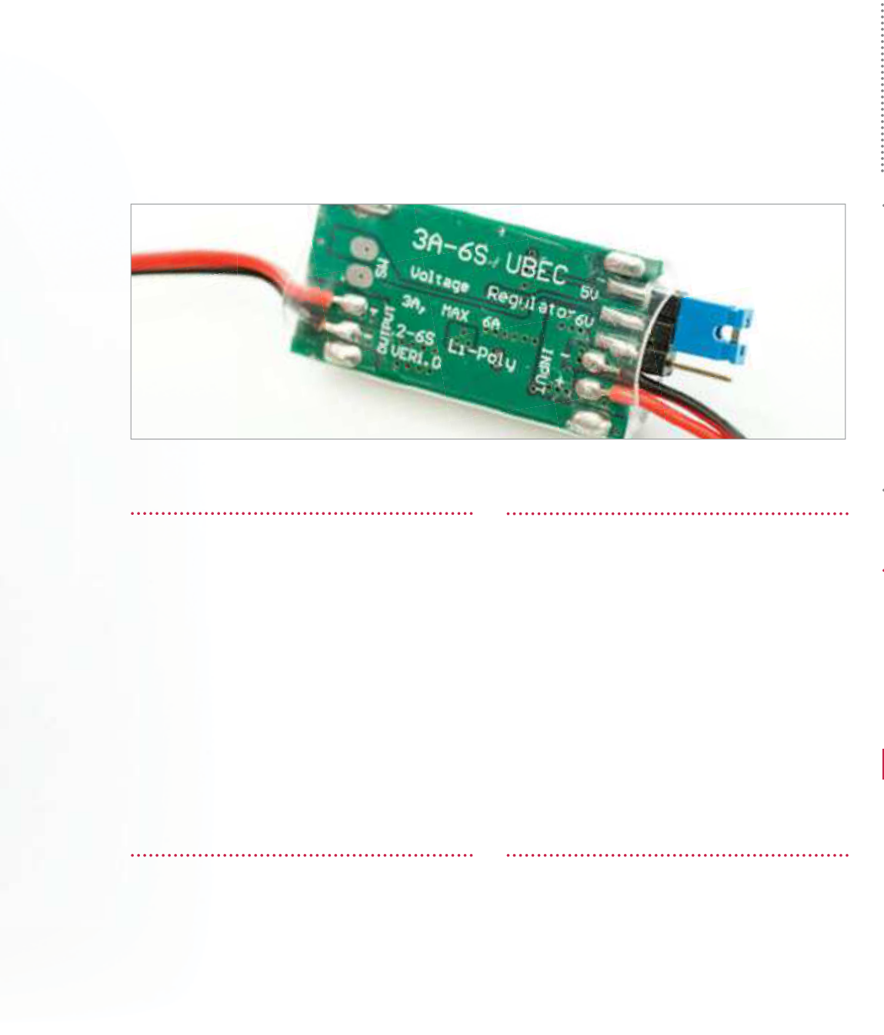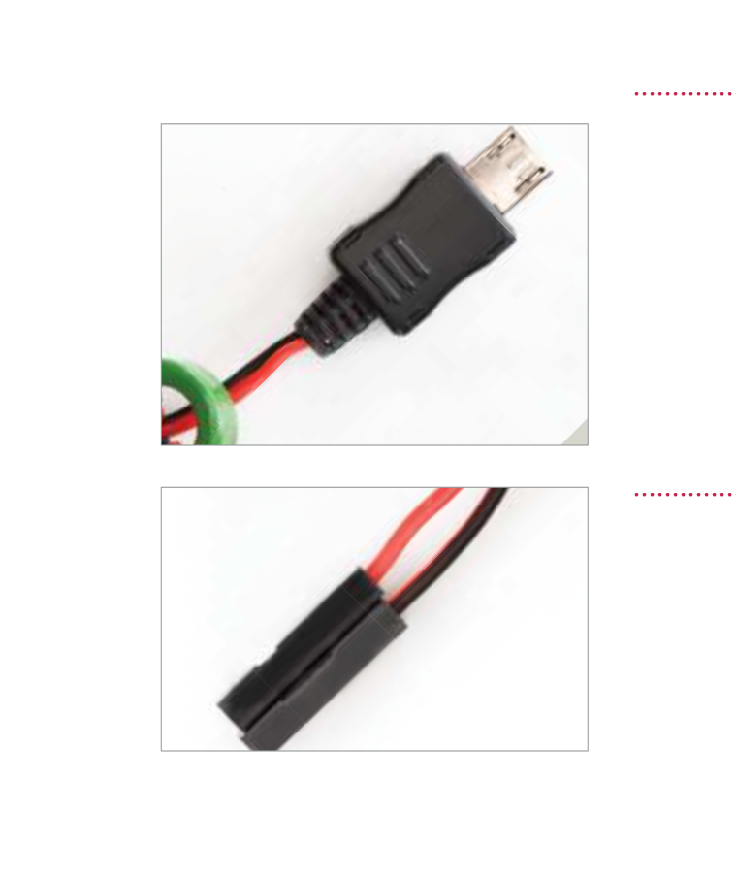

|  |  |  |
| --- | --- | --- |
| Check your UBEC | Connect to battery box | archlinux-hf-2013-02-11.img |
| of=/dev/disk1 |
| **02** available to choose from. If Two types of UBEC are  you used the store that we suggest | **04** battery box, connect it to With five batteries in the  the UBEC (red-to-red, black-to-black) |  |
| This command will display the system |
| uptime and also keep the Wi-Fi |
| in the resources box to the left, you’ll | by twisting the wires, soldering or | connection active. |
| receive one with a micro USB power | employing a 3-amp terminal strip, cut | Judge your uptime results |
| connector for easy connection to your | down to two pairs. It can be cut to size |
| Raspberry Pi. However, if you bought | using a modelling knife. |
| one from eBay then there is a strong | Add a battery to boot | |  |  | | --- | --- | | **08** | Uptime results depend upon the type of battery you use | |
| chance that you will receive one with |
| a 3-pin connector. |
|  | and the Raspberry Pi model. Single- |
| |  | | --- | |  | | **05** your Wi-Fi dongle plugged in, With your Pi ready to use and  connect the UBEC to the micro USB | charge batteries will last a little bit |
| longer, but this is a more expensive |
| option. Meanwhile, newer models |
| port and insert the sixth battery into | have greater power requirements but |
| the battery box. The Pi’s power and | run for less time. For more power, add |
| status lights should indicate that the | more batteries! |
| computer is booting up, which gives | Power extreme! |
| you a fully portable computer. |
|  | Connect the 3-pin UBEC | |  |  | | --- | --- | | **09** | More batteries added in | |
|  | **06** with the now-modified 3-pin If you purchased the UBEC  connector, you’ll need to connect |
| |  | | --- | |  | | parallel should result in almost double the uptime (at least 16 hours |
| on a 256MB Raspberry Pi Model A), |
| but instead of alkaline or rechargeable |
| this to the Raspberry Pi’s GPIO header. | batteries you might consider a |
| Connect the positive +5V (red) | modern lithium-based AA cell, which |
| connector to Pin 2 and the negative | will last considerably longer than |
| 0V connector to Pin 6. | alkaline batteries. |

|  |
| --- |
| **79** |

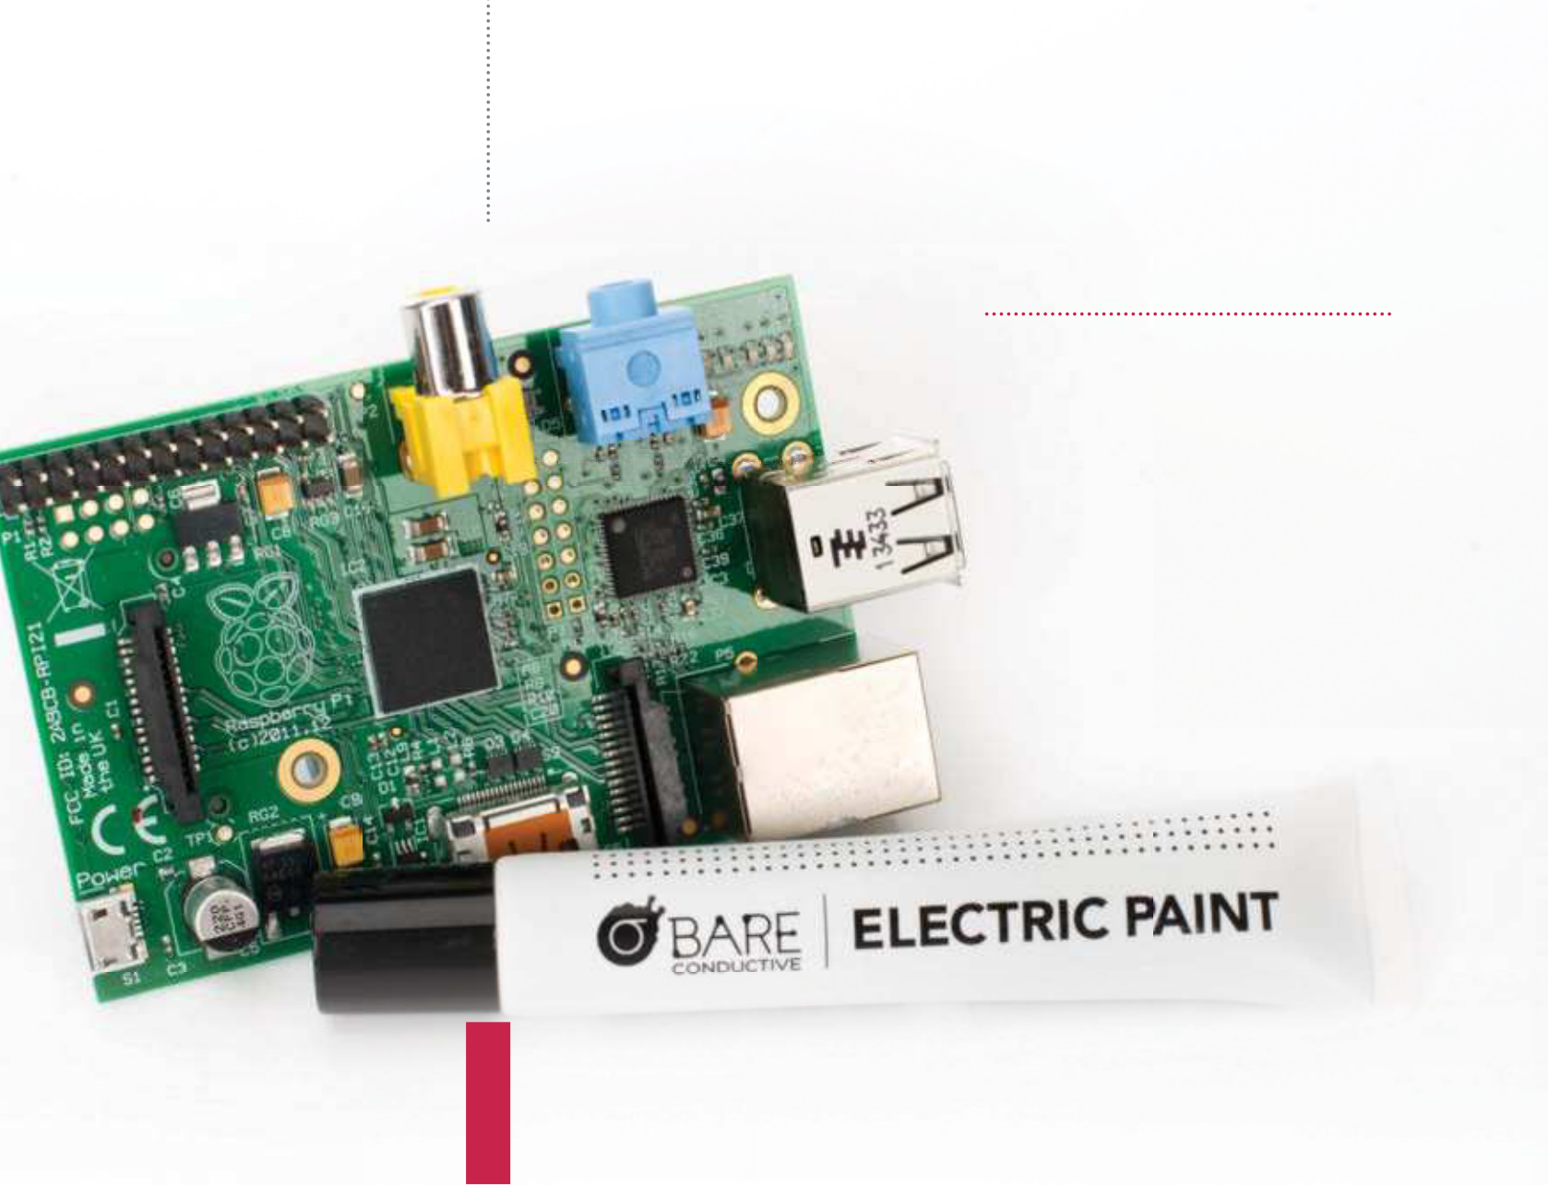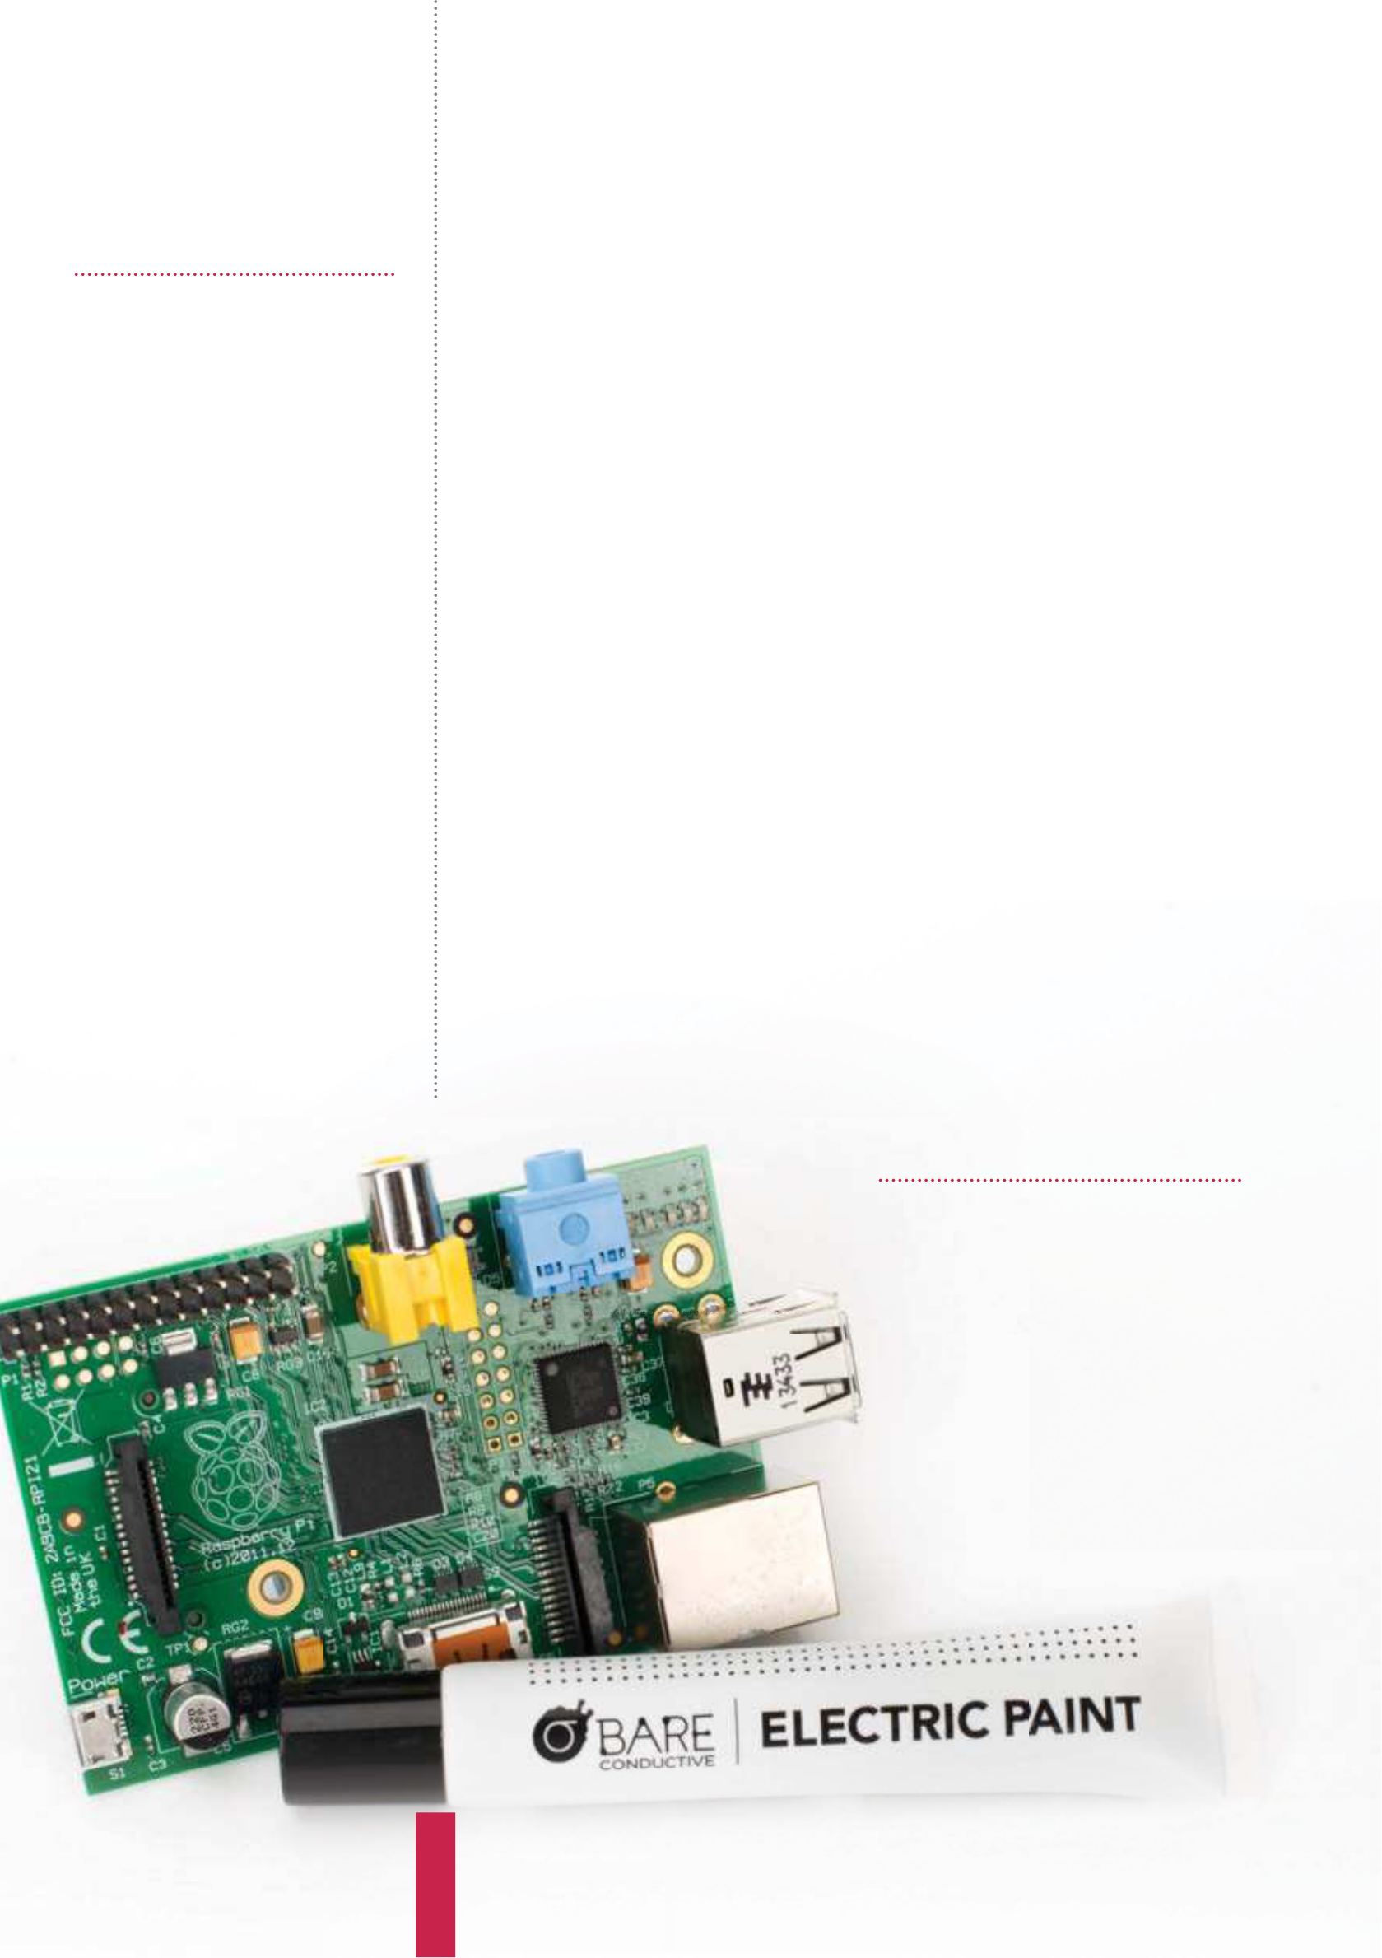

|  |  |
| --- | --- |
| **Projects**  What you’ll need…  **Bare Conductive paint (pen or tub)**  **Male to female jumper wires**  **An assortment of LEDs, switches and resistors (optional)** | Draw circuits with paint  Draw circuits with paint |

Assembling circuits has never been so easy with the joys of conductive paint, enabling you to bring together art and electronics in a whole new way

Playing with electronics and physical computing is a very rewarding

task. For a beginner though, the mess of wires and components can

become very confusing quite quickly and things like soldering can

be a safety concern when children are involved. Bare Conductive

has taken the joy of electronics and made it far safer, easier and

more versatile with their conductive paint. You can literally draw

wires on paper with a paintbrush, use it for cold-soldering or a

conductive adhesive and much, much more. There are not a

great deal of boundaries to what you can do. Pair this paint with

a microcontroller board and you could be creating interactive art,

clothing and projects in no time.

Get your tools

**01** aren’t the first items that   
 Paint and a paintbrush

come to mind when you think   
about electronics, so you may be   
wondering where to get them from.   
Bare Conductive stock the paint and a   
selection of components in their shop   
(bareconductive.com/shop) but you   
will need to go somewhere else for   
art supplies. We would recommend   
trying a high street craft shop such as   
Hobbycraft (hobbycraft.co.uk) or a   
local independent.

**80**

|  |  |  |
| --- | --- | --- |
| Draw circuits with paint | | **Projects**  “The mess of wires and components can become very confusing”  Clean up  **06** thinking that something as A lot of you are probably  cool as conductive paint is going to be  nasty stuff. Actually Bare Conductive  paint is non-toxic, water-based and |
| Pick your platform | Connect it up |
| **02** Conductive paint is that, when The great thing about Bare  dry, it works just like normal wiring! | **04** connect to the conductive There are plenty of ways to  paint (from battery packs for example) | water-soluble, and can therefore be cleaned easily with soap and water.  Make it waterproof  **07** black and is not waterproof. This paint only comes in  However, the great thing is that you can use it underneath or alongside any regular paints, varnishes and  waterproofing sprays in order to act as insulation – or just to add some colour |
| That means you can use it with any | no matter what surface it’s on, |
| of your favourite microcontrollers like | because once it is dry it acts just like |
| the Bare Conductive Touch Board, a | an uninsulated wire. Therefore you |
| Raspberry Pi or Adafruit’s wearable | can use wires glued on with the paint, |
| FLORA platform. Or you can just use | paper clips, bulldog clips, alligator clips |
| some small pin batteries and flashing | or even sewn-in conductive snaps for |
| LEDs for a standalone system. | wearable projects. |
| Start to paint | Make repairs |

into your designs!

|  |  |  |
| --- | --- | --- |
| **03** paint onto pretty much any You can paint Bare Conductive  surface – paper, fabric, walls, clothing, | **05** thick and when it’s dry it The conductive paint is  becomes quite strong. These means | Touch and sound  **08** can also be used as a Bare Conductive paint  capacitive surface, meaning you  can use it for touch, gesture or  proximity controls when it is paired with a suitable control board. Bare  Conductive make their own called the Touch Board which has everything you need to start experimenting  with touch and sound. It can even  act as a MIDI controller, an interface or an instrument! |
| wood, plastic and much more. For | you can use it to cold solder things |
| really accurate shapes and results, the | together and repair any breakages. |
| best idea is to create or purchase a | In other words, you could glue |
| stencil (paper stencils are easiest to | components into a circuit board or |
| make at home but use vinyl for the | glue wires together and they would |
| best edge finish). | still function electrically. |
|  | |

|  |
| --- |
| **81** |

|  |  |
| --- | --- |
| **Projects** | Send an SMS from your Raspberry Pi |

Send an SMS from your Raspberry Pi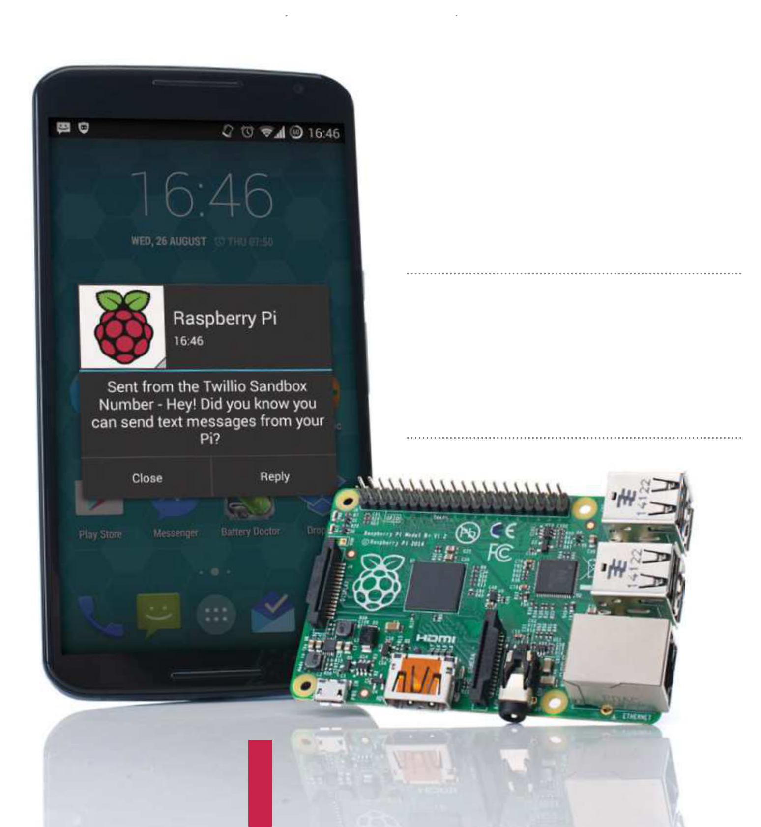

What you’ll need…

**Raspberry Pi**   
**Twilio account**   
 Text messaging, or SMS (Short Message Service), has become a staple of everyday communication.

What began life as a 40 pence message service   
is now of ered by most tarif providers as an   
unlimited service used worldwide. Twilio, a cloud communications company, enables you to send SMS messages for free from your Raspberry Pi to a mobile phone using just six lines of code.

“Create other communication   
programs, such as making   
phone calls, recording a call,   
and retrieving data”

|  |  |  |  |
| --- | --- | --- | --- |
| Send an SMS from your Raspberry Pi | | | **Projects**  the message that will be sent: |
| Set up your Twilio account | Install the software | |
| **01** is to register for a Twilio   The first step of this project  account and Twilio number. This is | **04** Pi and connect it to the   Now boot up your Raspberry  internet. Before you install the Twilio | | message = raw_input(“Please enter your message”)  Add your numbers  **07** need to add the code line To send the message, you  below and your two phone numbers.  The first number is your mobile  phone number, which is registered and validated with Twilio (Step 2). The second number is your Twilio account number, which can be retrieved from your dashboard page under ‘Call  the Sandbox number’. Change the |
| free and will enable you to send an | software, it is worth updating and | |
| SMS to a registered, verified phone. | upgrading your Pi. In the LX Terminal, | |
| Once signed up, you will receive | type sudo apt-get update, then sudo | |
| a verification code via SMS to the | apt-get upgrade. Once complete, | |
| registered phone. When prompted, | type sudo easy_install twilio or | |
| enter this onto the Twilio site to | sudo pip install twilio to install | |
| authenticate your account and phone. | the software. (If you need to install pip, | |
| Go to twilio.com/try-twilio and create | type sudo apt-get install python- | |
| your account now. | pip python-dev, press Enter, then | |
| type sudo pip install -U pip.) | | |
| Register numbers | Twilio authentication | |
| Sandbox number to your country |
| **02** a trial account unless you Your Twilio account is just  pay the upgrade fee, which means | **05** the SMS program that will Now you are ready to create  send the text message to your mobile | |
| location and remember to add the international country code. |
| you can only send and receive | message = client.messages.  create(to=“+44YOURMOBNUMBER”, from_=“+44YOURTWILIONUMBER”, body=message)  Send the message |
| communications from a validated | phone. Open your Python editor | |
| phone number. Enter the phone | and import the Twilio REST libraries | |
| number of the contact who you want | (line one, below). Next, add your | |
| to verify, ensuring that you select the | AccountSid and Auth Token, replacing | |
| correct country code. Twilio will text | the X with yours, as you will find on | |
| you a verification code and you will | your dashboard: | |
| need to enter it into the website form | from twilio.rest import | |
| **08** code below is not required, Now send your message. The  but is useful to indicate your message  has been sent. Add the lines and save |
| and press submit. | TwilioRestClient | |
| account_sid = “XXXXXXXXXXXXX | | |
| The dashboard | XXXXXXXXXXXXXXXX” | |
| # Enter | | |
| your program. Ensure your Raspberry Pi is connected to the internet and |
| **03** logged in on Twilio, visit the Once registered and  dashboard page, which will display | Yours  auth_token =  “XXXXXXXXXXXXXXXXXXXXXXXXXX” | |
| that your mobile is on, then run your program. You have just texted from your Raspberry Pi! |
| your AccountSid and your Auth Token. | | # Enter |
| These are both required to use the | Yours | |
| Twilio REST. Keep these secure and | client = | | print message.sid |
| print “Your message is being sent”  print “Check your phone!”  Other API and codes |
| private, but be sure to make a note of | TwilioRestClient(account_sid, | |
| them as you will need them for your | auth_token) | |
| Python program later. | | |
|  | Create your message | |
| **06** be able to change your You will probably want to  text messages rather than send the same one. Create a new variable in your program called message. This will prompt you to enter the phrase that you want to send to the mobile phone. When the program runs, this is | | **09** communication programs, You can create other  such as making phone calls, recording a call, and retrieving data including caller IDs and call duration. The API also complements a wide range of languages, including Ruby, PHP, Java and Node.js (twilio.com/api). |

|  |
| --- |
| **83** |

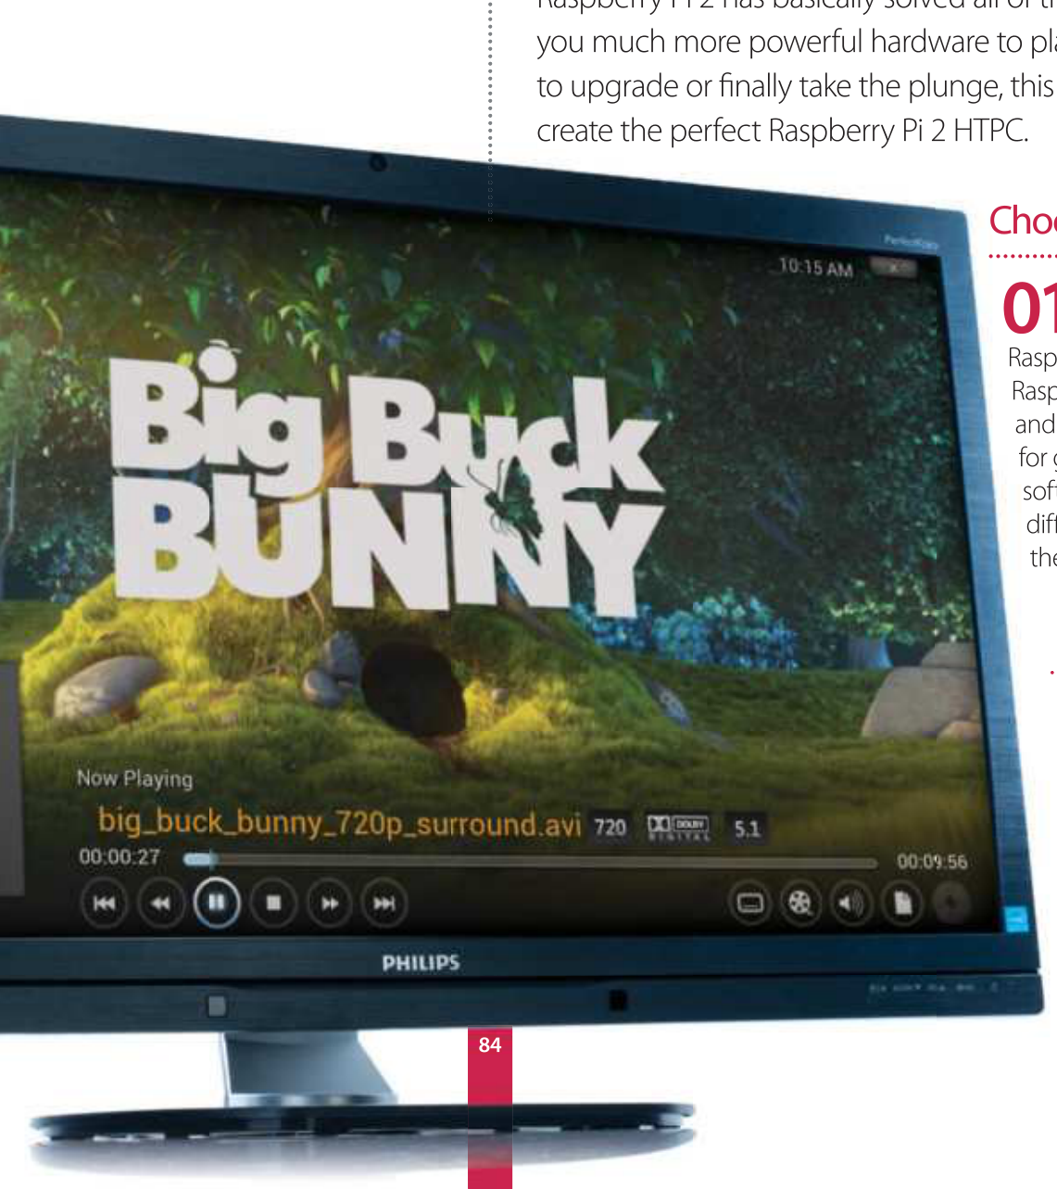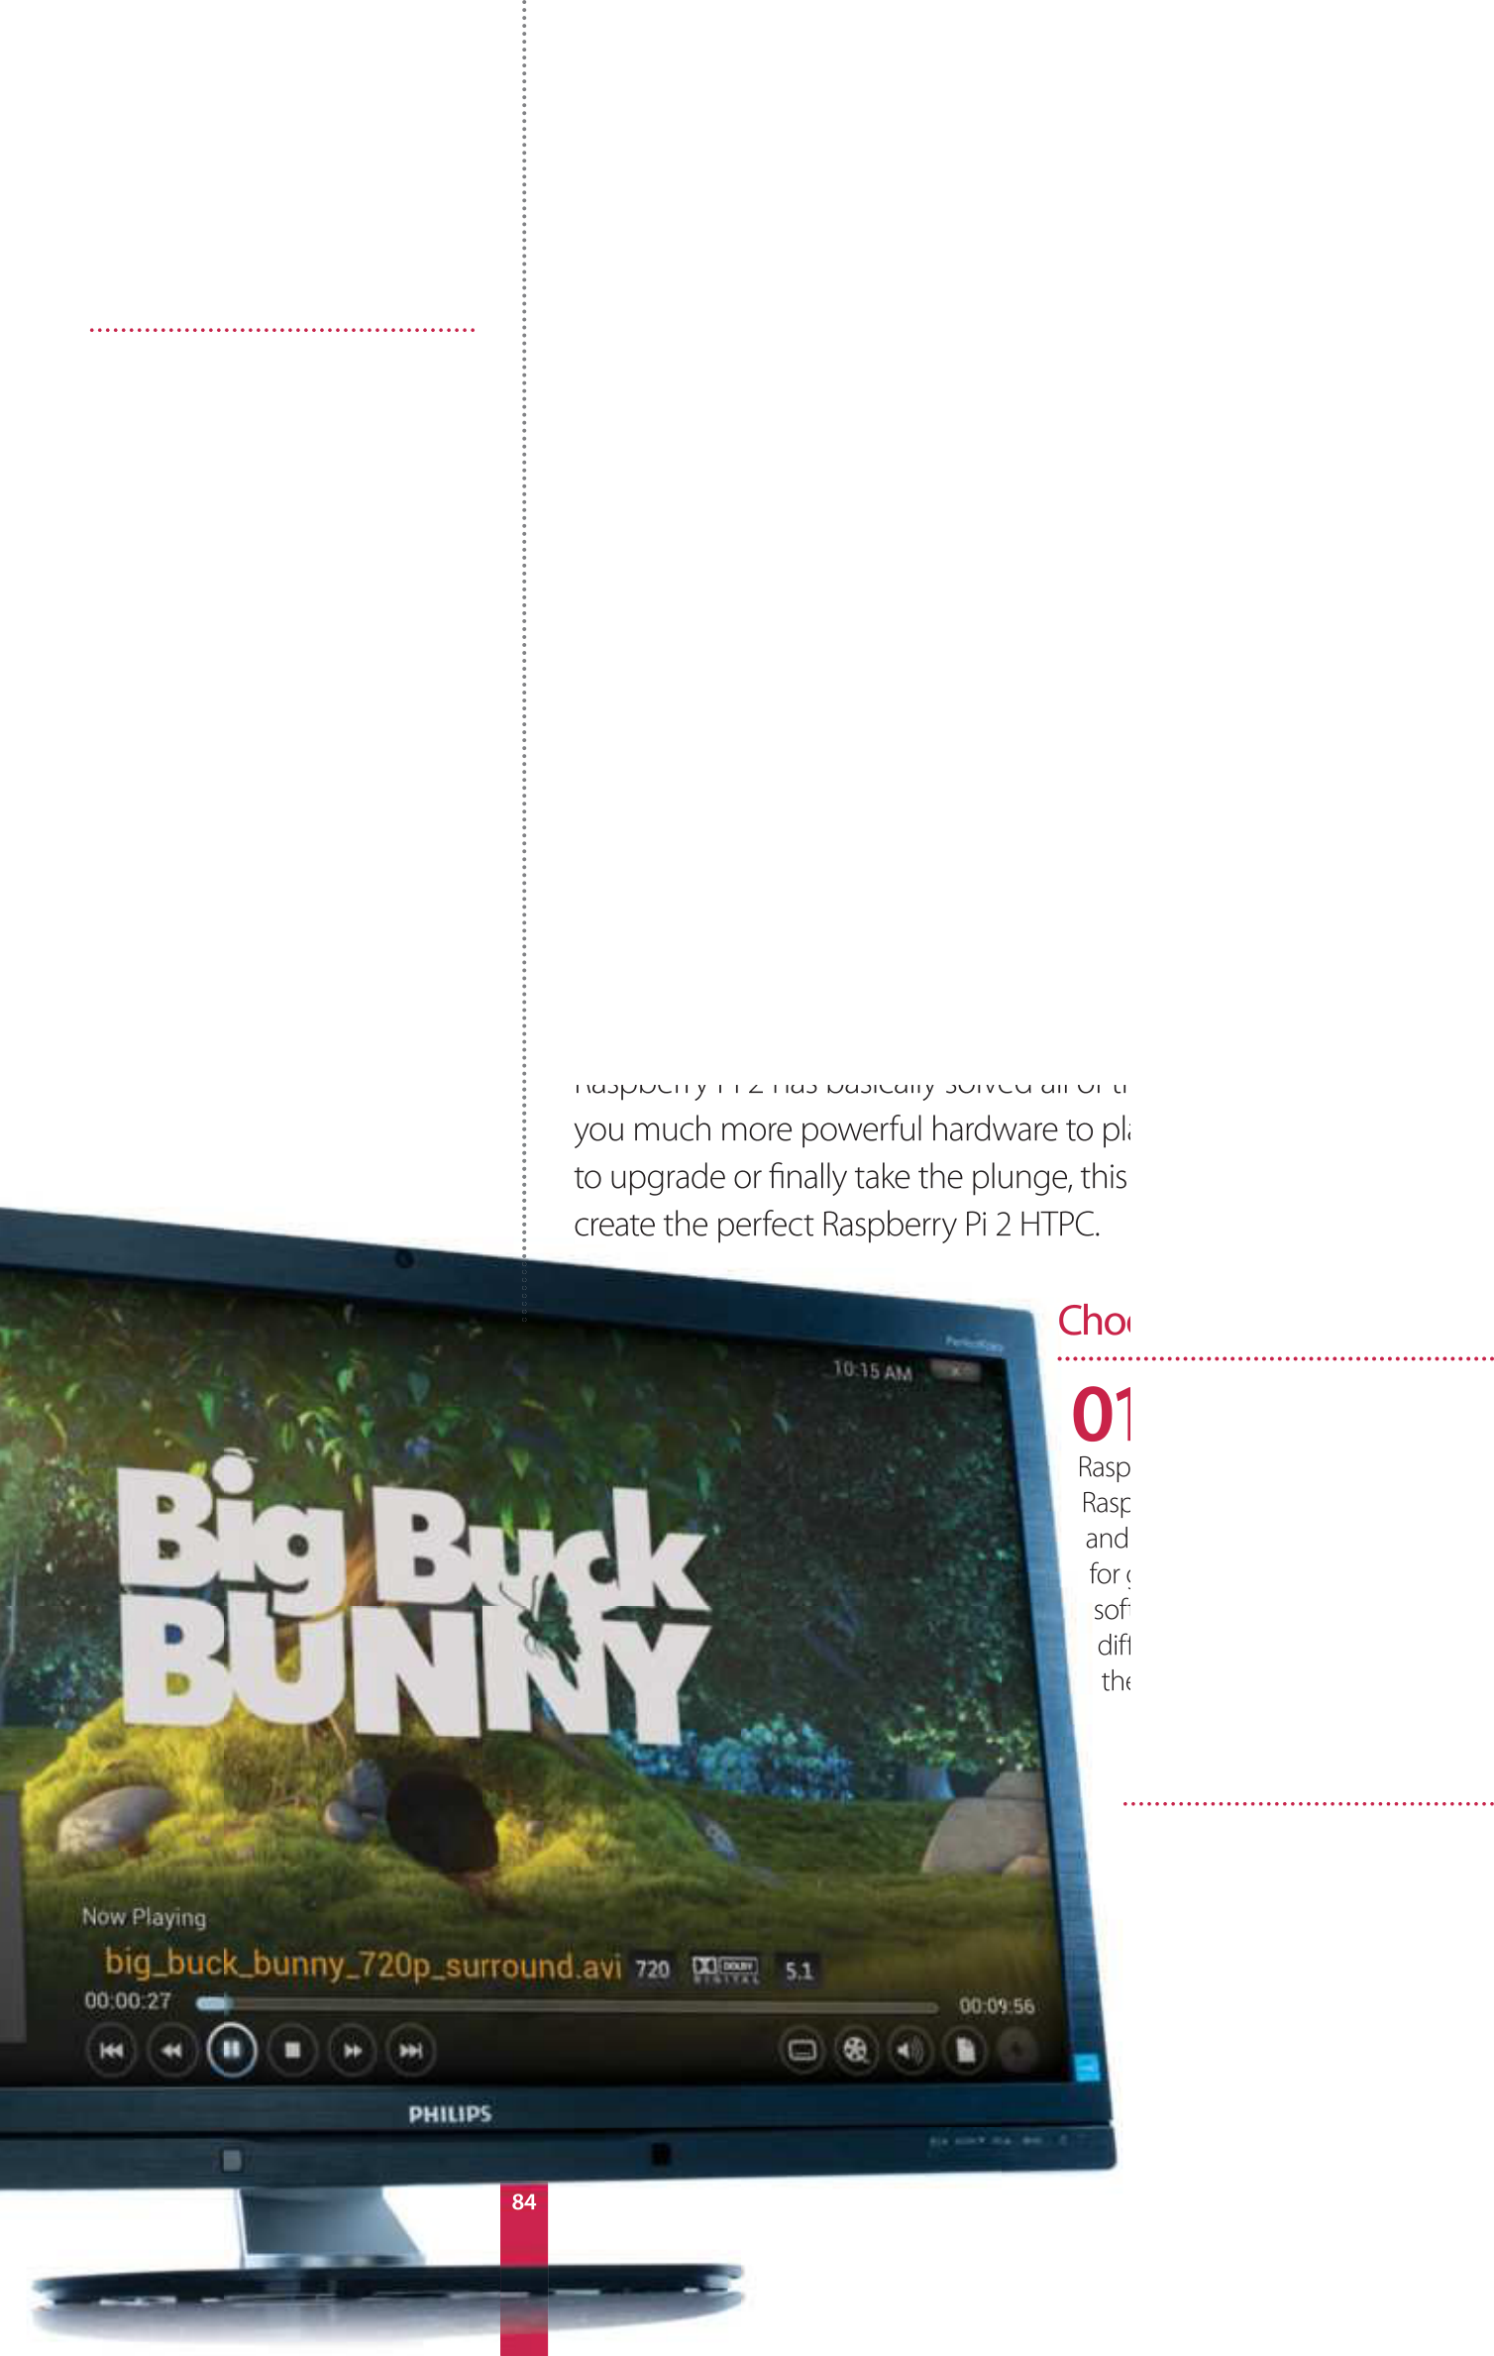

|  |  |
| --- | --- |
| **Projects**  What you’ll need…  **OpenELEC openelec.tv HDMI cable**  **USB IR receiver**  **IR remote**  **Case**  **Dedicated power supply Optional USB storage** | Make a Pi 2 HTPC  Make a  Pi 2 HTPC  Finally create a more powerful and capable  HTPC using the Raspberry Pi 2 and the excellent  OpenELEC project |

Get the software

**02** tv and look for the   
 Head over to openelec.

Download section. There’s a   
specific Raspberry Pi section   
which is split up into original   
(ARMv6) Pi and the newer   
Raspberry Pi 2 (ARMv7). Grab   
the image file from this page   
for the Pi 2.

|  |  |
| --- | --- |
| Make a Pi 2 HTPC | **Projects** |

Install to card

**03** use fdisk -l to determine Open up the terminal and

where your SD card is located on your system. Something like /dev/sdb or / dev/mmcblk0 will be ideal. Navigate to the image using cd and install it with

dd using:

$ dd bs=1M if=OpenELEC-RPi2. arm-5.0.5.img of=/dev/  
 mmcblk0

First boot

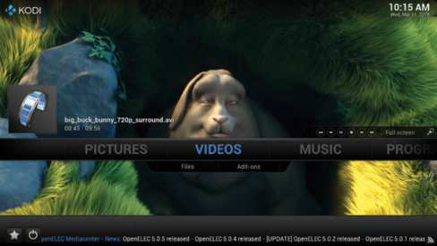

|  |  |
| --- | --- |
| **04** either to your TV or to Plug in your Raspberry Pi,  another screen just to begin with,  and turn it on. OpenELEC will resize the SD card partitions and write a few extra programs before finally booting | “It’s a great use for the Pi – it works just well enough that you can easily play media locally or over the network” |

into Kodi.

Configure Kodi

**05** to get through the interface – Go through the basic wizard

if you are connecting via wireless you will need to go to OpenELEC in the System menu and activate the wireless receiver before selecting your network and then entering your password.

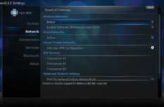

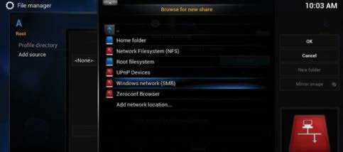

Add network shares

**07** time, we highly recommend getting a case for it – the Pibow cases from Placement of your Raspberry Pi is important. As it’s going to be out all the

Pimoroni are quite well suited for this type of use as they are sturdy and can be attached to the rear of some TVs.

|  |  |  |
| --- | --- | --- |
| Add network shares | IR sensors and controllers | Future updates |
| **06** hard drive or USB stick to the You can attach a portable  Pi for storage, but it is really to stream | **08** a number of different things Kodi can be controlled with  – including USB game controllers | **09** ability to update itself   OpenELEC has the excellent  without needing you to reinstall |
| over the network. Go to File manager | and compatible IR sensors. We’ve | it every few months, meaning |
| under System and Add source. Go | used FLIRC in the past, but if you | you won’t need to do much |
| to Browse and choose your network | have your Pi behind the TV, you’ll | maintenance on it at all. Now you |
| protocol to browse the network or | need a sensor on a wire that can | can sit back and enjoy your media |
| alternatively, add it manually. | stretch to a useful position. | much easier than before. |

|  |
| --- |
| **85** |

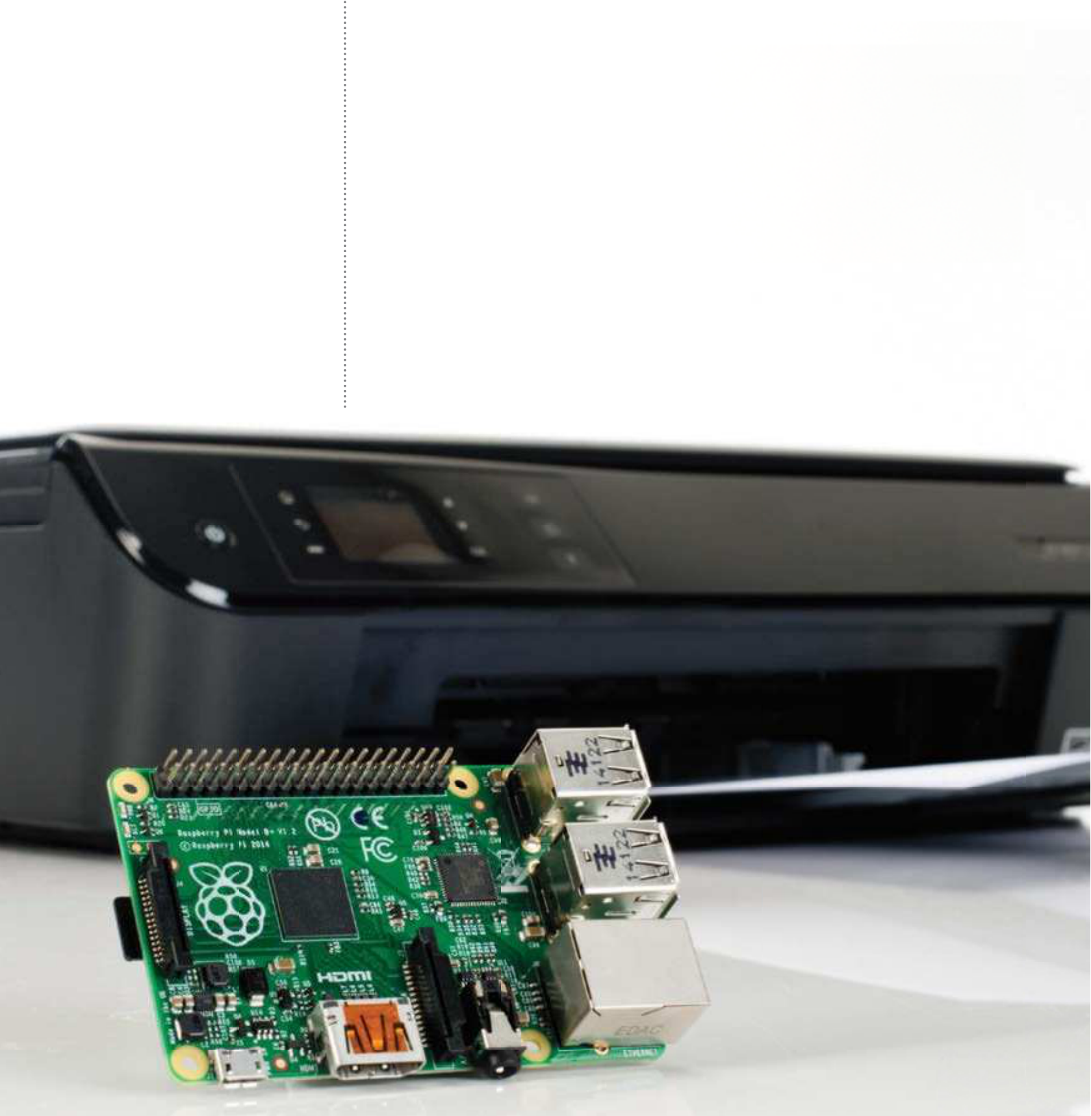

|  |  |
| --- | --- |
| **Projects**  What you’ll need…  **Latest Raspbian image USB printer**  **USB wireless card** | Print wirelessly  Print wirelessly |
| with your Pi |

Breathe new life into an old printer by using your Raspberry Pi as a wireless print server

Wireless printing has made it possible to print to devices stored in cupboards, sheds and remote rooms. You don’t have to own a shiny new printer for this to work; old printers without native wireless support don’t have to end up in the bin, thanks to the Raspberry Pi.

The setup is simple. With your Pi set up with a wireless USB dongle, you connect your printer to a spare USB port on the computer. With Samba and CUPS (Common Unix Printing System) installed on the Raspberry Pi, all that is left to do is connect to the wireless printer from your desktop computer, install the appropriate driver and start printing.

CUPS gives the Raspberry Pi a browser-based admin screen that

|  |  |
| --- | --- |
| **Below** Setting your Raspberry Pi to print wirelessly is a great way to get rid of  annoying cables at your workstation | can be viewed from any device on your network, enabling complete control over your wireless network printer. |

|  |  |
| --- | --- |
| Print wirelessly  Check your printer works | **Projects**  Join a Windows workgroup |
| **01** still works and has enough ink. The easiest way to do this is to check the Before starting, check that the printer you’re planning to use for the project  documentation (online if you can’t find the manual) and run a test print. | **07** search for “workgroup” in With these additions made,  the configuration file and then add |

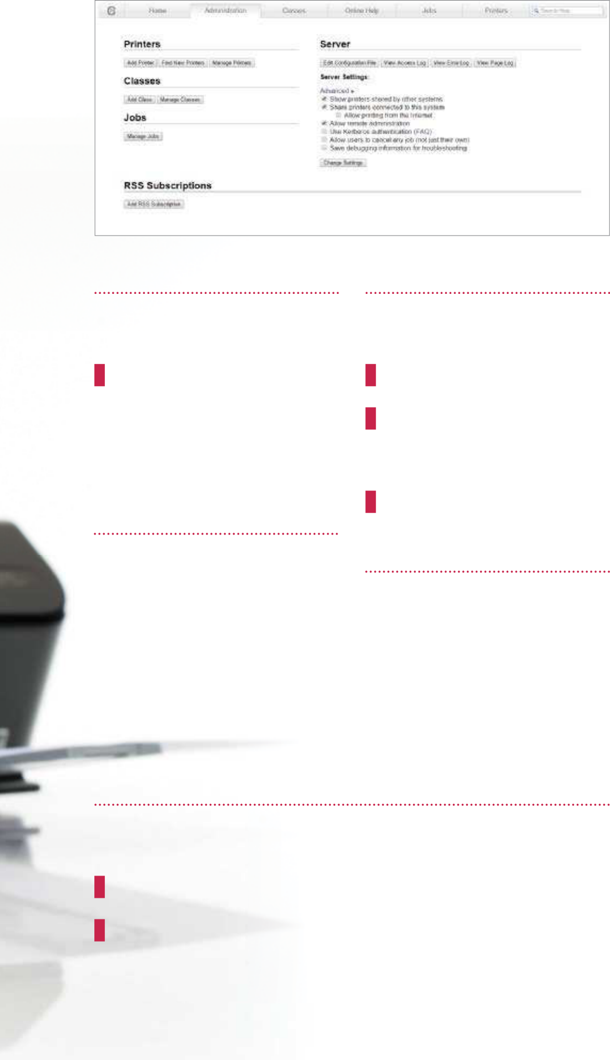

your workgroup:

workgroup = your_ workgroup_name

wins support = yes   
Make sure you uncomment the second setting so that the print server can be seen from Windows. Next, save your changes and then restart Samba:

sudo /etc/init.d/samba restart

|  |  |  |
| --- | --- | --- |
| Detect your printer | Install Samba and CUPS |  |
| **02** up as usual and the printer With your Raspberry Pi set  connected to a spare USB port, enter: | **03** enable file and print sharing Install Samba on your Pi to  across the entire network: |  |
| lsusb | sudo apt-get install samba |
| This will confirm that the printer has | Next, install CUPS: |
| been detected by your Raspberry | sudo apt-get install cups |
| Pi. In most cases you should see the |
| With a print server created, begin |
| manufacturer and model displayed. |
| configuration by adding default user |
| ‘pi’ to the printer admin group: | Accessing your printer |
|  |
|  | sudo usermod -a -G lpadmin pi |  |
| Set up print admin |  |
|  |
| |  |  | | --- | --- | | **04** | Set up the CUPS print admin | | Add your printer | **08** access your wireless printer Meanwhile, it’s a lot easier to |
| tool. Boot into the GUI (startx) and launch the browser, entering | from a Linux, Mac OS X or other |
| **05** displayed, so select yours to A list of printers will be  proceed to the next screen where | Unix-like system, thanks to CUPS. |
| 127.0.0.1:631. Switch to Administration, | All you need to do is add a network |
| before ensuring that the ‘Share printers’ | printer in the usual way and the |
| and ‘Allow remote administration’ | you can confirm the details, add | device will be displayed. |
| boxes are selected. Select Add Printer | a name and check the Share This | Add AirPrint compatibility |
| and proceed to enter your Raspbian | Printer box. Click Continue to load the |
| username and password. | list of printer drivers and select the |

appropriate one from the list.

Configure Samba for network printing

**06** configuration. Open ‘/etc/samba/smb.conf’ in nano, search (Ctrl+W) for Using a Windows computer for printing? Samba will need some

‘[printers]’ and find ‘guest ok’ which you should change as follows: guest ok = yes   
Next, search for “[print$].” Then change the path as follows:   
 path = /usr/share/cups/drivers

**09** wirelessly from your Apple It’s also possible to print

iPad using Apple’s AirPrint system. To do this, you need to add the Avahi Discover software:

sudo apt-get install avahi- discover   
Your wireless printer will now be   
discoverable from your iPad or iPhone and will be ready to print.

|  |
| --- |
| **87** |

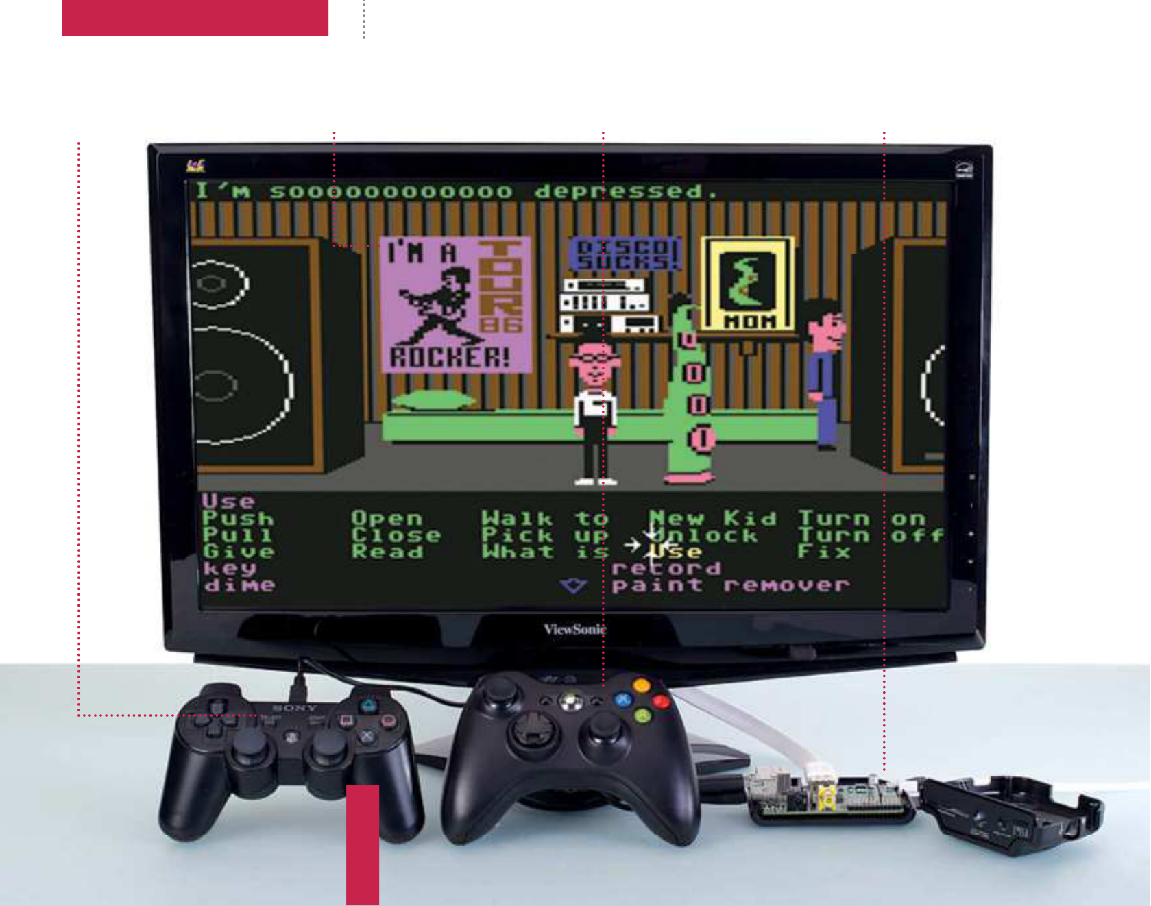

|  |  |
| --- | --- |
| **Projects**  What you’ll need…  **RetroPie**  blog.petrockblock.com/download/  retropie-project-image/ | Make your own retro games console  Make your own retro games  console |

Get your retro gaming f x with RetroPie, a distro for getting the games of yesteryear onto your Pi

|  |  |  |  |
| --- | --- | --- | --- |
| **Did you know…**  Emulation is something of a legal minef eld. You must own the original games to emulate them on your Pi.  **Take control**  Properly configure USB and PS3 controllers out of the box | There’s a growing trend for people to create their own arcade cabinet or hack together their own retro console, and the Raspberry Pi’s size and power makes it perfect for this. Follow our tutorial to turn your Pi into a fully functional emulating powerhouse. | | |
| **Fast and flexible** | **Xbox-friendly** | **Decades of fun** |
| Configure RetroPie for more | Install drivers to use the Xbox | Turn your Raspberry Pi into the |
| power control | 360 controller | ultimate portable retro console |
|  | | | |

|  |
| --- |
|  |

|  |
| --- |
| **88** |

|  |  |
| --- | --- |
| Make your own retro games console | **Projects** |

Install RetroPie

**01** image from the website and Download the latest RetroPie

unzip it. Like installing other Raspberry Pi distros, you simply need to write the image to the SD card with:

$ sudo dd bs=4M if=[path   
to image] of=/dev/[path to sd

Recognising the 360 controller

**05** file by first going to tools with:   
 Add the 360 pad to your configuration

$ cd ~/RetroPie/emulators/RetroArch/tools   
Then type in the following:  
 $ ./retroarch-joyconfig -o p1.cfg -p 1 -j 0   
And finally add the files to RetroArch with:  
 $ sudo cat p*.cfg >> ~/RetroPie/configs/all/retroarch.cfg

card] Save and reboot.

Initial setup Add some games

**02** asked to configure a controller, On the first boot, you’ll be

which can be done with a keyboard,

a standard USB controller or a PS3

**06** the Pi and put it in your PC. Move any ROMs or compatible PC files to the Adding games to your Raspberry Pi is fairly simple. Grab the SD card from

relevant folders in:

[path to SD card]/home/pi/RetroPie/roms/

|  |  |  |  |  |
| --- | --- | --- | --- | --- |
| controller. The initial setup on RetroPie is for very limited controls, and you’ll need to launch a separate tool for  better config.  Calibrating controllers   |  |  | | --- | --- | | **03** | Press the menu button you set up, and go to exit. You’ll | |  | |
| Navigate RetroPie  **07** know if there are games for RetroPie will automatically  a specific emulator and allow you to access it. Pressing left or right will move between the emulators, which then have options to load the games on the SD card. | Safe restart  **09** be quit out of, meaning you’ll Some of the emulators can’t  need to physically reboot your Pi by |
| get to a command line. Connect a USB controller and enter the following:  $ cd RetroPie/emulators/ RetroArch/tools …and then:  $ ./retroarch-joyconfig >> ~/ RetroPie/configs/all/retroarch.  cfg  Follow on the on-screen instructions to properly configure your controller. |
| Using an Xbox 360 pad  **04** PC-compatible Xbox 360 To use a wired or  controller, you’ll first need to install the correct drivers:  $ sudo apt-get install  xboxdrv  Then edit /etc/rc.local by adding:  xboxdrv --trigger-as-button --wid 0 --led 2 --deadzone 4000 --silent &  sleep 1 …before exit 0. Change --wid to --id if it’s a wired controller. Reboot. |
| Two players | unplugging it each time. We can add a hotkey to exit the emulators by again |
| **08** best to use two controllers of For multiplayer gaming, it’s  the same type. Go to the bottom of ~/ | going to retroarch.cfg and adding to the end:  input_enable_hotkey_btn = |
| RetroPie/configs/all/retroarch. | “X” |
| cfg and copy and paste the code | input_exit_emulator_btn = |
| from input_player1_joypad_index | “Y” |
| = “0” to the bottom. Change each | …with X and Y being the |
| instance of player1 to player 2, and a | corresponding numbers of buttons on |
| second controller will now work. | your controller. |

|  |
| --- |
| **89** |

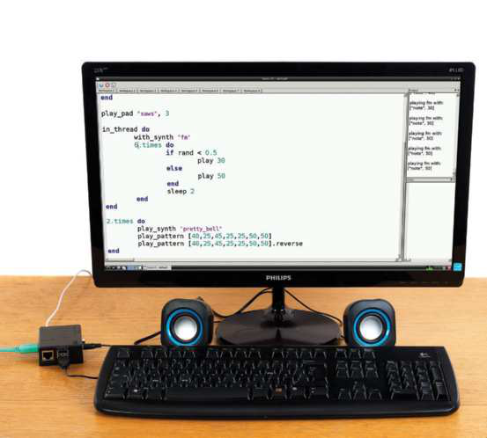

|  |  |
| --- | --- |
| **Projects**  What you’ll need…  **Portable speakers**  **or headphones**  **Sonic Pi**  www.cl.cam.ac.uk/projects/raspberrypi/  sonicpi/teaching.html | Make music with Sonic Pi  Make music  Program your own melodies using Sonic Pi and  create musical cues or robot beeps |

One of the major features of Scratch is its ability to teach the

fundamentals of coding to kids and people with no computing

background. For kids, it’s especially appealing due to the way it

allows them to create videogames to interact with as part of their

|  |  |
| --- | --- |
| **Did you know…**  Sonic Pi is installed by default on the latest versions of the Raspbian operating system. If it’s missing, follow Step 1! | learning. In this kind of vein then, Sonic Pi teaches people to code using music. With a simple language that utilises basic logic steps but in a more advanced way than Scratch, it can either be used as a next step for avid coders, or as a way to create music for an Internet of Things or a robot. |

“We can start making more   
complex melodies by using more

|  |  |
| --- | --- |
| **Below** Sonic Pi is a great way to learn basic | of Sonic Pi’s functions” |

coding principles and have fun

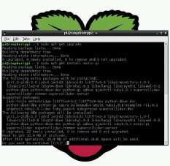

Getting Sonic Pi

**01** version of Raspbian, Sonic Pi   
 If you’ve installed the latest

will be included by default. If you’re   
still using a slightly older version, then   
you’ll need to install it via the repos.

Do this with:

$ sudo apt-get install sonic-  
pi

|  |
| --- |
| **90** |

|  |  |  |
| --- | --- | --- |
| Make music with Sonic Pi  Start with Sonic Pi | | **Projects**  Set the beat |
| **02** and you’ll be presented with something that looks like an IDE. The pane Sonic Pi is located in the Education category in the menus. Open it up  on the left allows you to enter the code for your project, with proper syntax highlighting for its own style of language. When running, an info pane details exactly what’s being played via Sonic Pi – and any errors are listed in their own pane as well, for reference.  Your first note | | **04** you’ll want to set the For any piece of music,  tempo. We can start by putting: with_tempo 200 …at the start of our code. We can test it out by creating a string of midi notes using play_pattern:  play_pattern |
| **03** Sonic Pi is simply being Our first thing to try on  able to play a note. Sonic Pi has a few defaults preset, so we can get started with:  play 50  Press the Play button and the output window will show  you what’s being played. The pretty_bell sound is the default tone for Sonic Pi’s output, and 50 determines the pitch and tone of the sound. |  | [40,25,45,25,25,50,50]  This will play pretty_bell notes at these tones at the tempo we’ve set. You can create longer and shorter strings, and also change the way they play. |
| Advance your melody   |  |  | | --- | --- | | **05** | We can start making more complex melodies by | |
| Full code listing  with_tempo 200  play_pattern [40,25,45,25,25,50,50]  2.times do   with_synth “beep”  play_pattern [40,25,45,25,25,50,50]   play_pattern [40,25,45,25,25,50,50].reverse end  play_pad “saws”, 3  in_thread do   with_synth “fm” | |
| using more of Sonic Pi’s functions.  You can change the note type  by using with_synth, reverse a  pattern, and even create a finite loop with the x.times function; do and end signify the start and end of the loop. Everything is played in sequence before repeating,  much like an if or while loop in normal code. |

6.timesdo   
 if rand < 0.5   
 play 30

Playing a concert

|  |  |  |  |  |
| --- | --- | --- | --- | --- |
| end | end | else | play 50 | **06** function, we are able to Using the in_thread  create another thread for the |
| end |
| sleep 2 | Sonic Pi instance, and have |
| several lines of musical code play |
| at once instead of in sequence. |

We have made it create a series of 2.timesdo notes in a random sequence, and

play_synth “pretty_bell”  
play_pattern [40,25,45,25,25,50,50]   
play_pattern [40,25,45,25,25,50,50].reverse

have them play alongside extra notes created by the position and velocity of the mouse using the

end play_pad function.

|  |
| --- |
| **91** |



|  |  |
| --- | --- |
| **Projects**  What you’ll need…  **Portable USB speakers python-espeak module eSpeak**  **Raspbian (latest image)** | Voice synthesizer  Voice  synthesizer |

Add the power of speech to your Raspberry Pi projects with the versatile eSpeak Python library

We’ve shown how the Raspberry Pi can be used to power all kinds of projects, but as a tiny computer it can also be the centre of an Internet of Things in your house too. For these reasons and more, using the Raspberry Pi for text-to-voice commands could be just

|  |  |  |  |
| --- | --- | --- | --- |
| **Did you know…** | | what you’re looking for. Due to the Debian base of Raspbian, the | |
| Using eSpeak you can control the way the words are spoken | | powerful eSpeak library is easily available for anyone looking to make use of it. There’s also a module that allows you to use eSpeak | |
| to add emphasis or make the voice sound diferent. | | in Python, going beyond the standard command-line prompts so you can perform automated tasks. | |
|  | | | Pi’s first words |
| **02** simple to use – to get it to just The eSpeak library is pretty  say something, type in the terminal:  $ espeak “[message]” This will use the library’s defaults  to read whatever is written in the  message, with decent clarity. Though this simple command is fun, there’s much more you can do…  Say some more |
| **03** eSpeak will read text with a You can change the way  number of different options, such as |
| Everything you’ll need  **01** to use in this tutorial at once. We’ll install everything we plan  This includes the eSpeak library and the Python modules we need to show it off. Open the terminal and install with:  $ sudo apt-get install espeak python-espeak python-tk |  | |
|  | | gender, read speed and even the way it pronounces syllables. For example, writing the command like so:  $ espeak -ven+f3 -k5 -s150 “[message]” …will turn the voice female,  emphasise capital letters and make the reading slower. |

|  |
| --- |
| **92** |

|  |  |  |
| --- | --- | --- |
| Take command | Voice synthesizer | **Projects** |
| Full code listing |
| with Python |

Import the 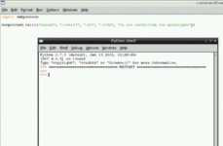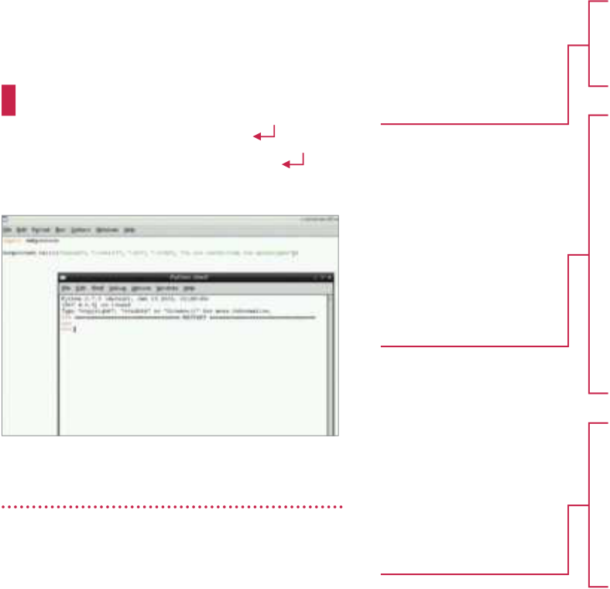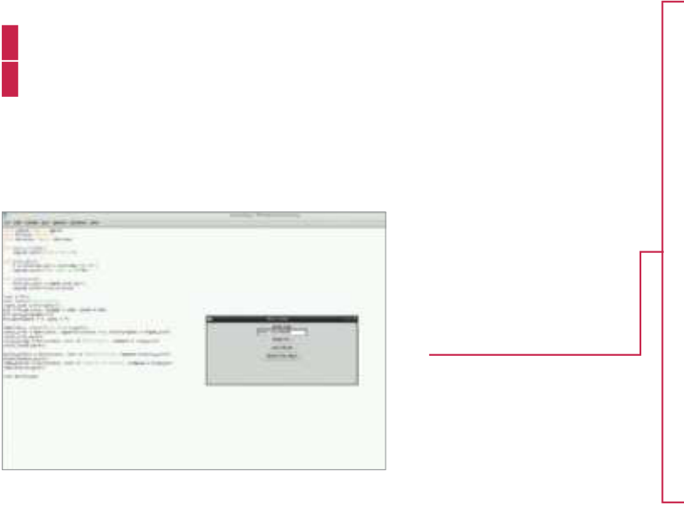

|  |  |  |
| --- | --- | --- |
| **04** eSpeak in Python is to use The most basic way to use  subprocess. Import it, then use: | necessary eSpeak | from espeak import espeak |
| and GUI modules, as | from Tkinter import * |
| well as the module | from datetime import datetime |
| subprocess.call([“espeak”, | to find out the time | def hello_world(): |
| “[options 1]”, “[option |
| 2]”,...”[option n]”, “[your | Define the different | espeak.synth(“Hello World”) |
| message here]”) | def time_now(): |
| functions that the |
| interface will use, |
| t = datetime.now().strftime(“%k %M”) |
| including a simple |
| espeak.synth(“The time is %s”%t) |
| fixed message, |

telling the time and   
a custom message def read_text():  
 text_to_read = input_text.get() espeak.synth(text_to_read)

|  |  |  |  |  |  |
| --- | --- | --- | --- | --- | --- |
| The native tongue  **05** is quite simple to use to just The Python eSpeak module  convert some text to speech. Try this sample code:  from espeak import espeak  espeak.synth(“[message]”) You can then incorporate this into Python, like you would any other module, for automation.    A voice synthesiser   |  |  | | --- | --- | | **06** | Using the code listing, we’re | | Create the basic | | |
| window with Tkinter | | root = Tk() |
| for your interface, | root.title(“Voice box”) | |
| as well as creating | input_text = StringVar() | |
| the variable for | box = Frame(root, height = 200, width = | |
| text entry | 500) | |
| box.pack_propagate(0)  box.pack(padx = 5, pady = 5)  Label(box, text=”Enter text”).pack()  entry_text = Entry(box, exportselection = | | |
| The text entry | 0, textvariable = input_text) | |
| appends to the | entry_text.pack() | |
| variable we created, | entry_ready = Button(box, text = “Read | |
| and each button | this”, command = read_text) | |
| calls a specific | entry_ready.pack() | |
| function that we | | |
| defined above in | hello_button = Button(box, text = “Hello | |
| the code | World”, command = hello_world) | |
| hello_button.pack()  time_button = Button(box, text = “What’s  the time?”, command = time_now)  time_button.pack()  root.mainloop() | | |
| “There’s even a module that allows you to use eSpeak in Python, so you can perform automated tasks” | | |
| creating a simple interface  with Tkinter with some predetermined voice buttons and a custom entry  method. We’re showing how the  eSpeak module can be manipulated to change its output. This can be  used for reading tweets or automated |

messages. Have fun!

|  |
| --- |
| **93** |

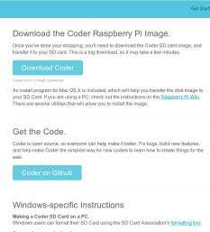

**Projects**

What you’ll need…

**Internet connectivity**   
**Web browser**   
**Google Coder**   
googlecreativelab.github.io/coder/ raspberrypi/sonicpi/teaching.html

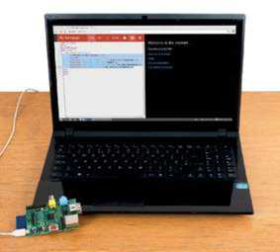

|  |
| --- |
| **Below** Google Coder is a  brilliant way to introduce  yourself to web development |

Get Google Coder

|  |
| --- |
| **01** website, and download the Head to the Google Coder  compressed version of the image. Unpack it wherever you wish, and install it using dd, like any other Raspberry Pi image:  $ dd if=[path to]/raspi.img of=/dev/[path to SD card] bs=1M  **94** |

Build your first web server

Build your first web server

Use Google Coder to turn your Raspberry Pi into a tiny, low-powered web server and web host!

We’re teaching you how to code in many diferent ways on the Raspberry Pi in this book, so it only seems ftting that we look at web development too.

There’s a new way to use the web on the Raspberry Pi as well: internet giant Google has recently released Coder specifcally for the tiny computer. It’s a Raspbian-based image that turns your Pi into a web server and web development kit. Accessible easily over a local network and with support for jQuery out of the box, it’s an easy and great way to further your web development skills.

|  |  |
| --- | --- |
|  | Plug in your Pi |
|  | **02** need to connect a network For this tutorial, you’ll only  cable into the Pi. Pop in your newly written SD card, plug in the power and wait a few moments. If you’ve got a display plugged in anyway, you’ll notice a Raspbian startup  sequence leading to the command-line login screen. |

|  |
| --- |
|  |

Connect to Coder

**03** You may have to manually accept the licence. It will ask you to set up your Open up the browser on your main system, and go to http://coder.local.

password, and then you’ll be in and ready to code.

|  |  |  |  |
| --- | --- | --- | --- |
| Language of the web | Build your first web server | | **Projects** |
| Full code listing | | |
| **04** your own app or website. Now it’s time to create  Click on the ‘+’ box next to the examples, give your app a name and then click Create. You’ll be taken to the HTML section of the app. Change the Hello World  lines to: | HTML | | |
| Some simple HTML code that can  point us to some  important websites. The h2 tag is used | <h1>Welcome to the internet...</h1> <h2></h2>  <p><a href=”http://www.linuxuser.  co.uk”>Linux User & Developer</p> <p><a href=”http://www.reddit.  com/”>Reddit</p>  <p><a href=”http://www.linuxfoundation.  org/”>The Linux Foundation</p> | |
| <h1>This is a HTML header</h1> | to display the time thanks to Java |
| <p>This is a new block of default text</p>    Styled to impress  **05** changes the look and style Click on the CSS tab. This  of the webpage without having to make the changes each time in the main code. You can change the background colour and font with: | <p><a href=”http://www.fsf.org/”>Free Software Foundation</p>  Java  We’re calling the | | |
| current time using | var d = new Date; | |
| jQuery in the JS | var hours = d.getHours(); | |
| tab so that we can | var mins = d.getMinutes(); | |
| ultimately display it | if (hours > 12) { | |
| on the webpage | var hour = (hours - 12); | |
| We’re going to  display the time as a 12-hour clock in  the first if statement, and use AM and PM to differentiate  the time | var ampm = “PM”;  } | |
| else {  var hour = hours; var ampm = “AM”; }   if (hours == 12) {  var ampm = “PM”; | |
| } | | |
| body {   background-color: #000000; | if (mins > 9){ | | |
| We make the  minutes readable | var min = mins;  }   else {  var min = “0” + mins;  }  var time = “The time is “ + hour + “:” + min + “ “ + ampm;  $(“h2”).html(time); | |
| color: #ffffff; }  Querying your Java  **06** to edit the jQuery, making The third tab allows you  the site more interactive. We can | by adding a 0 if  it’s below 10, then concatenate all the variables and assign to the tag h2 |
| make it create a message on click with: | “Coder is a Raspbian-based image that | | |
| $(document).click(function() {   alert(‘You clicked the website!’);  } | turns your Raspberry Pi into a web server and web development kit. It’s an easy and great way to further your skills” | | |

);

|  |
| --- |
| **95** |

|  |  |
| --- | --- |
| **Projects**  What you’ll need…  **Internet connectivity**  **Latest version of Raspbian**  www.raspberrypi.org/ downloads | Code your own Twitter bot |
| Code your own Twitter bot |

Create your very own Twitter bot that can retweet

chunks of wisdom from others

|  |  |
| --- | --- |
| Installing the | Twitter is a useful way of sharing information with the world and it’s our favourite method of giving our views quickly and conveniently.  Many millions of people use the microblogging platform from their computers, mobile devices and possibly even have it on their televisions.  You don’t need to keep pressing that retweet button, though. With a sprinkling of Python, you can have your Raspberry Pi do it for you. Here’s how to create your own Twitter bot…  Full code listing |
| required software  **01** with the username Pi and the Log into the Raspbian system  password raspberry. Get the latest |
| #!/usr/bin/env python2  # A Twitter Bot for the Raspberry Pi that retweets any content from |

package lists using the command

sudo apt-get update. Then install import sys

the Python Package installer using import time

sudo apt-get install python-pip. from datetime import datetime

Once you’ve done that, run sudo pip from twython import Twython

install twython to install the Twitter

library we’ll be using. class bot:

def __init__(self, c_key, c_secret, a_token, a_token_ 

secret):

|  |  |
| --- | --- |
| Registering your ‘app’ with Twitter | # Create a Twython API instance  self.api = Twython(c_key, c_secret, a_token,  a_token_secret) |

**02** Twitter using OAuth. Before We need to authenticate with

this, you need to go to https://dev.

# Make sure we are authenticated correctly try:  
 self.api.verify_credentials()

twitter.com/apps and sign in with except:

the account you’d like your Pi to sys.exit(“Authentication Failed”)

tweet from. Click the ‘Create a new

application’ button. We called our self.last_ran = datetime.now()

application ‘LUD Pi Bot’ and set the

website to www.linuxuser.co.uk. @staticmethod

|  |
| --- |
| **96** |

|  |  |  |
| --- | --- | --- |
| Creating an access token  **03** change the Access type Go to the Settings tab and  from ‘Read only’ to ‘Read and Write’.  Then click the ‘Update this Twitter  application’s settings’ button. Next we create an access token. Click the ‘Create my access token’ button. If you refresh the details page, you should | Code your own Twitter bot | **Projects** |
| def timestr_to_datetime(timestr):   # Convert a string like Sat Nov 09 09:29:55 +0000 # 2013 to a datetime object. Get rid of the timezone # and make the year the current one  timestr = “{0} {1}”.format(timestr[:19], datetime.  now().year)  # We now have Sat Nov 09 09:29:55 2013  return datetime.strptime(timestr, ‘%a %b %d %H:%M:  %S %Y’) | |

have a consumer key, a consumer   
secret and access token, plus an access token secret. This is everything we   
need to authenticate with Twitter.

def retweet_task(self, screen_name):  
 # Retweets any tweets we’ve not seen # from a user   
 print“Checking for new tweets from 

|  |  |
| --- | --- |
| Authenticating with Twitter | @{0}”.format(screen_name)  # Get a list of the users latest tweets |
| **04** bot as a class, where we We’re going to create our  authenticate with Twitter in the  constructor. We take the tokens from the previous steps as parameters and use them to create an instance of the Twython API. We also have a variable, last_ran, which is set to the current time. This is used to check if there are new tweets later on.  Retweeting a user | timeline = self.api.get_user_timeline  (screen_name = screen_name)  # Loop through each tweet and check if it was # posted since we were last called  for t in timeline:  tweet_time = bot.timestr_to_datetime  (t[‘created_at’])   if tweet_time > self.last_ran:   print“Retweeting {0}”.format(t[‘id’]) self.api.retweet(id = t[‘id’])  if __name__ == “__main__”: |

**05** is get a list of the user’s latest The first thing we need to do

tweets. We then loop through each

# The consumer keys can be found on your application’s # Details page located at https://dev.twitter.com/ # apps(under “OAuth settings”)

tweet and get its creation time as a c_key=””

string, which is then converted to a c_secret=””

datetime object. We then check that

|  |  |
| --- | --- |
| the tweet’s time is newer than the  time the function was last called – and if so, retweet the tweet.  The main section | # The access tokens can be found on your applications’s # Details page located at https://dev.twitter.com/apps # (located under “Your access token”)  a_token=””  a_token_secret=”” |

**06** straightforward. We create The main section is

an instance of the bot class using our

tokens, and then go into an infinite

# Create an instance of the bot class  
 twitter = bot(c_key, c_secret, a_token, a_token_secret)

# Retweet anything new by @LinuxUserMag every 5 minutes

loop. In this loop, we check for any whileTrue:

new retweets from the users we are monitoring (we could run the retweet task with different users), then update the time everything was last run, and

# Update the time after each retweet_task so we’re # only retweeting new stuff  
 twitter.retweet_task(“LinuxUserMag”)  
 twitter.last_ran = datetime.now()

sleep for five minutes. time.sleep(5 * 60)

|  |
| --- |
| **97** |

|  |  |
| --- | --- |
| **Projects**  What you’ll need…  **ADXL accelerometer** shop.pimoroni.com  **Latest Raspbian Image** www.raspberrypi.org/downloads  **Breadboard**  shop.pimoroni.com  **Male-to-female**  **prototyping cables** shop.pimoroni.com  **30W soldering iron** shop.pimoroni.com | Use an accelerometer |
| Use an  accelerometer  Adding tilt technology to your next Raspberry Pi  project is easier than you might think  In this project we’ll be using an ADXL345 accelerometer kit to create |

a prototype controller for a Space Invaders-style game we’re working on. The kit is only £20, but does require about 15 minutes of basic soldering. Beyond that, the physical setup is really quite simple. We’ll be placing the ADXL345 on our breadboard ‘controller’ and using just four wires to communicate with the Raspberry Pi’s GPIO pins using I2C. You’ll have a full set-up guide available from the retailer.

Let’s start by making sure your Pi is up to date. Open a terminal window and type: sudo apt-get update && sudo apt-get upgrade

Install i2c-tools Full code listing

|  |
| --- |
| **01** install i2c-tools followed In a terminal, type: sudo apt-get  by sudo nano /etc/modprobe.d/ |

raspi-blacklist.conf. This will open a file in nano – locate the line ‘blacklist i2c-bcm2708’ and comment it out so it looks like this:

#blacklist i2c-bcm2708   
Save with Ctrl+X, then press Y and Enter to exit. Finally, edit the /etc/modules file with nano, adding the line i2c-bcm2708 i2c-dev to ensure it loads every time you boot. Reboot to finish the operation.

Connect the hardware

**02** smbus Python library. Type We’ll also need to install the

sudo apt-get install python-

import pygame   
from adxl345 import ADXL345

adxl345 = ADXL345() # Initialise the accelerometer pygame.init() # Initialise Pygame

# Create a screen of 800x600 resolution screen = pygame.display.set_mode([800, 600])

# Name the game window   
# Set the mouse visibility and start an FPS clock   
pygame.display.set_caption(‘ADXL345 Space Test - Press ESC 

to quit’)   
pygame.mouse.set_visible(False)   
clock = pygame.time.Clock()

# Load the images we’re using from:   
# http://opengameart.org/users/rawdanitsu   
background_image = pygame.image.load(“Space-Background-4_0.

jpg”).convert()   
player_image = pygame.image.load(“ship0.png”).convert()

|  |  |
| --- | --- |
| smbus in the terminal. Then wire up the accelerometer to the Pi with male-to-female prototyping cables. The correct pins are marked on the ADXL345, but check our pictures for where to plug things into the Pi. | # We can use colour key method to remove the # background from the ship  player_image.set_colorkey([0, 0, 0])  player_position = [450, 350] # Initial ship tarting point game_over = False# decide if the game should end |

|  |
| --- |
| **98** |

|  |  |
| --- | --- |
| Use an accelerometer | **Projects** |

Final checks

|  |  |  |
| --- | --- | --- |
|  | “We’ll be placing the | **03** to Pi, power it up, open a   With accelerometer attached  terminal window and type: sudo |
| ADXL345 on our |
| breadboard ‘controller’ | i2cdetect -y 1. The ‘1’ at the |
| end assumes you’re using a Rev 2 |
| using I2C” |
| Pi – replace it with ‘0’ if yours is older. |
| You should see some numbers |

denoting that the ADXL345 has been

defupdate_pos():  
 “““ Poll the adxl345 and update player pos based on 

readings”””  
 move_data = adxl345.getAxes(True) # Returns a dict of 

axes results   
 if move_data[‘x’] < -0.1or move_data[‘x’] > 0.1: player_position[0] += move_data[‘x’] * 20 if move_data[‘y’] < -0.1or move_data[‘y’] > 0.1: player_position[1] += move_data[‘y’] * 20

defcheck_pos():  
 “““ Check player pos to make it wrap-around the game window””” if player_position[0] > 850:   
 player_position[0] = -75 elif player_position[0] < -75: player_position[0] = 850

if player_position[1] > 650:   
 player_position[1] = -75   
elif player_position[1] < -75:   
 player_position[1] = 650

###### MAIN PROGRAM LOOP ######   
while not game_over: # Handle control events while the 

game is in play   
 for event in pygame.event.get():   
 if event.type == pygame.QUIT:   
 game_over = True# Quit if close button 

is pressed   
 if event.type == pygame.KEYDOWN:   
 if event.key == pygame.K_ESCAPE:   
 game_over = True   
 # Quit if escape key is pressed

update_pos() # Update the player’s position check_pos() # Check the player’s position

# Update the background then the player’s position on 

the screen   
screen.blit(background_image, [0, 0])   
screen.blit(player_image, [player_position[0],player_ 

position[1]])

pygame.display.flip() # Refresh the screen  
 clock.tick(20) # Force frame-rate to desired number

pygame.quit() #Quit gracefully when ‘game_over’ is True

recognised. Finally, we’ll use Git to grab the project – type the following:

sudo apt-get install git

Cloning and testing

**04** to your home folder (with cd From the terminal, navigate

~) and create a project folder for the   
project to live in using: mkdir adxl345_ project. Cd into the folder and from the terminal, type the following to clone the finished project from our **Github.com** account: git clone https://github.

com/russb78/adxl345_project.git

How it works

|  |  |
| --- | --- |
| **05** | To run the project from the adxl345_project folder type: |
| sudo python adxl_345_project.py | |

The Pygame window will open. Pick up your breadboard ‘controller’ and   
tilt it around. The ship should move   
around the screen in reaction to your movements. If it’s backwards, you can adjust the orientation of the breadboard – it might just be ‘upside down’!

Why it works

**06** an excellent backbone for a The code for this project is

Space Invaders-style game written in Python and Pygame. The code collects data from the ADXL345   
accelerometer in the update_pos() function using the move_data   
variable. This data is piped to the   
player_position array – which is in the form of x and y co-ordinates. The move_data pushes the image of the spaceship around the screen.

|  |
| --- |
| **99** |

|  |  |
| --- | --- |
| **Projects**  What you’ll need…  **Latest Raspbian Image**  www.raspberrypi.org/downloads **Breadboard**  **Connectors**  **Jumper wire**  **DSLR camera**  **Compatible shutter cable** | Time-lapse camera trigger |
| Time-lapse  camera trigger  Make shooting time-lapse video with your DSLR  camera a cinch with our expert advice |

You’d be forgiven for thinking that creating mesmerising time-lapse videos like those of Vincent Laforet (www.laforetvisuals.com) or John Eklund (www.theartoftimelapse.com) might be out of reach of the Average Joe. With the help of the Raspberry Pi and a sprinkling of   
Python code, though, that’s no longer the case. In this guide we’re going to trigger our DSLR camera to create pixel-perfect time-lapse imagery…

|  |  |
| --- | --- |
| Set up the Raspberry Pi | Full code listing |
| **01** you’re using a recent build of For this tutorial we’re assuming  Raspbian. With the Raspberry Pi set up with a keyboard, mouse and monitor, open the terminal and type: | import RPi.GPIO as GPIO  import time  print‘\nWelcome to the Complete Manual Time-lapse Tool.’print“Just tell us how many shots you’d like to take and  the interval between them.\n” |
| sudo apt-get update | print“Try googling ‘time-lapse interval calc’ if you need  help deciding.\n” |

Install the RPi.GPIO library

|  |  |
| --- | --- |
| **02** sure your development Next we want to make  environment is set up. Follow these  steps to make sure you’re all set. | def main():  shots = raw_input(‘How many shots would you like to  take?\n ->’)  interval = raw_input(‘How frequently do you want to  take them (in seconds)?\n ->’) |

In the terminal, type:

suda atp-get install python-dev

sudo apt-get install python-rpi.gpio

Set up the Pi Cobbler

**03** used a cheap prototyping For this tutorial we’ve

breadboard and an Adafruit Pi Cobbler to give us easy access to the Raspberry Pi’s GPIO pins. As you can see from   
the picture, the Cobbler straddles the centre-point of the breadboard and a ribbon cable connects the two.

if shots.isdigit() and interval.isdigit(): shots = int(shots)  
 interval = int(interval)

print“You’ll be shooting for %d minutes.\n” % 

(shots * interval / 60)  
 answer = raw_input(‘Are you ready to proceed?(yes/ 

no):’)  
 confirm = answer.lower() in [‘yes’, ‘y’]

if confirm:  
 GPIO.setmode(GPIO.BOARD)  
 GPIO.setup(16, GPIO.OUT)  
 taken = 1   
 print   
 print‘Starting a run of %d shots’ % (shots)

|  |
| --- |
| **100** |

|  |  |
| --- | --- |
| Time-lapse camera trigger | **Projects** |

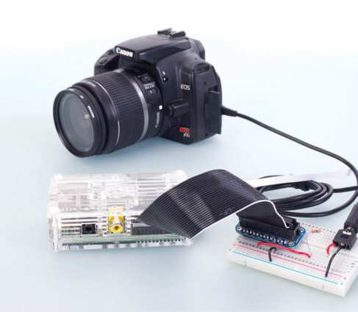

|  |  |  |  |  |  |
| --- | --- | --- | --- | --- | --- |
| **Manual focus**  We won’t be controlling   |  |  |  |  |  | | --- | --- | --- | --- | --- | | the autofocus with our  Python app, so set the  focus to manual and select your camera settings in  advance of the shoot   |  | | --- | |  |   **Pi Cobbler**  We’re using the Pi Cobbler as a breakout for the Pi’s GPIO pins, making the build process easier (though it’s not required) | **2.5mm to 3.5mm**  We’re using a cheap Canon EOS DSLR, so to trigger the shutter with the Raspberry Pi, all we need is a simple 2.5mm to 3.5mm cable   |  | | --- | |  |  |  | | --- | |  | | |

Configure the breadboard

**04** control the camera, we need For the Raspberry Pi’s GPIO to

to create a circuit between a pin on the GPIO (in this case pin 23 on the Cobbler – but it’s actually physical pin 16) and the pin that connects to the ‘head’ or ‘tip’ of the camera cable that activates the shutter when connected. The base of the connector cable is always ground, so make sure you ground the ‘GND’ pin on the Cobbler and the middle pin on the audio jack. With the circuit complete, we can focus on the code.

The Time-lapse   
Photography Tool

**05** Python utility called The Linux We’ve created a small 55-line

User Time-lapse Photography Tool, which asks the user to input how

for i in range(0, shots): many shots they’d like to take and

print the frequency they’d like them taken.

print‘Shot %d of %d’ % (taken, shots) It then takes that information and

taken +=1 uses it in a For loop to activate the

GPIO.output(16, GPIO.HIGH) shutter using GPIO pin 16 . If you’d like

time.sleep(0.5) to use the project ‘in the field’ we’d

GPIO.output(16, GPIO.LOW) recommend using the Android app

time.sleep(interval) ConnectBot to SSH into your RasPi

GPIO.cleanup()

else: for input and feedback. Don’t forget

print“Let’s try again (or press Ctrl + C to  to start your script with sudo python

quit):\n” time_lapse_camera.py

main()

else: Creating a video

print“Oops - You can only enter numbers. Let’s try 

main() **06** images, we need to collect again:\n” With your camera packed with

and output them as a video file. While

print it’s possible on the Pi, copy them to an

print‘Thanks for using the Complete Manual Time- 

lapse Tool!\n’ easily accessible folder on a separate

again = raw_input(‘Would you like to do another time-  Linux PC to make it much faster.

lapse? (yes/no):\n -> ‘) We’re going to use FFmpeg. With the

proceed = again.lower() in [‘yes’, ‘y’] terminal open in the folder where your

if proceed:  
 main()  
 else:   
 print‘\nSee you next time!\n’ quit()

if __name__ == ‘__main__’: main()

images are stored, type: ffmpeg -f image2 -i image%04d.jpg -vcodec libx264 -b 800k video.avi. This assumes you have libx264 installed on your machine and the ‘image%o4d.

jpg’ assumes the file format and the number of digits it’s dealing with (in this case: ‘picture0001.jpg’).

|  |
| --- |
| **101** |

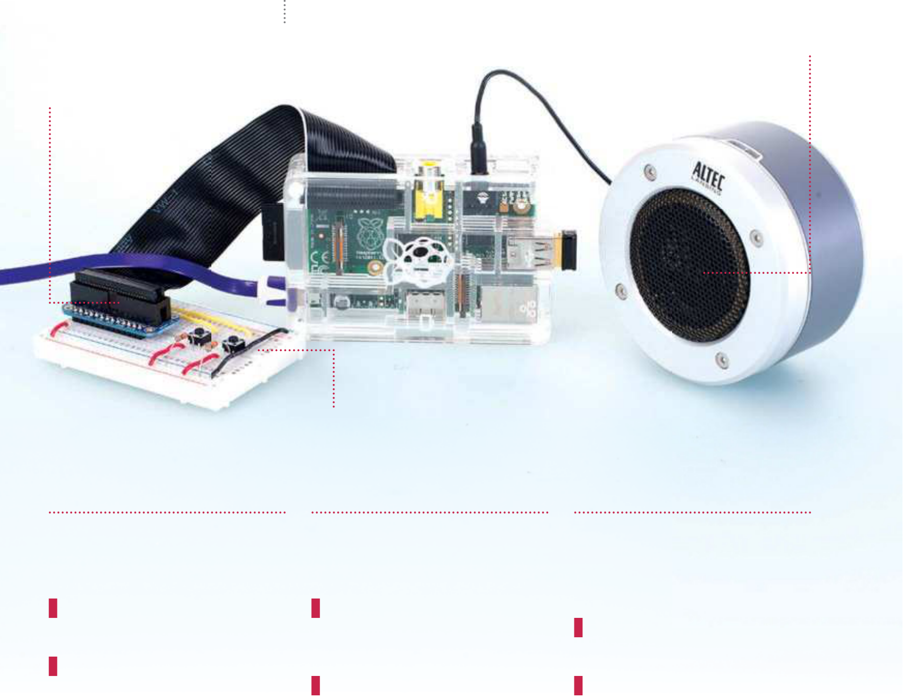

|  |  |
| --- | --- |
| **Projects**  What you’ll need…  **A wireless internet connection 2 x momentary switches**  **4 x female-to-male leads**  **(to connect your Pi to a**  **breadboard)**  **2 x 220-ohm resistors**  **4 x male-to-male leads**  **Speakers connected to a**  **3.5mm headphone jack** | Build a portable internet radio |
| Build a portable internet radio  Turn your Raspberry Pi into a portable Wi-Fi  streaming radio |

There are thousands of free radio stations on the internet, and with

this project you can listen to all of them from one tiny little box. So

let’s build our streaming radio using a Raspberry Pi, a speaker and a

few odds and ends…

**Listen**   
Connect your speaker(s)   
to the 3.5mm audio out

|  |  |
| --- | --- |
| **Build**  The completed project, | jack on the Pi |

with momentary switches   
to control stations

**Control**   
The circuit is very   
straightforward with   
just two buttons

|  |  |  |
| --- | --- | --- |
| Let’s get set up | Install some | Make the files |
| extra packages | executable and Install |
| **01** our Pi. Using Raspbian, and a Firstly, we need to prepare  Pi connected to the internet, open a | **02** packages to access the GPIO. We need to install the Python  In a terminal, logged in as root, enter | **03** to navigate to PiAUISuite- To install the tools, we need  master/Install. We now need to make |
| terminal and switch to the root user: | the following. | InstallAUISuite.sh executable for all |
| sudo su | apt-get install python-rpi. | users, so use: |
| And update your list of packages, then | gpio | chmod 777 InstallAUISuite.sh |
| upgrade your Pi to the latest software: | Now install MPlayer, which is what will | Now that the file is executable, |
| apt-get update && apt-get | be playing our audio. | let’s install: |
| upgrade -y | apt-get install mplayer | sudo ./ InstallAUISuite.sh |

|  |
| --- |
| **102** |

|  |  |
| --- | --- |
| Build a portable internet radio | **Projects** |

Full code listing

|  |  |
| --- | --- |
| We import the RPi GPIO library and  set it to use BCM numbering system | #!/usr/bin env python  import time import sleep  import os  import RPi.GPIO as GPIO |

# I found loads of BBC Radio streams

|  |  |
| --- | --- |
| Here we set up pins 23 and 24, which  control the radio  station selection  Here we say that if  the button is pressed for 23, run the  command below | # from http://bbcstreams.com/  GPIO.setmode(GPIO.BCM)  GPIO.setup(23 , GPIO.IN)  GPIO.setup(24 , GPIO.IN)  while True:   if GPIO.input(23)==1:  os.system(‘sudo killall mplayer’)  os.system(‘mplayer -playlist http://bbc.co.uk/  radio/listen/live/r1.asx &’) |

if GPIO.input(24)==1:

|  |  |  |  |  |  |  |  |  |  |  |  |  |
| --- | --- | --- | --- | --- | --- | --- | --- | --- | --- | --- | --- | --- |
| Here we see the | | | | os.system(‘sudo killall mplayer’) | | | | | | | | |
| script kill any open | | | | os.system(‘mplayer -playlist http://bbc.co.uk/ | | | | | | | | |
| MPlayer processes | | radio/listen/live/r6.asx &’) | | | | | | | | | | |
| and then load the | | | sleep(0.1); | | | | | | | | | |
| radio station | GPIO.cleanup() | | | | | | | | | | | |
| Set up the software | | | | Configure the | | | | Raspi-config | | | | |
| **04** ly/1JphBL0 and put that in Copy radio.py from bit.  your home directory. You can tweak it | | | | radio to start at boot | | | | | | | | **08** raspi-config to change the In a terminal as root, use  boot behaviour of your Pi. We don’t |
| **06** to /etc/init.d/ and then create In a terminal, as root, navigate  a file called radio using nano. | | | | | | | |
| to suit your needs if you wish later on. | | | | want it to load the desktop, a terminal |
| Now open a terminal and switch to root, | | | | | nano radio | is all we need, as the project will not | | | | | | |
| and edit your network interface config | | | | In that file, type in the following: | | | | | | require a screen for future use. Once | | |
| by doing the following: | | | | #! /bin/bash | | | complete, reboot the Pi and watch as | | | | | |
| nano /etc/network/interfaces | | | | modprobe snd_bcm2835 | | | | | the output from boot whizzes across | | | |
| Wi-Fi configuration | | | | amixer cset numid=3 1 | | | | | | | the screen. | |
| python /home/pi/radio.py | | | | | | |
| First test | |
| This loads the kernel module for the | | | | | | |
| **05** connect to your router via Wi-Fi We want the Pi to automatically  during boot. Edit your /etc/network/ | | | | sound card Amixer sets the output | | | | | | | | **09** press one of the buttons on   Once the Pi has finished loading,  your breadboard. In a few seconds you |
| to the 3.5mm headphone jack (that’s | | | | | | | |
| what 1 means, HDMI is 2). Lastly it calls | | | | | | | |
| interfaces file to resemble this: | | | | the Python script. | | | | | | | |
| auto lo | | | | Make it executable | | | | | should hear the audio come through | | | |
| iface lo inet loopback | | | | the speakers that you attached to the | | | |
| iface eth0 inet dhcp | | | | headphone jack. That’s it, you have a | | | | | | | | |
| allow-hotplug wlan0 | | | | **07** by pressing Ctrl+X and then Save and exit radio in /etc/init.d  answer yes to the prompt. Now make | | | | | | | | wireless internet radio. Why not add a |
| auto wlan0 | | | | mute function using amixer (manpages. |
| iface wlan0 inet dhcp | | | | ubuntu.com/manpages/gutsy/ |
| wpa-ssid “ssid” | | | | radio executable by typing (as root): | | | | | | | man1/amixer.1.html) and another | |
| wpa-psk “password” | | | | chmod 755 radio | | | | momentary switch. Or even add an LCD | | | | |
| Replace the “ssid” and “password” | | | | Then, as root, register radio to start on | | | | | | | | screen (www.rpiblog.com/2012/11/ |
| with your own details, but keep the | | | | boot by typing in a terminal: | | | | | interfacing-16x2-lcd-with-raspberry-pi. | | | |
| quotation marks. | | | | update-rc.d radio defaults | | | | | | | html) to show the station details. | |

|  |
| --- |
| **103** |

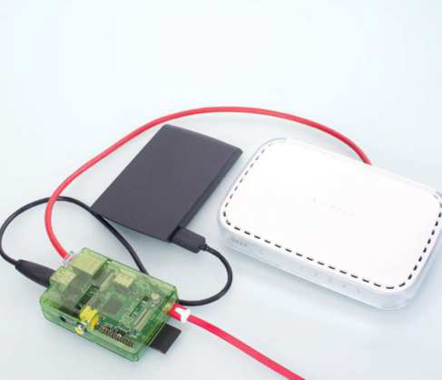

|  |  |
| --- | --- |
| **Projects**  What you’ll need…  **A portable hard drive**  **Raspbian**  www.raspberrypi.org/downloads  **PC with a desktop**  **environment with Deluge** www.deluge-torrent.org | Build an always-on torrent box |
| Build an always-on torrent box |

Get the latest distros, packages and test builds faster with a low-power, mini torrent box

Torrenting your open source software has a number of advantages – it can be faster, alleviates bandwidth and allows you to share back with the community. Distros, packages and more are available via torrents, and the Raspberry Pi makes for a great tiny, low-wattage, always-on torrent box to better manage your fles.

|  |  |  |  |  |  |  |  |  |
| --- | --- | --- | --- | --- | --- | --- | --- | --- |
| |  |  | | --- | --- | | **External storage**  Store completed files on an external hard drive, for more space or easy transport | **Wired networking**  You’ll be transferring large amounts of data, so wired networking is a must |  |  | | --- | |  |   WHAT YOU'LL NEED   |  |  | | --- | --- | |  | | | |  | | --- | |  | | **Tiny and convenient**  Turn your Pi into an always-on torrent |   box you can hide in a (well-ventilated)  small space |

|  |
| --- |
| “The Raspberry Pi makes for a great tiny, low-wattage, always-on torrent box to better manage your fles”  **104** |

Install Raspbian

**01** torrent box. Install the image Raspbian works just fine for our

on an SD card and go through the basic setup process, making sure to enable SSH in the advanced options and to disable the desktop.

Remote access

**02** command line to find the IP Type ifconfig into your Pi’s

address. At this point you can unplug the monitor and set it up remotely, but either way you can now access the Pi by typing:

$ ssh [user]@[IP address]…and entering your password to log in.

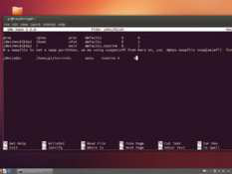

|  |  |
| --- | --- |
| Build an always-on torrent box | **Projects** |

Mount hard drive

**03** your portable drive, you’ll need Unless you plan to reformat

to install NTFS support onto your Pi. Type in:

$ sudo apt-get install ntfs-3g   
Add the hard drive to **/etc/fstab**   
(open it with sudo nano /etc/fstab) by adding the line:

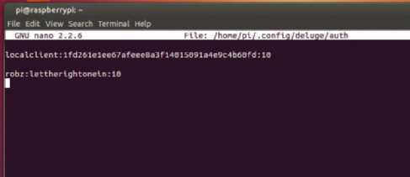

|  |  |  |  |
| --- | --- | --- | --- |
| /dev/[hard drive address] | | Remote connection |  |
| [mount point] auto noatime 0 0 | |
| Use fdisk to find the name of the | | **06** type the following three Now you’re in the client,  commands: |  |
| storage, and create a mount point | |
| such as /home/pi/torrents with mkdir. | |
| Reboot for it to mount. | |
|  |
|  | | config -s allow_remote True |  |
| config allow_remote |
| exit |
| Restart the Deluge daemon with: |
| $ sudo pkill deluged && | Download location |
|  |
| deluged | **08** Preferences, and change to Go to Edit again and then  the Downloads tab if it’s not on there |
| Now open the graphical client on your |
| Linux PC. |
| Install Deluge | |
|  |
| already. Set the download location |
| **04** | We’ll use Deluge for our torrents. Install it with: |  |  |
| to the directory we mounted the |
| hard drive to, and enable ‘Auto add |
| .torrents’, setting it to any destination if |
| $ sudo apt-get install | |
|  | you plan to dump torrents to the Pi. |
| deluged deluge-console | |
| Now start and then stop Deluge so it | | Start on boot |
| creates a config file we can edit with: | |
| $ deluged | |  | **09** be used to have Deluge start An init script from Ubuntu can  on boot. Download it with: |
| $ sudo pkill deluged | |
| And finally, run the following to copy | |
| the config file in case we mess up: | | $ sudo wget -O /etc/default/ |
| $ cp ~/.config/deluge/auth ~/.config/ | |
| deluge-daemon http://bit. |
| deluge/auth.old | |
| ly/13nKOSj |
| Basic configuration | | Open **/etc/default/deluge-daemon** |
| with nano and change the username |
| **05** | Edit the file with: |  |
| Remote interface | to the one we set up earlier. Save it, |
| then download the full init script and |
| $ nano ~/.config/ |  |
| **07** Interface, then disable Classic Go to Edit>Preferences>  Mode and restart Deluge. Click | update with: |
| deluge/auth | | $ sudo wget -O /etc/init.d/ |
| And add to the bottom: | |
| deluge-daemon http://bit. |
| [user]:[password]:10 | |
|  |
| Add on the Connection Manager, | ly/13nKKlz |
| …to restrict access. | | $ sudo chmod 755 /etc/init.d/ |
| and enter the IP in Hostname and |
| Now start it up with: | | the user we set up earlier. Click | deluge-daemon |
| $ deluged | |
|  |
| Connect to see any torrents you have | $ sudo update-rc.d deluge- |
| $ deluge-console | |
| downloading or uploading. | daemon defaults |

|  |
| --- |
| **105** |

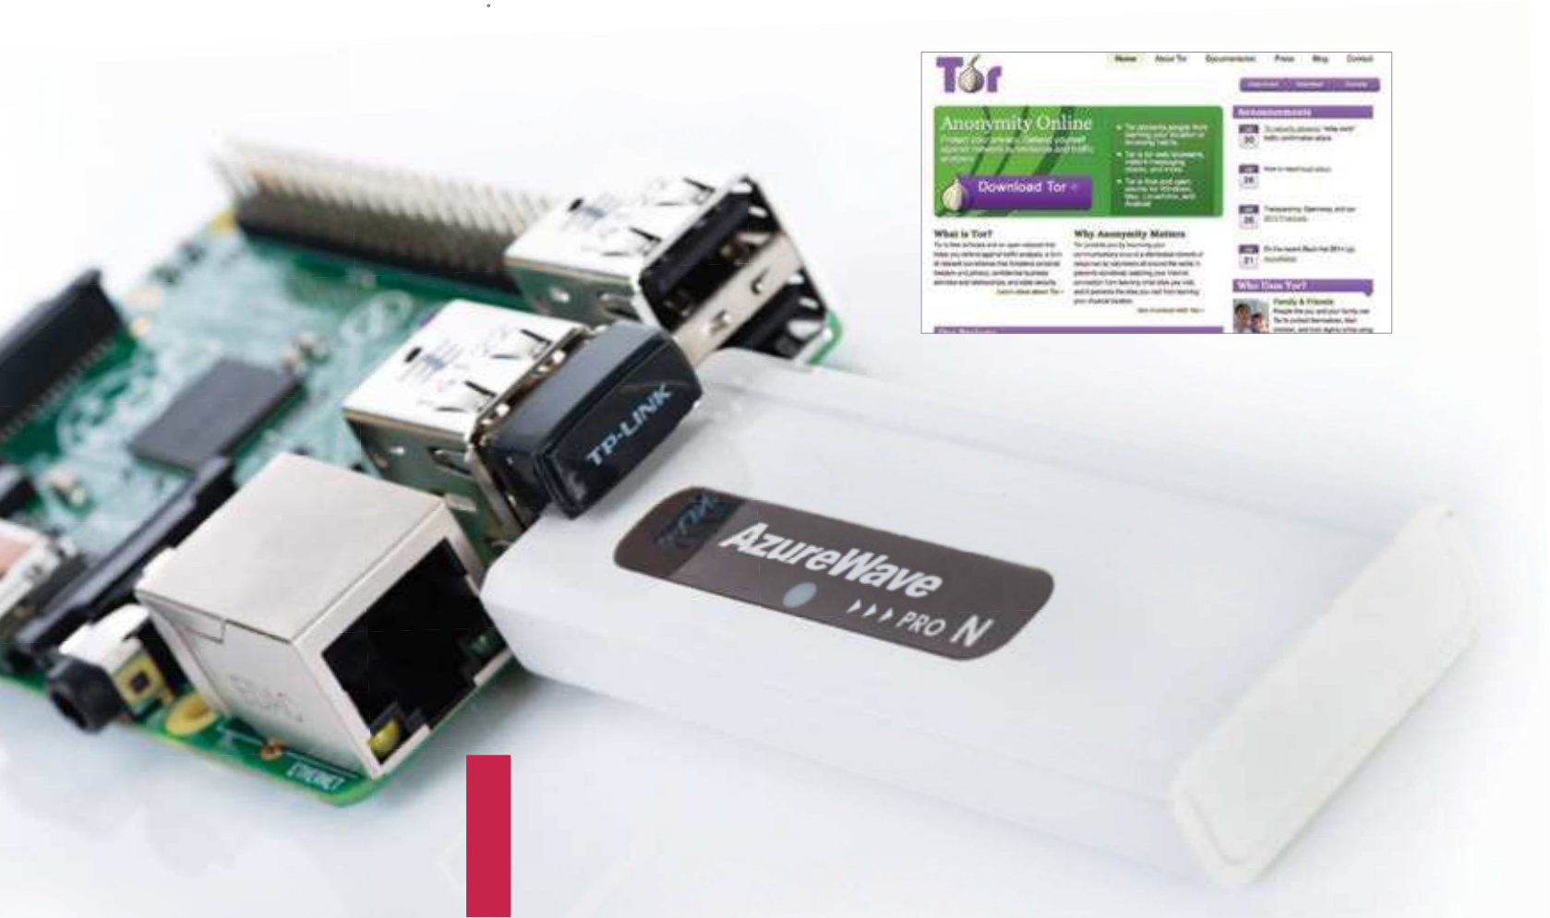

|  |  |
| --- | --- |
| **Projects**  What you’ll need…  **2 USB Wi-Fi adaptors Raspberry Pi case**  **Portable power pack** | Portable Wi-Fi signal repeater |
| Portable Wi-Fi signal repeater |

Boost your signal using a Raspberry Pi and two USB Wi-Fi dongles

What we like about the Raspberry Pi for this project is that it’s very low maintenance and extremely easy to put in an appropriate location. All you need for this project are two USB wireless adaptors, a nice little case and a way to power it. Once you’ve set it up, you can basically leave it to its own devices, checking in over SSH every now and then to do some updates.

Set this up on a monitor with a keyboard, using a fresh image of Raspbian and with your Wi-Fi dongles plugged in. On f rst boot keep it as CLI and after doing the usual apt-get updates and upgrades, type startx to get to the desktop. Conf gure the wireless for wlan0 to connect to your home network and make sure it has a f xed IP address, then reboot to make sure it all works from the

|  |  |
| --- | --- |
| Below One Wi-Fi adaptor picks up your main Wi-Fi network, while the other one broadcasts a new signal | command line by using ping www.google.com. Now you need to install your f rst bit of software using: |

|  |
| --- |
|  |

Above As well as from the main Tor website, you can also   
download Tor from **bit.ly/1vh9LN5**

|  |
| --- |
| **106** |

|  |  |  |
| --- | --- | --- |
| $ sudo apt-get install hostapd iw  After it’s installed, you’ll want to download and save the f le we’ve created directly  to conf g by entering the  following two commands: | Secure Tor web station | **Projects** |
| Secure Tor web station  Stay private online by routing all your web traf c  through Tor on your Raspberry Pi | |

$ wget http://www.

|  |  |  |
| --- | --- | --- |
| linuxuser.co.uk/wp- content/ | In a much more privacy- | AutomapHostsOnResolve 1 |
| uploads/2014/08/repeater.zip | focused world, being able to | TransPort 9040 |
|  |
|  |
| $ cp LUDRepeater.conf /etc/ | browse securely online is an | DNSPort 53 |
| hostapd/hostapd.conf | important freedom for many | Save this and then open the next |
| Do a reboot and test the | people. With the use of Tor | f le with sudo nano /etc/resolv. |
| and a few tweaks to the | conf f le and modify it: |
| conf guration f le with: |
| Raspberry Pi, you can make | nameserver 127.0.0.1 |
|  |
|  |  | Finally, you need to change |
| hostapd/hostapd.conf | sure all your internet traf c is |
| If there are no errors, open the | kept private. | the iptables ruleset, but before |
| First of all you’ll need to | you do this, use top to conf rm |
| f le using nano /etc/hostapd/ | the uid of Tor and make a note |
| make sure to install Tor from |
| hostapd.conf and then add | of it. Now open up a new f le |
| the repos. Open up the |
| the following to the f le: | with nano /etc/init.d/iptables |
| LXTerminal and simply type: |
|  | and enter the code found at: |
|  | $ sudo apt-get install |  |
| DAEMON_CONF=“/etc/hostapd/ | tor | http://www.linuxuser.co.uk/ |
| hostapd.conf” |
| Once that’s done, edit the |
| wp-content/uploads/2014/08/ |
| RUN_DAEMON=yes |
| Also change the SSID to | torrc f le by using sudo nano | tor.zip. Now save it and enter: |
| /etc/tor/torrc and add this to | $ chmod 755 /etc/init.d/ |
| be the same one for your | iptables |
| the top of the f le: |
| network in the ssid f eld. Once | VirtualAddrNetworkIPv4 | $ update-rc.d iptables |
| that’s done, you’ll need to | 10.192.0.0/10 | defaults 12 |

install the bridge utilities with

|  |  |  |
| --- | --- | --- |
| apt-get install bridge-utils. |  | **Left** Adafruit’s Onion Pi Pack |
| Then conf gure it with the | contains all the components |
| you will need to set up a |
| following four commands: | secure connection |
| brctl addbr bridge0 |
| brctl addif bridge0 wlan0 |
| brctl addif bridge0 wlan1 |
| ifconfig bridge0 up |
| Test it out to make sure it |
| works and then place it |
| around the house to extend |
| your wireless signal! |

|  |
| --- |
| **107** |

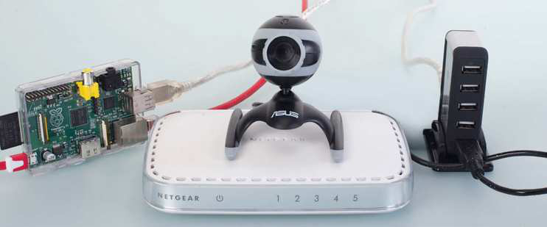

|  |  |
| --- | --- |
| **Projects**  What you’ll need…  **A router or switch**  **A Linux-compatible webcam Raspbian**  www.raspberrypi.org/downloads  **Powered USB hub** | Build a security camera  Build a security camera |

Want to keep an eye on something from the comfort of your web browser? All you need is a Pi and a webcam!

|  |  |
| --- | --- |
| **Did you know…**  Most modern webcams are  compatible with the Raspberry Pi, but check it supports Linux before you buy. | This article will teach you how to use the MJPG-streamer software to stream video straight from a webcam to your web browser.  You could record the stream, and also display multiple streams from multiple Raspberry Pis on one page. The streams can also be viewed from mobile devices and tablets. |

|  |  |  |  |
| --- | --- | --- | --- |
| |  |  |  | | --- | --- | --- | | **Check compatibility**  Most USB cameras should work with  your Pi ‘out of the box’, but it’s worth  checking compatibility first   |  | | --- | |  | | **Extra power**  Depending on your model of webcam, you may need a  powered USB hub to get it working | |

Network investigation   
**01** your Raspberry Pi is on, so we can assign it a static The first job we need to do is investigate the network

IP address. That way, we’ll always know where it is on the

Assign a static IP address   
**02** can assign a static IP address. Open   
 Now that we have the network configuration, we

/etc/network/interfaces in an editor such as nano, and

|  |  |
| --- | --- |
| network so we can access with ease.  pi@raspberrypi ~ $ ip addr show dev eth0 | grep inet  inet 172.17.173.94/24 brd 172.17.173.255 scope global eth0  pi@raspberrypi ~ $ ip route | grep default default via 172.17.173.1 dev eth0  pi@raspberrypi ~ $ cat /etc/resolv.conf  nameserver 172.17.173.1  **108** | change the line:  iface eth0 inet dhcp  to a configuration similar to our expert’s. Reboot to load the new configuration.  iface eth0 inet static  address 172.17.173.94  netmask 255.255.255.0 network 172.17.173.0  broadcast 172.17.173.255 |
| gateway 172.17.173.1 |
|  | |

|  |  |  |
| --- | --- | --- |
| **Below** It even works from | Build a security camera | **Projects** |
| Testing it out | Recording the stream |
| mobile devices and tablets! |
|  | **05** export LD_LIBRARY_PATH=. To start MJPG-streamer:  ./mjpg_streamer -i “input_uvc. | **07** motion JPEG stream and convert You can easily download a  it to a more useful format using VLC: |
| so” -o “output_http.so -w ./www” | cvlc http://172.17.173.94:808 |
| You have to export the library path | 0/?action=stream --sout file/ |
| variable to the current directory (.) | mp4:stream.mp4 |
| so that the various input and output | Alternatively, you can just download |
| plug-ins can be used. Type your | the stream URL with wget like so: |
| Raspberry Pi’s IP address followed | wget http://172.17.173.94:8080/? |
| by :8080 into a browser and click the | action=stream |
| Stream tab. If the Stream tab doesn’t | Multiple streams at once |
| work, try the example that uses |
| JavaScript, as that should work on |
|  |  | **08** to put multiple streams on a Here is an example of how  single webpage. These streams could |
| most browsers, including Android. |
| Start MJPG-streamer |
| at boot | come from a number of different |
|  |
|  | Raspberry Pis all over the house. |
|  |
|  |
| Installing the software | |  |  | | --- | --- | | **06** | Edit the /etc/rc.local file  (you’ll need to use sudo) to | | <html> |
| <h1>Streaming Example</h2> |
|  |
| **03** with the username ‘pi’ and Log into the Raspbian system  the password ‘raspberry’. The MJPG- |  |  |
| that it still ends with exit 0: | <tr> |
| export STREAMER_PATH=/home/ | <td><h2>Stream 1</h2></td> |
| pi/mjpg-streamer-code/mjpg- | <td><h2>Stream 2</h2></td> |
|  |  |
| streamer software isn’t packaged for the | streamer | </tr> |
|  |  |
| Raspberry Pi, so we’ll need to compile | export LD_LIBRARY_ | <tr> |
|  |  |
| it ourselves. Update the package index | PATH=$STREAMER_PATH | <td><img src=”http://172.17.173 |
|  |  |
| with sudo apt-get update. We need | $STREAMER_PATH/mjpg_streamer | .94:8080/?action=stream”/></td> |
|  |  |
| to install Subversion, which we’ll use to | -i “input_uvc.so” -o “output_ | <td><img src=”http://172.17.173 |
| http.so -w $STREAMER_PATH/ | .94:8080/?action=stream”/></td> |
| download source code. We’ll also need |
|  |  |
| libjpeg, and imagemagick, both of | www” &s | </tr> |
|  |  |
| which are required by MJPG-streamer. |  |  |
|  |  |
| Install these with: | back up happily and starts the stream. | </html> |

sudo apt-get install

|  |  |
| --- | --- |
| subversion libjpeg8-dev imagemagick | Extensions and improvements |
| Compile MJPG-streamer | **09** authentication or SSL encryption, which means the streams are insecure This example setup is very basic and has a few flaws. There is no  and shouldn’t be shared over the internet. The HTTP module that comes with |

**04** streamer as shown below:   
 Download and compile MJPG-

pi@raspberrypi ~ $ svn

MJPG-streamer is quite simple, so you could get SSL by using a reverse proxy, such as Pound. You’d be able to do SSL for each Pi you had with a single Pound instance and access the different Pis by having something like ‘stream1, stream2’ in the URL.

checkout svn://svn.code.

|  |  |
| --- | --- |
| sf.net/p/mjpg-streamer/code/ mjpg-streamer-code  pi@raspberrypi ~ $ cd mjpg-streamer-code/mjpg-streamer  pi@raspberrypi ~/mjpg- streamer-code/mjpg-streamer $ | “Use the MJPG-streamer software to  stream video straight from a webcam to your web browser” |

make clean all

|  |
| --- |
| **109** |

|  |  |
| --- | --- |
| **Projects**  What you’ll need…  **A toy RC car with two**  **channels (steering and drive) Adafruit PWM I2C**  **servo driver**  **Female-to-female**  **jumper cables**  **5V battery power bank**  **Estimated cost:£60 / $100 Components from**  www.modmypi.com | Build a Raspberry Pi-powered car |
| Build a  Raspberry  Pi-powered car  Make use of cutting-edge web technologies to take control of a remote controlled car with a smartphone or tablet… |

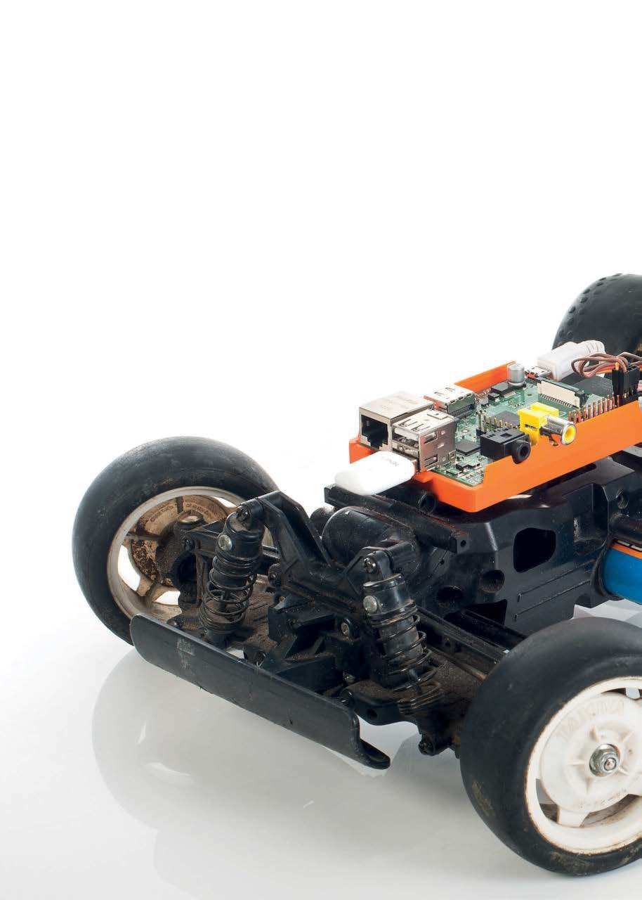

|  |
| --- |
| **110** |

|  |  |
| --- | --- |
| Build a Raspberry Pi-powered car | **Projects** |

Web technologies are moving forward at a huge pace, cloud technologies are bringing mass computing to individuals, and hardware has reached a perfect moment in time where sensors, displays and wireless technology have all evolved into ef cient and af ordable devices. We truly are at a point where nearly anyone can take an idea from nothing to a working product in a week and at very little cost. Just like this project, which is fun, quick and easy to build on and a fantastic way to learn. 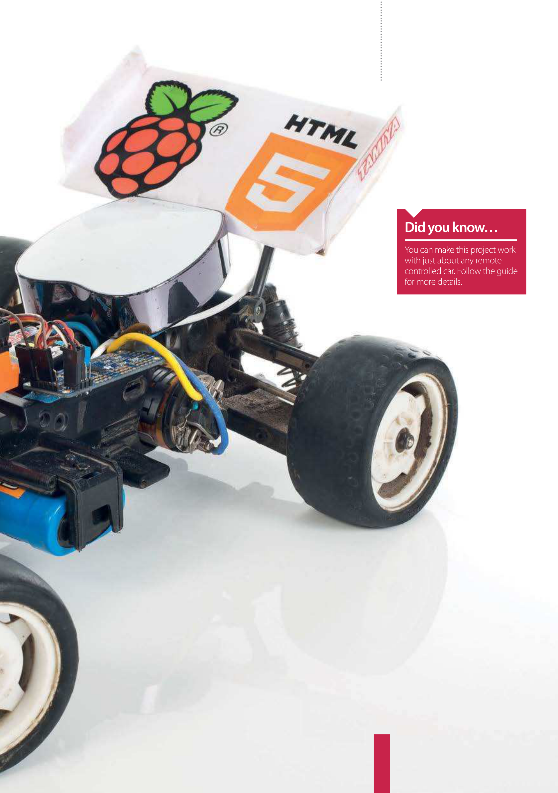

We’re going to grab an old remote-control car, rip of its radio receiver and replace it with the Raspberry Pi, hook it up on the network, f re up a bleeding-edge web server and then get your smartphone or tablet to control it by tilting the device. By the end of this, not only will you have a fun toy, you will have learnt about the basic technologies that are starting to power the world’s newest and biggest economy for the foreseeable future.

|  |
| --- |
| **111** |

|  |  |
| --- | --- |
| **Projects** | Build a Raspberry Pi-powered car |

Raspberry Pi-controlled car build process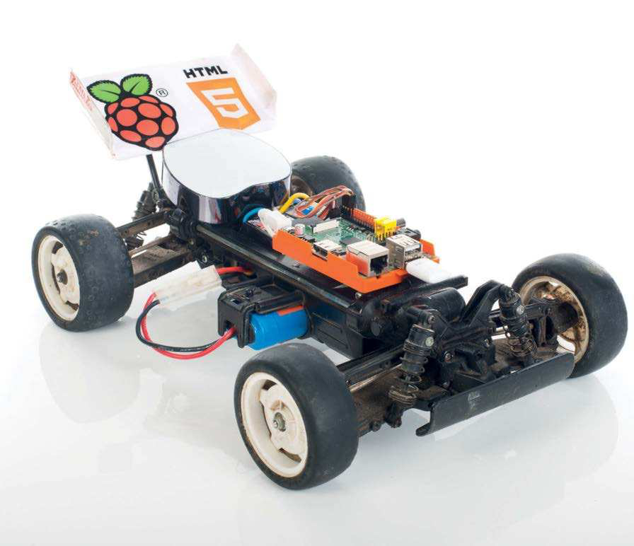

To help our toy car come to life using the latest web technologies and our credit card-sized computer, we’re going to need to make some pretty signifcant changes to its workings. Fortunately, the most complex aspects of the build can be accomplished with a couple of afordable purchases, namely a servo controller board to take care of the steering and throttle, and a 5V battery pack to keep the Raspberry Pi running smoothly.

Identify and remove old radio

|  |  |  |
| --- | --- | --- |
| **01** replacing the car’s normal This project is effectively  transmitter and receiver. Notice the | battery for the electronics, but those | supply elsewhere. Many shops sell |
| (especially with an electronic speed | 5V battery power supplies – often as |
| controller with BEC) get their 5V | mobile phone emergency top-ups. |
| three sockets on the original receiver: | power supply directly from the speed | www.modmypi.com sells a suitable |
| one goes to the motor controller | controller, saving on components. | 5V battery power bank for under £20 |
| and one to the steering servo. Some | If you don’t have a speed controller | and you should get a couple of hours |
| remote-control cars also have separate | with 5V BEC, you’ll need to get a 5V | of use from your Raspberry Pi. |

**Power up**   
This 5V battery pack keeps   
our Raspberry Pi running for a   
good few hours   
 **Servo control**   
 Adafruit PWM I2C servo driver board   
 from **www.modmypi.com**

|  |  |  |
| --- | --- | --- |
| |  | | --- | |  | | **Pi-powered**  The Raspberry Pi sits front and centre to keep it as safe as possible |

|  |
| --- |
|  |

**Pick a car**

|  |
| --- |
| **112** |

You can use pretty much any   
affordable car for this project

|  |  |
| --- | --- |
| Build a Raspberry Pi-powered car | **Projects** |

Attach the servo cables to the new controller

**02** I2C servo controller board We soldered our 16-channel

from www.modmypi.com as per   
its instructions and simply plugged   
channel 0 (steering) and channel 1   
(motor) headers onto it. There are six   
cables in total: the bottom two are   
ground, the middle two are the power and the top two are the PWM (pulse-width modulation) signals. This is a good time to think of places to mount the   
extra components and the best fixing method seems to be sticky-back Velcro.

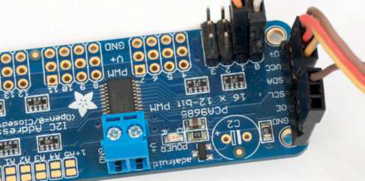

|  |  |  |  |
| --- | --- | --- | --- |
| Connect the I2C bus to the Raspberry Pi | | | Hook it up to the |
| Raspberry Pi  **04** cables look the same. Though On a Rev 1 Raspberry Pi, the  the Rev boards have different labelling, the physical pins are in the same   place. Bottom left (closest to the RasPi power connector) is the 3.3V power; next to that is the SDA header, which is the data channel. Next to that in the bottom right is the SCL channel, which controls the clock of the I2C devices.  And finally – on the top-right port – is the Ground. We recommend printing a labelled image of the GPIO pins. |
|  | |  |
| **03** I2C bus to control the servo We’re using the Raspberry Pi’s  interface board, which only needs  four cables – they all go between the Raspberry Pi and the servo controller board as pictured. Visit http://bit.ly/ N3nq4J for a tutorial on how to set up I2C on the Raspberry Pi.  From top to bottom we need to use the 1. GND, 2. SCL, 3. SDA and 4. VCC, which map directly to the same ports on the Raspberry Pi. Essentially this is power, ground and two  communication channels. |
| Overview of the main | | Find everything a home | |
| components | **06** or elastic bands to keep everything secure and find spaces in the car’s We can now put it together. Use plenty of sticky-back Velcro, tie wraps  body to hide the wires where possible. While it is possible to stick or screw the  Raspberry Pi directly to the car, we recommend to use at least the bottom half of | | |
| **05** servo board in the middle You should now have the  with the steering servo and speed |
| controller on one side and the | | a case for added protection and ease of access. Insert your SD card, network cable | |
| Raspberry Pi on the other. The motor | | or Wi-Fi dongle and power supply. Sit back and admire your hacking skills! | |
| is connected to the other end of the speed controller (that end should have much thicker wires); the speed controller also has two thick wires going to the main car’s battery – in this case a 7.2V NiCad. We now have two very separate power systems with the high current motors on one side and the low current electronics on the other. Let’s make sure it stays that way! |  | | |

|  |
| --- |
| **113** |

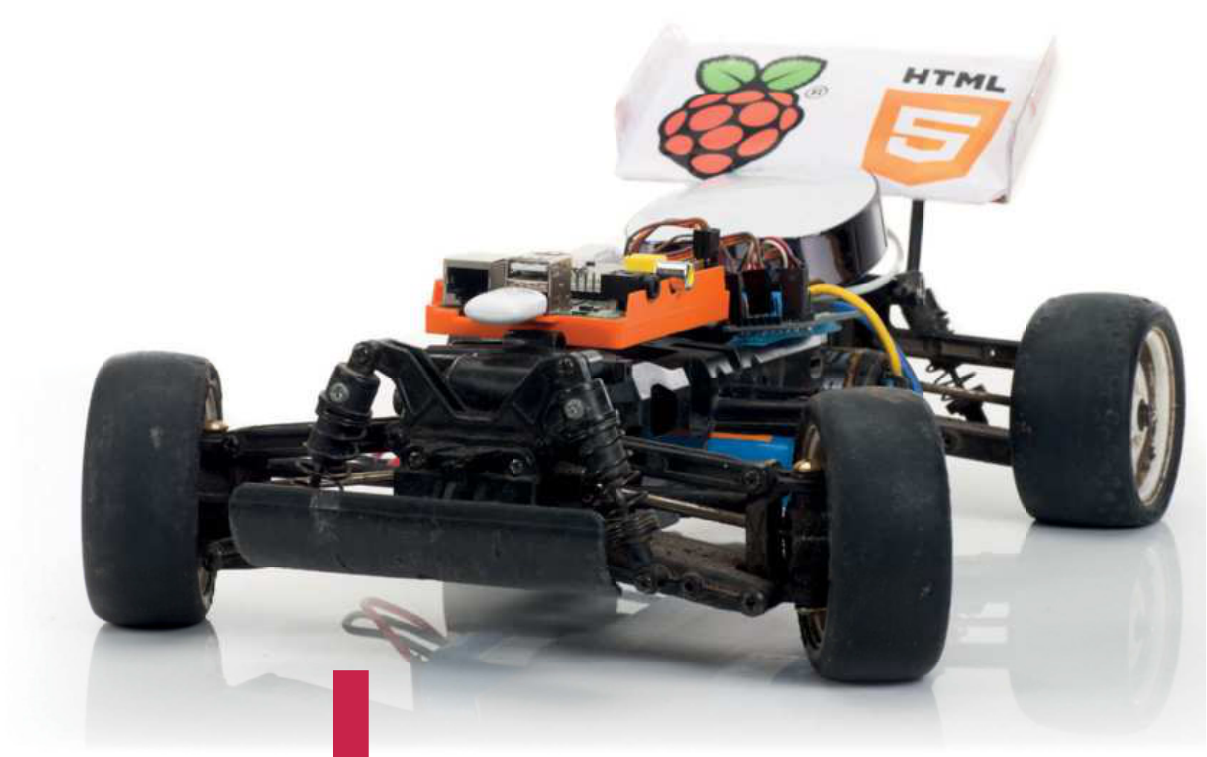

|  |  |
| --- | --- |
| **Projects**  What you’ll need…  **A RasPi car, ready to go An internet connection A reasonably modern smartphone/tablet**  **Pi car source code**  github.com/shaunuk/picar | Control your Raspberry Pi-powered car  Control your  Raspberry  Pi-powered car |

Control a toy car with a smartphone and the latest web technologies

Now we have our fantastic Raspberry Pi-powered car all wired and

|  |  |  |
| --- | --- | --- |
| **Did you know…** | charged, it’s time to make it come alive. We’re using the best web | |
| Our code will send instructions to our car over twenty times | technologies that the JavaScript programming language of ers, to harness the natural movement of your hand and wirelessly drive the | |
| per second. It will be very responsive to drive! | vehicle. Each little movement will trigger an event that calculates what the car should do and then sends it over a socket connection. | |
| Download and install the software | | **Below** All you need to finish off your project is access to a smartphone or tablet |
| **01** working. Next we’ll need to find a home for our   First of all, you will need to the I2C connectivity  new project code – how about /var/www/picar? Type | | |

sudo mkdir /var/www/picar in the terminal to make the   
directory and then change into that directory: cd /var/   
www/picar   
 Now, to download the project using Git, type sudo git   
clone http://github.com/shaunuk/picar. If you haven’t   
got Git, install it with sudo apt-get install git.

This will download the custom software for   
driving the car, but we still need the web   
server and some other bits before we   
can start burning rubber…

|  |
| --- |
| **114** |

|  |  |
| --- | --- |
| Control your Raspberry Pi-powered car | **Projects** |

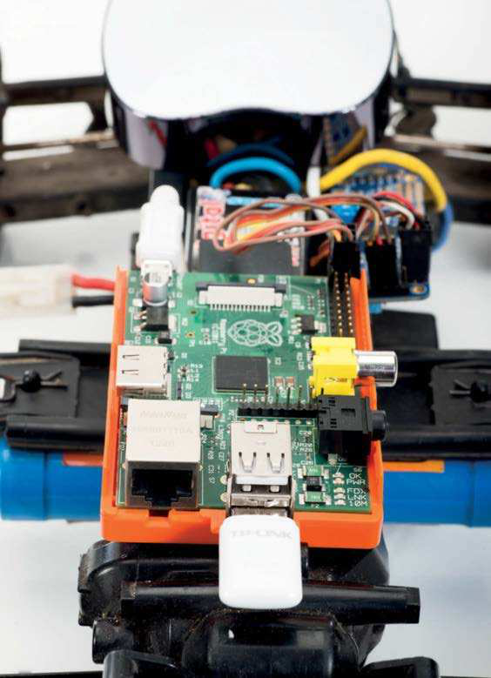

Download and install Node.js

**02** Node package manager (npm). Type sudo wget Next we’re using Node.js and its package tool, the

http://nodejs.org/dist/v0.10.21/node-v0.10.21-linux-arm-pi.tar.gz. This will download a fairly recent version of Node.js – the version Raspbian has in its repositories is way too old and just doesn’t work with the new technologies we’re about to use. Extract the node package by typing:  
 sudo tar -xvzf node-v0.10.21-linux-arm-pi.tar.gz

Configure Node.js

**03** will create symbolic links for Node and npm To make it easy to run from everywhere, we

binaries. Type sudo ln -s /var/www/node-v0.10.21-linux-arm-pi/bin/node /bin/node and then sudo ln -s /var/www/node-v0.10.21-linux-arm-pi/bin/ npm /bin/npm. Then, to get the extra modules, type npm install socket.io node-static socket.io adafruit-i2c-pwm-driver sleep optimist

|  |  |  |
| --- | --- | --- |
|  |  | Get to know |
| the project |
|  |  | **04** everything, you Now we have  should see three files: the |
| server (app.js), the client |
| (socket.html) and the |
| jQuery JavaScript library |
| for the client. The server |
| not only drives the servos, |
| but it is a web server and |
| sends the socket.html |
| file and jQuery to the |
| browser when requested |
| – it’s a really neat and |
| simple setup and just |
| right for what we’re trying |
| to achieve. |
| Test the servos |
|  |  | **05** program (app.js) Our handy little  has a special mode just |
| for testing. We use two |
| keywords here: beta for |
| servo 0 (steering) and |
| gamma for servo 1 (motor |
| control). Type node app. |
| js beta=300. You should |
| see the front wheels turn. |
| Now the numbers need |
| experimenting with. On |
| our example, 340 was left, |
| 400 was centre and 470 |
| was right. Do the same for |
| the motor by typing node |
| app.js gamma=400 and |
| take note of the various |
| limits of your car. |
| **115** |
|  |  |
|  | | |

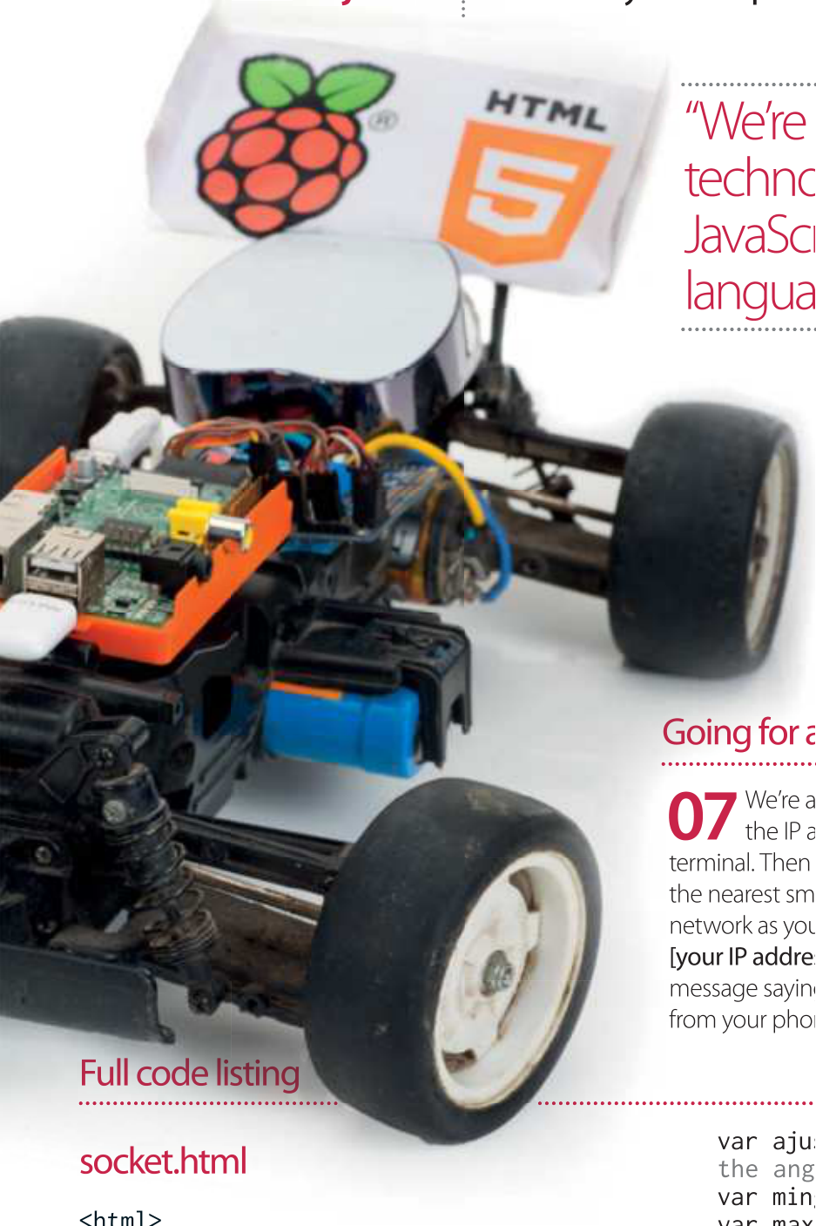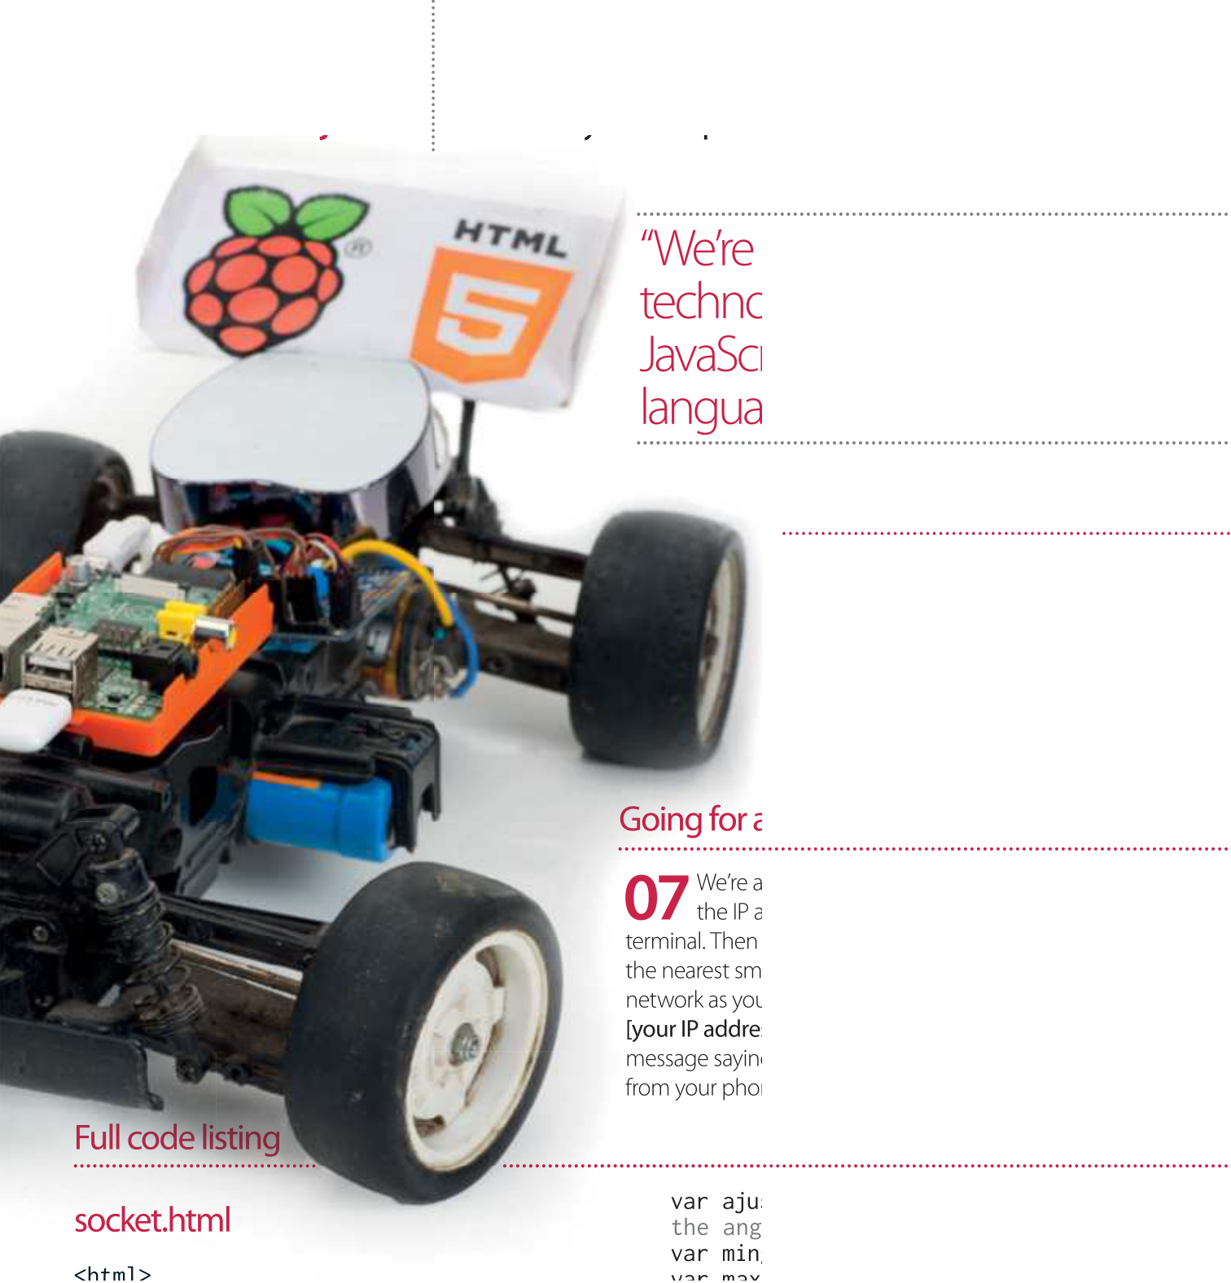

Configure sensible defaults

**06** of, we can set the defaults in app.js and   
 Now you know what your car is capable

socket.html. Edit app.js and find the section that

says ‘function emergencyStop’. Adjust the two

numbers to your car’s rest values. Then open

socket.html and adjust the predefined values

under ‘Define your variables here’.

var ajustmentgamma = 70; //what do we do to the angle to get to 0?

var mingamma = 250; //backwards limit   
var maxgamma = 400; //forward limit   
var multgamma = 1; //factor to multiply the //raw gyro figure by to get the desired   
//rate of acceleration   
window.lastbeta=’0’;   
window.lastgamma=’0’;   
$(function(){   
 window.gyro = ‘ready’;  
 alert(‘Ready -- Lets race !’);   
});   
window.ondeviceorientation = function(event) {  
  beta = centerbeta+(Math.round(

event.beta*-1)*multbeta);  
 if (beta >= maxbeta) {  
 beta=maxbeta;  
 }  
 if (beta <= minbeta) {  
 beta=minbeta;

|  |
| --- |
| **116** |

|  |  |
| --- | --- |
| Control your Raspberry Pi-powered car | **Projects** |

}   
gamma = event.gamma;  
 gamma = ((Math.round(event. 

gamma)+ajustmentgamma)* multgamma)+ 

centergamma;   
//stop sending the same command more than once   
send = ‘N’;   
if (window.lastbeta != beta) { send = ‘Y’ } if (window.lastgamma != gamma) { send = ‘Y’}   
window.lastbeta=beta;   
window.lastgamma=gamma;   
if (window.gyro == ‘ready’ && send==’Y’) { //don’t send another command until ready...

window.gyro = ‘notready’;  
 socket.emit(‘fromclient’, { beta: beta

 gamma: gamma } );   
 window.gyro = ‘ready’; }}

app.js

//declare required modules var app = require(‘http’).

createServer(handler)  
 , io = require(‘socket.io’).listen(app) , fs = require(‘fs’)  
 , static = require(‘node-static’)  
 , sys = require(‘sys’)  
 , PwmDriver = require(‘adafruit-i2c-pwm-driver’)  
 , sleep = require(‘sleep’)  
 , argv = require(‘optimist’).argv;  
 app.listen(8080);   
//set the address and device name of the 

breakout board   
pwm = new PwmDriver(0x40,’/dev/i2c-0’);   
//set pulse widths   
setServoPulse = function(channel, pulse) { var pulseLength;  
 pulseLength = 1000000;  
 pulseLength /= 60;  
 print(“%d us per period” % pulseLength); pulseLength /= 4096;  
 print(“%d us per bit” % pulseLength); pulse *= 1000;  
 pulse /= pulseLength;  
 return pwm.setPWM(channel, 0, pulse); };   
//set pulse frequency   
pwm.setPWMFreq(60);   
//Make a web server on port 8080   
var file = new(static.Server)();   
function handler(request, response) {  
 console.log(‘serving file’,request.url) file.serve(request, response);   
};

console.log(‘Pi Car we server listening 

on port 8080 visithttp://ipaddress:8080/ 

socket.html’);

lastAction = “”;   
function emergencyStop(){   
//center front wheels  
 pwm.setPWM(0, 0, 400);  
 //stop motor  
 pwm.setPWM(1, 0, 330);   
 console.log(‘###EMERGENCY STOP - signal 

lost or shutting down’); }

if (argv.beta) {  
 console.log(“\nPerforming one off servo 

position move to:“+argv.beta);  
 pwm.setPWM(0, 0, argv.beta);   
//using direct i2c pwm module  
 pwm.stop();  
 return process.exit();   
}   
if (argv.gamma) {  
 console.log(“\nPerforming one off servo 

position moveto: “+argv.gamma);  
 pwm.setPWM(1, 0, argv.gamma); //using   
direct i2c pwm module  
 pwm.stop();  
 return process.exit();   
}   
//fire up a web socket server   
io.sockets.on(‘connection’, function (socket) {  
 socket.on(‘fromclient’, function (data) { console.log(“Beta: “+data.beta+” Gamma: “+data.gamma);   
 //exec(“echo ‘sa “+data+”’ > /dev/   
// ttyAMA0”, puts);   
//usinghttp://electronics.chroma.se/rpisb.php //exec(“picar.py 0 “+data.beta, puts);   
 //using python adafruit module  
 pwm.setPWM(0, 0, data.beta);   
//using direct i2c pwm module  
 pwm.setPWM(1, 0, data.gamma);   
//using direct i2c pwm module  
 clearInterval(lastAction);   
//stop emergency stop timer  
 lastAction = setInterval(emergencySt 

op,1000);   
//setemergency stop timer   
 });   
});   
process.on(‘SIGINT’, function() {  
 emergencyStop();  
 console.log(“\nGracefully shutting down from SIGINT  
(Ctrl-C)”); pwm.stop();  
 return process.exit();   
});

|  |
| --- |
| **117** |

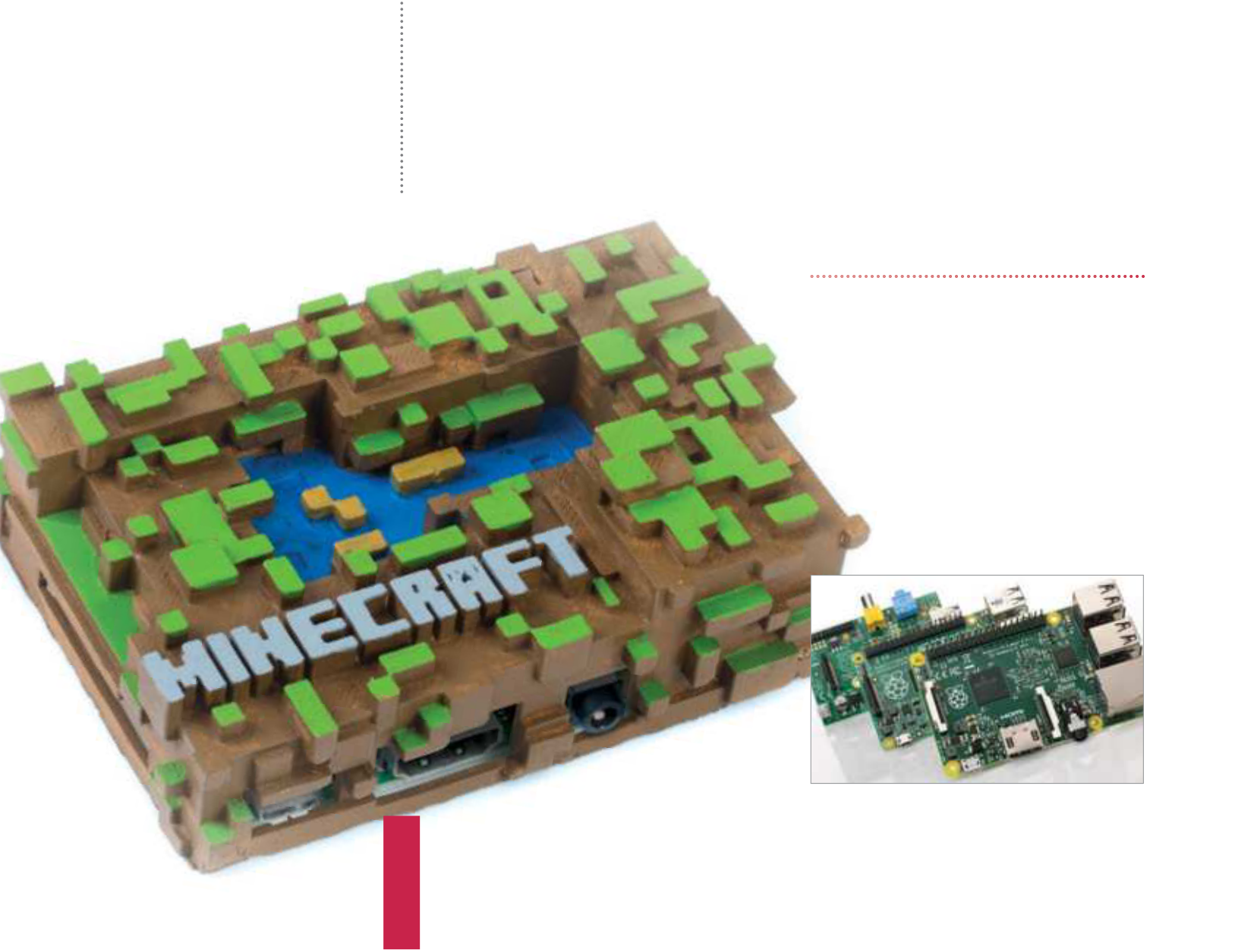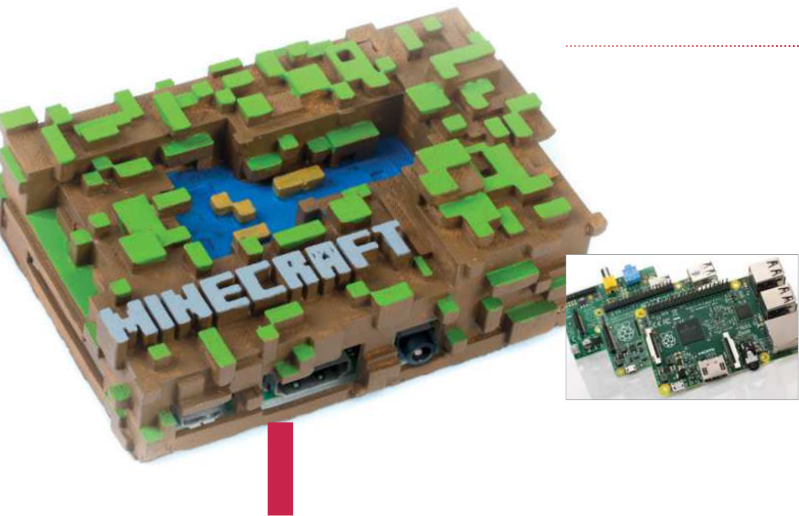

|  |  |
| --- | --- |
| **Projects**  What you’ll need…  **Raspberry Pi 2**  **Latest Raspbian image** raspberrypi.org/downloads  **Minecraft Pi Edition** pi.minecraft.net  **Raspberry Pi case**  **USB game controller (PS3 preferable)** | Build a Minecraft console for Pi |
| Build a Minecraft console for Pi  Create a fully functional, Pi-powered games console  that you can play Minecraft on and learn how to  program too |

Minecraft means many things to many people, and to Raspberry Pi users it’s supposed to mean education. Not everyone knows, though, that you can still have fun and play Minecraft as you normally would.

Using Raspberry Pi, it is also the cheapest way to get a fully   
functional version of Minecraft up onto your TV. However, in its normal state, just being on a TV isn’t the end of it. Using all the features and functions of the Pi, we can take it to a state more f tting of a TV by making it into a hackable, moddable Minecraft console.

In this tutorial, we will show you how to set it up in terms of both software and hardware, how to add a game controller to make it a bit better for TV use, and we’ll even give you some example code on how to mod it. Now, it’s time to get building, so head to Step 1.

Choose your Raspberry Pi

**01** everything we plan to   
 Before we start anything,

do in this tutorial will work on all   
Raspberry Pi Model Bs with at least   
512 MB of RAM. However, Minecraft:   
Pi Edition can chug a little on the   
original Model Bs, so we suggest   
 getting a Raspberry Pi 2 to get   
 the most out of this tutorial.

**118**

|  |  |
| --- | --- |
| Build a Minecraft console for Pi | **Projects** |

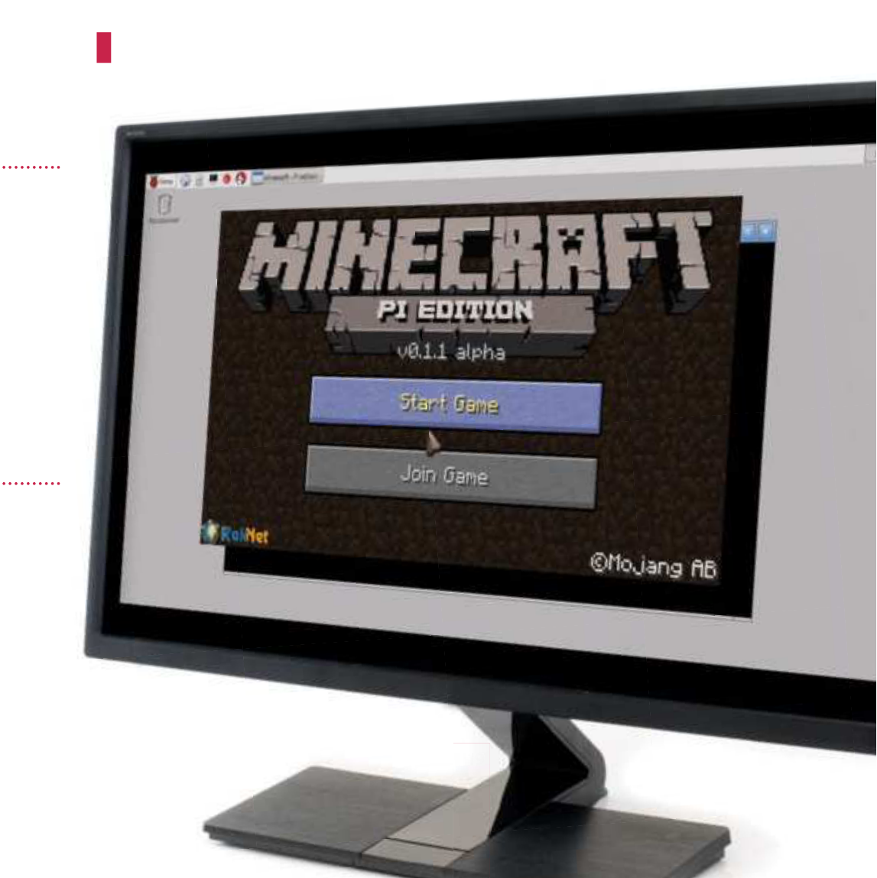

Prepare your Raspberry Pi

**02** works on Raspbian. We   
 Minecraft: Pi Edition currently

recommend you install a fresh version of Raspbian, but if you already have an SD card with it on, the very least you

should do is:

“If you’ve installed Raspbian from scratch, Minecraft is actually already installed – go to the Menu and look under Games to f nd it”

|  |  |  |
| --- | --- | --- |
| sudo apt-get update && sudo | Set up Python | Autostart language |
| apt-get upgrade |
|  | **06** bits, we might as well modify While we’re doing set up  Mincecraft using Python for a later | **08** @minecraft-pi on the bottom In here, you just need to add  line, save it and reboot to make sure |
| part of the tutorial. Open up the | it works. This is a good thing to know |
| terminal and use: | if you also want other programs to |
| $ cp /opt/minecraft-pi/api/ | launch as part of the boot-up process. |
| Prepare Minecraft | python/mcpi ~/minecraft/ | Turn off |
| Minecraft at startup |
|  |
|  |  | For now, we can use the |
| **03** from scratch, Minecraft is If you’ve installed Raspbian  actually already installed – go to the | **07** we’ll need it to launch into For this to work as a console,  Minecraft when it turns on. We can | **09** mouse and keyboard to shut  down the Pi in the normal way, but in |
| the future you’ll have to start turning |
| Menu and look under Games to find it |
| it off by physically removing power. |
| there ready. If you’ve just updated your | make it autostart by going into the |
| As long as you’ve exited the Minecraft |
| version of Raspbian, you can install it | terminal and opening the autostart |
| world and saved, that should be fine. |
| options by typing: |
| from the repos with: |
| $ sudo nano /etc/xdg/ |
| $ sudo apt-get install |
| minecraft-pi | lxsession/LXDE-pi/autostart |

Test it out

**04** Minecraft, it’s best just to   
 If you’ve had to install

check that it works first. Launch the   
desktop, if you’re not already in it, with   
startx and start Minecraft from the   
Menu. Minecraft: Pi Edition is quite   
limited in what it lets you do, but it   
does make room for modding.

X setup

**05** install and/or you have your   
If you have a fresh Raspbian

install launch into the command line,   
you need to set it to load into the   
desktop. If you’re still in the desktop,   
open up the terminal and type in   
raspi-config. Go to Enable Boot to   
Desktop and choose Desktop.

Build a Minecraft console for Pi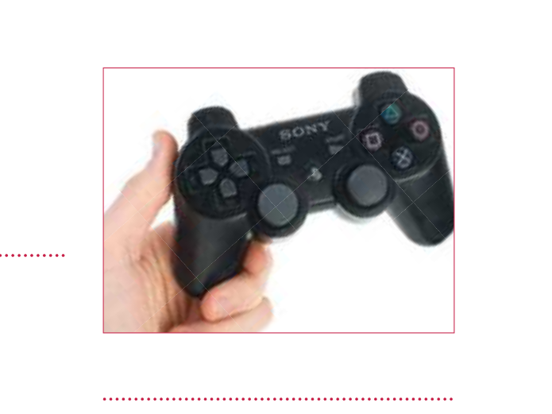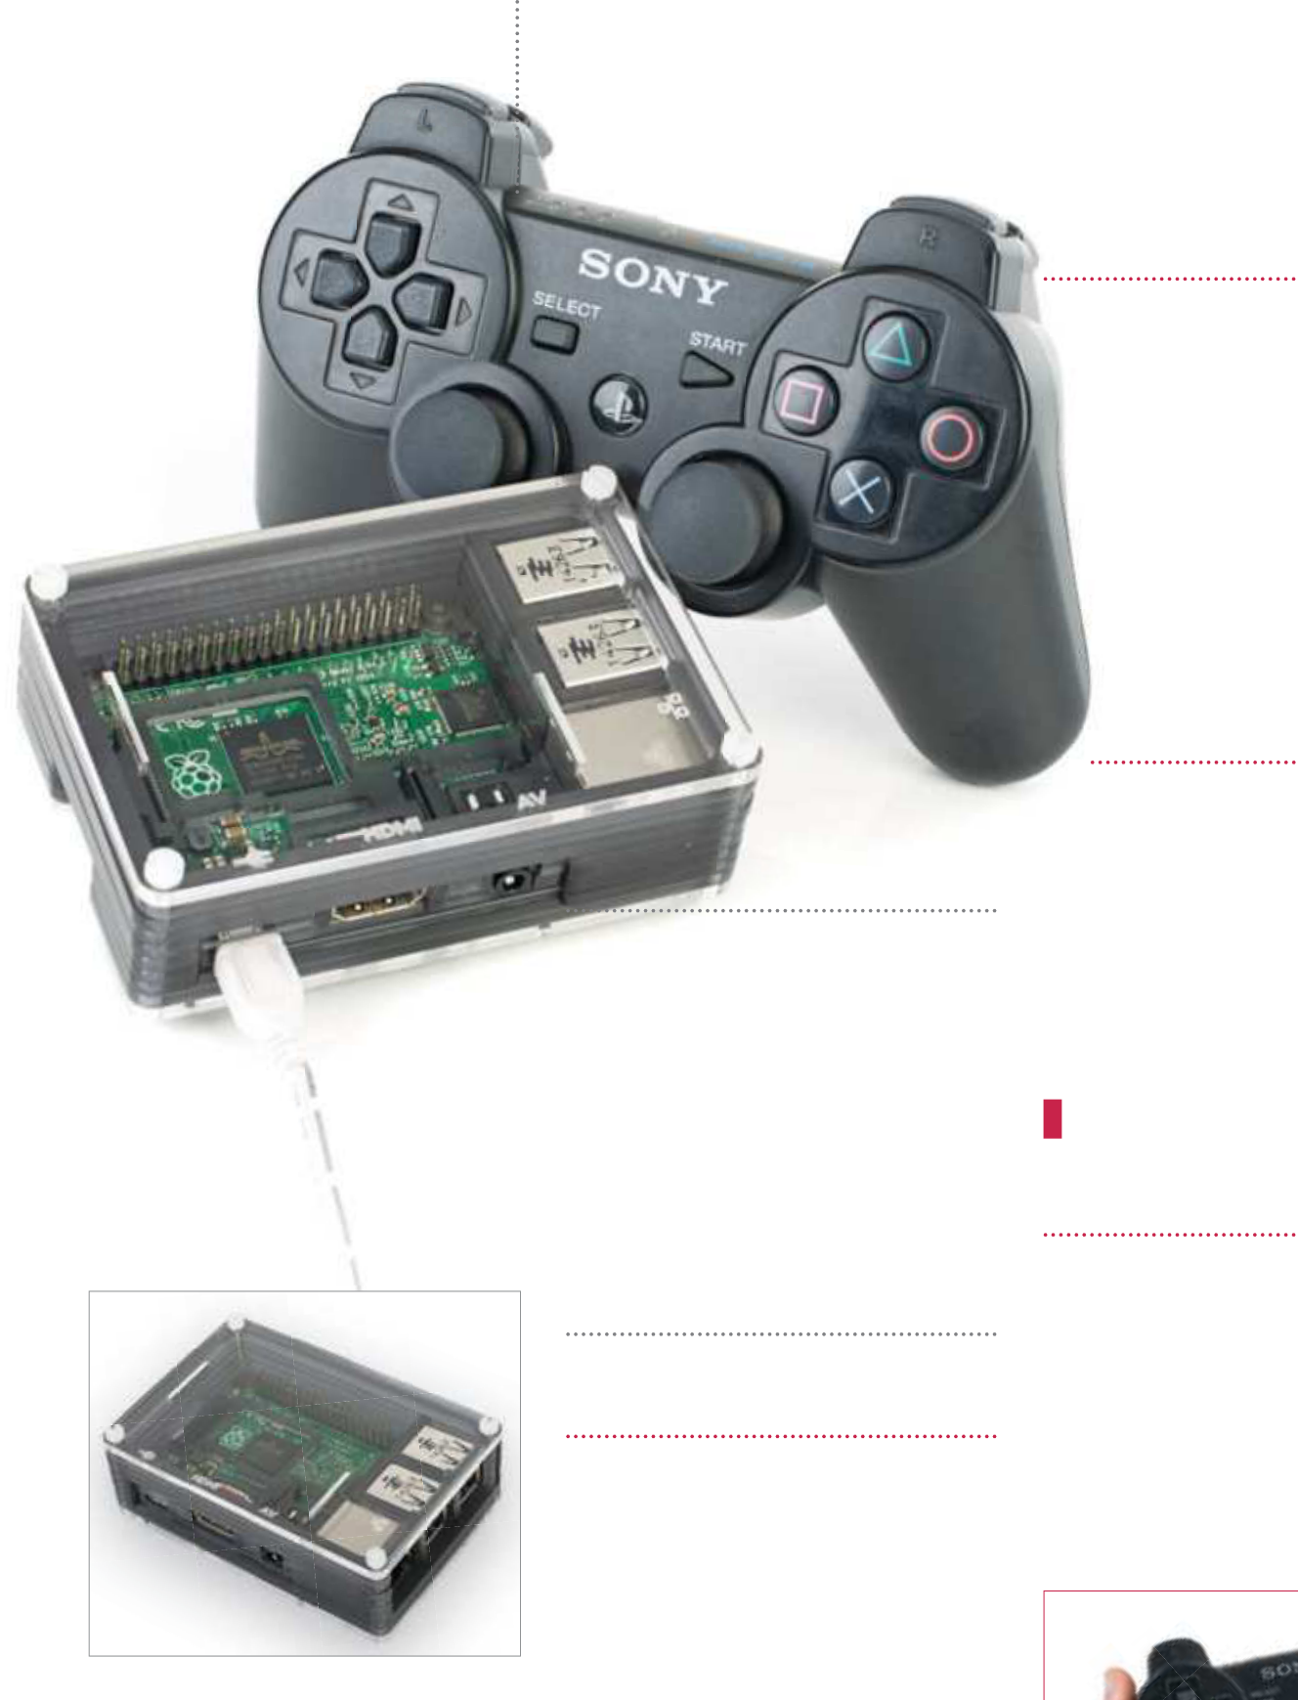

Mouse and keyboard

**13** Raspberry Pi ready to be   
 Now that we have the

hooked up, you should look at   
your controller situation – do you   
want to be limited by the wires or   
should you get a wireless solution   
instead? We will cover controller   
solutions over the page, but it’s   
worth considering now as it will   
 be easier to configure now than   
 it will be at a later date.

Get ready for SSH

|  |
| --- |
| **14** apply scripts to Minecraft by  It will be easier to create and  uploading them via the network |

rather than doing it straight on the Pi.

|  |  |  |  |
| --- | --- | --- | --- |
|  | “Getting power | In the terminal, find out what the IP | |
| address is by using ifconfig, and then | |
| you can access the Pi in the terminal | |
| to the Raspberry |
| of another networked computer using | |
| Pi 2 so that it runs | the following: | |
| ssh pi@[IP address] | |
| properly can be |
| Have a play | |
| tricky if you’re using |
|  | a USB port” | **15** Minecraft console. You could We have built a fully functional  start playing if you so wish and you | |
|  |
| Find a power supply | don’t need to add a controller. You can | |
| flip over to page 122 to begin learning | |
|  | **11** Pi 2 so that it runs properly can Getting power to the Raspberry  be tricky if you’re using a USB port or | how to mod your Minecraft. However, | |
| if you do want to add controller | |
| support then carry on and take a look | |
| at Step 16. | |
| a mobile phone charger – the former |
| |  | | --- | |  | | |
| will be underpowered and the latter |
| is not always powerful enough. Make |
| The correct case | sure you get a 2A supply, like the |
| official Raspberry Pi one. |
| |  |  | | --- | --- | | **10** | In this scenario, we’re hooking | | Go wireless |
| this Raspberry Pi up to a TV, which means it needs a case so that | **12** everyone has an ethernet cable We understand that not  near their TV, so it may be a good idea |
| there’s less chance of damage to |
| the components from dust or static. |
| There are many good cases you can | to invest in a Wi-Fi adapter instead. | Add controller support | |
|  |  |
| get – we are using the Pimoroni Pibow | There is a great list of compatible Wi-Fi | **16** | Make sure the controller  input functions are installed |
| here as you can mount it to the back | adapters on the eLinux wiki: elinux. |
| of the TV. | org/RPi_VerifiedPeripherals. |

|  |
| --- |
| **120** |

|  |  |  |  |  |  |
| --- | --- | --- | --- | --- | --- |
| **L2** Right click (hit) | Build a Minecraft console for Pi | | | **Projects** | **R2** Right click (hit) |
| **Select** | **PS Button** | **Start** Escape |
| Escape | Connect | |

controller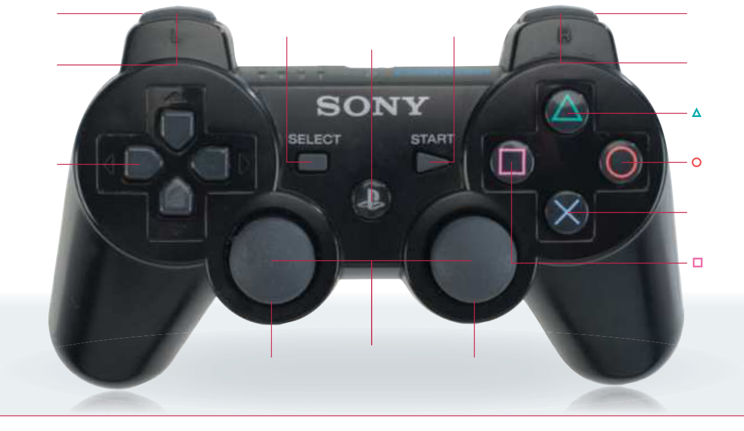

**L1** Cycle held item Cycle held item

Inventory

**Directional**  Escape **buttons**   
Movement

**X** Jump

**Controls**

**Here’s the full**  Inventory **layout of the**   
**buttons used by**   
**the PS3 controller**   
**by default – you**   
**can change them**   
**in the script that**

|  |  |  |  |  |
| --- | --- | --- | --- | --- |
| **you download in** | **L3 / R3** | | | Go full-screen |
| **Step 18** | **Left stick** | Descend | **Right stick** Camera |
| on the Raspberry Pi. To do this, | Movement | t while flying | |
|  | | |
|  |
| ssh into the Raspberry Pi like we | **20** noticed that Minecraft is So far you may have  running in a window – you can |
| did in Step 14 (where ‘raspberry’ is |
| the password) and then install the |
| following package: |
| $ sudo apt-get install | click the full-screen button to |
| xserver-xorg-input-joystick | make it fill the screen, however |
| you then heavily limit your mouse |
| Controller mapping | control. Thanks to the controller, |
| you can get around that. |
| |  |  | | --- | --- | | **17** | We have a controller map for | | Reboot to use | | | As soon as you load the game, |
| make sure you use the sticks for |
| **19** everything’s working, you After a reboot to make sure  should be able to control the mouse | | |
| the PS3 controller that you can download straight to your Pi, and with | movement and the d-pad for |
| selecting items in the inventory. |
| a bit of tweaking can fit most USB |
|  |
| controllers as well. Go to the controller | **Xbox controllers** |
| configuration folder with: | input on the console. R2 and L2 are | | |
| $ cd /usr/share/X11/xorg. | the normal mouse clicks and can be | | |
| conf.d/ | used to navigate the Minecraft menu | | | **Unfortunately, Xbox 360** |
| to access the game. | | | **controllers work slightly** |
| Replace the controller |
| **differently with Linux. As they** |
|  | | | **use their own drivers that** |
| mapping |
| **are separate to the normal** |
| **18** joystick controls by using We’ll remove the current  sudo rm 50-joystick.conf and then | **joystick drivers we used for** |
| **the PS3 pad and other USB** |
| **controllers, a 360 controller** |
| **doesn’t work as a mouse and** |
| replace by downloading a custom | **is harder to assign specific** |
| configuration using: | **functions to. This makes it** |
| $ sudo wget http://www. | **tricky to use in a situation such** |
| **as this.** |
| linuxuser.co.uk/wp-content/ |
| uploads/2015/04/50-joystick.conf |

|  |
| --- |
| **121** |

|  |  |
| --- | --- |
| **Projects** | Mod your Minecraft |

Mod your Minecraft   
Here is some example code, and explanations for it, so that you can learn how to program in Python and mod Minecraft Pi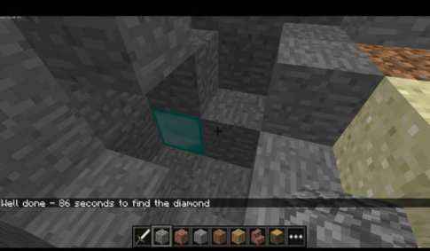

|  |  |  |
| --- | --- | --- |
| We program Minecraft to react | the Minecraft function from the | Over the page, we have a full listing for a hide and seek game that expands on the  kind of code we’re using  here, where the player must fnd a diamond hidden in the level, with the game telling you whether you’re hotter  or colder. You can write it  out from scratch or download it to your Pi using the  following commands:   $ wget http://www. |
| in python using the API that | fles we moved earlier, which |
| comes with Minecraft: Pi Edition | allows us to actually use Python |
| – it’s what we moved to the | to interact with Minecraft, along |
| home folder earlier on. Now’s | with the various other functions |
| a good time to test it – we can | and modules imported. We |
| do this remotely via SSH. Just cd | then create the mc instance |
| into the Minecraft folder in the | that will allow us to actually |
| home directory we made, and | post to Minecraft using the |
| use nano test.py to create our | postToChat function. There are |
| test fle. Add the following: | many ways you can interact |
| from mcpi.minecraft import | with Minecraft in this way – |
| Minecraft  from mcpi import block  from mcpi.vec3 import Vec3 mc = Minecraft.create() | placing blocks that follow the |
| player, creating entire structures | linuxuser.co.uk/tutorialfiles/ |
| and giving them random | Issue134/ProgramMinecraftPi.  zip  $ unzip ProgramMinecraftPi.  zip  $ cp Program\ MinecraftPi/  hide_and_Seek.py ~/minecraft  Check out the annotations to  the right to see how it works.  “We program  Minecraft to react in Python using  the API that comes with Minecraft  Pi – it’s what we  moved to the  home folder earlier” |
| mc.postToChat(“Hello, | properties as they’re spawned |
| Minecraft!”) | as well. There are very few |
| Save it, and then run it with: | limits to what you can do with |
| $ python test.py | the Python code, and you can |
| “Hello, Minecraft!” should pop | check out more projects here: |
| up on-screen. The code imports | https://mcpipy.wordpress.com. |
| |  | | --- | | **Below** You can see the hidden diamond just to the left of the crosshair at the centre of this screenshot | | |

|  |
| --- |
| **122** |

|  |  |
| --- | --- |
| Mod your Minecraft | **Projects** |

Full code listing

|  |  |  |
| --- | --- | --- |
| Import | from mcpi.minecraft import Minecraft | |
| Here we’re importing the | from mcpi import block |  |
| from mcpi.vec3 import Vec3 |
| necessary modules and APIs |
| from time import sleep, time |
| to program Minecraft | import random, math |
| Locate |
| mc = Minecraft.create() |
| playerPos = mc.player.getPos() |
| We find the player’s position |
| defroundVec3(vec3): |
| and round it up to an integer |
| return Vec3(int(vec3.x), int(vec3.y), int(vec3.z)) |
| Range finding |
| defdistanceBetweenPoints(point1, point2): |
| Calculate the distance from | xd = point2.x - point1.x |
| player to diamond. This | yd = point2.y - point1.y |
| zd = point2.z - point1.z |
| compares the co-ordinates | return math.sqrt((xd*xd) + (yd*yd) + (zd*zd)) |
| Creation  Create a random position for the diamond within 50 blocks | defrandom_block():  randomBlockPos = roundVec3(playerPos)  randomBlockPos.x = random.randrange(randomBlockPos.x -50, randomBlockPos.x +50) randomBlockPos.y = random.randrange(randomBlockPos.y -5, randomBlockPos.y +5) | |
| of the player position | randomBlockPos.z = random.randrange(randomBlockPos.z -50, randomBlockPos.z +50) return randomBlockPos | |
| Start  This starts the game. It asks to get the position of the player | defmain():   global lastPlayerPos, playerPos  seeking = True | |
| to start each loop | lastPlayerPos = playerPos | |
| Notification This pushes a message | randomBlockPos = random_block()  mc.setBlock(randomBlockPos, block.DIAMOND_BLOCK) mc.postToChat(“A diamond has been hidden - go find!”) | |
| through to let the player know that the game has begun | lastDistanceFromBlock = distanceBetweenPoints(randomBlockPos, lastPlayerPos) timeStarted = time() | |

while seeking:

|  |  |
| --- | --- |
| Checking  We start timing the player  with timeStarted, and set the last distance between the  player and the block  Message writing  If you’re two or more blocks away from the diamond, it will tell you whether you’re nearer or farther away than your last position check  Success  If the loop has been broken, it tallies up your time and lets you know how long it was before you found the | playerPos = mc.player.getPos()  if lastPlayerPos != playerPos:  distanceFromBlock = distanceBetweenPoints(randomBlockPos, playerPos) if distanceFromBlock <2:  seeking = False  else:   if distanceFromBlock < lastDistanceFromBlock:  mc.postToChat(“Warmer ” + str(int(distanceFromBlock)) + “ blocks away”) if distanceFromBlock > lastDistanceFromBlock:  mc.postToChat(“Colder ” + str(int(distanceFromBlock)) + “ blocks away”)  lastDistanceFromBlock = distanceFromBlock  sleep(2)  timeTaken = time() - timeStarted  mc.postToChat(“Well done - ” + str(int(timeTaken)) + “ seconds to find the diamond”)  if __name__ == “__main__”:  main() |

diamond. Finally, the last bit   
then tells Python to start the   
script at the main function

|  |
| --- |
| **123** |

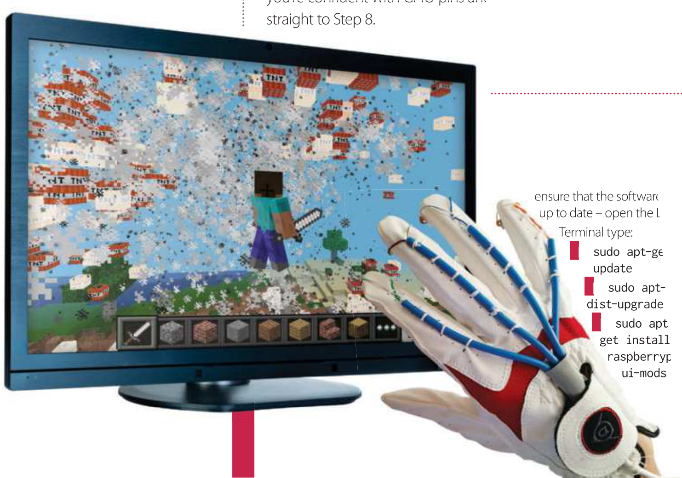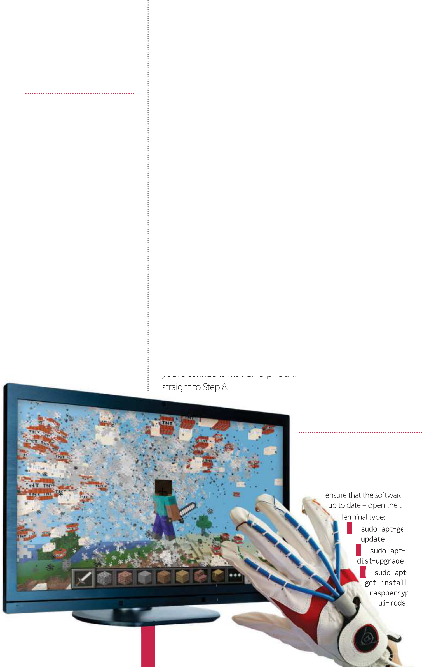

|  |  |
| --- | --- |
| **Projects**  What you’ll need…  **Raspberry Pi 2**  **4 x 6mm tactile buttons Female-to-female jerky Terminal blocks**  **A glove**  **Router**  **2x CAT5 cables** | Build a power move glove  Build a power move glove  Create a piece of wearable tech with power moves  assigned to each button to enhance your Minecraft game |

Update the Raspberry Pi

|  |  |  |
| --- | --- | --- |
| Connect a button to Pi | Build a power move glove | **Projects** |
| PiGlovePowerMoves.py |
| **02** and connect a wire to each Take one of the buttons  contact, then take the other two ends | import time | x+6, y+10, z+3, TNT) |
| from mcpi import minecraft | time.sleep(1) |
| and connect to the Pi. You may find | mc = minecraft.Minecraft. | #Lays Lava to slow down the |
| this easier using a female-to-female | create(“192.168.1.211”) | other player |
| connector. To set up a test button, | #Replace with the other | defLay_Lava(): |
| use GPIO pin 17 – this is physical pin | players IP address | Lava =10 |
| number 11 on the board. The other | import RPi.GPIO as GPIO | check =1 |
| wire connects to a ground pin, shown | mc.postToChat(“Lava |
| by a minus sign (the pin above GPIO | #Set up the GPIO Pins | Deployed”) |
| pin 17 is a ground pin). | while check ==1: |
| Test that the button works | GPIO.setmode(GPIO.BCM) | time.sleep(0.2 ) |
| x, y, z = mc.player. |
| #Sets the pin to high | getPos() |
| **03** button is functioning correctly. Use this test code to ensure the  Once it is, the same setup method | GPIO.cleanup() | mc.setBlock(x-1, y, |
| GPIO.setup(17, GPIO.IN, GPIO. | z, Lava) |
| PUD_UP) | check =0 |
| #11 on the BOARD GREEN | #Peforms a Mega Jump to lose |
| can be used throughout this project. |
| Firewall |
| To ensure the buttons are responsive, |
| GPIO.setup(18, GPIO.IN, GPIO. | players |
| use the pull-up resistor with the code |
| PUD_UP) | defMega_Jump(): |
| GPIO.PUD_UP – this will ensure that |
| #12 on the BOARD BROWN Lava | time.sleep(0.1) |
| multiple touches aren’t registered on |
| GPIO.setup(9, GPIO.IN, GPIO. | mc.postToChat(“Mega-Jump”) |
| each button. Using Python 2.8, type |
| PUD_UP) | x, y, z = mc.player. |
| in the code below, then save and run. |
| #21 on the BOARD BLUE Mega | getPos() |
| If working correctly, it will return the |
| Jump | mc.player.setPos(x, y+15, |
| message ‘Button works’. |
| GPIO.setup(4, GPIO.IN, GPIO. | z) |
|  |
| import RPi.GPIO as GPIO | PUD_UP) | time.sleep(1) |
|  |  |
| GPIO.setmode(GPIO.BCM) | #7 on the BOARD ORANGE Puddle | #Creates a Puddle to slow down |
| GPIO.cleanup() | GPIO.setwarnings(False) |

GPIO.setup(17, GPIO.IN, GPIO. PUD_UP)

while True:  
 if GPIO.input(17) == 0: print “Button works”

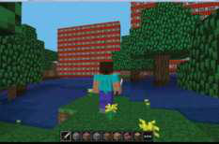

#switch off other ports your player

defMega_Water_Puddle():

|  |  |
| --- | --- |
| #Builds a wall of TNT which if the player hits will explode defFirewall():  mc.postToChat(“Firewall Placed”)  TNT =46,1  x, y, z = mc.player.  getPos()  mc.setBlocks(x-6, y, z+2, | mc.postToChat(“Mega Water Puddle”)  time.sleep(0.2)  WATER =9  x, y, z = mc.player.  getPos()  mc.setBlocks(x-5, y, z-4, x-1, y, z+4, WATER)  time.sleep(1) |
| create your own power moves and | it up, but it will slow them down. In a |

|  |  |  |
| --- | --- | --- |
| Create a power move | assign them to each button, keeping | new Python window, type the code |
| both your ideas and your gameplay | below and save the program into the |
| Now to create your first power |  |  |
| fresh. The first power move you will | home folder: |
| program enables you to place a wall |  |
| **04** move. The glove and code are  structured in such a way that once the | of TNT between you and the player | import time |
| def Firewall(): |
| trying to catch you. They have a |
|  |
| basic code template is set up, you can | choice to go around the wall or blow | mc.postToChat(“Firewall |

|  |
| --- |
| **125** |



|  |  |  |
| --- | --- | --- |
| **Projects** | Build a power move glove | Connect the wires |
| Placed”) | with the same method. Open a new |
| TNT = 46,1 | Python window and type in the code |
|  | below – save the file in the home |  |
| x, y, z = mc.player. | folder. Start a Minecraft game as | |  |  | | --- | --- | | **10** | Now you are ready to connect the wires to the Pi to enable all | |
| getPos() |
| shown in Step 6 and then run the new |
|  |
| mc.setBlocks(x-6, y, z+2, | program. Every time you press the | four power moves to be used. Take |
| x+6, y+10, z+3, TNT) | one end of each wire and connect |
| button you will place a TNT firewall. |
| time.sleep(10) | them to the respective pins, as shown |
|  |
| while True: | import time | below. The other end of the wire is |
| from mcpi import minecraft | placed into a ground pin. Note that |
| Firewall() | mc = minecraft.Minecraft. | the RPi.GPIO pin numbering system is |
| Open Minecraft | create() | used here rather than the physical pin |
| import RPi.GPIO as GPIO | number on the board – for example, |
| GPIO.setmode(GPIO.BCM) | GPIO pin 17 is physical pin number 11. |
| **05** Raspbian OS comes with The updated version of the  Minecraft pre-installed, it can be found |
| GPIO.setup(17, GPIO.IN, GPIO. | The following pins are used: |
| PUD_UP) | GPIO 17, pin 11 on the board |
| #11 on the BOARD | GPIO 18, pin 12 on the board |
| under Menu>Games – so load it up. |
| def Firewall(): | GPIO 9, pin 21 on the board |
| If you have used the Minecraft: Pi |
|  | GPIO 4, pin 7 on the board |
| Edition before you will be aware that it | mc.postToChat(“Firewall |  |
| runs better in a smaller-sized window, | Placed”) | Set the network up |
| so don’t make it full screen. You may | TNT = 46,1 |
|  | x, y, z = mc.player. |
| prefer to adjust and arrange each | **11** in the Minecraft world you To interact with other players  will need to set up a networked |
| window side-by-side to enable you to | getPos() |
| view both the Python code and the | mc.setBlocks(x-6, y, z-2, |
| Minecraft game at the same time. | x+6, y+10, z-1, TNT) |
| multiplayer game. This is simple and |
| Engage the firewall | while True: |
| can be achieved using an old router. |
| if GPIO.input(17) == 0: |
| Connect each Raspberry Pi via an |
| Firewall() |
|  | Ethernet cable to the router and |
| **06** then go to the Python   Start a new Minecraft game,  program and press F5 to run it. You | Set up further buttons |
| then back to the Ethernet port on |
| each Raspberry Pi. Turn on the router |
|  |
|  | and wait about 30 seconds for the IP |
| may need to press the Tab key to | **08** the same method from Step For the other buttons, use  2. Take the button and connect the |
| addresses to be assigned. Now load |
| release the mouse from the Minecraft | up Minecraft and one of the players |
| window. The program will place a 12 x | will start a new game. |
| 10 wall of TNT behind the player every | two wires to either side. You can |  |
| ten seconds – you can blow them up | add all three buttons and test them |
| but the Pi might lag. | for connectivity. Connect each set |
| Assign the buttons | to the GPIO 17 and run the firewall |
| program. If the firewall power move |
| **07** button and a power move, Now you have a working  you can combine these two together. |  |
| builds on each click of the button, the |  |
| connections and buttons are working |
| and you’re ready to attach the buttons. |
| Run the game! |
| Create the glove |
| Basically, when you press the button |
| the power move will deploy. Once | **09** fingers. There are a number of Attach the four buttons to the  ways to do this: glue the button on, | **12** other connected player will see After the game has loaded, the  an option to ‘connect to a multiplayer |
| this is working you |
| can then set up |
| the other three |
| buttons | sew them in, stick them with double- | game’, usually called Steve. The player |
| sided tape – the choice is up to you. | selects this option and the networked |
| Wires can be hidden or on display, | game will begin. You will be able to |
| depending on your preferences and | see two ‘Steves’ and the Minecraft |

how you want the glove to look. chat will inform you that ‘Steve has

|  |  |  |  |
| --- | --- | --- | --- |
| joined the game’. Open Python and the glove code, press F5 to run and | Build a power move glove | | **Projects** |
| Test for hits | | Game on |
| you will be able to see the power moves being deployed.    Interact in other worlds  **13** if the Pi Glove is connected to Under the current setup that  the game and you use one of your power moves, it will only appear in your Minecraft world and not in the other players. This isn’t great, as the power move is supposed to stop the other player! To resolve this, find the IP address of the other Pi, then enter this IP address into this line of code: mc = minecraft.Minecraft.create( ), filling the empty brackets with the IP address of the other Pi within your game.  Remember that this is the IP address of the other player’s Pi and not your IP address.  Find your IP addresses  **14** load the LX terminal, type To find the IP address of a Pi,  ipconfig and press Enter – the address will be displayed on the line that  begins int addr:. This is the number that you enter into the brackets.  Remember on the Glove Pi to enter the IP address of the other player’s Pi, not yours.  Run both programs  **15** without some healthy   No game would be complete  competition and strategy. A second program is deployed by the other player on the network which tracks and registers if they catch or hit you. The program checks the block that they have hit and compares it to the player’s location. | **16** has hit you, run the second To check if the other player  program on the Pi of your opponent. | **17** addresses are set for the other Check again that the IP  Raspberry Pi and not your own. Build a | |
| The program finds the other ‘glove’ | | new Minecraft world and start a new |
| players current position and stores it. It | | game on the Raspberry Pi with the |
| then compares the position that you | | player who is chasing. When loaded, |
| hit with your sword, storing this too. | | the glove player joins the multiplayer |
| The program compares values, if they | | game – this will be called Steve (see |
| match then you have hit the other | | Step 11). When loaded, you should see |
| player. Note that in order to monitor | | both players in the world. Then run |
| where the other player is, you must | | the ‘Pi Glove power moves’ program, |
| set the code line mc1 = minecraft. | | and on the other Pi run the ‘You hit |
| Minecraft.create( ) to their IP address. | | me program’. |
| PiGlovePowerMoves.py(Cont.)  #Main code to run | | |
| try: | | #GPIO.output(18, |
| lava_check =0 | | GPIO.LOW) |
| mc.postToChat(“Minecraft | | if GPIO.input(9) ==0: |
| Power Glove Enabled”) | | Mega_Jump() |
| while True: | | if GPIO.input(4) ==0: |
| if GPIO.input(17) == | | Mega_Water_ |
| 0:  Firewall()   if GPIO.input(18) == 0: #needs to stop  Lay_Lava() | | Puddle()  time.sleep(3)  except:  print “Error” |
| YouWereHit.py  import time  from mcpi import minecraft | |
| blockHits = mc.events. | | |
| mc1 = minecraft.Minecraft. | | pollBlockHits() |
| create(“192.168.1.245”) | | if blockHits: |
| #The other players IP address | | for blockHit in blockHits: |
| goes here | | if stood_z == blockHit. |
| pos.z and stood_y == blockHit. | | |
| mc = minecraft.Minecraft. | | pos.y+1: |
| create() | | mc.postToChat(“I got |
| mc.postToChat(“###Here I | | you”) |
| come”) | | time.sleep(2) |
| Hit =1 | | mc.postToChat(“###GAME |
| OVER###”) | | |
| while Hit ==1: | | time.sleep(1) |
| Hit =0 #Find the block stood on | | |
| stood_x, stood_y, stood_z = | | mc.postToChat(“###Restart Hit |
| mc1.player.getTilePos() | | Code”) |

|  |
| --- |
| **127** |



Enjoyed this book?

**Exclusive offer for new**

**Try**   
**3 issues**   
**for just**  
 **£ 5 \***

* This of er entitles new UK direct debit subscribers to receive their f rst three issues for £5. After these issues, subscribers will then pay £25.15 every six issues. Subscribers can cancel this subscription at any time. New subscriptions will start from the next available issue. Of er code ZGGZINE must be quoted to receive this special subscriptions price. Direct debit guarantee available on request. This of er will expire 31 October 2016.

** This is a US subscription of er. The USA issue rate is based on an annual subscription price of £65 for 13 issues, which is equivalent to approx $102 at the time of writing compared with the newsstand price of $16.99 for 13 issues $220.87. Your subscription will start from the next available issue. This of er expires 31 October 2016.

|  |
| --- |
| **128** |



**The only magazine**   
**all about Linux**   
**Written for you**   
Linux User & Developer is the only   
magazine dedicated to advanced users, developers   
and IT professionals

|  |  |
| --- | --- |
| **About**   **the**   **mag** | **In-depth guides & features** Written by grass-roots developers and  industry experts  **Free assets every issue**  Four of the hottest distros feature every month – |

log in to FileSilo, download and test them all!

**w subscribers to…**

**Try 3 issues for £5 in the UK\***   
**or just $7.85 per issue in the USA** (saving 54% off the newsstand price)**

**For amazing offers please visit**   
**www.imaginesubs.co.uk/lud Quote code ZGGZINE**   
**Or telephone UK 0844 249 0282 Overseas +44 (0)1795 418 661 +**

+Calls will cost 7p per minute plus your telephone company’s access charge

|  |
| --- |
| **129** |



From the makers of

**Practical**   
**Raspberry Pi**  **ProJects**

A world of content at your f ngertips Whether you love gaming, history,   
animals, photography, Photoshop,   
sci-f or anything in between, every   
magazine and bookazine from   
Imagine Publishing is packed with   
expert advice and fascinating facts.

**BUY YOUR COPY TODAY**   
Print edition available at www.imagineshop.co.uk Digital edition available at www.greatdigitalmags.com

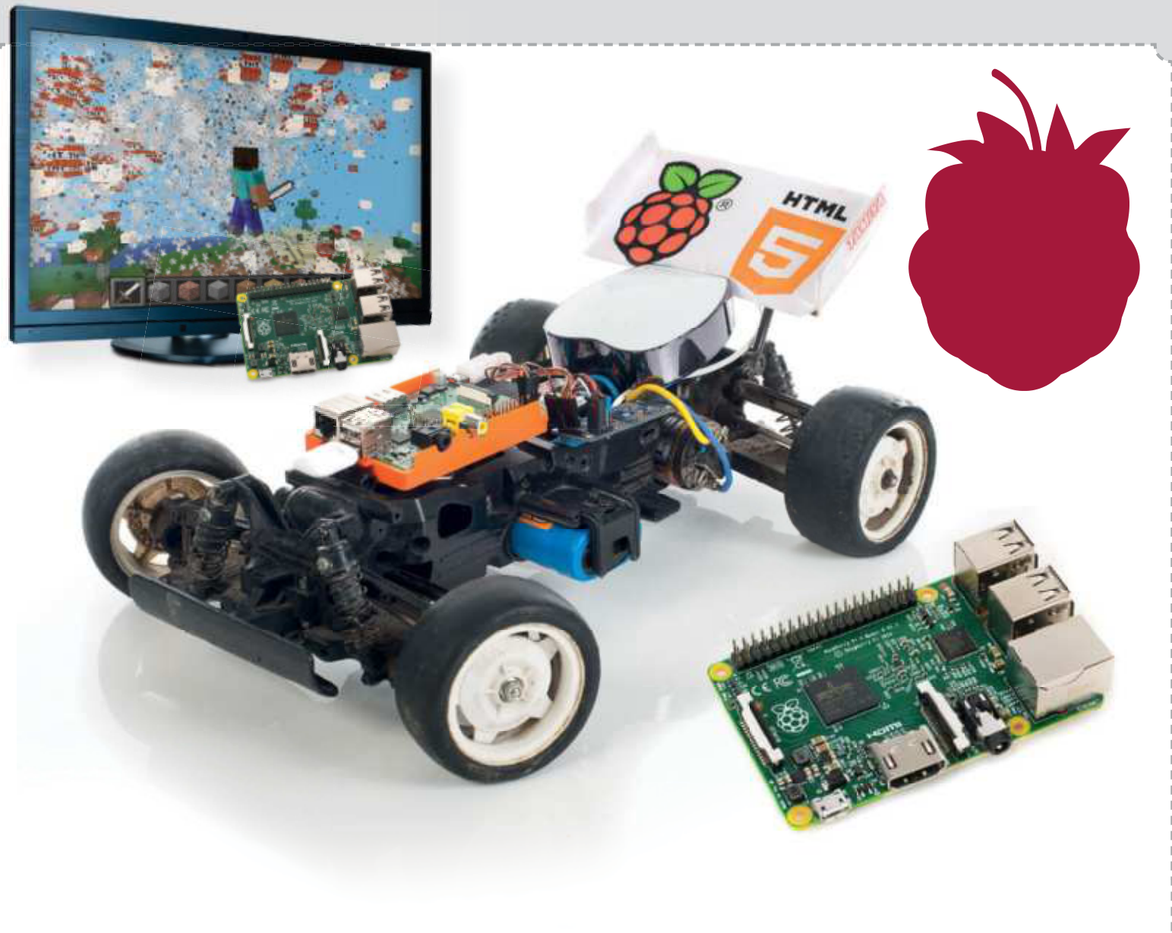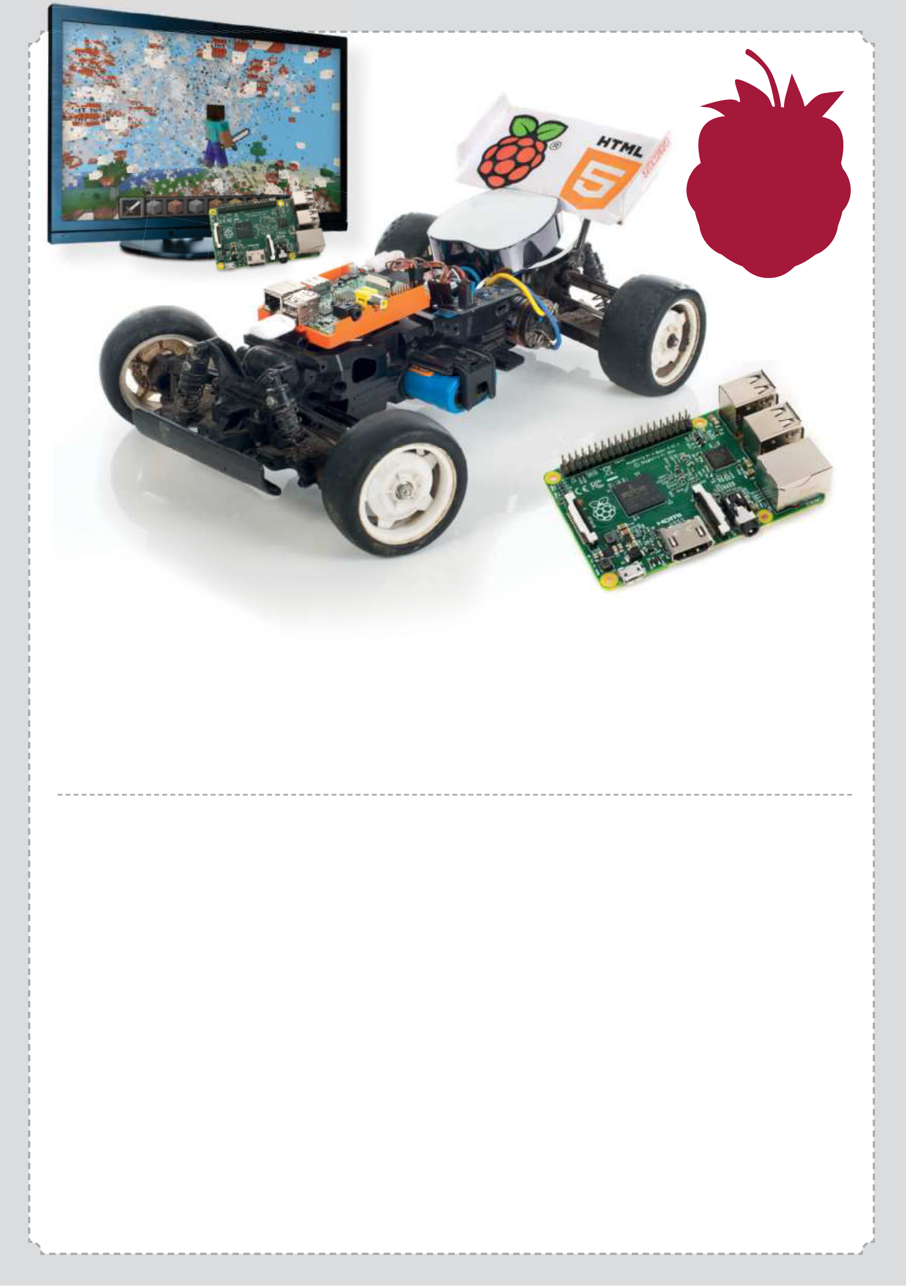

**Guides**   
**for Pi &**   
**Pi 2**

**Raspberry Pi**

**The Complete Manual**

✔Introducing the Raspberry Pi Find your way around the most recent versions of the innovative Raspberry Pi computer

✔Set up your Pi  
 Make sure you have the essential kit and the know-how to get started straight out of the box

✔Master Raspbian  
 Get comfortable using the of cial Raspberry Pi operating system by following simple tutorials

✔Understand applications Everything you need to know about the best applications included with the Raspberry Pi

✔Get to grips with Linux  
 Learn how to use common Linux applications and master the command line basics

✔Get started with programming Navigate the world of Scratch and Python   
programming through easy-to-follow tutorials

✔Take control with your Pi  
 Use the GPIO pins on your Raspberry Pi to control lights, switches and more

✔Create a wireless hotspot Access the internet anywhere by tethering your Raspberry Pi to your Android device

✔Build & code with the web Tether to an Android device, print wirelessly and stream music to your smartphone

✔Creative projects made easy Add a battery pack, send SMS messages, build a Raspberry Pi car and much more!